Functional Requirement Specification (FRS)
Scientific Research CoP
Particulars | Prepared by | Reviewed by | Approved by
Name | Radhika
Role | Freelance Health IT BA
Date | 18/05/21
Signature | Radhika

Contents
1 Overview 3
1.1 Purpose 3
1.2 Audience – User Persona 4
1.3 Terms & Abbreviations 5
2 Requirements 5
2.1.1 PART 01 – CoP LAYOUT 5
2.1.2 PART 02 – FUNCTIONALITIES 15
2.2 Use Cases: 17
Use case 1: Advanced Search 17
Use case 2: Submission Process 17
Use case 3: Curating Articles. 18
2.3 Clinical safety constraints 19
2.4 Operating environment 19
2.5 Interfaces (with software/applications/hardware) 19
2.6 Performance 19
2.7 Security 19
2.8 Deployment, Upgrade and Migration 19
2.9 Others 19
3 Assumptions and Dependencies 20
3.1 Assumptions 20
3.2 Dependencies 20
4 References 21

Overview
*Disclaimer – This ‘Overview’ is for the internal team and will not be shared with the external users such as Dr. Khan or Roshan foundation.

This ‘Scientific CoP’ will cater to the needs of all those users who wish to become member of this community in order to learn and disseminate knowledge in the different areas of science and medicine.

For instance, The Medigy ‘Scientific CoP’ will help the with the initiative of NASIHA a community of scientific academic researchers and doctors focused on knowledge sharing and helping others learn, started by Dr Uzma Khan, wherein the members help find resources useful for their peers to learn, review and guide each other to improve their scientific methods and techniques of analysis.
Dr. Uzma Khan is an Endocrinologist at the University of Missouri Health Care and is a specialist in treating conditions like Diabetes, Endocrine Disorders, Lipid Disorders, Metabolism, Osteoporosis and Thyroid Disorders.

Uzma runs her own website NASIHA https://www.nasihaonline.com/about.html and approached the Medigy team to have this idea of hers to be one of the CoP on Medigy.

The Medigy CoP will also help non-profits such as the Roshan Foundation that are focused on helping first-generation/low-income Muslim college students in the United States advance their academic and professional careers through scholarship and mentorship.

At the moment this is an unpaid project with the implementation of minimal functionalities as discussed below. The ‘Scientific Research’ CoP is created with the understanding that Dr. Khan will bring in at least 100 doctors from varied fields, a couple of pre-medical students and researchers (mainly from Pakistan) to look at the Medigy site and its CoP. Dr. Khan will also help the Medigy team with advice and inputs on the FemTech CoP and guide with user inputs with help of her network in whatever way possible.

By making it available for the use by Roshan Foundation Medigy will be able to drive the traffic by brining in Vrious healthcare professionals on board.

Purpose
The purpose of building this CoP on Medigy is to establish a core platform for scientific researchers to share their knowledge and help in contributing towards the latest research in the field of medical treatment. This CoP would also mean quality traffic of user personas as described in section 1.2.

This document covers the following OKRS:

- Driving Audience to the CoP page
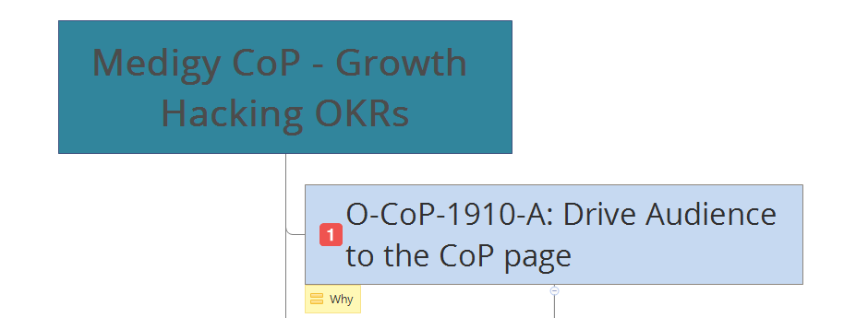
- Audience Engagement
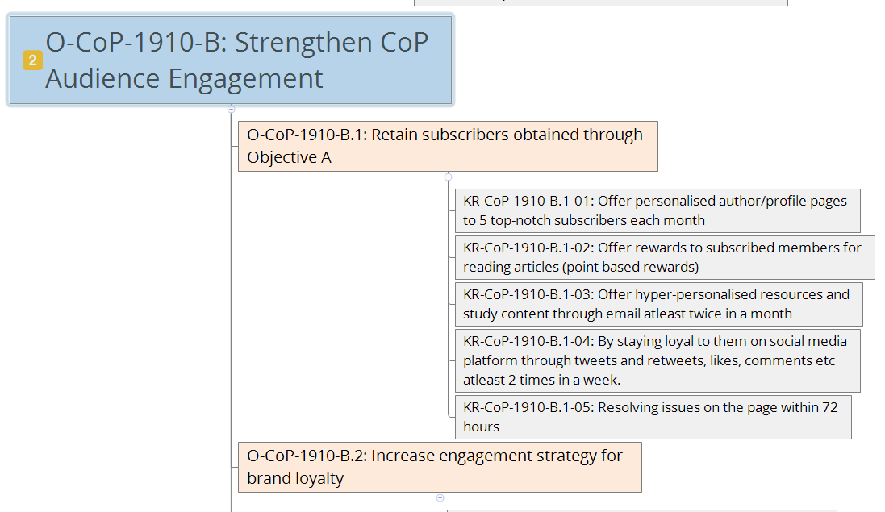

- Monetization

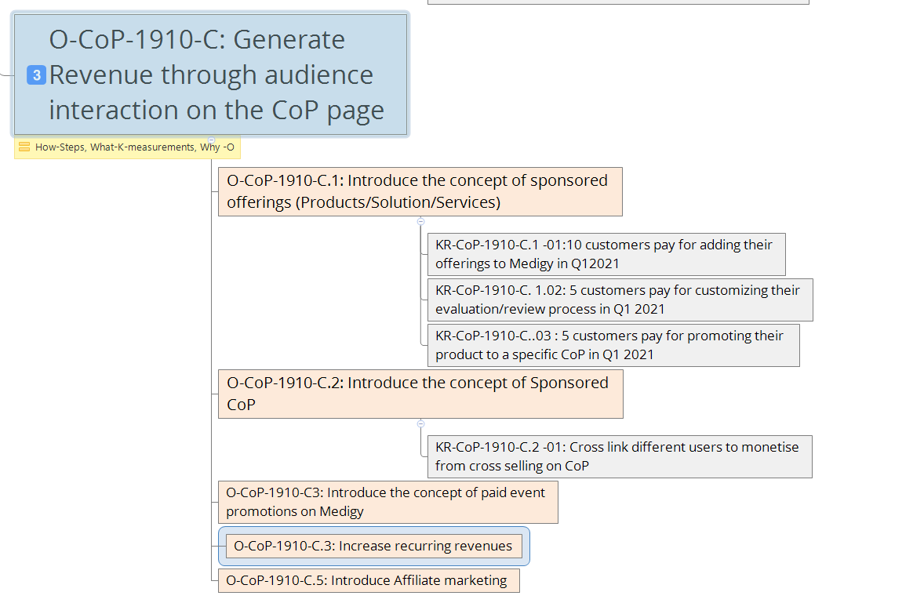

Audience – User Persona
    - Scientific researchers
    - Physicians
    - Ancillary healthcare professionals (nurses, pathologists, radiologists etc)
    - Pre-medical students
    - Health IT influencers
    - Public Health Professionals
    - Physicians Assistants (junior doctors etc)
    - Pharmacists
    - Biologists
    - Mental Health Professionals
    - Nutritionists
    - Physical Therapists

Terms & Abbreviations
Terms and abbreviations used in this document are described in the table below.

Term/Abbreviation | Description
CoP | Community of Practice

Requirements
The following requirements are to be implemented to build the ‘Scientific Research’ CoP in Medigy:

PART 01 – CoP LAYOUT

- When the user clicks on the ‘Communities’ link on Medigy they would land on https://www.medigy.com/communities/ and on that page along with ‘Chronic Care Management’, ‘FemTech’, ‘COVID 19 Pandemic’ CoPs there should be a section ‘Scientific Research’ on that page.

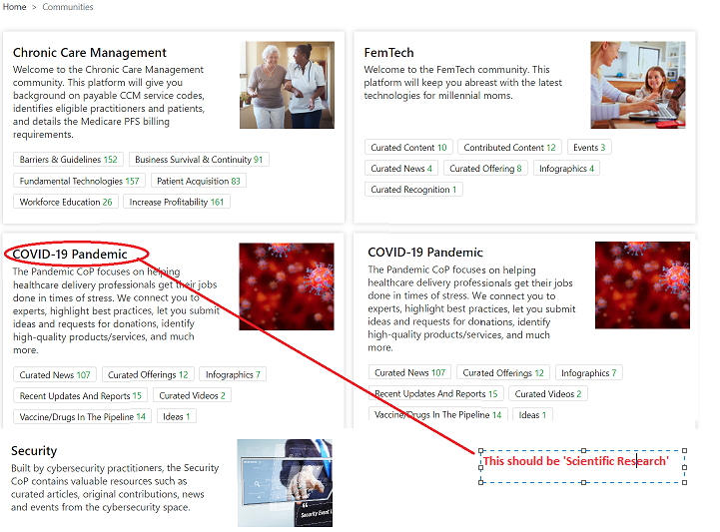

- Description:

A suitable image from here: https://pixabay.com/no/images/search/scientific%20research/ or based on the design team’s discretion.

- The CoP should be displayed in the following sequence:
  - Chronic Care Management
  - FemTech
  - Scientific Research
  - COVID 19 Pandemic
  - Security

- Under the ‘Scientific Research’ CoP the following ‘Focus Groups’ should be displayed as seen in the screenshot below:
  - Mentor
  - Mentee
  - Publications
  - Opportunities
There should be a provision to add more ‘Focus Groups’ that may come up in future.

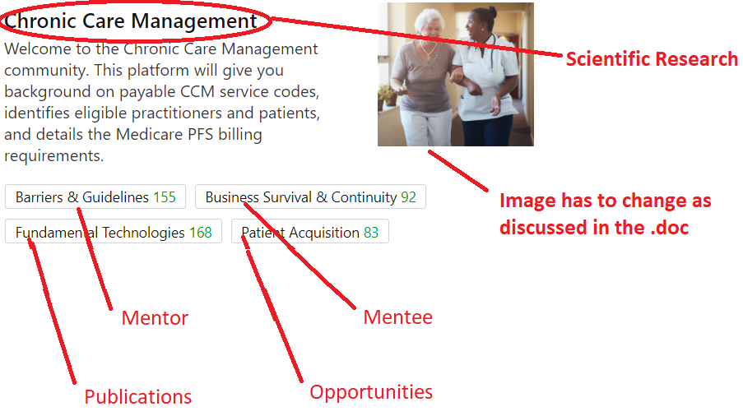

- When the user clicks on the ‘Scientific Research’ link on the communities’ homepage they should land on a page that describes a bit about the ‘Scientific Research’ CoP (as discussed in point. No. 2) and with options to explore each link as seen in the image below.

https://www.medigy.com/communities/scientific-research/

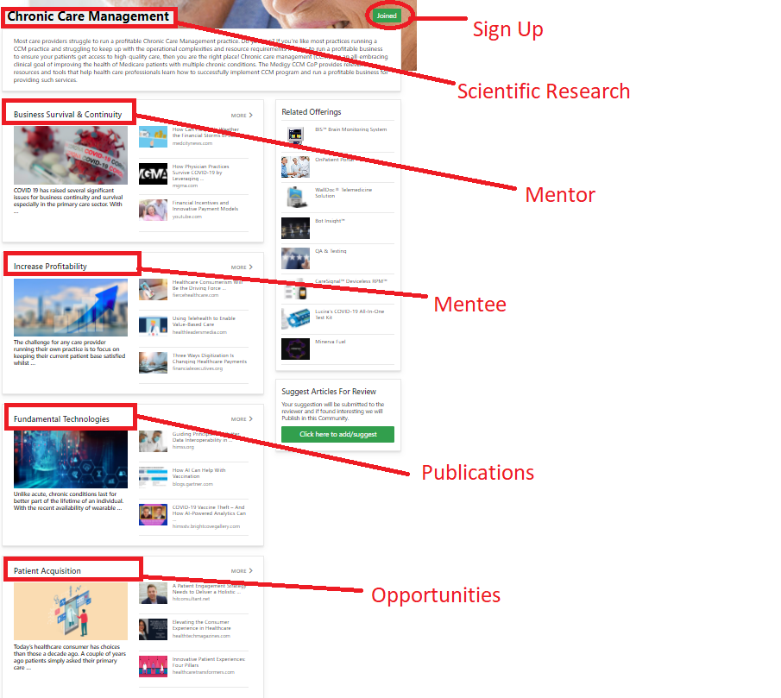

- The ‘Sign-up’ option should display the following fields for the users to answers before signing up as a member of the ‘Scientific Research’ CoP

Field | Description | Data Type | Mandatory | Current Availability in the System
Sign Up | Option1: Healthcare Professional  Option 2: Student  Option 3: Individual | Dropdown | Yes | No
Option 1: Healthcare Professional

(e.g., physicians, nurses etc)
First Name |  | Text | Yes
Last Name |  | Text | Yes
Email ID |  | Text (validation required) | Yes
Phone number with ISD |  | Binary (Validation required) | Yes
Gender | Option 1: Male  Option 2: Female  Option 3: Prefer not to say | Dropdown | Yes
Date of Birth |  | Calendar | Yes
Occupation | Pulled from the SOC Topic list | Dropdown | Yes
ME/License Number |  | Validation (look up) | Yes
Speciality | Pulled from https://health.usnews.com/doctors/specialists-index - please include the list in 1.2 and an option that says ‘Others’ as well. | Dropdown with an option to enter text | Yes
Description |  | Text (200 ch word limit) | Yes
Country of Residence |  | Dropdown | Yes
Reason to Join |  | Text | Yes
Do you wish to be a mentor to our mentees? | Yes, No | Check box | Yes
Social media links | FB, LinkedIn, Twitter | Text (needs to be verified) | No
Option to tick the ‘Terms and Conditions’ and Privacy Policy’ |  | Check box | Yes
‘CAPTCHA’ to tell ‘humans’ and ‘system’ apart. |  |  | Yes
Upload Image |  | JPG, PNG
Option 2: Student

(e.g., Medical students, nursing, life science students etc)
First Name |  | Text | Yes
Last Name |  | Text | Yes
Email ID |  | Text (validation required) | Yes
Phone number with ISD |  | Binary (Validation required) | Yes
Gender | Option 1: Male  Option 2: Female  Option 3: Prefer not to say | Dropdown | Yes
Date of Birth |  | Calendar | Yes
University | Pulled from the SOC Topic list | Dropdown | Yes
Description |  | Text (200 ch word limit) | Yes
Country of Residence |  | Dropdown | Yes
Reason to Join |  | Text | Yes
Do you wish to seek advice from our mentors? | Yes, No | Check box | Yes
Social media links | FB, LinkedIn, Twitter | Text (needs to be verified) | No
Option to tick the ‘Terms and Conditions’ and Privacy Policy’ |  | Check box | Yes
‘CAPTCHA’ to tell ‘humans’ and ‘system’ apart. |  |  | Yes
Upload Image |  | JPG, PNG
Option 3: Individual

(e.g Analyst/Supplier etc)
First Name |  | Text | Yes
Last Name |  | Text | Yes
Email ID |  | Text (validation required) | Yes
Phone number with ISD |  | Binary (Validation required) | Yes
Gender | Option 1: Male  Option 2: Female  Option 3: Prefer not to say | Dropdown | Yes
Date of Birth |  | Calendar | Yes
Occupation | Pulled from the SOC Topic list | Dropdown | Yes
Description |  | Text (200 ch word limit) | Yes
Country of Residence |  | Dropdown | Yes
Reason to Join |  | Text | Yes
Social media links | FB, LinkedIn, Twitter | Text (needs to be verified) | No
Option to tick the ‘Terms and Conditions’ and Privacy Policy’ |  | Check box | Yes
‘CAPTCHA’ to tell ‘humans’ and ‘system’ apart. |  |  | Yes
Upload Image |  | JPG, PNG

Reference: https://mdforlives.com/gb#signup

- When the user signups as a Mentor (HP) or Mentee (Student) then when they land on https://www.medigy.com/communities/scientific-research/ they should be able to see the following view:

- When the user clicks on https://www.medigy.com/communities/scientific-research/mentor/ it should display a list of mentors (also sign up as Healthcare professionals) as seen below:
Only those Healthcare professionals who have checked ‘YES’ to Do you wish to be a mentor to our mentees? Should be displayed on the ‘Mentor page’ in this community.

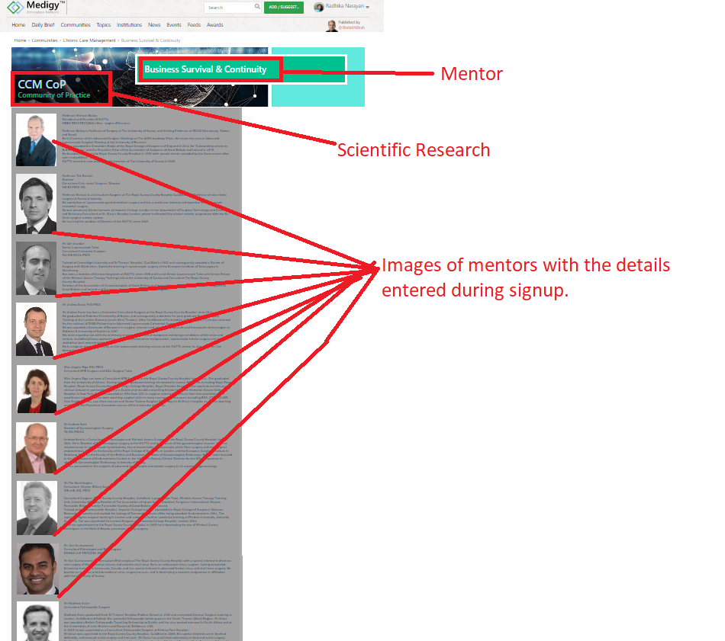
https://www.mattu.org.uk/meet-the-team

- When clicked on a single profile form the above it could display the page for the mentor:

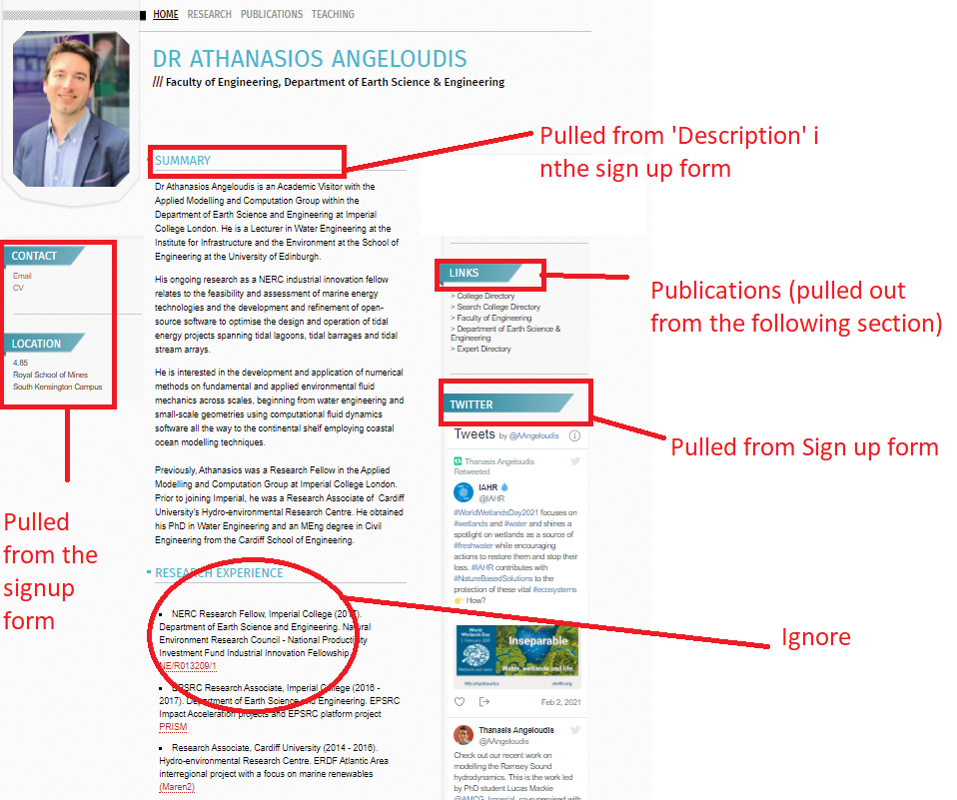
https://www.imperial.ac.uk/people/a.angeloudis06

Likewise, when the user clicks on the ‘Mentee’ section it should display a list of students (signed up as students) as seen in this link https://www.city.ac.uk/people/research-students. Only those ‘Students’ who have ticked a ‘YES’ to the question ‘Do you wish to seek advice from our mentors? Should be displayed as ‘Mentees’ on this page of the community.

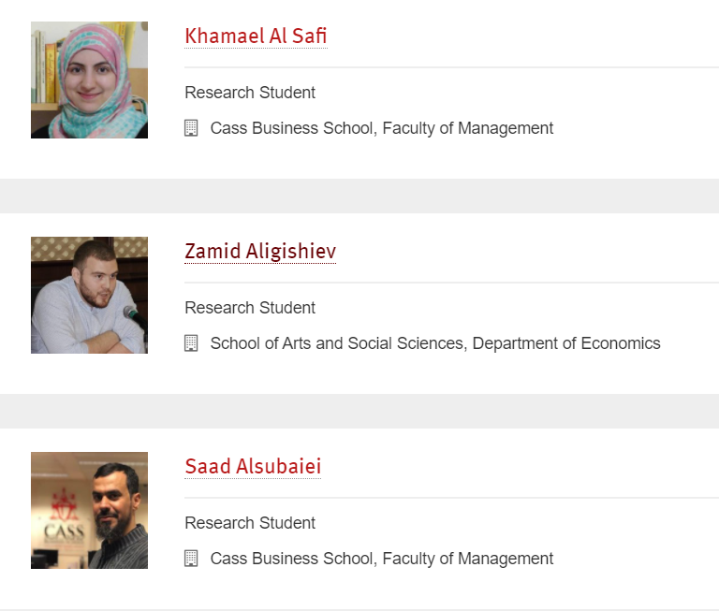
- When clicked on Individual profile should show as seen below:

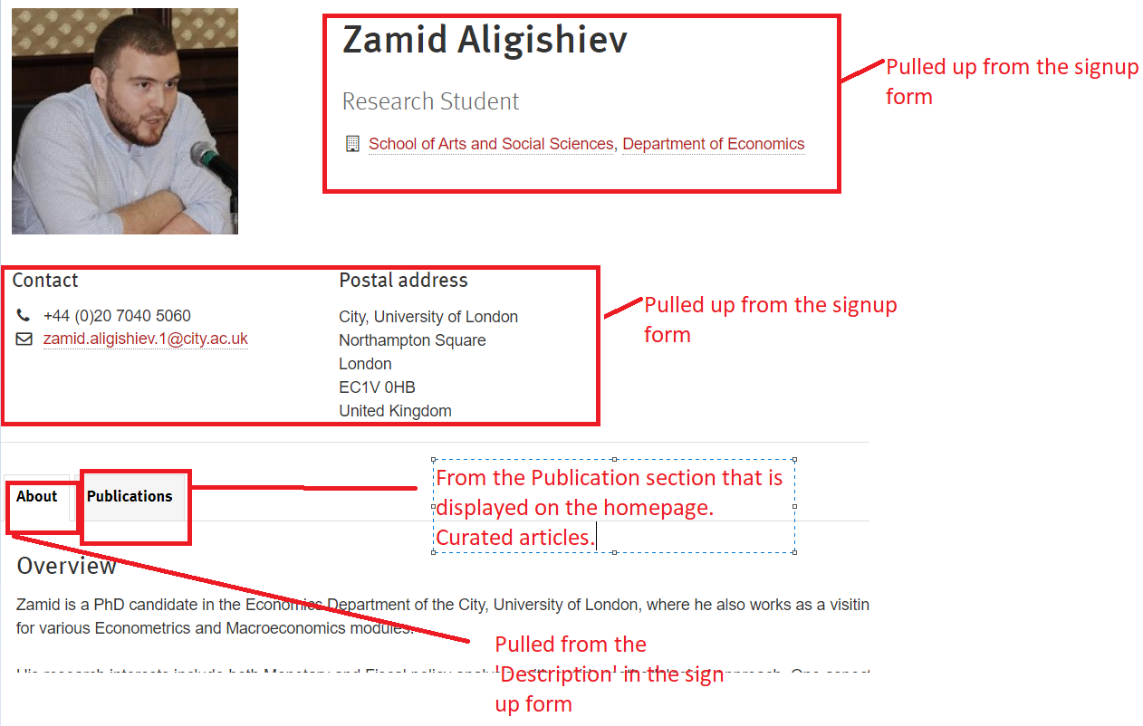
https://www.city.ac.uk/people/research-students/zamid-aligishiev

- When clicked on ‘Publications’ as mentioned in point 7, it should show all articles curated from CQA and list the name of the authors so it can be displayed in the corresponding ‘Mentor’ and ‘Mentee’ Publications section on their profile page. Only those publications that are approved by the mentor and with the consent form that is GDPR compliant to publish to the homepage of this CoP should be listed under this section and visible to public.

- When the user clicks on ‘Opportunities’ section only users that have ‘ticked’ to pay a nominal fee will be able to access this feature.

At the time of sign up each profile should have an option to become a paid member and able to (a) Subscribe to a Monthly Newsletter (b) Subscribe to Opportunities (we will need to link to external job websites that advertise healthcare jobs) (c) Download an ebook

On signing up as a subscribed member the user should be forwarded to a payment processing secured gateway such as PayPal.

PART 02 – FUNCTIONALITIES
The goal of offering a ‘Scientific Research’ community is help the members to:

- ‘READ’ – This functionality should allow users of this focus group to download and read .pdf, .doc, .txt, .xls (data), allow links to youtube and vimeo.

- A limited number of members of thus focus group should have access to ‘Medigy’s CQA’ functionality to curate posts using the https://cqa.bzo.medigy.com/curate link and via an extension.
- The users with permission to access the CQA functionality should also be able to suggest relevant ‘TOPICS’ and the internal team will verify based criteria such as SEO etc and approve.
- The user will also have an option to curate the articles to the community.

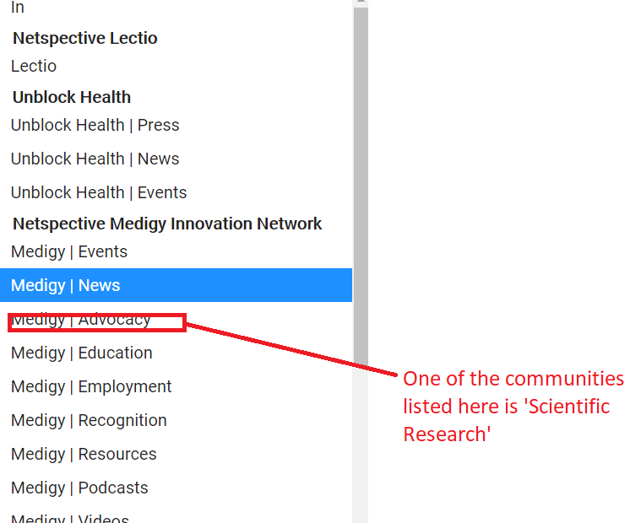

- ‘WRITE’ – This functionality should allow users of this focus group to submit an article or any piece of work in any format such as pdf, .doc, .txt, .xls using the ‘Contribute to <CoP>’:

- Medigy should be able to provide an access for the members to use the ‘Contribute to <CoP>’ feature to easily share articles with their peers who would review and approve for submission.
- All this should be done through a secure portal system such that members of other CoP on Medigy should not have access to any of this material.



- The user should be able to submit an article by selecting a specific ‘reviewer’ for approval using this link https://www.medigy.com/add-suggest/ and

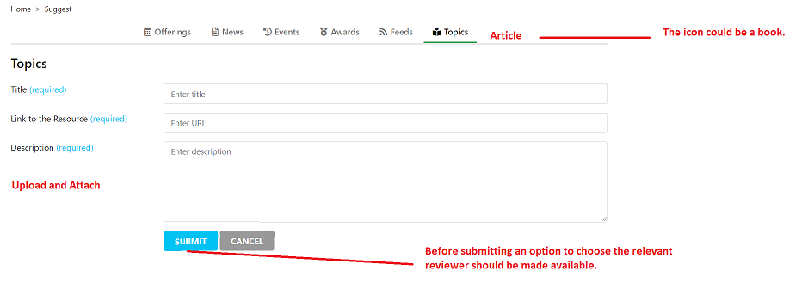
- Users with the permission to ‘review’, ‘approve’ and ‘publish’ articles should be displayed as ‘reviewers’ in this secion.

- The articles exchanged with peers for review/approval, once ‘APPROVED’ should be made publicly available on the portal to help build a library in parallel to ensuring that there is no infringement of copyrights. The approval of article will be offline for the moment and when approved the user with the relevant permission will be able to curate the article via https://cqa.bzo.medigy.com/curate available for other members of the ‘Scientific Research’ community to read.

- ‘TEACH’ – This functionality should allow users of this focus group to interactively teach and learn with peers.
  - There should be an option for the members of this community to set up meetings or webinars external to the platform.
  - Members should be able to organize events and

Search based on advanced search criteria such as (i) Member’s names (first and last names) (ii) Country of residence (iii) Speciality (iv) Gender.

Use Cases:

Use case 1: Advanced Search
Pre-requisite: Only registered member of the focus group should be able to use the search functionality.

- Prof. Jas is a registered member of the ‘Scientific Research’ community
- Mr Jas is looking for a keynote speaker in Endocrinology to address a summit in Lahore.
- Through the advanced search filter criteria one Prof. Jas types in the <Speciality> which is ‘Endocrinology in this case, <Interest> which is Keynote speaker in this case and ‘<Occupation> which is ‘Consultant – Internal Medicine and the, Location> as Lahore’ to speed up the search.
- The system pulls the results available from the database (registered members of the ‘Scientific Research’ community)

- Prof Jas selects ‘Dr Uzma Khan’ from the list.
- Prof Jas refers to the contact details and social media links to take the conversation forward.

Use case 2: Submission Process
Pre-requisite: Only registered member of the community should be able to use the submission functionality.

Super admins with the permission to review/approve/reject an article should be listed in the list of reviewers that is made available before submitting an article.

- Mr. Lal a researcher and member of the focus group has an article that needs reviewing by Dr. Khan.
- Me. Lal uses the https://www.medigy.com/sumbit/? scientific--research link and types in the title, the description and attaches a document ready to be reviewed.
- He selects Dr khan from the reviewer list and clicks on ‘Submit’
- An email with the attachment is sent to Dr. Khan and is shown as pending for approval. The content of the email will be documented later.
- Dr. Khan reviews and approves the article.
- This approved article is published to the Scientific Research community based to the ‘Publication’ section on the homepage.
- Following approval, the student will be sent an ‘Approval email’
- Following approval the curators and reviewers with permission to curate and edit topics will assign a relevant topic to the approved article, which will appear as tags in the ‘Publication’ section, similar to the tagging the ‘News’ section.

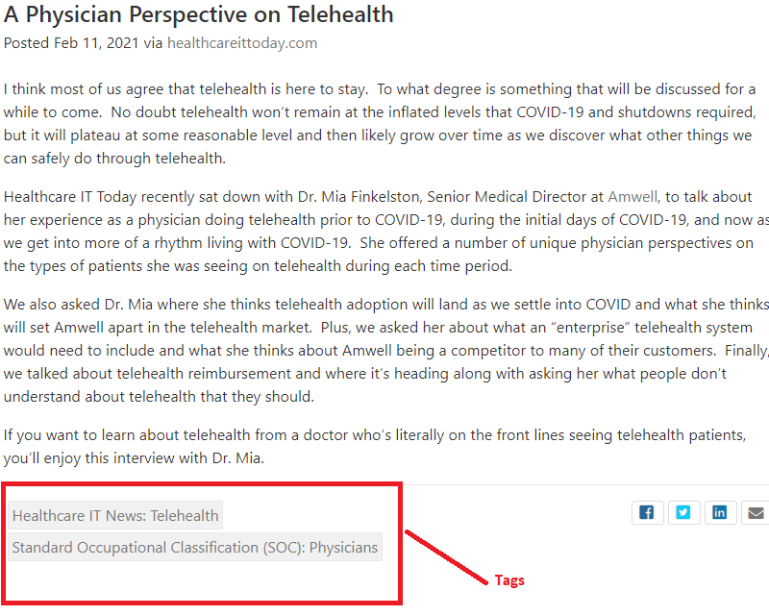

COROLLLARY

If the article is rejected an email should be sent to the members who submitted the article. Also, the reviewer should be provided with a description field (200-character word limit) to state the reason for rejection.

- Basically, we need emails to be sent out whenever an article is (1) Submitted for review by the student/mentee. Email from the system to the mentor. (2) Article is approved by the reviewer/mentor. Email from the system to the mentee. (3) Article is rejected by the reviewer/mentor. Email from the system to the mentee.
- The description of these emails will be shared later but for the time being we can use relevant one from our email template database.

Use case 3: Curating Articles.
Pre-requisite: Only registered member and limited members with the permission to curate should be able to curate articles using the https://cqa.bzo.medigy.com/ functionality.

- Jamal research about an interesting story on ML in the diagnosis of mental health
- He uses the https://cqa.bzo.medigy.com/ (because of his permissions) and curates the article by assigning a Topic to the article.
- The article is submitted for approval to the reviewers (not an email but the reviewers should be able to see that a submission is pending for approval and if they wish, they could modify the topic)
- The article is approved and gets published to the homepage of this community.

COROLLLARY

- If the article is rejected an email should be sent to the member that submitted the curation. Also, the reviewer should be provided with a description field to state the reason for rejection.
- If a particular topic is not available whilst curation, the curator can submit a Topic to be added via ‘Add/Suggest Topic’ which should be made available in CQA and the internal team at Medigy would approve based on a standard set of criteria. The user who submits a topic for suggestion should accordingly receive an email if the topic is approved or rejected with valid reasons.

Clinical safety constraints

Operating environment

Interfaces (with software/applications/hardware)

Performance

Security
A secure portal to ensure member and data privacy with suitable access privileges

Deployment, Upgrade and Migration

Others

Assumptions and Dependencies

Assumptions

Dependencies

References
https://www.nasihaonline.com/about.html
https://mdforlives.com/gb#signup

Revision History
Date of issue | Issue status | Version | Details | Author
 | Final |  |  | Radhika

