**Orxe ImageList**

### Document Properties

| Item | Details |
| --- | --- |
| Document | Technical Specification Document |
| Application | Orxe ImageList |
| Author | Divya Chadichal |
| Creation Date | 09/24/2020 |
| Last Updated | 09/24/2020 |
| Status | Completed |

Contents

Document Properties 1

1. Component Overview 3

1.1 Objective 3

1.2 Use Cases 3

2. Technical Specifications 4

2.1 NPM details 5

2.2 NPM repo 6

3.Unit Testing 6

4. Assumptions 7

5. Concerns and Issues 7

1. Component Overview

This document provides a high-level overview of Orxe Image List Component, which basically consists list of images of different sizes, that can be scrolled horizontally.

1.1 Objective

To design an Image List component using Orxe cli. Below is the architecture of the component.

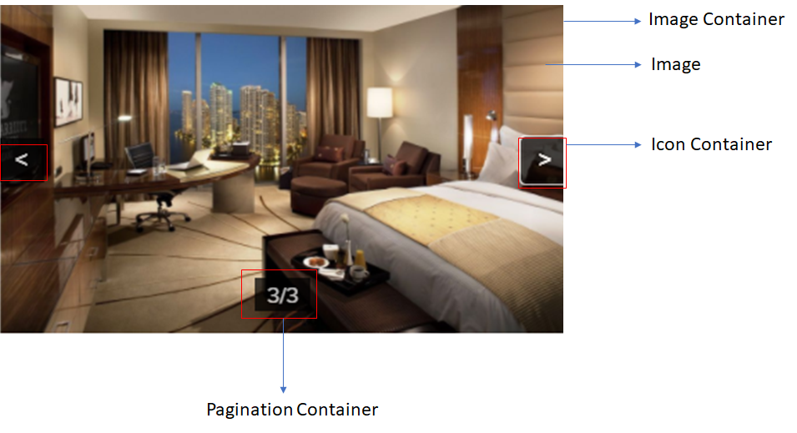

1.2 Use Cases

There are 3 use cases:

1. Full Size Image
2. Regular Size Image
3. Small Size Image.

Below is the screenshot showcasing each use case

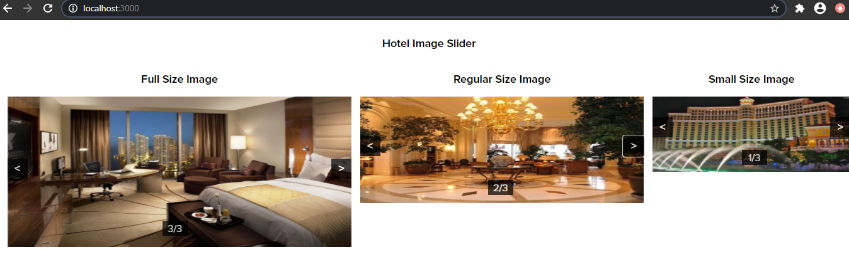

2. Technical Specifications

Component needs ‘size’ and imageurls properties to be passed as attribute, i.e.

<orxe-image-list size=’string’ imageurls=’array’></orxe-image-list>

Where size can be:

* full (for Full Size Image)
* regular (for Regular Size Image)
* small (for Small Size Image)

and imageurls is the array of images path

Below are the details of properties/styles/methods:

* **Shape Properties**

|  |  |  |  |
| --- | --- | --- | --- |
| **Name** | **Full Size Image** | **Regular Size Image** | **Small Size Image** |
| Image Width | Stretched to a Full Width | Stretched to a Full Width | Stretched to a Full Width |
| Image Height | 240px | 170px | 120px |
| Icon Container Width | 32px | 32px | 32px |
| Icon Size | 16px | 16px | 16px |
| Pagination Container Width | 40px | 40px | 40px |
| Pagination Container Height | 24px | 24px | 24px |

* Style Properties

|  |  |
| --- | --- |
| Property | Value |
| --image-font-family | $primary-font-family |
| --image-font-size | 16px |
| --image-font-weight | bold |
| --image-font-color | White |
| --image-container-width | 100% |
| --pagination-container-width | 32px |
| --pagination-container-height | 32px |
| --container-color | #000000 |
| --container-opacity | 72% |

* Methods

|  |  |  |  |
| --- | --- | --- | --- |
| Method Name | Access Modifier | Parameters | Return Type |
| __goPrevious() | private | size (full, regular, small) | void |
| __goNext() | private | size (full, regular, small) | void |

2.1 NPM details

Following packages are installed for project:

* lit-element – ^2.2.1
* lit-html – ^1.1.2
* orxe/cli version – v2.0.20

Use following commands for creating and running the component:

1. npm package – **npm install @orxe-imagelist/orxe-image-list@0.0.3**
2. Use Render Selector – **<orxe-image-list size=’’ imageurls=’’></orxe- image-list>**

Where size is the image size to be used i.e. full, regular, small and imageurls is the list of images path in array format. For example:

imageurls='["./assets/locales/hotel-image-1.jpg","./assets/locales/hotel-image-2.jpg"]'

**Note:** Images should be added to packages/<component-folder>/assets/locales

2.2 NPM repo

Npm repository link –https://packages.common.cnxloyalty.com/service/rest/repository/browse/npm-stage- hosted/@orxe-imagelist

3.Unit Testing

The test cases written for orxe-image-list component consists of two test suites. One is default orxe-image-list.axe.ts file and other is orxe-image-list.spec.ts file. All functions and line coverage are done with spec file.

Test cases cover below scenarios:

1. Should check type of variable
2. Should check default value properties
3. Should check Next button click event for full/regular/small image
4. Should check Previous button click event for full/regular/small image
5. Current Index for full/regular/small image should not change on click of Previous button, if the current image is the first image
6. Current Index for full/regular/small image should not change on click of Next button, if the current image is the first image

Total No. of test suite: **2**

Total No of test cases: **17**

Below are the test coverage screenshots

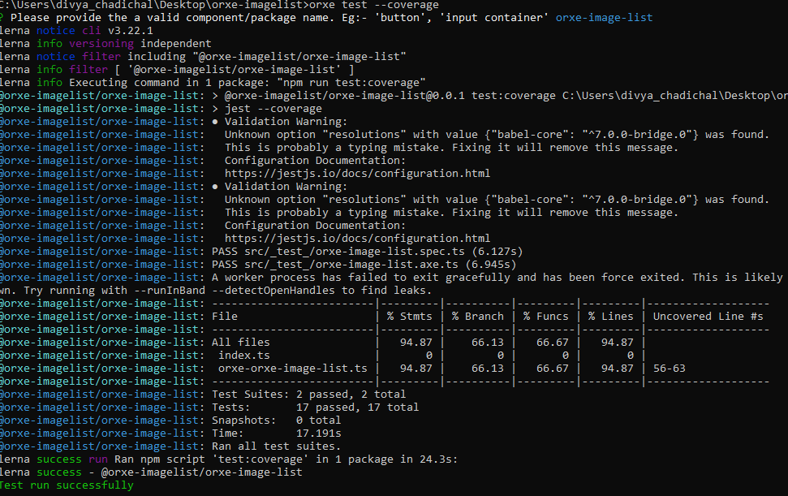

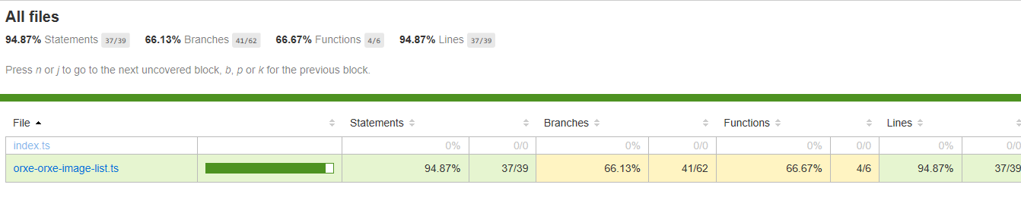

4. Assumptions

This component is developed referring to the design guidelines provided by Tavisca on the confluence page.

5. Concerns and Issues

NA