Team BlueChip

Statement of Work

Submitted by -

Deepti Sunder Prakash

Divya Chandra Sekar

Marcelo Dominguez

Rashmi Krishnan

# **Table of Contents**

## 

|  |  |  |
| --- | --- | --- |
| **Sno.** | **Topics** | **Page** |
| 1 | Logistics | **3** |
| 1 | Executive Summary | **3** |
| 2 | Purpose | **3** |
| 3 | Scope | **3** |
| 4 | Goals | **4** |
| 5 | Assumptions & Specifications | **4** |
| 6 | Project Timeline | **5** |
| 7 | Work Breakdown Structure | **5** |
| 8 | Risk Management | **6** |

## 

## 

## Logistics

Team

Deepti Sunder , dsunderp@andrew.cmu.edu

Divya Chandra, divyac@andrew.cmu.edu

Marcelo Domiguez, marcelod@andrew.cmu.edu

Rashmi Krishnan, rashmik@andrew.cmu.edu

Faculty Advisor

Patrick Tague, patrick.tague@west.cmu.edu

Sponsor - Intel Corp.

Jonathan Buhacoff, jonathan.buhacoff@intel.com

Eric Gee, eric.r.gee@intel.com

**Executive Summary**

The practicum team consist of four CMU students in Silicon Valley working for satisfying Intel’s requirements. The project with Intel has the objective to integrate Barbican with KMIP, and at the same time extent Barbican functionality via plugin to verify client credentials through an attestation service.

## Purpose

The objective of this practicum project is to develop a working model of Barbican instance integrated with OpenAttestation for the purpose of trust attestation as part of trusted compute pools in a functioning OpenStack framework.

## Scope

The scope of this project is limited to research on plugin support and KMIP support for Barbican and development of plugin to implement key wrapping functionality. The timeline for this project is six weeks.

## 

## Goals

The project is divided into three major milestones, which are described below:-

1. Inspect current OpenStack Barbican codebase for enhancements in the area of plugin structure and determine if it's possible to write a plugin as described in Milestone II; if not yet possible then completion of Milestone I includes making the necessary code changes in Barbican.
2. Write a Barbican plugin that will accept extra input parameters (client's AIK public key) in a key request, call out to an attestation service to determine the client's trust and client's public key, if client is trusted retrieve the key from the key store, and wrap the key with client's public key before returning to client.
3. Write a Barbican plugin that will enable Barbican to use a backend KMIP server for key generation, storage, and retrieval, so that an administrator can seamlessly integrate an existing key server into an OpenStack deployment.

If the above goals are completed ahead of proposed timeline, then additional deliverables may be completed as extension goals:

1. Write a Barbican plugin that will track how many times each key has been retrieved, and host much data has been encrypted with it (may require additional input for key retrieval), present the usage metadata to clients during key retrieval, and also allow clients to submit how much data they have encrypted using a retrieved key after the fact.

## 

## Assumptions and Specifications

* The project is an open source project and does not require any Intel assets, but could involve other open source projects using either MIT, BSD, or Apache 2.0 licenses.
* The project must be open source: if contributing to an existing open source project it should be licensed in accordance with that project's license; if publishing any independent source code it should be licensed as MIT, BSD, or Apache 2.0.
* Code and documentation will be stored on github as a public repository (no cost).
* All the work would be done by the interns completely outside of Intel, using either personal or school equipment - no Intel badges needed, and no Intel equipment or assets needed.
* If access to Intel systems becomes available the students can access our lab equipment for demonstrating a fully working project (complete openstack install, servers can be attested, etc)

## Project Timeline

|  |  |  |  |  |
| --- | --- | --- | --- | --- |
| **Description** | **Phase** | **Progress** | **Deliverable** | **Completion Date** |
| Research on OpenStack Barbican for plugin and KMIP support | Milestone 1 | Started | Progress  Report v1.0 | 11-06-2014 |
| Creation of plugin for attestation & key wrapping | Milestone 2 | Not Started | Progress Report v2.0 | 11-20-2014 |
| Plugin Support for KMIP server | Milestone 3 | Not Started | Technical Report and Final Presentation | 12-05-2014 |

**Work Breakdown Structure**

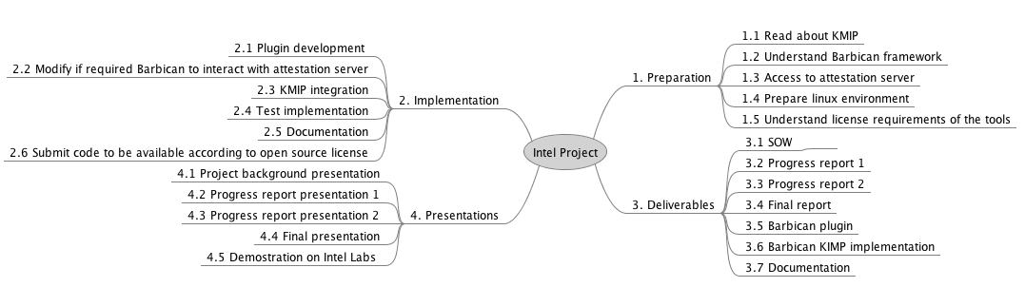

**Risk Management**

|  |  |  |
| --- | --- | --- |
| **Risk** | **Impact** | **Mitigation** |
| **Limited timeframe** | The project had a late start. Time management is critical for project success given the reduction of time available from twelve weeks to six weeks. Also the timeframe match with the highest load period in the semester. | Project scope was reduced. Tasks will be divided between team members in order to work concurrently. |
| **NDA** | Team members signed a NDA. Important to be aware of not revealing sensitive information in deliverables. | Project deliverables are double checked by faculty advisors and Intel staff before any submission. |
| **Lack of experience with OpenStack and Barbican** | Most of the team members do not have experience with OpenStack and Barbican. It could affect the progress of the project at the early stages. | Team member will read documentation about the Open Source tools which are going to be used. One team member has previous experience and could act like mentor for solving technical difficulties. |
| **Open Source license scheme** | Team members are not familiar with Open Source license scheme and should take care of respecting and contributing officially with the changes made. | One of the tasks to be performed by the team is to understand the license scheme and make the necessary controls to respect the license requirements and contribute with the open source initiative. |
| **Lack of documentation or support** | Support with Open Source generally relies on the community. However, answers could not be obtained on time. Given the time constraints, a technical difficulty with the tools could hurt the success of the project | Team members have knowledge and expertise in debugging and solving difficult problems. Also we count on Intel staff expertise to receive guidance if required. |