**Week-1**

**Problem-1**

**Create a Navigation bar using HTML (With out CSS and Bootstarp), it should contain**

**-> Home**

**-> Signup**

**-> Login**

**-> Search Bar.**

**Note: once you create web page upload the page to Github account with public access and submit that**

<!DOCTYPE html>

<html lang="en">

<head>

<meta charset="UTF-8">

<meta name="viewport" content="width=device-width, initial-scale=1.0">

<title>Simple Navigation Bar</title>

</head>

<body>

<nav>

<a href="#">Home</a>

<a href="#">Signup</a>

<a href="#">Login</a>

<a href="#">Search Bar</a>

<input type="text" placeholder="Search...">

<button>Search</button>

</nav>

</body>

</html>

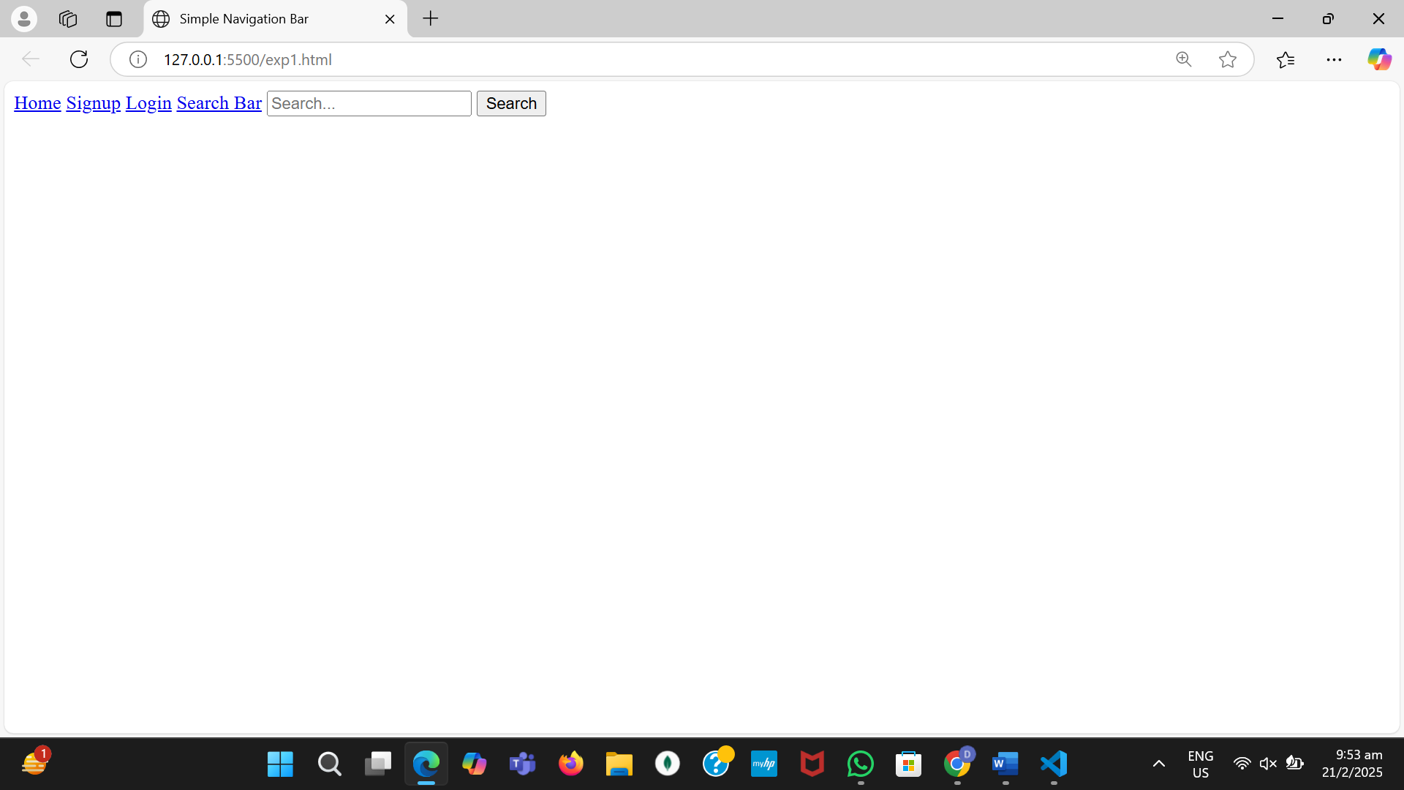

**Problem-2**

Create a Portfolio page using HTML , it should contain

-> Self introduction

-> skills

-> projects/work experiences (Git links)

-> Feedback /achievements

-> Education profile

-> Contact information.(Social media /phone /email)

Note: once you create the poftfolio upload the page with neccesary document to Github account with public access

and submit that github link here :

<!DOCTYPE html>

<html lang="en">

<head>

<meta charset="UTF-8">

<meta name="viewport" content="width=device-width, initial-scale=1.0">

<title>My Portfolio</title>

</head>

<body>

<header>

<h1>My Portfolio </h1>

<h1><strong>Divya</strong></h1>

<p><strong>Aspiring Developer</strong></p>

</header>

<section id="introduction">

<h2><strong><u>About Me</u></strong></h2>

<p>Hello! I am <strong>Divya</strong>, a passionate developer with a keen interest in web development, programming, and technology.</p>

</section>

<section id="skills">

<h2><strong><u>Skills</u></strong></h2>

<ul>

<li><strong>Languages:</strong> HTML, CSS, JavaScript, Java, C++, Python</li>

<li><strong>Frameworks & Libraries:</strong> React, Node.js, MongoDB</li>

<li><strong>Database Management:</strong> SQL, DBMS</li>

</ul>

</section>

<section id="projects">

<h2><strong>Projects & Work Experience</strong></h2>

<ul>

<li>

<a href="#" target="_blank"><strong>Law Assistance App</strong></a> -

A web-based platform to know basic laws to be followed by all the citizens.

<br><br>

<strong>Technologies Used:</strong> MERN Stack (MongoDB, Express.js, Node.js)

</li>

</ul>

</section>

<section id="feedback">

<h2><strong>Achievements</strong></h2>

<p>Have devloped a e-comerce websirte.</p>

</section>

<section id="education">

<h2><strong>Education</strong></h2>

<p><strong>B.Tech in Computer Science:</strong> KMIT (Keshav Memorial Institute of Technology), 2022-2026</p>

<p><strong>Intermediate:</strong> Narayana Junior College, 2020-2022</p>

<p><strong>School:</strong> Slate-The-School, 2010-2020</p>

</section>

<section id="contact">

<h2><strong>Contact</strong></h2>

<p><strong>Email:</strong> divyakanaparti@gmail.com</p>

<p><strong>Phone:</strong> +91 xxxxxxxxxx</p>

<p><strong>GitHub:</strong> <a href="#" target="_blank">GitHub Profile</a></p>

</section>

</body>

</html>