**Week-3**

**Problem-1**

1. Update the portfolio and feedback forms using Bootstrap CDN

Note: once you update the poftfolio and Feedback pages upload the pages to Github account with public access

and submit that github link here :

portfolio (with boostrap cdn)

portfolio.html

<!DOCTYPE html>

<html lang="en">

<head>

<meta charset="UTF-8">

<meta name="viewport" content="width=device-width, initial-scale=1.0">

<title>My Portfolio</title>

*<!-- Bootstrap CDN -->*

<link href="https://cdn.jsdelivr.net/npm/bootstrap@5.3.0/dist/css/bootstrap.min.css" rel="stylesheet">

<style>

body {

font-family: "Arial", sans-serif;

background-color: #3d8d7a; */* Teal Background */*

color: #fbffe4; */* Light Cream Text */*

margin: 0;

padding: 0;

}

header {

background-color: #a3d1c6; */* Light Teal */*

padding: 20px;

text-align: center;

color: #3d8d7a; */* Teal Text */*

}

section {

padding: 40px;

margin: 20px 10%;

background-color: #fbffe4; */* Light Cream */*

border-radius: 8px;

color: #3d8d7a; */* Teal Text */*

}

.contact a {

display: block;

margin: 10px 0;

font-size: 1.2em;

color: #3d8d7a; */* Teal */*

}

footer {

background-color: #a3d1c6; */* Light Teal */*

text-align: center;

padding: 20px;

margin-top: 30px;

color: #3d8d7a; */* Teal Text */*

}

</style>

</head>

<body>

<header>

<h1 class="fw-bold">MY PORTFOLIO</h1>

<h2 class="fw-bold">Divya</h2>

<p class="fw-bold">Aspiring Developer</p>

</header>

<section id="introduction" class="container">

<h2>About Me</h2>

<p>Hello! I am <strong>Divya</strong>, a passionate developer interested in web development, programming, and technology.</p>

</section>

<section id="skills" class="container">

<h2>Skills</h2>

<ul class="list-group">

<li class="list-group-item">Languages: HTML, CSS, JavaScript, Java, C++, Python</li>

<li class="list-group-item">Frameworks: React, Node.js, MongoDB</li>

<li class="list-group-item">Database Management: SQL, DBMS</li>

<li class="list-group-item">Tools: Git, Docker, AWS, GenAI</li>

</ul>

</section>

<section id="projects" class="container">

<h2>Projects & Work Experience</h2>

<ul class="list-group">

<li class="list-group-item">

<a href="#" target="_blank">Law Assistance App</a> - A web-based platform to know basic laws to be folowed by every citizen.

</li>

</ul>

</section>

<section id="feedback" class="container">

<h2>Achievements</h2>

<p>🎓 Academic Excellence - Awarded for top performance in Computer Science.</p>

</section>

<section id="education" class="container">

<h2>Education</h2>

<p>B.Tech in Computer Science: KMIT (2022-2026)</p>

<p>Intermediate: Narayana Junior College (2020-2022)</p>

<p>School: Slate-The-School (2010-2020)</p>

</section>

<section id="contact" class="container contact">

<h2>Contact</h2>

<p><strong>Email:</strong> divyakanaparti@gmail.com</p>

<p><strong>Phone:</strong> +91 xxxxxxxxxx</p>

<a href="https://github.com/sahasra126" target="_blank">GitHub Profile</a>

</section>

<footer>

<p>&copy; 2025 | All Rights Reserved</p>

</footer>

</body>

</html>

Output:

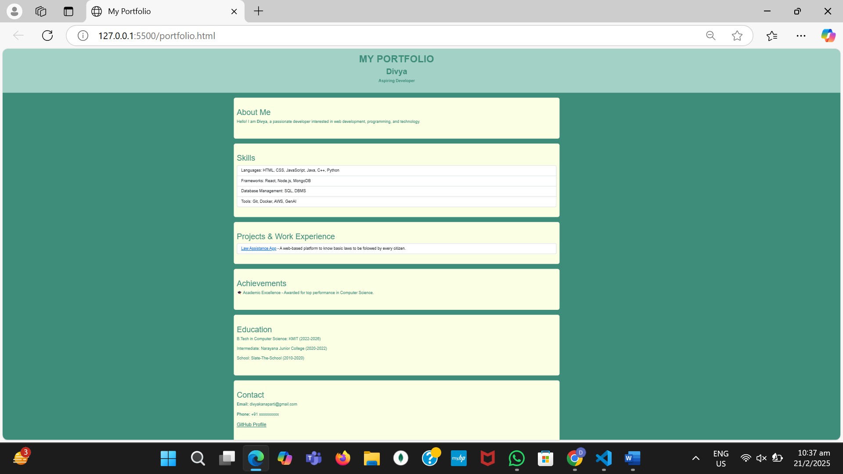

Feedback(with boostrap):

Feedback.html