* **Business overview:-**
* Atliq mart is a retail giant with over 50 supermarkets over southern regions of india. All their 50 superstores ran a massive promotion during Diwali 2023 & Sankranti 2024. On their Atliq branded products.
* Now the sales director want to know which products did well after promotions and which did not to make an even better decision during the next promotional period.
* So, analyze promotions & provide tangible insights to sales director by solving various business requests & helping him take well informed decisions as per the analysis in SQL.
* **Business questions:-**

1. Provide a list of products with a base price greater than 500 and that are featured in promo type of ‘BOGOF’ (buy one get one free).

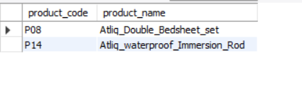

* The above are the two products

1. **Atliq double bedsheet set**
2. **Atliq waterproof immersion rod**

Which have price higher and having promo of BOGOF. This are heavily discounted products. So its pricing & promotion strategies should be decided properly.

2) Generate report for total number of stores per city.

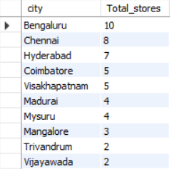

* So, from the report it is clear that Bengaluru holds the highest store presence, following by Chennai. So the products which are in high demand in Bengaluru & Chennai should be priotized & various promotional strategies should be made keeping this in our mind.

3) Generate report that shows campaigns along with its revenues. So we can get idea about the impact of campaigns on the revenue generated.

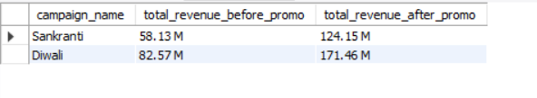

* There were 2 main campaigns organized recently

1) Diwali

2) Sankranti

* We can clearly see a major boost in the revenues generated after this campaigns. Especially during Diwali this campaign was massive for Atliq.
* This campaigns surely created a lot of attention & attracted a wider customer base for us.

4) Create a report which calculates incremental sold quantity (ISU%) for each category during Diwali campaign.

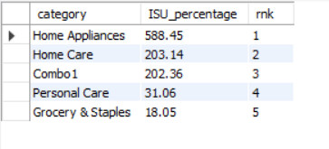

* This report helps us analyze how our products of different cstegories are doing. Gives us a bigger idea about which category products were most effective after the campaign was conducted. Shows us the impact of Diwali campaign on products category -wise.

5) Create a report containing top 5 products by incremental revenue % across all the campaigns.

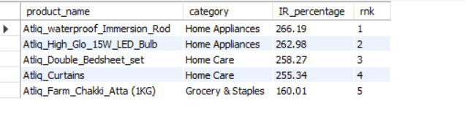

* This report helps us identify the most successful products in terms of revenue across campaigns, assisting in product optimization.
* Home appliances of Atliq have a huge revenue increment across both the campaigns.