Quick-Bite analytics:
List of ad-hoc questions:
1. Monthly orders pre-crisis vs crisis
How did monthly orders compare between the pre-crisis period and the crisis period?
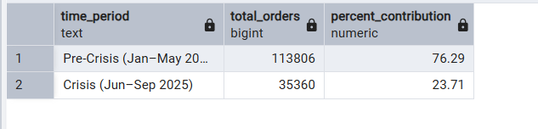
2. Top 5 cities by order decline
Which top 5 city groups experienced the highest percentage decline in orders during the crisis period compared to the pre-crisis period?
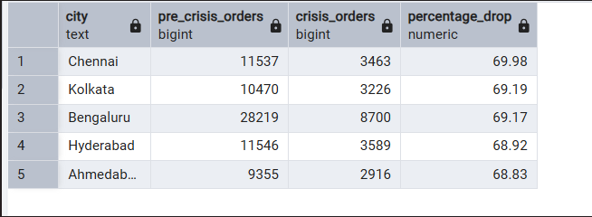

3. Top 10 high-volume restaurants by decline
Among restaurants with at least 50 pre-crisis orders, which top 10 high-volume restaurants experienced the largest percentage decline in order counts during the crisis period?
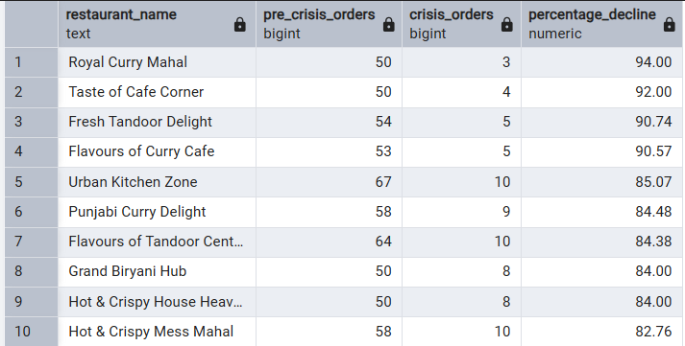

4. Cancellation analysis
What is the cancellation rate trend pre-crisis vs crisis, and which cities are most affected?
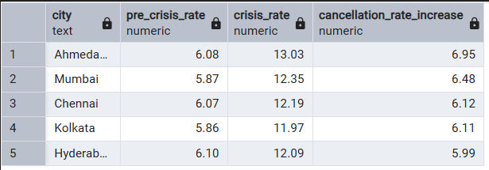

5. Delivery SLA average delay
What is the average delivery duration/delay time across phases?
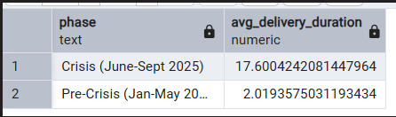
6. SLA compliance rate
What was the SLA compliance rate during the pre-crisis and crisis phases?
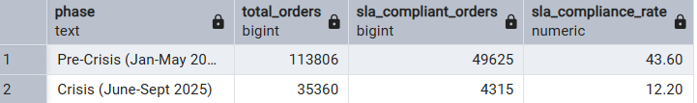

7. Average customer rating month by month
What was the average customer rating month by month, and which months saw the drop?
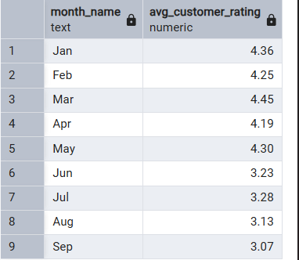

8. Revenue loss estimate
What was the estimated revenue loss from pre-crisis vs crisis based on subtotal, discount, and delivery fee?
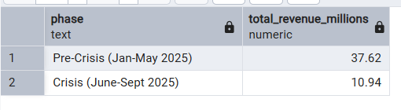

9. Loyal customer churn and high-rating churn
Among customers who placed five or more orders before the crisis, how many stopped ordering during the crisis, and out of those, how many had an average rating above 4.5?
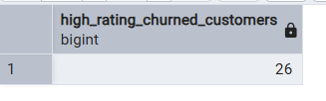
10. Top 5% customers by pre-crisis spend
Who are the top 5% of customers based on pre-crisis money spent?
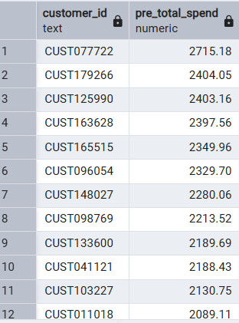

11. High-value customer order-frequency drop
Among high-value customers, how many experienced the largest drop in order frequency during the crisis?
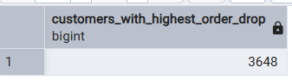

12.Delivery delay vs cancellation rate
Do longer delivery delays directly increase cancellation rates?
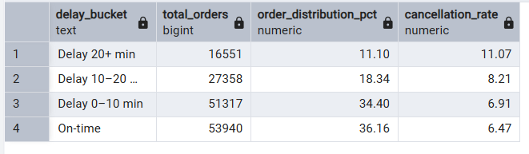

13. Severe 20+ minute delay contributors
Out of the orders with delivery delay greater than 20 minutes, which cities, restaurants, and delivery partners are key contributors to these delivery delays?
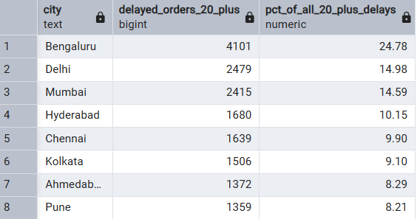

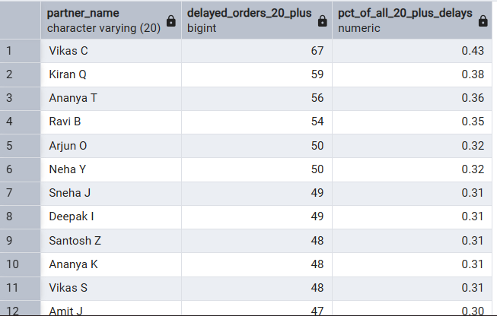

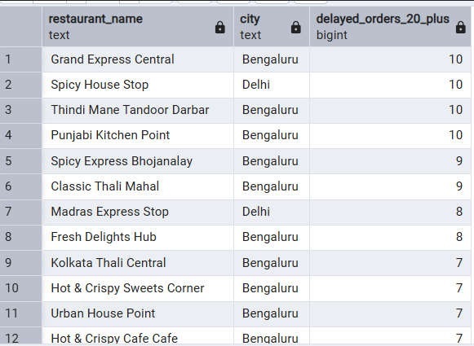

14. Worst delivery and cancellation cities during crisis
Which cities experienced the worst delivery and cancellation performance during the crisis?
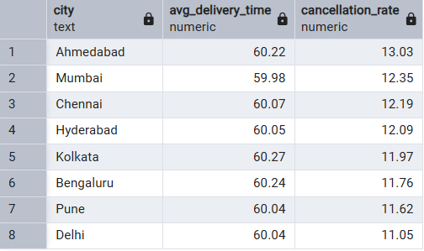

15. Sentiment bucket analysis
What is the distribution of customer reviews across sentiment buckets: Negative, Neutral, Positive, and Very Positive?
