**GARBAGE CLASSIFICATION**

Using Machine Learning (CONVOLUTION NEURAL NETWORKS)

# **Introduction**

Since the early beginning of the development of natural sciences, collecting and assay of huge amounts of data was one of the leading analytical tools. The same goes for environmental sciences and environmental engineering, which produce higher demand for efficient and productive approaches to work with continuously increasing sizes of the collected data from a huge variety of research fields every day. (Kendall and Costello 2006)

Nowadays, machine learning algorithms have proven themselves as a universal tool for different types of tasks, giving advanced possibilities for dealing with analysed data, including such types of tasks as *data imputation*, *unsupervised clusterization*, *classification* and *regression*. They are commonly used in many research areas; however, they are yet less common among environmental engineering workers, though such tools may provide an extremely efficient alternative to the traditional analytical approaches. (Wilcox, Woon and Aung 2013)

The purpose of the research behind this thesis was in presenting of examples of how such advanced tools may be used on a particular data set meant for increasing water quality in European region. In the following chapters one will go through the presentation of the machine learning, it’s origins and possibilities in general, explanation of the data and models used during the research, results of the application of algorithms, discussion (covering obstacles one can face while working with this kind of models) and conclusion, which will cover the presented material, give advices for engineers and scientists who would like to use this models for their environmental tasks and finally and give some words about the possible future of the development of these tools in environmental field.

## **Overview**

Its main purpose is to facilitate information exchange regarding the waste to be collected from individuals or from waste collection points, thereby exploiting the wide acceptance and use of smartphones. To improve waste collection planning, individuals would photograph the waste item and upload the image to the waste colle2ction company server, where it would be recognized and classified automatically. The proposed system can be operated on a server or through a mobile app. A novel method of classification and identification using neural networks is proposed for image analysis: a deep learning convolutional neural network (CNN) was applied to classify the type of e-waste, and a faster region-based convolutional neural network (R-CNN) was used to detect the category and size of the waste equipment in the images.

## **Purpose**

Our aim of the project is to make use of train and test sets to predict the material given like it is plastic or metal or glass etc.

# **LITERATURE SURVEY**

A Convolutional Neural Network (ConvNet/**CNN**) is a Deep **Learning** algorithm which can take in an input image, assign importance (learnable weights and biases) to various aspects/objects in the image and be able to differentiate one from the other.

A test set and train set are used to validate the model.

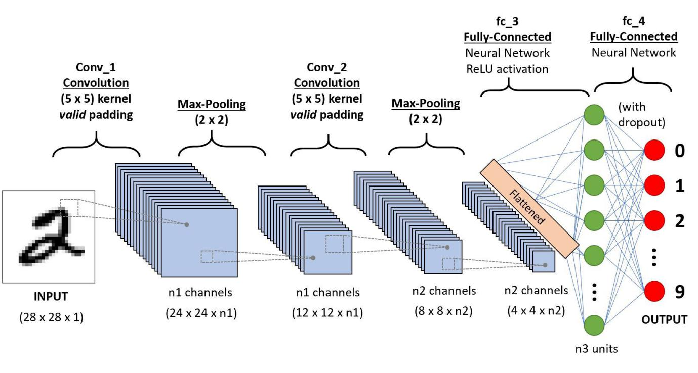

## **Existing Problem**

The accumulation of solid waste in the urban area is becoming a great concern, and it would result in environmental pollution and may be hazardous to human health if it is not properly managed. It is important to have an advanced/intelligent waste management system to manage a variety of waste materials.

## **Proposed Solution**

The present way of separating waste/garbage is the hand-picking method, whereby someone is employed to separate out the different objects/materials. The person, who separate waste, is prone to diseases due to the harmful substances in the garbage. With this in mind, it motivated us to develop an automated system which is able to sort the waste and this system can take short time to sort the waste, and it will be more accurate in sorting than the manual way. With the system in place, the beneficial separated waste can still be recycled and converted to energy and fuel for the growth of the economy. The system that is developed for the separation of the accumulated waste is based on the combination of Convolutional Neural Network with recognition and classification.

**3.Block Diagram**

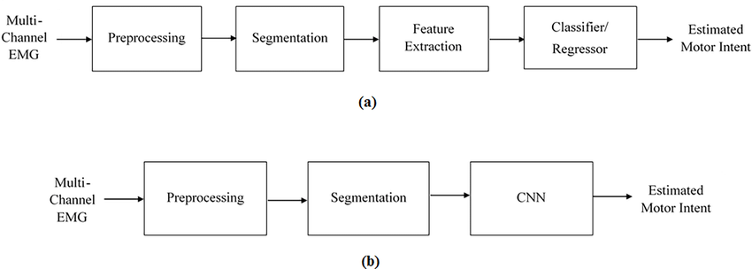

# **3. Software Analysis**

* Jupyter Notebook Environment
* Spyder Ide
* Python ()
* HTML
* Flask

We developed this Garbage Classification model by using the Python language which is an interpreted and high-level programming language. For coding we used the Jupyter Notebook environment of the Anaconda distributions and the Spyder, it is an integrated scientific programming in the python language.

For creating user interface for the prediction, we used the Flask. It is a micro web framework written in Python. It is classified as a micro framework because it does not require particular tools or libraries. It has no database abstraction layer, form validation, or any other components where pre-existing third-party libraries provide common functions, and a scripting language to create a webpage is HTML by creating the templates to use in the functions of the Flask and HTML.

1. FLOW CHART

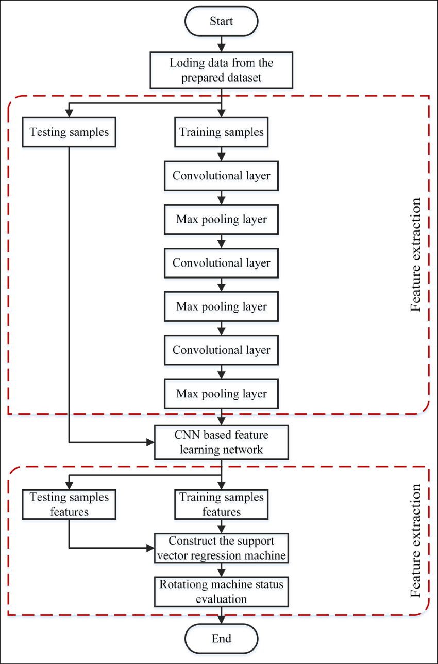

# **5.RESULT**

It shows whether the chosen image is Glass, Metal, Cardboard, Trash, Plastic, Paper.

Example:

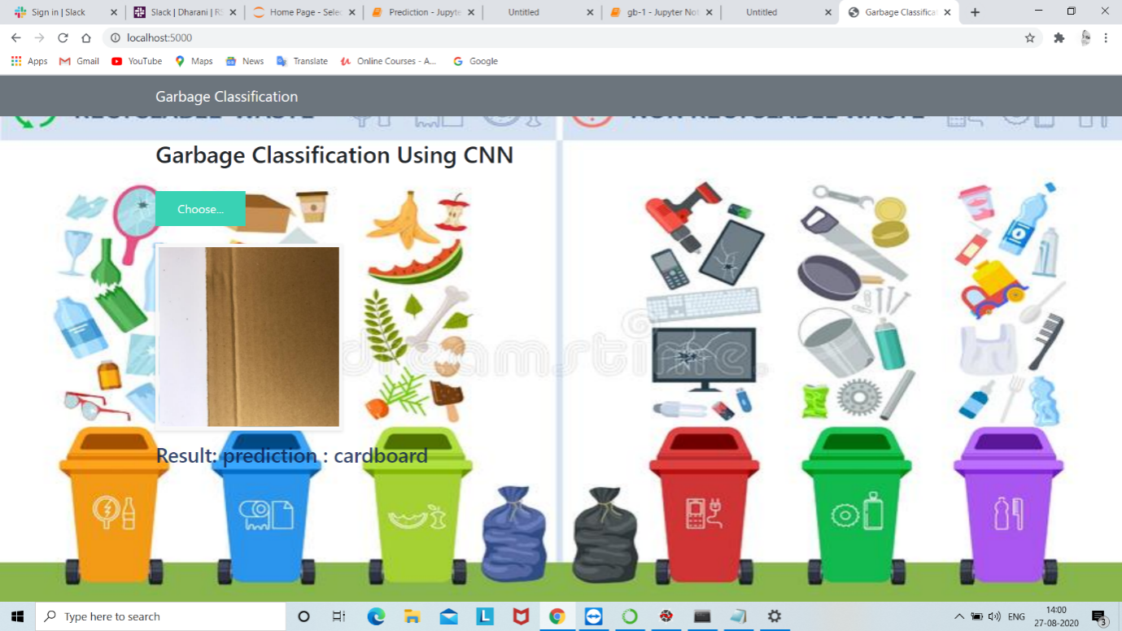

# **6.ADVANTAGES AND DISADVANTAGES**

**Advantages:**

The main **advantage of CNN** compared to its predecessors is that it automatically detects the important features without any human supervision. For example, given many pictures of cats and dogs, it can learn the key features for each class by itself

**Disadvantages:**

* **CNN** do not encode the position and orientation of object.
* Lack of ability to be spatially invariant to the input data

# **7.Conclusion**

The classification of trash within the scope of recycling is possible with machine learning methods. Further data are needed to achieve higher accuracy rates. In the context of our proposed model, we have achieved high classification success without using any method of data augmentation. Studies show that the number of images and classes in the data set can be increased and a more comprehensive recycling project can be realized

# **8.Future Scope**

It can reduce the man power and can also can prevent humans and animals in spreading of diseases due to the waste material

# APPENDIX

**HTML:**

Base.html:

<html lang="en">

<head>

<meta charset="UTF-8">

<meta name="viewport" content="width=device-width, initial-scale=1.0">

<meta http-equiv="X-UA-Compatible" content="ie=edge">

<title>Garbage Classification</title>

<link href="https://cdn.bootcss.com/bootstrap/4.0.0/css/bootstrap.min.css" rel="stylesheet">

<script src="https://cdn.bootcss.com/popper.js/1.12.9/umd/popper.min.js"></script>

<script src="https://cdn.bootcss.com/jquery/3.3.1/jquery.min.js"></script>

<script src="https://cdn.bootcss.com/bootstrap/4.0.0/js/bootstrap.min.js"></script>

<link href="{{ url_for('static', filename='css/main.css') }}" rel="stylesheet">

<style>

.bg-dark {

background-color: #42678c!important;

}

#result {

color: #0a1c4ed1;

}

</style>

</head>

<body style = "background-image: url('https://mandarinbean.com/wp-content/uploads/2019/12/5093-750x430.jpg'); background-size: 100% 100%;">

<body>

<nav class="navbar navbar-dark bg-secondary">

<div class="container">

<a class="navbar-brand" href="#">Garbage Classification</a>

<button class="btn btn-outline-secondary my-2 my-sm-0" type="submit">Help</button>

</div>

</nav>

<div class="container">

<div id="content" style="margin-top:2em">{% block content %}{% endblock %}</div>

</div>

</body>

<footer>

<script src="{{ url_for('static', filename='js/main.js') }}" type="text/javascript"></script>

</footer>

</html>

Index.html:

{% extends "base.html" %} {% block content %}

<h2>Garbage Classification Using CNN</h2>

<br>

<form id="upload-file" method="post" enctype="multipart/form-data">

<label for="imageUpload" class="upload-label">

Choose...

</label>

<input type="file" name="file" id="imageUpload" accept=".png, .jpg, .jpeg">

</form>

<div class="image-section" style="display:none;">

<div class="img-preview">

<div id="imagePreview">

</div>

</div>

<div>

<button type="button" class="btn btn-primary btn-lg " id="btn-predict">Predict!</button>

</div>

</div>

<div class="loader" style="display:none;"></div>

<h3 id="result">

<span> </span>

</h3>

</div>

{% endblock %}

**APP.PY:**

from flask import Flask, redirect, url_for, request, render_template

from werkzeug.utils import secure_filename

from gevent.pywsgi import WSGIServer

# Define a flask app

app = Flask(__name__)

# Model saved with Keras model.save()

MODEL_PATH = 'models/GarbageCollection.h5'

# Load your trained model

model = load_model(MODEL_PATH)

# Necessary

# print('Model loaded. Start serving...')

# You can also use pretrained model from Keras

# Check https://keras.io/applications/

#from keras.applications.resnet50 import ResNet50

#model = ResNet50(weights='imagenet')

#model.save('')

print('Model loaded. Check http://127.0.0.1:5000/')

@app.route('/', methods=['GET'])

def index():

# Main page

return render_template('index.html')

@app.route('/predict', methods=['GET', 'POST'])

def upload():

if request.method == 'POST':

# Get the file from post request

f = request.files['file']

# Save the file to ./uploads

basepath = os.path.dirname(__file__)

file_path = os.path.join(

basepath, 'uploads', secure_filename(f.filename))

f.save(file_path)

img = image.load_img(file_path, target_size=(64, 64))

x = image.img_to_array(img)

x = np.expand_dims(x, axis=0)

with graph.as_default():

preds = model.predict_classes(x)

index = ['cardboard', 'glass', 'metal', 'paper', 'plastic', 'trash']

text = "prediction : "+index[preds[0]]

# ImageNet Decode

return text

if __name__ == '__main__':

app.run(debug=False,threaded = False)