Measuring Client-centric Inconsistency on Cassandra Datastore

Divya Ramachandran

Abstract- Across the Internet, many databases exist for serving different purposes. For any database replicated across different nodes, the aim is to find a perfect balance of consistency, availability and partition tolerance. This project aims to check and mesaure client-centric inconsistencies of Apache Cassandra. The YCSB benchmark, which was designed for evaluating performance of cloud data serving systems, is used to carry out the measurement. Two methods of analysis are followed - active measurement and passive analysis, measuring when conducting operations and concluding after analysing from a log generated at the Cassandra database, respectively. Inconsistencies observed for various number of clients and replicas have been reported.
I. Introduction
In today’s market, the advent of distributed data stores is a natural step towards providing users with a ‘perfect’ service. Databases are offered to a user by services so that he/she may access/modify it in order to complete a transaction with the service. Example of a transaction is updating the personal profile information of the user i.e. updating the user’s personal records maintained by a service or accessing an array of products in the market so that the user can access and make a purchase. A distributed datastore maintains such a database across different nodes across a network. This involves maintaining replicas across the network. Maintenance of replicas necessitates the requirement of maintaining consistency across different replicas so that every user is able to read the same data as well as see updates from every other user. This describes the ideal consistency expectation of a user. However, this is practically impossible to maintain due to overheads such as latency of the network and certain other qualities the database is expected to meet. This remark has been elaborated in the subsequent section. An important characteristic of a distributed database is their querying capability.
A. CAP Theorem

CAP theorem talks about how it is impossible for a distributed database to provide a full extent of the three metrics – consistency, availability and partition tolerance. It is always a matter of deciding which metric must be satisfied by the store to how much extent. [8]
Datastore designers often increase availability at the expense of consistency. Cassandra stresses on availability and partitioning tolerance rather than consistency. Consistency and latency are tunable and inversely proportional. This has been described in the following section.
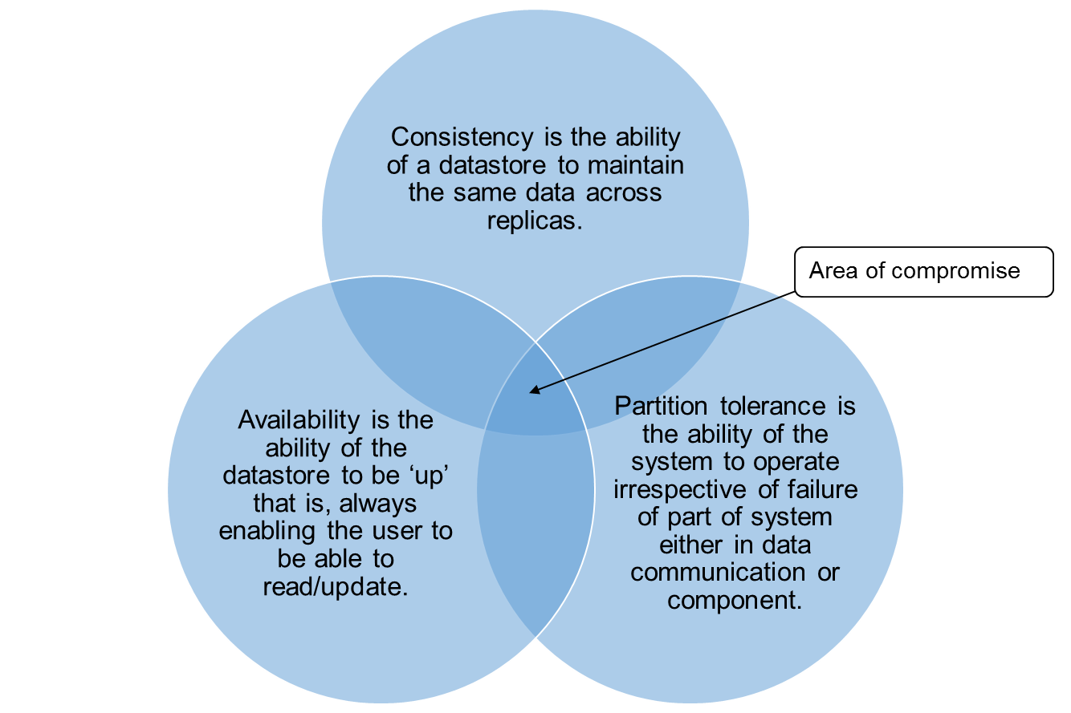
Figure 1. CAP theorem

II. Cassandra Architecture
Cassandra is a distributed data storage system that was originally designed to support inbox search in Facebook. It is an open-source version of Dynamo, designed for storing and managing large amounts of data across commodity servers [1]. It can be characterized by the following properties:
1) It is a non-relational database
2) It provides high availability with no single point of failure as it has peer to peer nodes (no concept of master node).
3) The administrator decides the replication factor – how many copies of the data is to be made.
4) The system is designed to be easily scalable with almost no loss in performance.
5) The system is eventually consistent, that is, updates are eventually propagated to all replicas.
Data Structure: Cassandra uses a tuple structure of key, value and timestamp. A key is used to identify a row of elements. A row may have a variable number of columns. Columns are grouped together to form column families. Column families can be considered as tables. A column family is a container of rows and columns. A super column consists of key-value pairs with many columns. Super column families is a set of key-value pairs with a key that maps to column families. It is analogous to a map of tables. [6]
Basic exchange of data: Consider a cluster with multiple nodes. Activity (writes) at each node is recorded by a commit log. Data writing happens across two stages. First, data is written to a memtable which once full, is followed by a write to a data file called an SSTable which is on disk. Data between nodes is exchanged through a peer-to-peer gossip strategy. Nodes exchange messages to which version information is attached. Version information ensures that each node maintains the most updated data. Also, the gossip strategy is useful to keep a check on the health of nodes and help nodes maintain a record of nodes that are up and those that are not.
Partitioning Strategy: Data distribution across the nodes is determined by the partitioner strategy. It is the hash function used to decide where data must be placed as per the key generated by the function. The strategy used must guarantee even distribution of data. Cassandra offers three different strategies which are basically three different hash functions.
Replication Strategy: Replication strategy determines on which nodes replicas are to be placed. Depending on whether the cluster is deployed across a single data center or multiple data centers, two replacement strategies are available. A snitch defines the topology information regarding nodes required in order to implement replication.
III. Consistency in Cassandra
As mentioned above, consistency in Cassandra is tunable. The following options are available to the administrator to determine what kind of consistency is required. Also, higher the consistency, lower the availability.
Write Consistency: This determines how many nodes must acknowledge the write of the same data value before the value can be considered written. Different types have been described in Table 1.
Read Consistency: This determines how many nodes must return the same data value before it can be returned to a client application. This has been described in Table 2.
In both Table 1 and Table 2, quorum indicates a number equal to (replication factor +1) /2.

TABLE I
write consistency [5]
Level | Description
ANY | A write must be written to at least one node. If all replica nodes for the given row key are down, the write can still succeed once a hinted handoff has been written. Note that if all replica nodes are down at write time, an ANY write will not be readable until the replica nodes for that row key have recovered.
ONE | A write must be written to the commit log and memory table of at least one replica node.
QUORUM | A write must be written to the commit log and memory table on a quorum of replica nodes.
LOCAL_QUORUM | A write must be written to the commit log and memory table on a quorum of replica nodes in the same data center as the coordinator node. Avoids latency of inter-data center communication.
EACH_QUORUM | A write must be written to the commit log and memory table on a quorum of replica nodes in all data centers.
ALL | A write must be written to the commit log and memory table on all replica nodes in the cluster for that row key.
TABLE 2
read consistency [5]
Level | Description
ONE | Returns a response from the closest replica (as determined by the snitch). By default, a read repair runs in the background to make the other replicas consistent.
QUORUM | Returns the record with the most recent timestamp once a quorum of replicas has responded.
LOCAL_QUORUM | Returns the record with the most recent timestamp once a quorum of replicas in the current data center as the coordinator node has reported. Avoids latency of inter-data center communication.
EACH_QUORUM | Returns the record with the most recent timestamp once a quorum of replicas in each data center of the cluster has responded.
ALL | Returns the record with the most recent timestamp once all replicas have responded. The read operation will fail if a replica does not respond.

IV. Client Centric Consistency Models
This project attempts to measure two kinds of inconsistencies as defined below.
Monotonic Reads Inconsistency: In this consistency model, if a user has read an updated data value, if the user accesses the same data from another location (and hence data may be retrieved from a server which is different from the prior one), then the data read earlier must be available to read. If this fails, monotonic read inconsistency is detected. Example: If I access my mail from my laptop in one zone, read a new mail. Later, when I access my mail from a mobile client in some other zone, I should be able to see that mail that I read earlier as well as any newer mails.
Read your Writes Consistency: In this consistency model, if a user has updated a data value, the same updated data value should be returned when the user attempts to access the same value. If this fails, read your writes inconsistency is detected. Example: If I post some article on a social networking website from my laptop in one zone, I should be able to view the same when I access my profile on the social networking site from another location (maybe through a mobile client).
Table 3 explains the consistency model in technical terms.
TABLE 3
Inconsistency Conditions for Operation on the same Key
Consistency Model | Timestamp returned by first read for a particular key | Timestamp returned for last write for the same key | Timestamp returned by second read | Inconsistency detected if
Monotonic Reads | T1 | - | T2 | T1 > T2
Read Your Writes | T1 | T2 |  | T1 < T2
V. Measurement Technique
Two methods of analysis were carried out. Active measurement and passive logging.
Active Measurement: In this method of measurement, at runtime, the timestamps corresponding to reads/writes are measured at runtime and compared in order to check for inconsistency.
Passive Logging: In this method, the execution of writes at a particular client location are logged and the trace is analyzed at the end to check for inconsistencies.
For carrying out the entire measurement, Apache Cassandra (available on the ACIS lab – 5 node cluster) has been used. YCSB benchmark has been tweaked to carry out the measurements.
YCSB Structure: YCSB contains a main client class that performs the actions of taking in the user arguments (setting of different parameters/properties). From the main function of this class, CassandraClient10.java calls different operations such as read/insert/scan/update.
The files have been modified to separately log the timestamps of read and writes, check the timestamps and report if violations occur.
TABLE 4
Modification to Code
Modified Files:
Client.java (YCSB\core\src\main\java\com\yahoo\ycsb)
CassandraClient10.java (YCSB\cassandra\src\main\java\com\yahoo\ycsb\db)
Active Measurement
In file 1: initialize two hash tables –
readTimes: to hold the timestamps corresponding to the records that have been read.
writeTimes: to hold the timestamps corresponding to the records that have been written/updated.

In read function of file 2, note the timestamps of all columns and find the maximum value - maxTimeStamp (to find the timestamp of the most recently updated field corresponding to the key being read).

If (maxTimeStamp < value @ readTimes(key) and if the value is not NULL)
Then increment monontonic read inconsistency counter.
Else update value @ readTimes(key)

If (value @ readTimes(key) < value@ writeTimes(key) and if value is not NULL)
Then increment read your writes inconsistency counter.

In the write function of file 2, update hash table writeTimes(key) when a field for record corresponding to key is updated.

At the end of execution, report number of violations.
(Output report in file: violations.txt)

Passive Analysis
In file 2:
Log all actions – reads/writes with recorded timestamp for Cassandra and system timestamp.

After file execution, order the files as per the system timestamp and check whether the recorded timestamps are in order.

The number of out-of-order timestamps = number of violations.
(Log file generated: smalllog.txt)

CQL: Cassandra Query Language CQL is the interface used to interact with the database.
Configuration:
1) YAML Properties: In the Cassandra ‘conf’ folder, files contain configuration information related to Cassandra. For instance, the cluster name, seed name, listening port, commit log folders, etc. are configured to support a cluster on a single machine. For configuring and setting up a local cluster on the author’s personal laptop, a script was used [4]. For the final measurement, the ACIS lab 5-node cluster was used.
2) Workload Properties: In the workload file of YCSB, read and write consistency levels have been set to ONE and ANY respectively for most of the measurements. As read consistency being ONE means that only one replica returning a data value is sufficient to be considered passable to the client application. Also, if the write consistency level has been set to ANY, then the value needs to be held to be written (even if node is down and hinted handoff is required) to be considered as a completed write operation. Keeping these two points in mind, the consistency levels have been set so in order to create a condition of maximum inconsistency.
The hosts are configured to accommodate the cluster replica IPs. Read and Update proportion have been fixed at 0.5. Different values of operation count, record count have also been dabbled with. The requestdistribution parameter is set to LATEST so that whenever multiple records are used, operations are carried out on the latest record.
Different clients and different replicas:
5 replicas are set up in the ACIS lab test cluster. Different clients are set up by using different number of threads. The number of threads is passed as an argument when running the YCSB code.
VI. Result and Analysis

Results obtained for different number of threads and different configuration parameters are reported below. Tests were carried out on the ACIS lab Cassandra cluster containing 5 nodes.
Table 5 illustrates the parameters that stayed constant throughout the tests.
TABLE 5
Configuration
YAML parameter | value | YAML parameter | value
readproportion | 0.5 | updateproportion | 0.5
scanproportion | 0 | insertproportion | 0
readallfields | true | requestdistribution | latest

TABLE 6
Results
Results | Configuration and Analysis
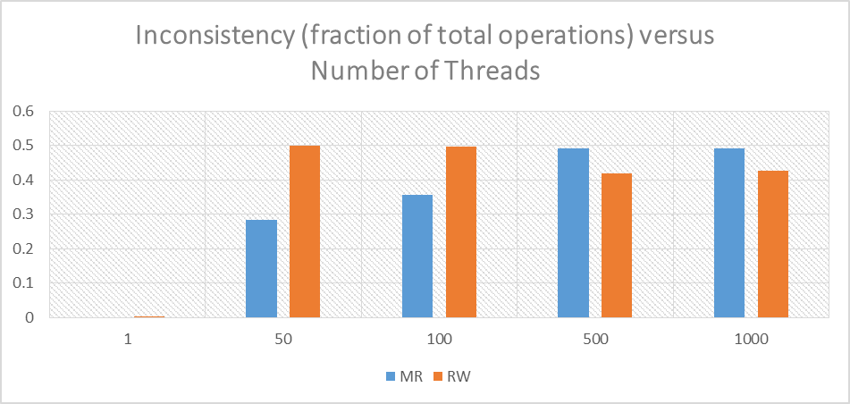 | Recordcount = 1,  operationcount = 500000, readconsistencylevel = ONE, writeconsistencylevel = ANY  As record count is 1, 0 monotonic reads inconsistency is expected. However, as the threads increase, the percentage of monotonic reads increases but that of read after write reduces. This could be attributed to increased number of threads = increased number of clients trying to modify data, causing inconsistency.
  Threads | MR (number) | RW (number) | Throughput (operations/second)
  1 | 0 | 1 | 1000-2000
  50 | 141509 | 249470 | 1000-5000
  100 | 178881 | 248155 | 1000-5000
  500 | 245862 | 209915 | 1000-5000
  1000 | 246337 | 213322 | 1000-5000
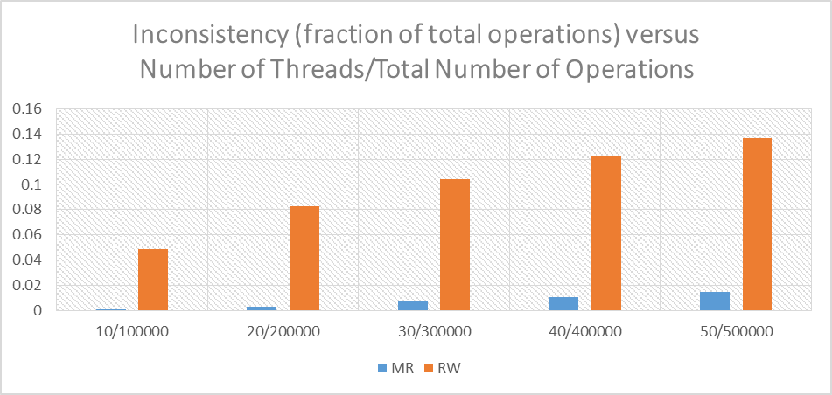 | Recordcount = 1000,  readconsistencylevel = ONE, writeconsistencylevel = ANY  In this analysis, the total number of threads and operations have been increased in proportion to maintain the operations/thread constant. The monotonic read inconsistency observed is low and increases with increase in threads and operations. The read after write inconsistency is very high and exhibits an increasing graph. Throughput observed during this operation was very high. Higher the throughput, higher is the concurrency and hence parallel operations occur.
  Number of threads/ operationcount | RW(number) | MR(number) | Throughput (1000-10000 operations/ second)  Some runs witnessed a throughput of greater than 10000 operations/sec
  10/100000 | 4865 | 94
  20/200000 | 16473 | 563
  30/300000 | 31249 | 2062
  40/400000 | 48950 | 4126
  50/500000 | 68507 | 7516
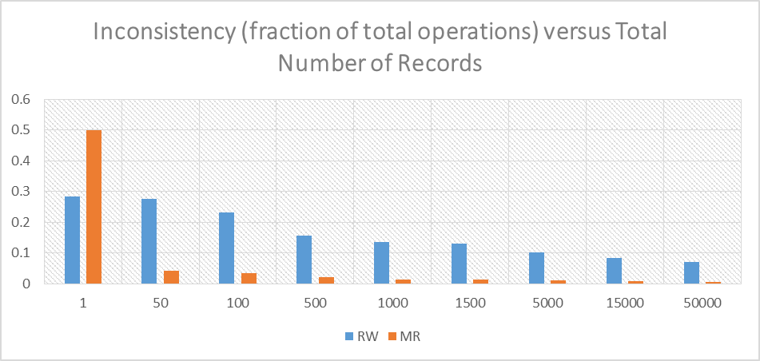 | Number of threads = 50,  operationcount = 500000,  readconsistencylevel = ONE,  writeconsistencylevel = ANY  In this analysis, the number of records being operated on are being varied. As the number of records are increased, the changes made are to diverse records and hence inconsistencies reduce. Thus, in a service that sees a tendency of distributed and diverse access of records, this model will provide a reasonably low consistency.
  Number of Records | RW (number) | MR (number) | Throughput (1000-5000 operations/ second)
  1 | 141509 | 249470 | Throughput (1000-5000 operations/ second)
  50 | 138703 | 21676 | Throughput (1000-5000 operations/ second)
  100 | 116053 | 17513 | Throughput (1000-5000 operations/ second)
  500 | 78717 | 10237 | Throughput (1000-5000 operations/ second)
  1000 | 68507 | 7516 | Throughput (1000-5000 operations/ second)
  1500 | 64838 | 6419 | Throughput (1000-5000 operations/ second)
  5000 | 51383 | 5488 | Throughput (1000-5000 operations/ second)
  15000 | 42449 | 3938 | Throughput (1000-5000 operations/ second)
  50000 | 35885 | 3264 | Throughput (1000-5000 operations/ second)
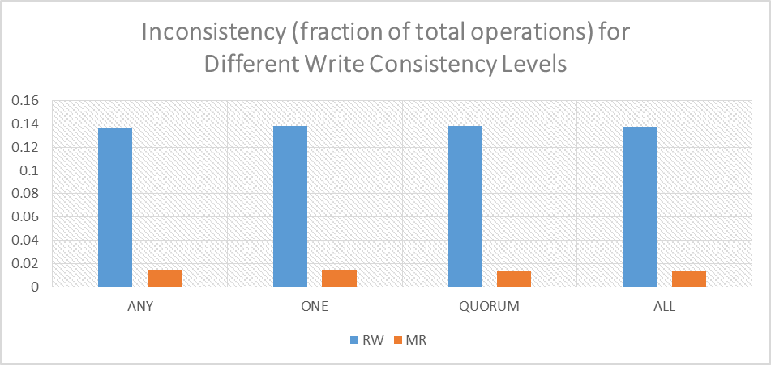 | Number of threads = 50,  Recordcount = 1,  operationcount = 500000,  readconsistencylevel = ONE  In this analysis, we see that as the consistency level is increased, a reduction in inconsistency is expected. However, the values remain around the same value.
  writeconsistencylevel | RW(number) | MR(number) | Throughput (1000-5000 operations/ second)
  ANY | 68507 | 7516 | Throughput (1000-5000 operations/ second)
  ONE | 69021 | 7350 | Throughput (1000-5000 operations/ second)
  QUORUM | 69218 | 7149 | Throughput (1000-5000 operations/ second)
  ALL | 68730 | 6884 | Throughput (1000-5000 operations/ second)
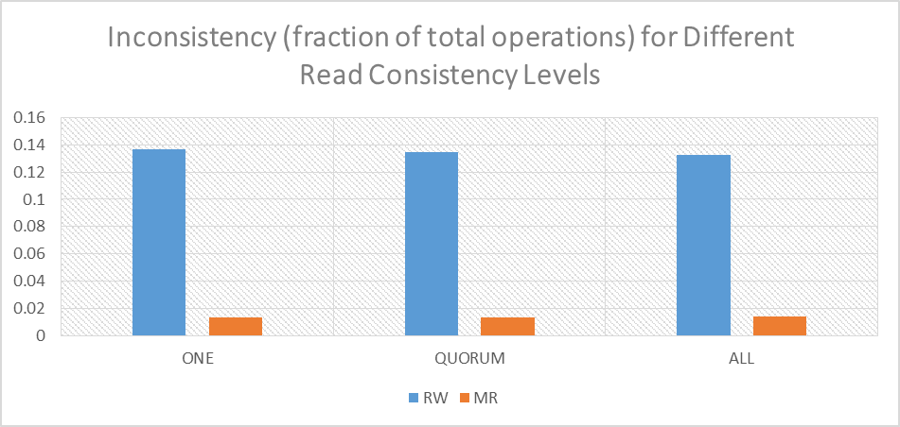 | Number of threads = 50, Recordcount = 1, operationcount = 500000,  writeconsistencylevel = ANY  In this analysis, we see that as the consistency level is increased, a reduction in inconsistency is expected and is observed in both monotonic writes and read your writes.
  readconsistencylevel | RW(number) | MR(number) | Throughput (1000-5000 operations/ second)
  ONE | 68218 | 6575 | Throughput (1000-5000 operations/ second)
  QUORUM | 67355 | 6778 | Throughput (1000-5000 operations/ second)
  ALL | 66421 | 7160 | Throughput (1000-5000 operations/ second)
Excerpt of the Log file generated:  D W user4152828024211893584 1398605474825 1398605474825 45  D R user5600544008911404201 1398605418276 1398605474826 53  D R user9119376631661606007 1398605418126 1398605474826 22  D W user35282298430039176 1398605474827 1398605474827 22  The log file generated is sorted as per Column 5. Disorder in the Column 5 of the ordered list results in violations. The adjacent log is naturally sorted as per system timestamp. However Rows 3 and 4 should be before Row 2 – these are violations. | Col1: Signature; Col2: R-read operation, W- an update operation; Col 3: key; Col4: Timestamp logged for data record; Col5: Local system timestamp; Col6: Thread ID
Monotonic Writes Consistency: (This has not been measured)
For monotonic writes consistency, the writes must be seen in the same order by a process. This can be verified by checking the writes recorded at each replica from either the log file or at run time. The timestamp from the Cassandra end will be required.
VII. Conclusion
Data stores form an important part of today’s services. Also, they play a very important role in today’s cloud systems.
That Cassandra stresses on availability and partition tolerance more than consistency is a known fact. Also, the fact that Cassandra consistency is tunable lays the power of deciding the best configuration when setting up a cluster, in the hands of the administrator. The study of the inconsistencies in Cassandra and quantification of these inconsistencies for a certain set configuration have been reported in this paper. This information helps in knowing what factors to leverage and what factors to pay special attention to when setting up a cluster. It helps us determine what standards are to be set for particular sevices/applications and accordingly how these standards can be met and even tweaked when necessary.
Acknowledgment
I would like to thank Prof. Jose Fortes, Miss Meng Han and Miss Wenjie Zhang for their guidance through the semester for the course ‘Distributed Computing’ and for sparking a keen interest in this subject. I am extremely grateful to Miss Meng Han for her explanation of the project and for always being ready to guide through different steps through the project.
References
[1] Cassandra - A Decentralized Structured Storage System by Avinash Lakshman and Prashant Malik of Facebook
[2] Session Guarantees for Weakly Consistent Replicated Data by Douglas B. Terry, Alan J. Demers, Karin Petersen, Mike J. Spreitzer, Marvin M. Theimer,and Brent B. Welch of Computer Science Laboratory, Xerox Palo Alto Research Center, Palo Alto, California
[3] Benchmarking Cloud Serving Systems with YCSB by Brian F. Cooper, Adam Silberstein, Erwin Tam, Raghu Ramakrishnan, Russell Sears of Yahoo! Research, Santa Clara, CA, USA
[4] https://github.com/pcmanus/ccm - script available for setting up a Cassandra cluster by Sylvain Lebresne
[5] Apache Cassandra 0.8 Documentation on datastax (http://www.datastax.com/docs/0.8/dml/data_consistency)
[6] Apache Cassandra 2.0 Documentation on datastax (http://www.datastax.com/documentation/cassandra/2.0/cassandra/gettingStartedCassandraIntro.html)
[7] YCSB Documentation by Brian Frank Cooper (https://github.com/brianfrankcooper/YCSB/wiki/Core-Properties)
[8] Brewer’s Conjecture and the Feasibility of Consistent, Available, Partition-Tolerant Web Services by Seth Gilbert and Nancy Lynch
Of Laboratory for Computer Science, Massachusetts Institute of Technology, Cambridge
[9] Wikipedia articles (www.wikepedia.org)

