Projects: ML

1.Setting up the github- Repository (for commiting our code and development be in sync with the team working)

a) new environment (before implementing project)

b) setup.py

c) requirements.txt

2. Src folder and build the package

(workings done: github new repository created with name and as public,no description and all given; folder name created where my all deployment of project will happen(copy the path - Eg here C:\Users\Divya\ML Projects;

go to anaconda prompt, type -> cd C:\Users\Divya\ML Projects

type -> code . (it will launch vs code)

Now vscode opened: sync the github repository here

(Terminal-> a

1. Create environment i.e here create within folder ,so all installation under this env only will happen

conda create -p venv python==3.8 -y (y notation for yes as installation happens and it doesn’t ask any approval )

conda activate venv/ (To activate environment)

To clear the terminal -> type cls

1. Clone the repository created and sync with github

* Initialize empty git repository in the folder – git init

(before this ,git should I installed on pc and its path should be given in environment variables of git and bin both : /git and / bin

* Create readme file on vs code/ github repository -> README.md

If creating in vs ,then after that add on github too by -> git add README.md

* Since doing first time ,so set git global ->

git config --global user.email "your Email Address"

git config --global user.name "Name”

* Now commit

git commit -m “First Commit”

* To push
* See branch name

git branch -M main

git remote add origin <https://github.com/divya-ranka/MLProject.git>

* To check its snyc or not -> git remote -v
* To push git push -u origin main (i.e from origin to main,commit will happen)

So Readme will was added ,now when committed to github,u can see on github readme file by refresh . So sync is done .so any code will be written will committed

1. Add a file on github repository itseld-> .gitignore

And select template as python and commit changes

(we do this bcoz some files that need not be committed in github, that all will be removed Eg .python-version is not required when u built the packages, all this comes)

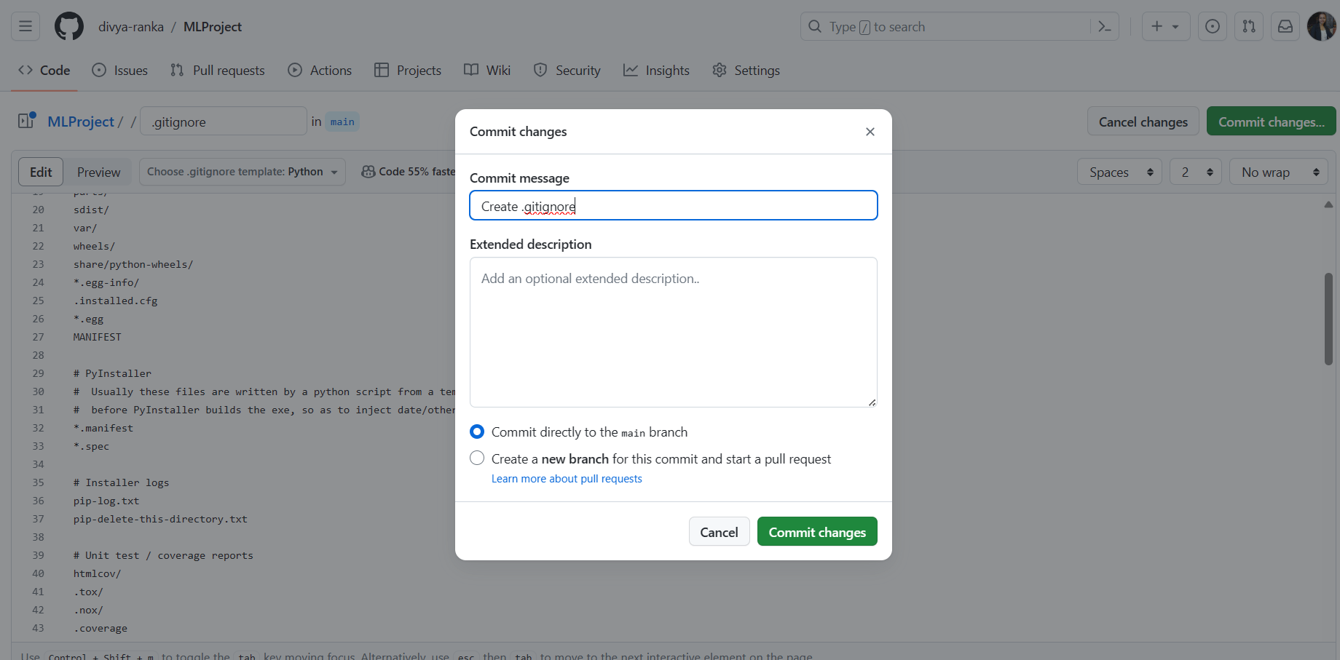

Now whatever I do on github like I added .gitignore ,ill update on vscode too -> git pull

b)

create on vs setup.py file and requirements.txt

setup file – This file will be responsible in creating ML application as a package and even deploy PyPi

setup file with some metadata on project , also created src i.e source to know all packages and all for setup.py

So whenever it will run find_packages() of setup.py file , it will go and see in how many folder it has __init__.py file,then that folder as source will be considered as package

Here creating src folder with __init__.py file

Note: setup file either can be directly installed or

whenever installing all requirements.txt,with it setup file should also run to build the packages (to enable this one – write in requirements.txt -> -e . )

-e . will automatically trigger setup file

Also, it should connect to setup file , not get read as -e . while get_requirements() function ,for that if condition given

c)

Now run requirements.txt file -> pip install -r requirements.txt

So can see MLProjectegg-info with different files into it

Now,

Whatver done in vs-> Terminal -> git add .

git status - can see what all got added

Terminal->

git commit -m “Setup”

git push -u origin main