MARKET AND DATA-MODEL REPORT
Inventory & Asset Management Applications
Market overview, entity models of 21 apps, reference schema and a gap analysis of assets-erd_1
October 2026
Contents: 1. Market overview · 2. Entity models · 3. Entity diagrams and schemas · 4. Gap analysis of assets-erd_1

Contents

If the page numbers above are missing, right-click the table and choose Update Field.

Part 1. Market overview
Prices are list or third-party-reported figures as of mid/late 2026 and change often. Many comparison sites are vendor-owned or earn referral fees. Confirm prices with each vendor before you decide.

1. Market snapshot
Segment | 2025–26 size | Forecast | Source
Inventory management software | ~$2.7B (2026) | $5.5B by 2034 (9.1% CAGR) | Fortune Business Insights
Inventory management software | ~$2.7B (2026) | $9.4B by 2036 (13.1% CAGR) | Future Market Insights
Asset management systems (HW + SW: RFID, GPS, software) | $17.6B (2025) | $26.4B by 2030 (8.4% CAGR) | MarketsandMarkets

- Cloud is the default. About 68% of inventory software is expected to be cloud-deployed (FMI).
- North America is the largest region at about 35% share. APAC (especially India) is growing fastest.
- Retail is the lead vertical for asset systems. RFID is the largest technology segment.

2. The four sub-categories
The phrase "inventory and asset apps" covers four different kinds of product, and buyers often mix them up:
Category | Tracks | Typical buyer | Key capabilities
A. Inventory / stock management | Goods you sell or consume (SKUs, quantities) | Retail, e-commerce, wholesale, light manufacturing | Stock levels, reorder points, POs/SOs, multichannel sync, batches/serials, multi-warehouse
B. Fixed / physical asset tracking | Things you own and reuse (equipment, tools, furniture, vehicles) | Schools, hospitals, construction, offices, govt | Barcode/QR/RFID tags, check-in/out, audits, maintenance, depreciation
C. IT asset management (ITAM) | Hardware, software licences, cloud/SaaS | IT teams, MSPs | Auto-discovery, licence compliance, CMDB, ITSM/helpdesk link, MDM
D. EAM / CMMS | Heavy plant & facilities | Manufacturing, utilities, facilities | Work orders, preventive/predictive maintenance, IoT sensors

3. Major players by category

A. Inventory / stock management
Product | Starting price* | Free tier | Best for | Watch-outs
Zoho Inventory | ~$39/mo (500 orders) | Yes (50 orders/mo) | SMBs on a budget, Zoho Books users, India/GST | Order caps per tier
Sortly | Advanced $49 · Ultra $149 · Premium $299/mo | Yes (100 items, 1 user) | Simple, photo/mobile-first stock and small-asset tracking | Weak on orders/accounting; item caps
inFlow Inventory | ~$129–186/mo | No | Flat pricing, B2B/wholesale, barcode workflows | Price calculator based on users, locations and orders
Ordoro | ~$59/mo | Limited | E-commerce shipping + dropship, unlimited users | Less suited to manufacturing
Fishbowl | Quote / ~$50+/user | No | QuickBooks-centric manufacturers & warehouses | Higher setup effort
Cin7 (Core / Omni) | ~$349/mo+ | No | Multichannel retail, POS + B2B + 3PL | Expensive for small teams
Odoo Inventory | ~$31–47/user/mo (whole ERP); Community free | Community (self-host) | Growing firms wanting a full modular ERP | Implementation partner usually needed
ERPNext (open source) | Free self-host; paid cloud | Yes | Cost-sensitive SMEs wanting ERP | Needs technical skills
NetSuite / SAP B1 / MS Dynamics 365 BC | Enterprise quotes | No | Mid-market & enterprise | Long, costly implementations

India-focused options: TallyPrime and Vyapar (GST billing + stock), Zoho Inventory, Marg ERP (pharma/FMCG distribution).

B. Fixed / physical asset tracking
Product | Starting price* | Strengths | Weaknesses
EZOfficeInventory (EZO) | Essentials ~$40/mo (250 items), Advanced $55, Premium $65 | Clear pricing, check-in/out, POs, warranties, repair history | Item-based pricing grows quickly
Asset Panda | Quote only (~$1.5k/yr+ reported) | Highly configurable, mobile app, 5 depreciation methods | No public pricing, setup takes effort
Sortly | From free | Easiest to adopt | No GPS/BLE, limited depreciation
Reftab | Low-cost tiers | Simple check-in/out for IT & equipment | Fewer enterprise features
UpKeep / Limble / Fiix (CMMS) | ~$20–75/user/mo | Maintenance-heavy assets | Overkill for plain tracking

C. IT asset management (ITAM)
Product | Model | Best for
ServiceNow ITAM | Enterprise quote | Large enterprises already on ServiceNow
Flexera One | Enterprise quote | Software licence optimisation, SaaS/cloud spend
Lansweeper | Tiered by asset count | Agentless network discovery
ManageEngine AssetExplorer / Endpoint Central | Low cost, on-prem or cloud | Budget mid-size IT, India-based vendor
Freshservice | Per agent | ITSM + ITAM for SMB/mid-market
Jira Service Management (Assets) | Per agent | Atlassian shops
Ivanti Neurons for ITAM | Quote | Endpoint- and security-heavy estates
SysAid, InvGate, Virima | Quote / per agent | Helpdesk + ITAM combined, CMDB/service mapping
Snipe-IT (open source) | Free self-host; hosted $39.99 / $99.99 / $249.99 per mo | Cheapest credible ITAM, strong community
Jamf Pro / Kandji | Per device | Apple fleets (MDM + inventory)

4. Comparative positioning
High functionality / enterprise
▲
NetSuite, SAP, D365 │ ServiceNow, Flexera, Ivanti
Cin7, Fishbowl │ Lansweeper, Freshservice
│
Inventory ◄─────────────┼─────────────► Asset / ITAM
│
Zoho Inventory, inFlow│ Asset Panda, EZO, Reftab
Ordoro, Odoo, ERPNext │ Snipe-IT, ManageEngine
Sortly, Vyapar, Tally │ Sortly
▼
Low cost / SMB / simple

5. Key trends (2025–2026)
- AI features are now table stakes. Vendors ship demand forecasting, reorder suggestions, anomaly detection on stock counts, natural-language queries ("what's running low in warehouse 2?") and AI-generated item descriptions and categorisation.
- IoT, RFID and BLE tracking. Asset tracking is moving from barcode scans to passive RFID and Bluetooth/GPS tags with live location. RFID is the largest technology segment.
- Convergence. Inventory tools are adding asset modules, ITAM is merging with ITSM and FinOps/SaaS management, and SMB tools are growing into "lite ERP".
- Mobile-first. Phone-camera barcode scanning has replaced dedicated scanners for SMBs.
- Usage-based pricing. Prices are increasingly tied to orders, items or assets rather than per seat. Low entry prices can grow quickly at scale.
- Open source and self-hosting (Snipe-IT, ERPNext, Odoo Community, InvenTree) attract cost-sensitive buyers and those with data-residency requirements.
- Compliance pressure. E-invoicing/GST (India), software licence audits and ESG/asset lifecycle (e-waste) reporting drive purchases.

6. Gaps / opportunities in the market
- The SMB middle ground. Simple apps like Sortly lack accounting depth, and ERPs are too complex. Few products handle both consumable stock and reusable assets well at SMB prices.
- Unpredictable pricing. Buyers complain about item, order or asset caps and quote-only pricing (Asset Panda, Cin7, enterprise ITAM).
- Local compliance + language. Regional players (Tally, Vyapar) win in India on GST, offline use and local languages, which global SaaS tools handle less well.
- Offline / low-connectivity use for field sites, warehouses and rural areas.
- Affordable RFID/BLE. Most products that do live tracking are enterprise-priced.
- AI that acts, not just reports. Few products auto-create POs, schedule maintenance or reconcile audits end-to-end.

7. How to choose (quick guide)
If you are… | Shortlist
Micro/small business, mostly tracking items | Sortly (free), Zoho Inventory (free)
Indian SMB needing GST billing + stock | Zoho Inventory, TallyPrime, Vyapar
E-commerce, multichannel | Ordoro, Zoho Inventory, Cin7
Wholesale / light manufacturing | inFlow, Fishbowl, Odoo
Office/school/hospital equipment | EZOfficeInventory, Asset Panda, Reftab
IT team, small budget | Snipe-IT, ManageEngine, Freshservice
Enterprise IT | ServiceNow, Flexera, Lansweeper, Ivanti
Want a full ERP | Odoo, ERPNext, NetSuite, D365 Business Central

Evaluation checklist: item/asset volume and pricing caps · barcode/QR/RFID support · mobile and offline use · multi-location · integrations (accounting, e-commerce, ITSM, MDM, SSO) · depreciation methods · audit trail and roles · API access · data export and lock-in · local tax compliance · total cost over 3 years.

Part 2. Entity models of the leading apps

Summary
Every app in this market is built on the same five core entities: Item/Product, Location, Party (customer, vendor, user), Transaction and Movement/Stock record. What separates them is how they model quantity versus identity.
- Inventory apps count quantities. The core is an Item (SKU) with a quantity per Location. Serial and batch numbers are optional add-ons.
- Asset apps track identities. The core is one record per physical thing (an Asset with a tag), with an assignee, a status and a history of check-outs, maintenance and depreciation.
- ITAM apps add discovery and relationships. They split the financial Asset from the technical Configuration Item (CI) and track Licences as entitlements consumed by installs or users.
- CMMS/EAM apps add hierarchy and work. Assets nest into parent–child trees and drive Work Orders, PM schedules and Meters.
- Schema flexibility is the main architectural split. Snipe-IT, Zoho and inFlow ship a fixed schema with custom fields. Asset Panda and Jira Assets let users define their own entity types. Odoo, ERPNext and NetSuite use a full double-entry stock ledger.
No SMB product models consumables, stock and serialised assets equally well in one schema. That is the main gap for anyone designing a new product.

Method and scope
This part covers 21 apps from the market analysis in Part 1. Each app's entities are taken from its public REST API resources, import templates and documented data model. They show the objects a developer or integrator actually works with.
- Entity means a first-class record with its own ID and API endpoint, not a field.
- The entity names are each vendor's own. Fields are listed only where they define the model, such as serial, lot, status or parent.
- Caveat: this analysis comes from vendor documentation as known up to mid-2026. The docs were not re-fetched for this report, so treat entity lists as approximate and check the vendor's API reference before building an integration.

Inventory and stock apps
Inventory apps centre on an Item/Product whose quantity is held per Warehouse/Location and changed by orders and adjustments. The products differ in three ways: whether they support variants, whether locations nest, and whether stock is a stored number or a ledger of moves.
App | Item / product entities | Location entities | Transaction entities | Tracking and stock record | Model notes
Zoho Inventory | Item, Item Group (variants), Composite Item (kit), Price List | Warehouse (Location in newer orgs) | Sales Order, Package, Shipment, Invoice, Purchase Order, Purchase Receive, Bill, Transfer Order, Inventory Adjustment, Credit Note | Serial number and batch on items; stock-on-hand per warehouse | Shares Contacts and Items with Zoho Books
Sortly | Item, Folder (nested), Tag, Custom Field | Folder doubles as location | Activity log, Alert (low stock, date); Purchase Order on higher tiers | Quantity per item, min level | Folder tree is the only hierarchy; very light model
inFlow Inventory | Product, Product Category, Pricing Scheme, Bill of Materials | Location, Sublocation (bin) | Sales Order, Purchase Order, Stock Adjustment, Stock Transfer, Stock Count, Manufacturing Order | Serial and lot per product; inventory row per location + sublocation | Customer, Vendor as separate entities
Ordoro | Product, Kit, Supplier Product link | Warehouse | Order, Shipment, Purchase Order, Dropship PO, Return (RMA) | Quantity per warehouse; no lots | Shipping-first: Shipper, Label, Rate are core
Fishbowl | Part (what you stock) vs Product (what you sell), BOM, UOM + conversion | Location Group > Location | Sales Order, Purchase Order, Manufacture Order, Work Order, Transfer Order, Pick, Ship, Receipt | Tracking types: lot, serial, expiry, revision; Tag holds quantity per location | Part/Product split is unique to Fishbowl
Cin7 Core | Product, Product Family (variants), Bill of Materials, Price Tier | Location > Bin | Sale, Purchase, Stock Adjustment, Stock Transfer, Assembly / Production Order, Stocktake | Batch/serial with expiry; stock per location + bin | Sale is one entity spanning quote → order → invoice → fulfilment
Odoo Inventory | product.template + product.product (variant), product.category, UoM | stock.warehouse, stock.location (tree, incl. virtual: Vendors, Customers, Scrap) | stock.picking (transfer), stock.move, stock.move.line, stock.route / stock.rule | stock.quant (qty by product + location + lot + package), stock.lot, stock.package | Double-entry: every move goes from one location to another
ERPNext | Item, Item Group (tree), Item Variant, BOM | Warehouse (tree) | Material Request, Purchase Receipt, Delivery Note, Stock Entry, Stock Reconciliation, Work Order | Stock Ledger Entry (immutable) + Bin (running balance), Batch, Serial No | Ledger-first; valuation by FIFO or moving average
NetSuite | Item with record types: Inventory, Non-inventory, Assembly, Kit, Lot-numbered, Serialized, Matrix (variants) | Subsidiary > Location > Bin | Sales Order, Item Fulfillment, Invoice, Purchase Order, Item Receipt, Transfer Order, Inventory Adjustment, Work Order | Inventory Number (lot/serial), Inventory Detail subrecord | Multi-subsidiary; item type decides behaviour

Patterns to note
- Variants are modelled three ways: a parent group (Zoho, Cin7), a template–variant pair (Odoo, ERPNext) or a matrix item type (NetSuite).
- Stock record: simple apps store a quantity field (Sortly, Ordoro). Mid-tier apps store a row per item + location (inFlow, Zoho). ERPs derive it from a move ledger (Odoo, ERPNext, NetSuite).
- Kits and BOMs appear in every tool aimed at light manufacturing or bundles. Only Sortly lacks them.

Fixed asset tracking apps
Asset apps put a uniquely tagged Asset at the centre. Around it sit a custodian (member, employee, loanee), a location, and events: check-out, reservation, audit, maintenance, disposal.
App | Core entities | Custody and event entities | Finance entities | Model notes
EZOfficeInventory | Asset (serialised), Asset Stock (consumables, quantity), Inventory (stock items), Group > Subgroup, Bundle, Package | Member, Location, Checkout/Checkin, Reservation, Work Order (service, maintenance), Audit | Vendor, Purchase Order, Depreciation (straight-line, declining) | Three item classes in one app: the closest an asset tool gets to inventory
Asset Panda | Group (user-defined: Assets, Employees, Locations, Vehicles…), Record, Field, Linked Group | Action (user-defined: Check Out, Audit, Repair…) with its own fields and status changes | Depreciation (5 methods), Purchase/Warranty fields | Meta-model: users define entities and actions, so no two accounts share a schema
Reftab | Asset, Category, Custom Field | Loanee, Loan (check-out), Reservation, Location, Maintenance Event | Purchase fields, Depreciation basics | Flat, fixed schema; quick to integrate
Sortly (as asset tool) | Item, Folder, Tag | Activity history, Alert | None | Treats assets as items with quantity 1; no custodian entity

Patterns to note
- Custody is a first-class entity (checkout, loan, action) in every asset tool. In inventory apps it does not exist.
- Asset Panda's meta-model is the most flexible, but it makes reporting and integrations account-specific.
- EZOfficeInventory is the only one to split serialised assets, consumable stock and resale inventory into separate entities.

IT asset management apps
IT asset management apps add two things the other categories lack: discovered records and software licences. Enterprise tools also keep the financial asset separate from the technical configuration item (CI).
App | Hardware entities | Software / licence entities | Supporting entities | Model notes
Snipe-IT | Asset, Asset Model, Category, Manufacturer, Status Label, Component (parts inside assets), Accessory, Consumable, Kit | License, License Seat (checked out to user or asset) | User, Location, Company (multi-tenant), Supplier, Department, Depreciation, Custom Fieldset, Maintenance, Action Log | Clear fixed schema; check-out targets can be a User, Location or another Asset
ServiceNow ITAM | alm_asset → alm_hardware, alm_consumable, alm_facility; Model (cmn_model) + Model Category; Stockroom | alm_license, Software Entitlement, Software Installation, Software Model, SaaS Subscription | cmdb_ci class tree (cmdb_ci_computer, _server, _app…), CI Relationship, Contract, Lease, Location, Cost Center, Discovery Source | Asset (owned, financial) ↔ CI (operational) synced 1:1; deep class inheritance
Freshservice | Asset with Asset Type tree (Hardware > Computer > Laptop), Product, Component | Software, Installation, License, Contract | Vendor, Location, Department, Relationship, Purchase Order, Discovery agent data | Asset type decides which fields apply, so inheritance is lighter than ServiceNow's
Jira Service Management Assets | Object Schema > Object Type > Object, Attribute (incl. reference attributes) | Modelled as object types the admin defines | Reference (typed link), Import Structure, Discovery | Pure graph meta-model, like Asset Panda but for IT; links to tickets
Lansweeper | Asset (discovered), Asset Type, Site, Hardware details (CPU, disk, NICs) | Software, OS, Patch, Vulnerability | User (AD/Entra), Scan Target, Credentials, Relation | Discovery-first: most entities are written by scans, not people
ManageEngine AssetExplorer | Workstation, Asset, Product, Product Type, Component | Software, Software License, License Agreement, Installation | Site, Group, Vendor, Purchase Order, Contract, CMDB CI | Classic split of IT (workstation) vs non-IT assets
Flexera One | Inventory Device (from many sources), Hardware Model | Application, Purchase, License (entitlement), Consumption, SaaS App, Cloud Instance | Contract, Vendor, Org Unit, Content library (normalised SKUs) | Licence-position engine: entitlement minus consumption equals compliance

Patterns to note
- Licence = entitlement + consumption. Snipe-IT models this as seats, Flexera as purchases versus installs, and ServiceNow as entitlements versus installations.
- Components and consumables (Snipe-IT, Freshservice) bring quantity-based stock back into asset tools.
- Discovery source is an entity in enterprise tools. A record can be created by a scan, an MDM or a person, and rules reconcile duplicates.

CMMS and EAM apps
Maintenance apps model assets as a parent–child hierarchy and organise all activity around the Work Order.
App | Asset entities | Work entities | Parts and stock | Model notes
IBM Maximo | Asset (hierarchy), Location (hierarchy, separate from asset), Classification, Failure Code | Work Order, Job Plan, PM (preventive maintenance), Service Request, Route | Item, Storeroom, Inventory, Reorder, Purchase Requisition / PO | Asset and Location are two separate trees; full inventory module
UpKeep / Limble / Fiix | Asset (parent/child), Location, Asset Category | Work Order, Preventive Maintenance schedule, Request, Meter + Reading | Part, Part Inventory per location, Vendor, Purchase Order | Simplified Maximo model; IoT sensors post Meter Readings that can trigger work

Pattern to note: CMMS tools are the only category where Asset and Part are separate entities that both live in one product. They are the closest existing model to a unified inventory + asset system.

Cross-app entity matrix
Only the ERPs and Maximo cover both the stock side and the asset side. Every SMB tool is strong on one side and thin on the other.
App | Variants | Kit / BOM | Nested locations + bins | Lot / serial | Stock ledger | Custody / check-out | Maintenance / work order | Depreciation | Licences | Discovery / CI | User-defined entity types
Zoho Inventory | Yes | Yes | Partial | Yes | No | No | No | No | No | No | No
Sortly | No | No | Partial (folders) | No | No | Partial | No | No | No | No | No
inFlow | Partial | Yes | Yes | Yes | No | No | No | No | No | No | No
Ordoro | No | Yes | No | No | No | No | No | No | No | No | No
Fishbowl | Partial | Yes | Yes | Yes | Partial | No | Partial | No | No | No | No
Cin7 Core | Yes | Yes | Yes | Yes | Partial | No | No | No | No | No | No
Odoo | Yes | Yes | Yes | Yes | Yes | Partial (module) | Partial (module) | Yes (Accounting) | No | No | Partial (Studio)
ERPNext | Yes | Yes | Yes | Yes | Yes | Partial | Yes (Asset module) | Yes | No | No | Yes (Custom DocType)
NetSuite | Yes | Yes | Yes | Yes | Yes | No | Partial | Yes (FAM) | No | No | Yes (custom records)
EZOfficeInventory | No | Partial (bundles) | Yes | Partial | No | Yes | Yes | Yes | Partial | No | No
Asset Panda | No | No | Partial | Partial | No | Yes | Yes | Yes | Partial | No | Yes
Reftab | No | No | Partial | Partial | No | Yes | Yes | Partial | No | No | No
Snipe-IT | No | Partial (kits) | Partial | Yes | No | Yes | Yes | Yes | Yes | No | No
ServiceNow ITAM | No | Partial | Yes | Yes | No | Yes | Yes | Yes | Yes | Yes | Yes
Freshservice | No | No | Partial | Yes | No | Yes | Partial | Yes | Yes | Yes | Partial
Jira Assets | No | No | Partial | Partial | No | Partial | Partial (tickets) | No | Partial | Yes | Yes
Lansweeper | No | No | Partial (sites) | Yes | No | No | No | No | Partial | Yes | No
Flexera One | No | No | No | Partial | No | No | No | No | Yes | Yes | No
Maximo | No | Yes | Yes | Yes | Yes | Partial | Yes | Yes | No | Partial | Partial
UpKeep / Limble | No | No | Yes | Partial | No | No | Yes | Partial | No | No | No

"Partial" means the concept exists only as a field, an add-on module or a narrow special case, not as a full entity.

Design patterns and differences
Five modelling decisions explain almost every difference between these apps.
- Quantity vs identity. Inventory apps store how many of an Item sit at a Location. Asset apps store which one and who holds it. Lot and serial tracking is the bridge: a serialised item is an inventory row with quantity 1 and an identity. EZOfficeInventory and Snipe-IT add stock classes (consumables, components) to asset tools. ERPNext and Odoo add asset modules on top of serial numbers.
- Stored balance vs ledger. Simple apps update a quantity field in place, which is fast but hard to audit. Odoo (stock.move → stock.quant), ERPNext (Stock Ledger Entry → Bin) and NetSuite derive balances from immutable moves. That gives full history, point-in-time valuation and reconciliation.
- Location shape. Locations are either flat (Ordoro), a two-level warehouse + bin (inFlow, Cin7), or a full tree with virtual locations (Odoo's Vendors, Customers, Scrap; Maximo's separate Location tree). Virtual locations let every transaction be a move between two places.
- Product master vs instance. Mature tools split the type from the thing. Examples: Snipe-IT Asset Model → Asset, ServiceNow Model → Asset → CI, Odoo product.template → product.product → stock.lot. Simple tools merge them, which duplicates specs across records.
- Fixed schema vs meta-model. Fixed schemas (Snipe-IT, Zoho, Reftab) are easy to integrate and report on. Meta-models (Asset Panda Groups, Jira Object Types, ERPNext DocTypes, NetSuite custom records) fit any business. The cost is weaker built-in logic and account-specific APIs.
Two smaller patterns repeat. Custody (checkout, loan, assignment) is always a separate event entity, never a field overwrite, because history matters. Licences are always modelled as entitlement + consumption pairs.

Reference unified data model
A product that covers both inventory and assets needs nine entities. The Stock Move ledger sits at the centre, and a serialised Instance is both a stock unit and a trackable asset.
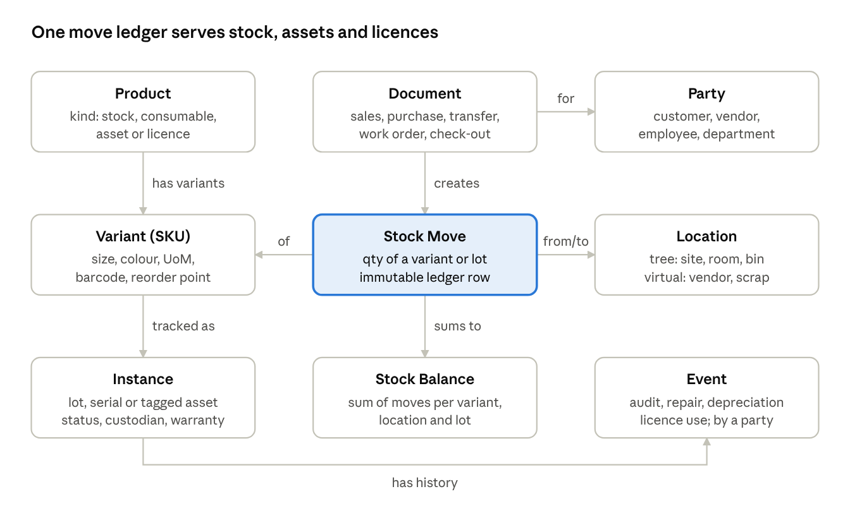
Figure 1. Reference data model: nine entities around one move ledger
Documents create moves. Balances are derived from moves, never edited. Custody, maintenance, depreciation and licence use are append-only events on an instance.
How the leading apps map onto it
Canonical entity | Zoho Inventory | Odoo | Snipe-IT | ServiceNow
Product | Item Group | product.template | Asset Model | Model (cmn_model)
Variant (SKU) | Item | product.product | Asset Model | Model
Instance | Serial / Batch | stock.lot | Asset, License Seat | alm_asset + cmdb_ci
Location | Warehouse | stock.location | Location | Location, Stockroom
Party | Contact | res.partner | User, Supplier, Company | User, Vendor (core_company)
Document | Sales / Purchase / Transfer Order | stock.picking, sale.order | Checkout request | Request, Transfer Order
Stock Move | Adjustment + order lines | stock.move | Action Log | Asset history
Stock Balance | Stock on hand | stock.quant | Remaining counts | Stockroom quantity
Event | Activity history | mail.message, maintenance.request | Action Log, Maintenance | Asset audit, Task

Recommendations for building or choosing a system
- One product master with a kind field (stock, consumable, asset, licence) avoids the two-app split most SMBs live with today.
- Start with a move ledger. Retrofitting audit history onto a stored-quantity model is the most common rewrite in this market.
- Promote, don't copy. When a serial-tracked unit is put into use, the same Instance gains a custodian and depreciation, so stock and asset reports never disagree.
- Use a location tree with virtual locations. Receipts, sales, scrap and losses then all become moves between locations.
- Keep a fixed core schema plus custom fields. Add user-defined entity types only for edge cases; full meta-models (Asset Panda, Jira Assets) make integrations and reporting account-specific.
- Model licences as entitlement vs consumption from the start if IT assets are in scope.

Part 3. Entity diagrams and schemas
Each category's data model is drawn below from one representative app, with primary keys (PK), foreign keys (FK) and cardinality. Arrows run from the parent (1) to the child (N); a dashed arrow is derived data, not a foreign key. The last section turns the reference model into a database schema.

Inventory apps (Odoo, ERPNext, Zoho Inventory)
Stock is never edited directly. Orders create STOCK_MOVE rows, and STOCK_QUANT is the running balance per variant, location and lot.
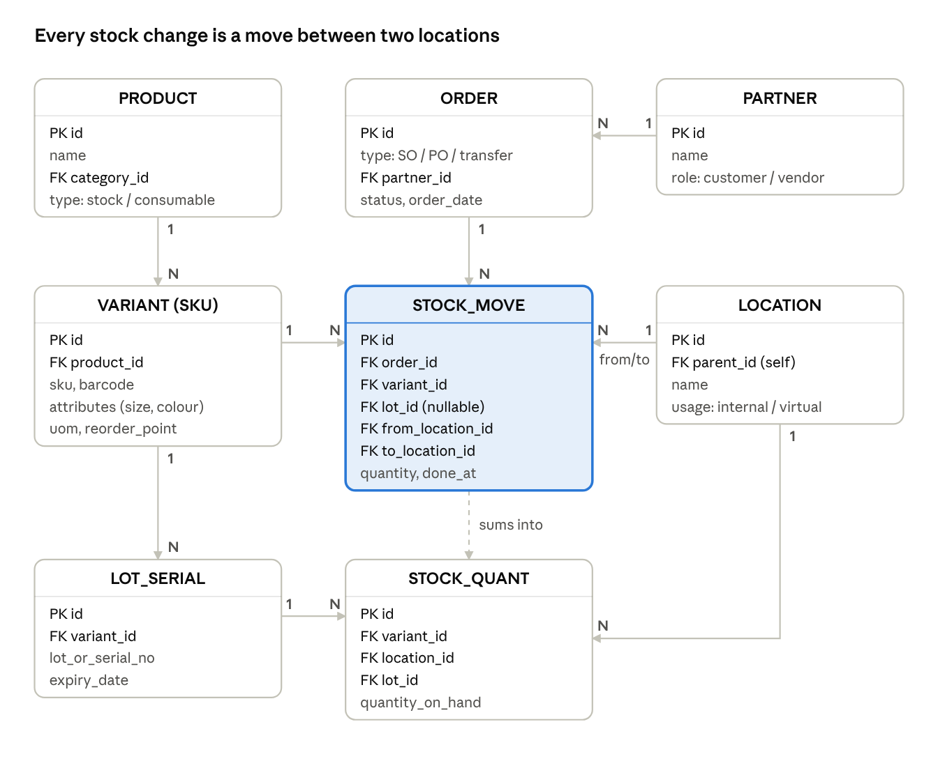
Figure 2. Inventory ERD, Odoo / ERPNext / Zoho style, 8 tables
LOCATION nests through parent_id, and virtual locations (vendor, customer, scrap) make receipts and sales ordinary moves. Zoho and inFlow store the QUANT row directly instead of deriving it from moves.

Fixed asset apps (EZOfficeInventory, Reftab)
The ASSET row carries identity (tag, serial) and current state. Custody and upkeep are kept as child rows (CHECKOUT, RESERVATION, WORK_ORDER), so the full history survives.
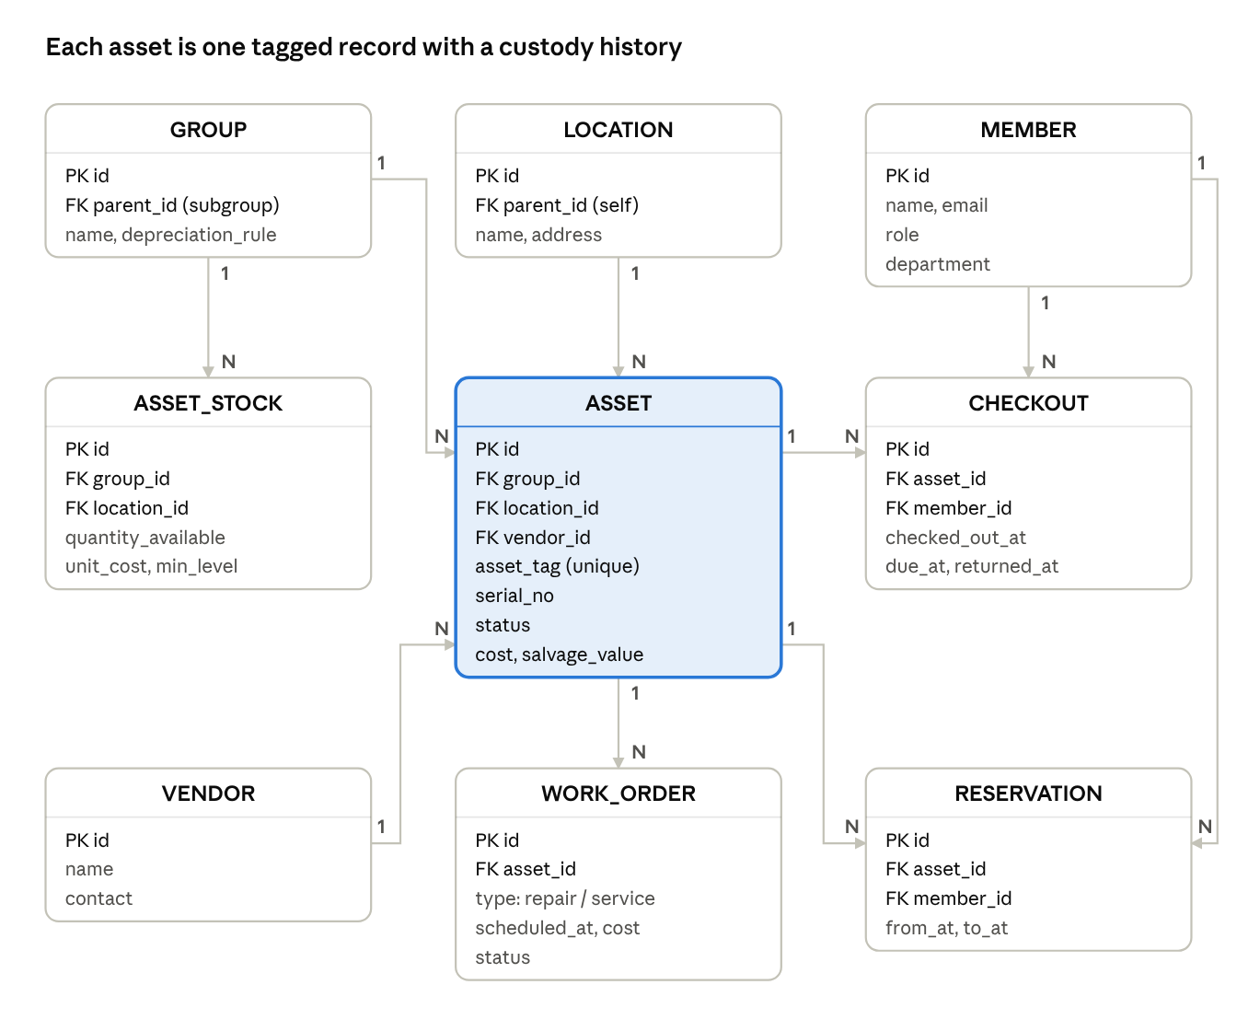
Figure 3. Fixed asset ERD, EZOfficeInventory style, 9 tables
ASSET_STOCK holds consumables by quantity next to serialised assets. That is how EZOfficeInventory covers both in one app. Reftab follows the same shape with LOANEE and LOAN in place of MEMBER and CHECKOUT. Asset Panda swaps these fixed tables for user-defined groups and actions.

IT asset management (Snipe-IT)
Snipe-IT separates the ASSET_MODEL (the type) from the ASSET (the tagged unit). Licences are modelled as a pool of LICENSE_SEAT rows, each checked out to a user or an asset.
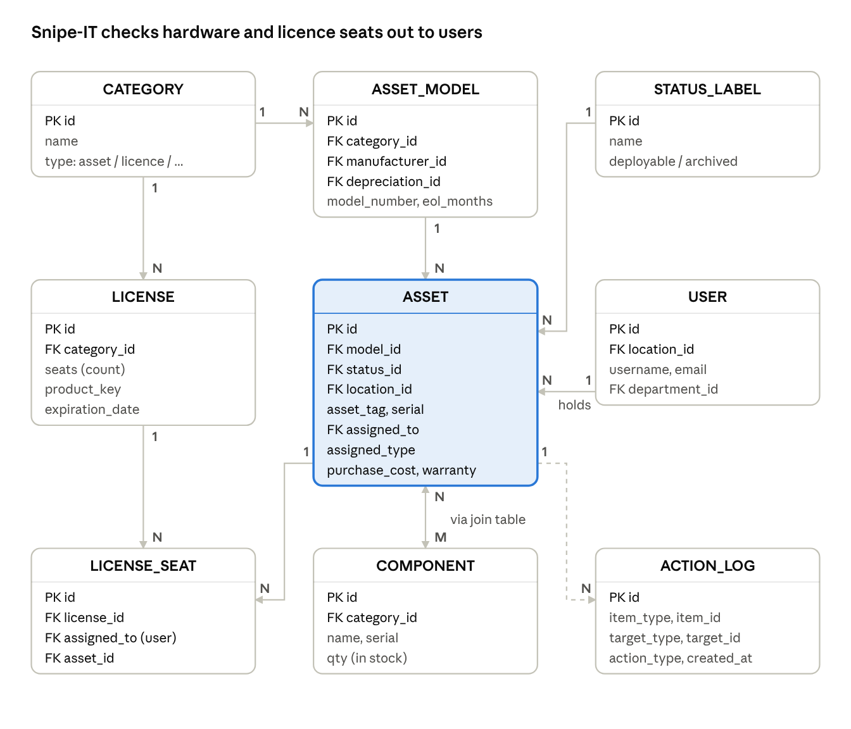
Figure 4. ITAM ERD, Snipe-IT schema, 9 tables
assigned_to + assigned_type is a polymorphic link, so an asset can be checked out to a user, a location or another asset. ASSET and COMPONENT are many-to-many through the components_assets join table. ACTION_LOG is a polymorphic audit trail that covers every item type.

Enterprise ITAM (ServiceNow)
ServiceNow stores each device twice. alm_asset is the financial record: cost, contract, owner, stockroom. cmdb_ci is the operational record: discovered attributes and dependencies. The two are linked 1:1 and kept in sync.
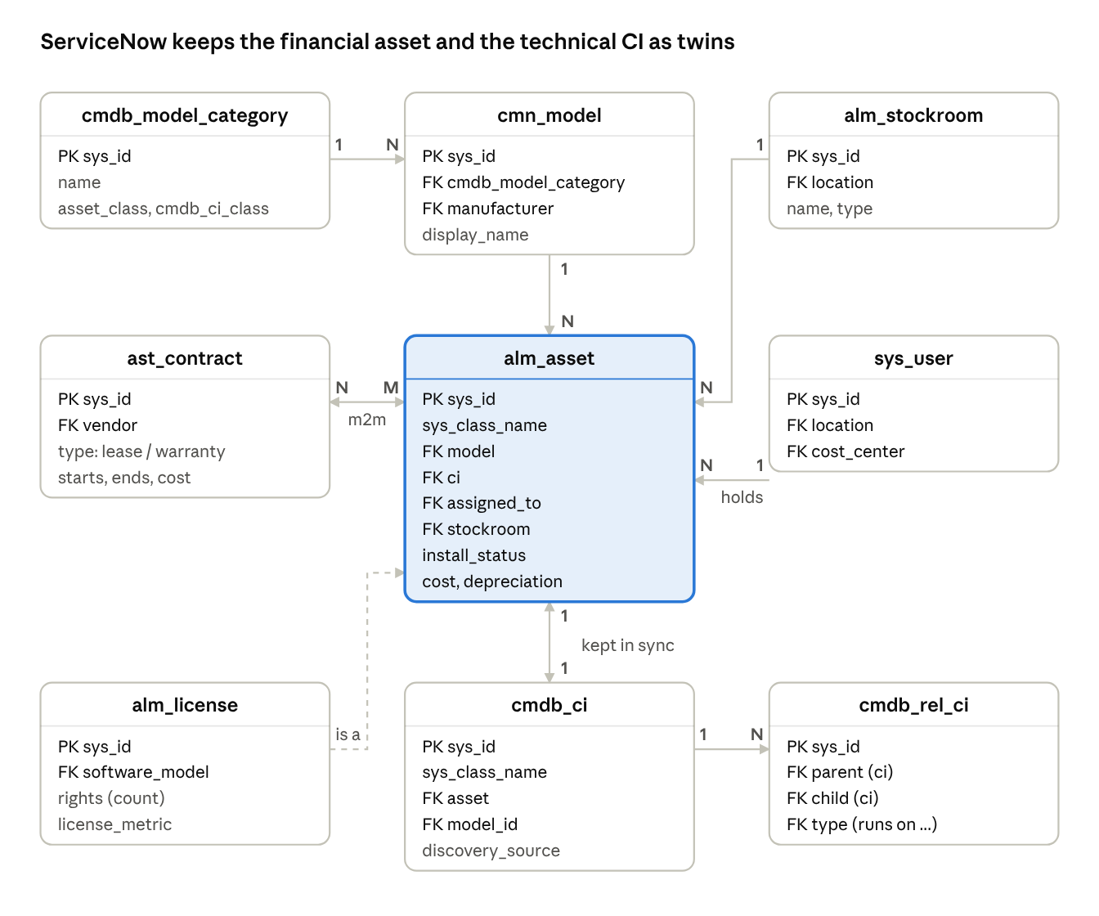
Figure 5. Enterprise ITAM ERD, ServiceNow tables
Both tables are roots of class hierarchies (sys_class_name). alm_hardware and alm_consumable extend alm_asset, and alm_license is the licence subclass. Contracts link to assets many-to-many through clm_m2m_contract_asset. Software installs are matched against entitlements to compute compliance.

CMMS and EAM (Maximo, UpKeep, Limble)
Maintenance systems nest ASSET in a parent–child tree and centre all activity on the WORK_ORDER. A PM_SCHEDULE, triggered by calendar time or by a meter reading, generates work orders automatically.
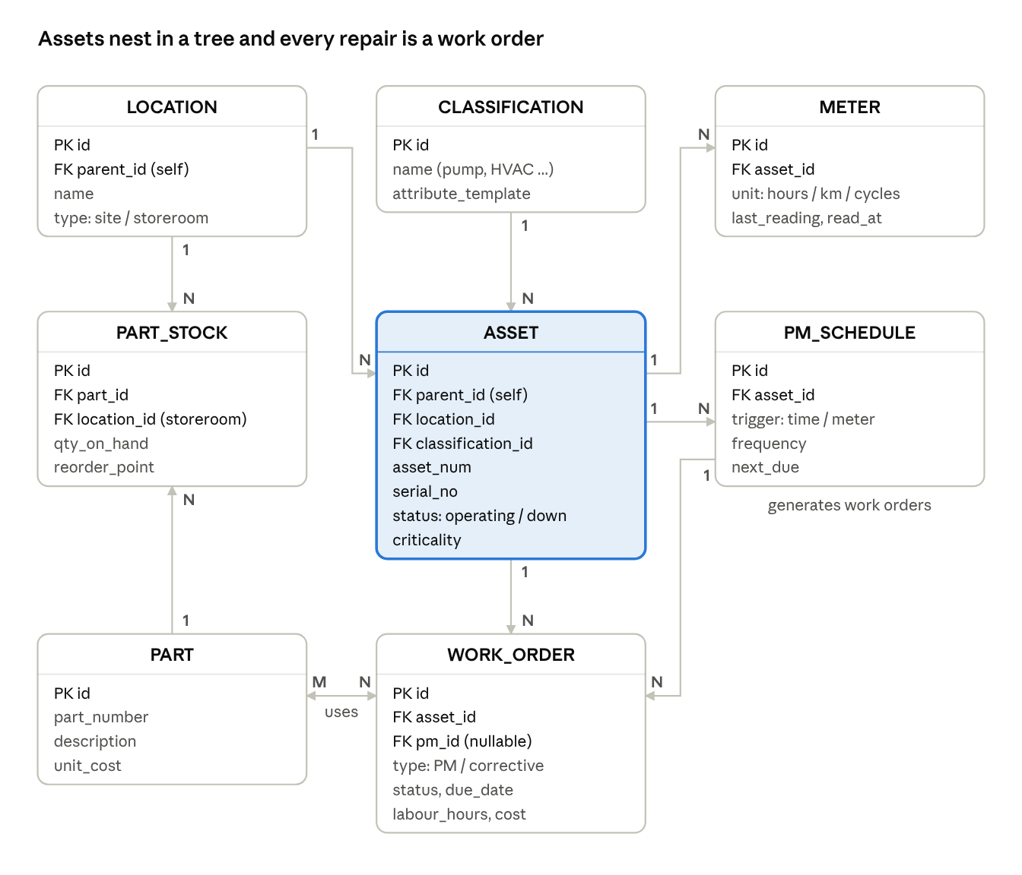
Figure 6. CMMS / EAM ERD, Maximo / UpKeep style, 8 tables
Work orders consume PART rows held in storerooms (PART_STOCK), many-to-many through a work-order-parts line table. Maximo also keeps LOCATION as its own tree, separate from the ASSET tree, so a pump can be swapped out without losing the history of its position.

Unified schema (reference model)
Nine tables are enough to run stock, assets and licences in one product. product.kind decides the behaviour. stock_move is the only table that changes quantities, and event is the only table that records what happens to a single unit.
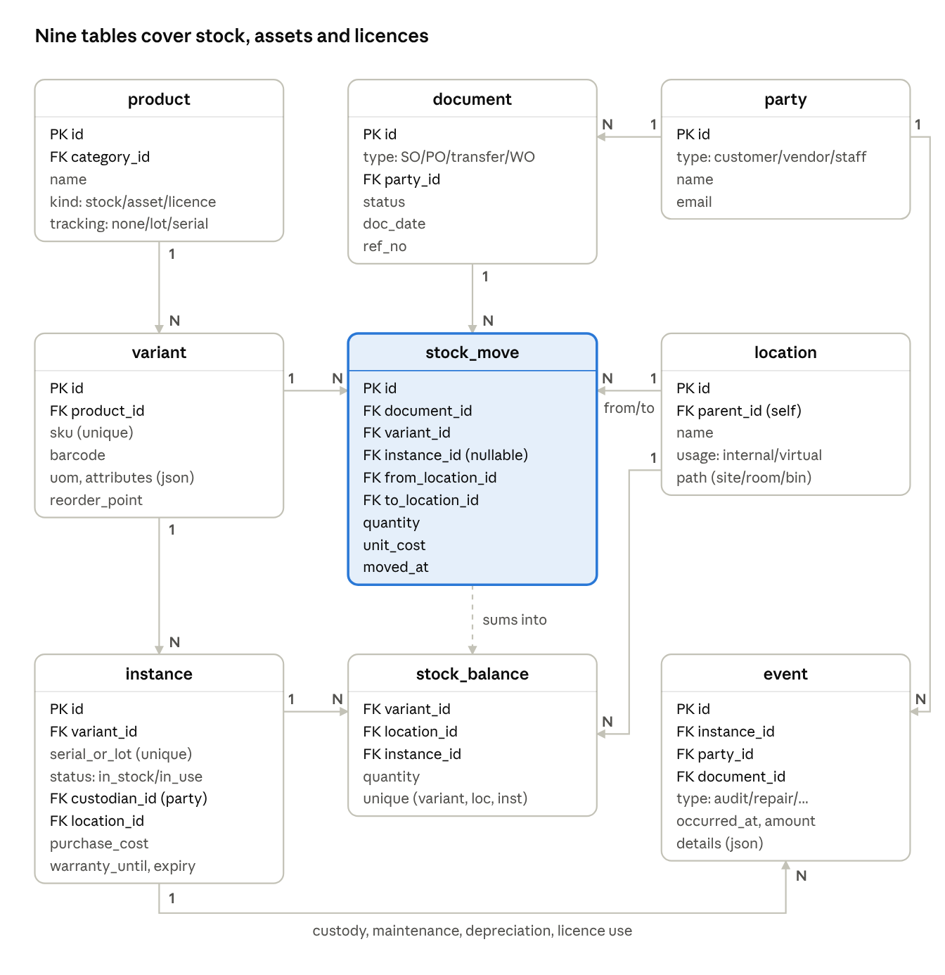
Figure 7. Unified schema ERD, 9 tables plus category
- Stock and consumables: tracking = none or lot. They live in stock_move and stock_balance only.
- Assets: tracking = serial. Each unit is an instance, and its custody and upkeep are event rows.
- Licences: kind = licence. Each entitlement is an instance with a seat quantity, and each assignment is a licence_use event.
PostgreSQL DDL
-- Enumerations
CREATE TYPE product_kind AS ENUM ('stock', 'consumable', 'asset', 'licence');
CREATE TYPE tracking_mode AS ENUM ('none', 'lot', 'serial');
CREATE TYPE party_type AS ENUM ('customer', 'vendor', 'employee', 'department');
CREATE TYPE location_usage AS ENUM ('internal', 'vendor', 'customer', 'scrap', 'transit', 'adjustment');
CREATE TYPE document_type AS ENUM ('sales_order', 'purchase_order', 'transfer', 'work_order', 'checkout', 'adjustment');
CREATE TYPE instance_status AS ENUM ('in_stock', 'in_use', 'in_repair', 'retired', 'disposed');
CREATE TYPE event_type AS ENUM ('checkout', 'checkin', 'audit', 'repair', 'maintenance', 'depreciation', 'licence_use', 'disposal');

-- Master data
CREATE TABLE category (
id bigserial PRIMARY KEY,
parent_id bigint REFERENCES category(id),
name text NOT NULL
);

CREATE TABLE product (
id bigserial PRIMARY KEY,
category_id bigint REFERENCES category(id),
name text NOT NULL,
kind product_kind NOT NULL,
tracking tracking_mode NOT NULL DEFAULT 'none',
depreciation_months int, -- assets only
CHECK (kind <> 'asset' OR tracking = 'serial')
);

CREATE TABLE variant (
id bigserial PRIMARY KEY,
product_id bigint NOT NULL REFERENCES product(id),
sku text NOT NULL UNIQUE,
barcode text,
uom text NOT NULL DEFAULT 'unit',
attributes jsonb NOT NULL DEFAULT '{}', -- size, colour ...
reorder_point numeric(14,3)
);

CREATE TABLE party (
id bigserial PRIMARY KEY,
type party_type NOT NULL,
name text NOT NULL,
email text
);

CREATE TABLE location (
id bigserial PRIMARY KEY,
parent_id bigint REFERENCES location(id),
name text NOT NULL,
usage location_usage NOT NULL DEFAULT 'internal',
path text NOT NULL -- e.g. 'HQ/Store/Bin-A3'
);

CREATE TABLE instance (
id bigserial PRIMARY KEY,
variant_id bigint NOT NULL REFERENCES variant(id),
serial_or_lot text NOT NULL,
status instance_status NOT NULL DEFAULT 'in_stock',
custodian_id bigint REFERENCES party(id),
location_id bigint REFERENCES location(id),
purchase_cost numeric(14,2),
warranty_until date,
expiry_date date,
UNIQUE (variant_id, serial_or_lot)
);

-- Transactions
CREATE TABLE document (
id bigserial PRIMARY KEY,
type document_type NOT NULL,
party_id bigint REFERENCES party(id),
status text NOT NULL DEFAULT 'draft',
doc_date date NOT NULL DEFAULT current_date,
ref_no text UNIQUE
);

CREATE TABLE stock_move ( -- append-only ledger
id bigserial PRIMARY KEY,
document_id bigint REFERENCES document(id),
variant_id bigint NOT NULL REFERENCES variant(id),
instance_id bigint REFERENCES instance(id),
from_location_id bigint NOT NULL REFERENCES location(id),
to_location_id bigint NOT NULL REFERENCES location(id),
quantity numeric(14,3) NOT NULL CHECK (quantity > 0),
unit_cost numeric(14,4),
moved_at timestamptz NOT NULL DEFAULT now(),
CHECK (from_location_id <> to_location_id)
);
CREATE INDEX ON stock_move (variant_id, moved_at);

CREATE TABLE stock_balance ( -- derived; maintained by trigger
variant_id bigint NOT NULL REFERENCES variant(id),
location_id bigint NOT NULL REFERENCES location(id),
instance_id bigint REFERENCES instance(id),
quantity numeric(14,3) NOT NULL DEFAULT 0,
UNIQUE NULLS NOT DISTINCT (variant_id, location_id, instance_id)
);

CREATE TABLE event ( -- append-only history
id bigserial PRIMARY KEY,
instance_id bigint NOT NULL REFERENCES instance(id),
type event_type NOT NULL,
party_id bigint REFERENCES party(id),
document_id bigint REFERENCES document(id),
occurred_at timestamptz NOT NULL DEFAULT now(),
amount numeric(14,2), -- repair cost, depreciation ...
details jsonb NOT NULL DEFAULT '{}'
);
CREATE INDEX ON event (instance_id, occurred_at);
The stock_balance table can be rebuilt at any time from the ledger: sum quantity into to_location_id and subtract it from from_location_id, grouped by variant, location and instance. Keep it as a trigger-maintained table for fast reads, or as a materialised view while volumes are small. UNIQUE NULLS NOT DISTINCT needs PostgreSQL 15 or later. The SQL has not been run against a database; test it before building on it.

Part 4. Gap analysis of assets-erd_1

Summary
The uploaded ERD (assets-erd_1) has 19 entities and 33 relationships. It already covers asset identity, check-out, maintenance logs, an append-only stock ledger and bills of materials (BOM). Compared with the apps in this report, it is missing 17 entities. Five gaps block core inventory work and should be built first:
- Location / Bin and a per-location stock balance. StockMovement has no location, so quantity_on_hand is one global number and stock cannot be split across sites or bins.
- Stock Transfer. Moving stock or assets between sites overwrites current_site_id, so no history is kept.
- Vendor / Party. Vendors are free text on AssetInvoice, so there is no supplier master for purchasing, warranty claims or spend reports.
- Stock Count / Audit. There is no physical-count or asset-audit session. Only a raw adjust movement exists.
- Lot / Batch. Quantity items cannot carry batch numbers or expiry dates.
The remaining gaps are finance (depreciation, disposal, contracts), operations (reservations, maintenance plans, meters, documents) and optional IT asset management (licences).

What the ERD already has
Area | Entities in assets-erd_1 | Compared with the market
Tenancy and access | Organization, User, AssetManagerGrant, SavedAssetFilter | Multi-tenant with grant history; on par with Snipe-IT companies
Catalogue and identity | AssetType (forkable, JSON attribute schema, lifecycle states), AssetSequence (prefix + padding IDs), Asset | Flexible like Freshservice asset types; auto-numbering matches EZOfficeInventory and Snipe-IT
Place and project | Site (site / warehouse), Project, Task | Site is flat; Project and Task links are rare in competitors
Custody | AssetAssignment (check-out / check-in, quantity, linked movements) | Good: keeps history and handles partial quantities
Upkeep | MaintenanceLog (scheduled / repair / inspection, cost, next_due) | Basic; no plan or work-order layer
Stock | StockMovement (signed, append-only, source document link, opening balance flag) | Ledger-first like ERPNext, but without locations
Manufacturing | Bom, BomLine, BomLineAlternate, BomBuild | Ahead of every asset tool: alternates and costed builds match Fishbowl and Cin7
Documents | AssetImage, AssetInvoice | One photo and one invoice per asset (1:1)
Finance (as fields) | purchase_value, current_value, landed_cost, GST tax fields (CGST_SGST / IGST) | India GST fields and landed cost are strengths; no depreciation logic

One Asset table holds both serialised units (tracking_mode = single) and quantity stock (quantity), flagged by is_catalog_part. That mirrors EZOfficeInventory's mix of assets and stock in one app.

Missing entities to build
Seventeen entities found in comparable apps have no counterpart in assets-erd_1. Priority reflects how much core inventory and asset work each one blocks.
# | Entity to build | Gap it closes | Seen in | Links to (existing) | Priority
1 | Location (bin / shelf tree under Site) | Asset.location is a free-text string, so bins cannot be counted, searched or validated | Odoo, inFlow, Cin7, Maximo | Site (parent), Asset, StockMovement | P1 – build first
2 | StockBalance (asset + location + lot) | StockMovement has no location, so quantity_on_hand is one global total and per-site stock is impossible | Odoo stock.quant, ERPNext Bin, Zoho | Asset, Location, Lot | P1 – build first
3 | StockTransfer + TransferLine | Moving between sites overwrites current_site_id with no record of who moved what, when | Zoho, inFlow, Cin7, NetSuite | Site, Location, StockMovement (two legs), User | P1 – build first
4 | Party (vendor, manufacturer, customer) | AssetInvoice.vendor is free text; no supplier master for purchasing, warranty claims or spend reports | Every app surveyed | Asset, AssetInvoice, Contract, Lot | P1 – build first
5 | StockCount / AuditSession + AuditLine | No cycle count or asset audit; only a raw adjust movement without expected-vs-found | EZOfficeInventory, inFlow, Odoo, Asset Panda | Site, Location, Asset, StockMovement (variance) | P1 – build first
6 | Lot / Batch | Quantity items cannot carry batch numbers, expiry or recall traceability | Fishbowl, Cin7, Odoo, ERPNext | Asset, StockMovement, StockBalance | P1 – build first
7 | AssetModel (product master) | Serialised units of one model repeat name, manufacturer, cost and specs on every row | Snipe-IT, ServiceNow, Odoo | AssetType, Party (manufacturer), Asset | P2 – next
8 | DepreciationSchedule + DepreciationEntry | current_value is a typed number with no method, useful life or posting history | Asset Panda, EZOfficeInventory, NetSuite, ERPNext | Asset, AssetType | P2 – next
9 | Disposal | Retirement is only a status string; no sale price, method, approval or write-off record | ERPNext, ServiceNow, Maximo | Asset, Party (buyer), User (approver) | P2 – next
10 | Contract (warranty, AMC, lease, insurance) | No warranty end dates or service contracts, so no expiry alerts or claim tracking | ServiceNow, Freshservice, EZOfficeInventory | Asset (many-to-many), Party | P2 – next
11 | Reservation | Assets cannot be booked ahead; AssetAssignment only records actual check-outs | EZOfficeInventory, Reftab | Asset, User, Project | P2 – next
12 | MaintenancePlan (preventive schedule) | next_due sits on each log row; no recurring plan that generates the next job | UpKeep, Limble, Maximo, EZOfficeInventory | Asset, AssetType, MaintenanceLog, Task | P2 – next
13 | Attachment (1:N, typed) | AssetImage and AssetInvoice are 1:1, so only one photo and one invoice per asset; no manuals or certificates | Snipe-IT, Asset Panda, Freshservice | Asset, MaintenanceLog, Contract | P2 – next
14 | AssetEvent / ActivityLog | Changes to status, value, site or custodian on Asset are overwritten, with no field-level history | Snipe-IT action log, ServiceNow audit, Asset Panda actions | Asset, User | P2 – next
15 | Department / CostCenter | Assets can only be held by a person; no department ownership or cost allocation | ServiceNow, Freshservice, ManageEngine | Asset, AssetAssignment, User | P2 – next
16 | Meter + MeterReading | No usage-based maintenance (hours, km, cycles) | Maximo, UpKeep, Limble | Asset, MaintenancePlan | P3 – optional
17 | Licence + LicenceSeat | No software licences or seat assignment; needed only if IT assets are in scope | Snipe-IT, ServiceNow, Flexera | AssetType, Asset, User | P3 – optional

The ledger already points at an outside procurement module (StockMovement.source_kind / source_id, for example a goods-receipt line). If PurchaseOrder and GoodsReceipt do not exist in that module, add them as well; they are not counted above.

Fields to add or change on existing entities
Entity | Change | Why
StockMovement | Add location_id (or from_location_id + to_location_id) and lot_id; add transfer and return to kind | Makes the ledger location-aware so StockBalance can be derived per site and bin
Asset | Replace location string with location_id FK; add asset_model_id, vendor_id, barcode / rfid_tag, warranty_until | Validated places, a shared model master, a supplier link and scannable identifiers
Asset | Move quantity_on_hand to StockBalance, or keep it only as a cache rebuilt from the ledger | One global quantity cannot show stock per site
Asset | Make status an enum (or FK to AssetType lifecycle_states) | Free-text status breaks filters and reports
AssetAssignment | Add assignee_type (user / department / site / asset) | Lets assets be issued to a team, a site or a parent asset, as Snipe-IT does
AssetInvoice | Replace free-text vendor with vendor_id FK to Party; allow many invoices per asset | Spend by vendor, and invoices for repairs and upgrades
MaintenanceLog | Add plan_id (FK to MaintenancePlan), status and vendor_id | Separates planned from completed work and records outside service providers
Site | Add parent_id (region > site) and timezone | Multi-region roll-ups
AssetType | Add default_depreciation_method and useful_life_months | Depreciation defaults per type

Where the build-first entities attach
The five build-first gaps share one fix. Give every StockMovement a location and an optional lot, then derive StockBalance from the ledger. Transfers and counts then become ordinary movements.
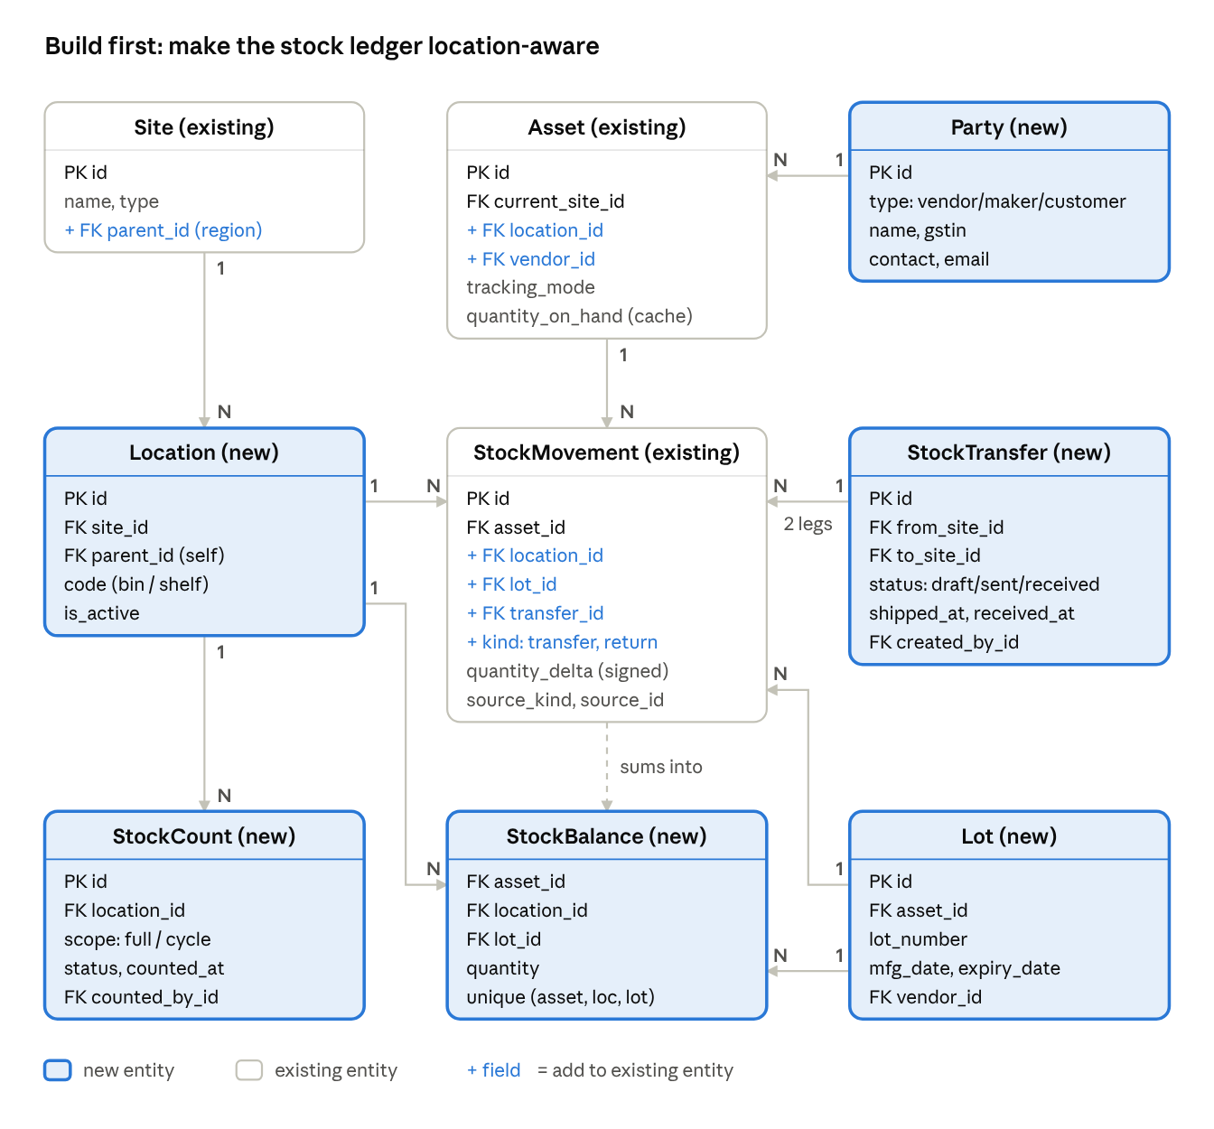
Figure 8. Proposed P1 additions to assets-erd_1
A StockTransfer posts two movements: out of the source location and into the destination. A StockCount compares counted quantities with StockBalance and posts the differences as adjust movements; add an AuditLine table (expected, counted, variance) under it. Party replaces the free-text vendor on Asset and AssetInvoice. Keep Asset.quantity_on_hand only as a cache of the StockBalance total.

Target data model: existing + to build
The target model has 42 entities: the 19 in assets-erd_1 plus 23 new tables. The 23 are the 17 missing entities and 6 child tables (transfer lines, count lines, depreciation entries, contract–asset links, meter readings, licence seats).
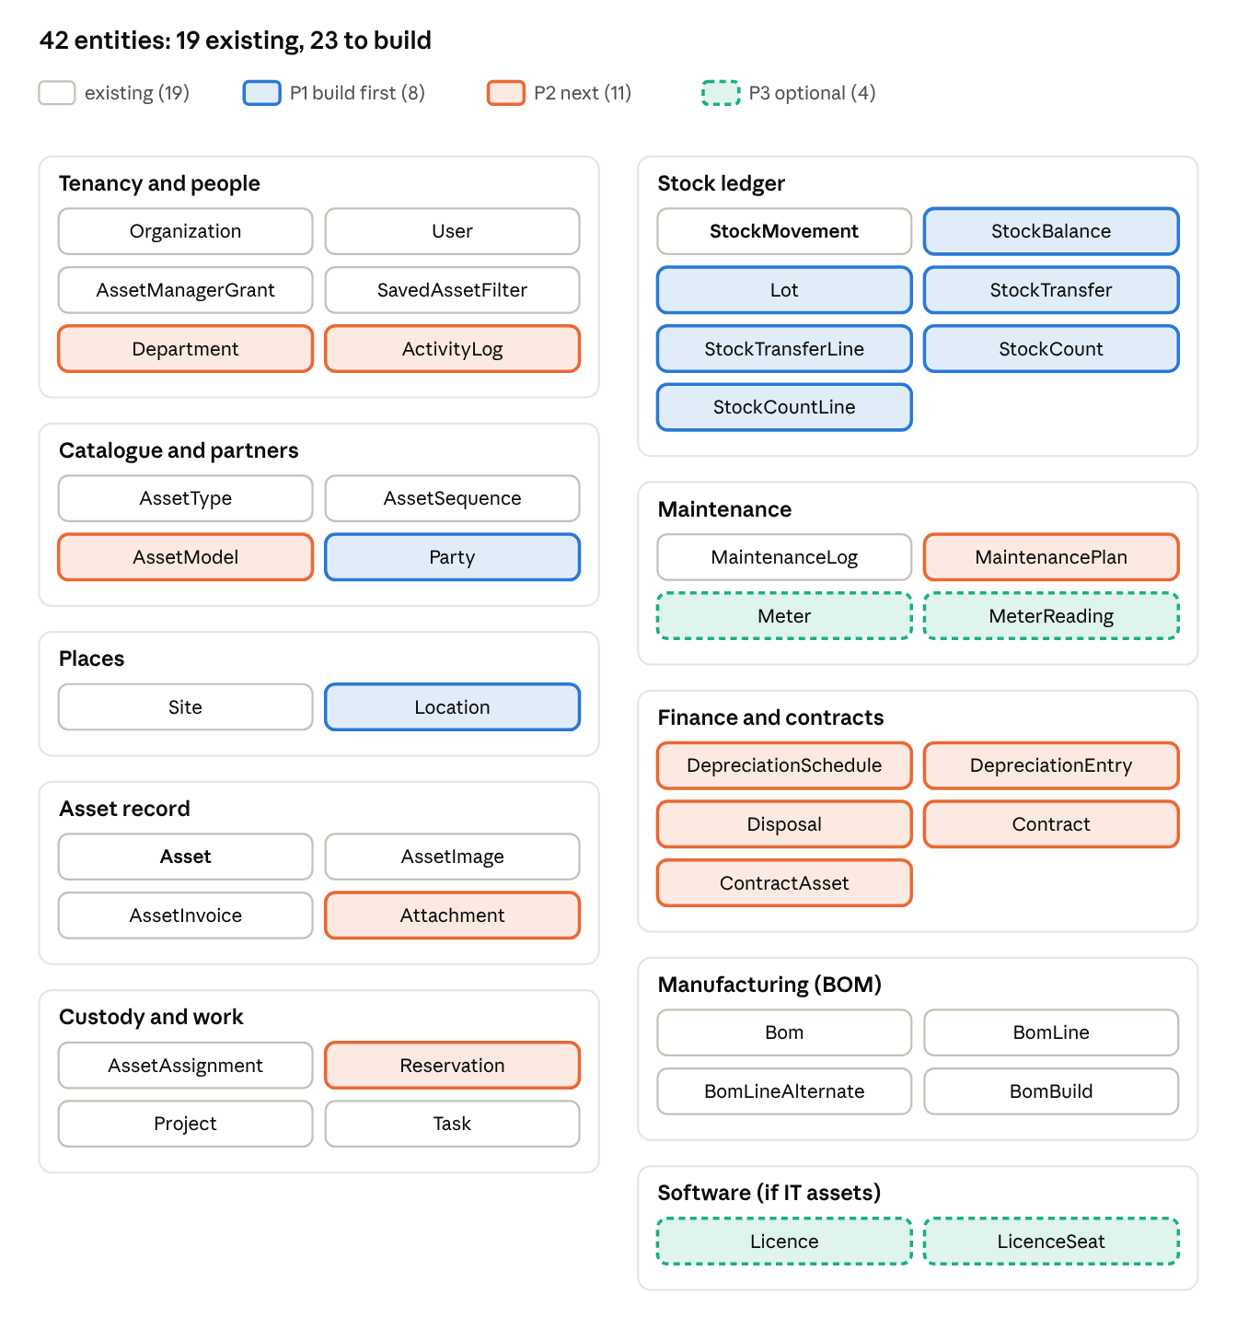
Figure 9. Target data model, 42 entities grouped by domain
The full entity diagram, with every column and all 89 relationships, follows on the next page. New columns on existing tables carry a comment starting with NEW. The diagram files (Mermaid source, SVG and full-resolution PNG) are in the repository under research/assets-erd-full.* on branch claude/funny-ride-acbkua.

Full entity diagram: 42 entities, 89 relationships
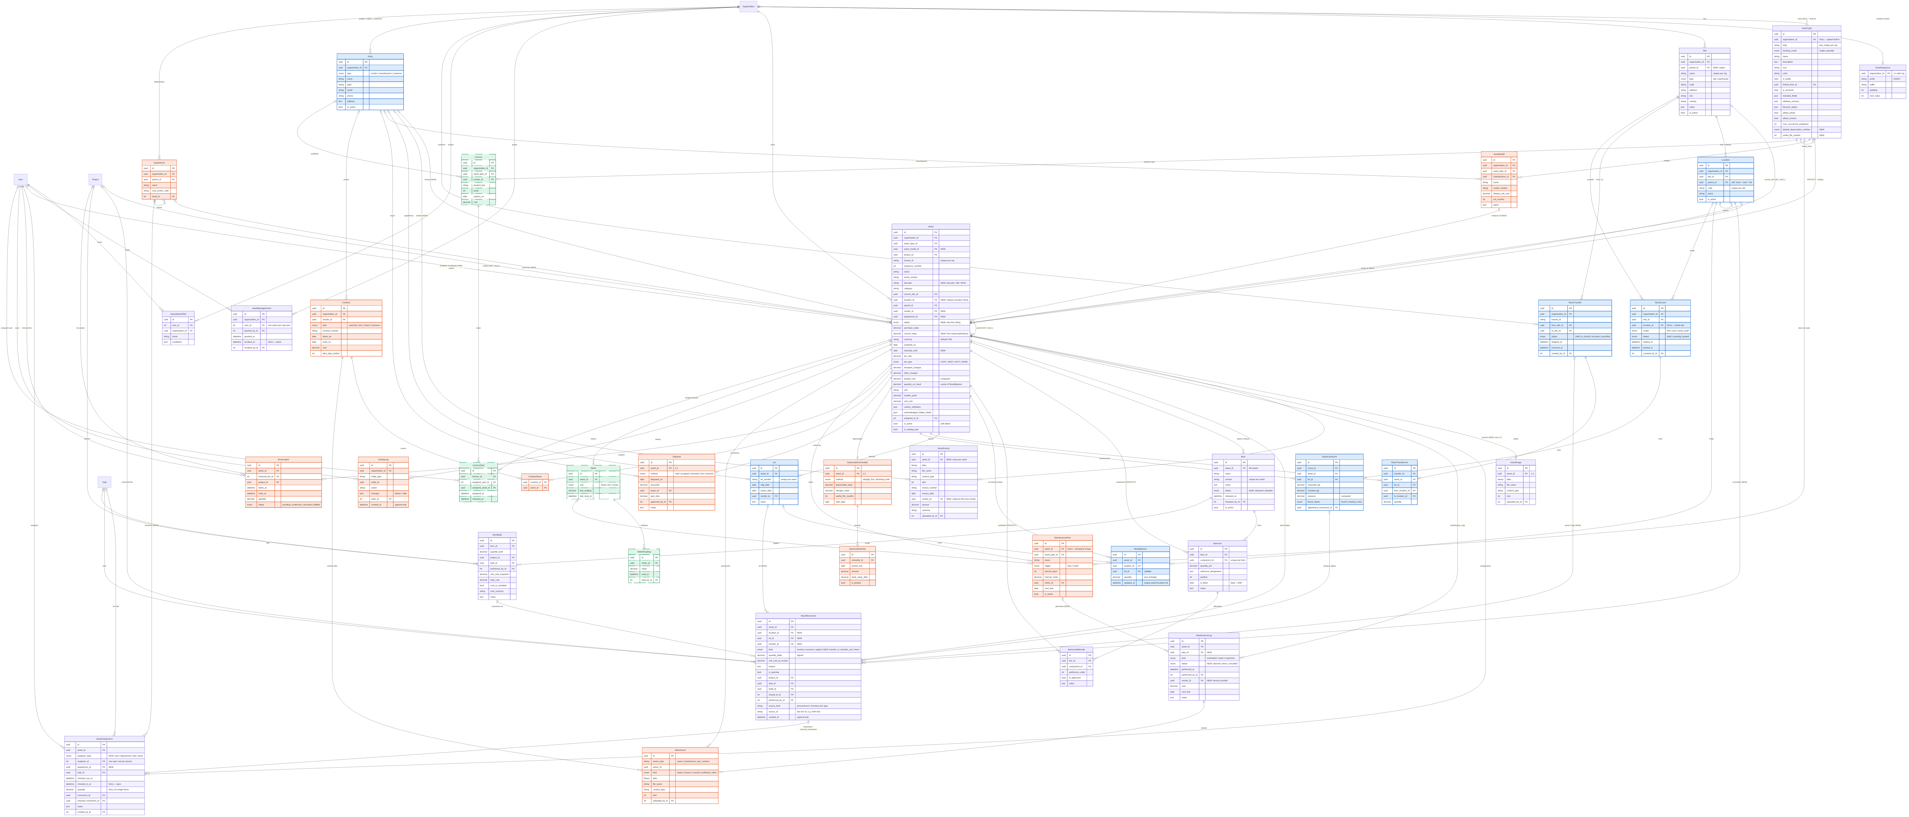
Figure 10. Full target ERD. Blue: P1 build first; orange: P2 next; green dashed: P3 optional; purple: existing. Zoom in to read columns.

Sources
- Software Advice – Inventory Management 2026
- CostBench – Inventory Management Pricing 2026
- CostBench – Best for Small Business
- CostBench – Sortly Pricing 2026
- inFlow – Top 10 inventory software compared
- Fortune Business Insights / Future Market Insights – Inventory software market
- Technavio – Inventory management market
- MarketsandMarkets – Asset Management System Market
- InvGate – 15 Best ITAM Software 2026
- Virima – Best ITAM Tools 2026
- Asset Panda – Best ITAM Software 2026
- Rework – Asset Panda vs EZOfficeInventory 2026
- Capterra – Asset Panda
- Snipe-IT pricing · Desk365 – Snipe-IT pricing
- Ecosire – Odoo vs Zoho Inventory 2026
Prices are third-party-reported, in USD, and billing terms (monthly or annual, per user or flat) vary. India-focused products and enterprise tools are quote-based or priced locally.

