**TEXT TO HANDWRITTING GENERATOR**

**Activity 2 & 3**

**T&T Lab ( AJAY ANAND )**

**Kalinga Institute of Industrial technology**

*1805120 - Divya Shiv Pandey*

*1805 -*

*1805 -*

*1805 -*

# Project initially by:- Rituraj Dutta

GitHub:- <https://github.com/Rituraj-commits/txttohandwritting>

**Introduction**

For an adult population (age range 18–60) the average speed of copying is 40 letters per minute[1] meanwhile a average person types at 190 letters per minute[2]. That is more than 4 times the speed so why write when u can type? Some paper works require document to be handwritten only where this python script could be quite handy.

Text to hand writing generator is a python script which converts text to handwriting. It is a black box that takes .txt file as input and outputs a PDF file with text converted to handwriting.

**Working**

To convert text to handwriting it has pre written letters, numbers and characters cropped as small png to create a dateset, reads the text and starts placing these letters accordingly on a blank white background. But before that all the text in the text is parsed into Pages then Words then letters.

All these letters are send to a function which takes letters as input and throws handwritten image as output.

It has various dependencies like PILLOW, FPDF and runs on Python 3.6 or above.

**Drawbacks with current model**

There are various problems with the current code like:

* It fails to print Capital Letters as handwritten and skips them.
* The output file doesn't look even close to a handwritten document rather a computer generated one.
* No GUI available.
* Output file has improper writing format and page parsing doesn't fit well so it ends up cutting lines.
* Uncertainty of a human hand aspect is missing from the project.
* No option of adding own handwriting.
* No feature to copy another printed document into handwriting.

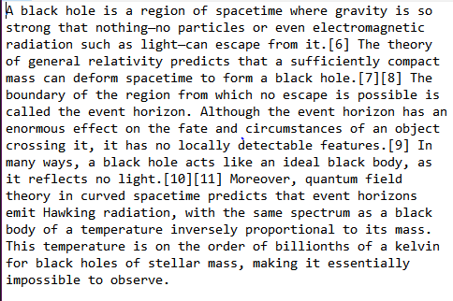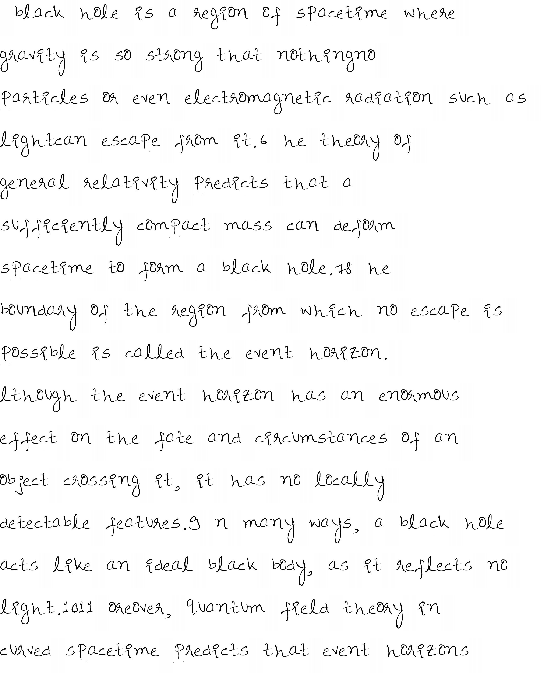

**Our Solutions**

Their are a lot of aspects that can be improved in the python script:

* Proper page parsing is required with fine tuning of the whole code. Script should be updated to run on python 3.8 or above.
* Good arrangement of text on blank page with all characters being printed. This will be done by a better page parsing function and pre planning before placing letters.
* Writing style should be made match to that of humans. A random space and styling technique can be added using python's by default RANDOM lib.

Further this program can be extended with features like:

* Designing and attaching a GUI to make it use-able to end user.Commonly used library for this is Tkinter.
* Own handwriting can be added to make it write in the same. Text recognition model can be used to crop and label each letter and store in in the data set folder.
* Program should choose a letter by random from a pool of 4 sets of a particular letter. This will add randomization.
* It should be able to read a PDF or printed text document and convert it to handwriting. A machine learning text recognition model can be used to extract text from the page and then feed it to the program.

**Future Works**

Further more this project can be shifted to more easy access platforms. This program will be of great use as it enable students and to work efficiently and save time with paper works. This program can also be used to add a crisp to Story books.   
Also, Machine learning can be used to generate the handwriting and make it undistinguished from that of human hand.

**Acknowledgment**

1: writing speed: <https://en.wikipedia.org/wiki/Words_per_minute>

2: Typing speed: <https://www.daytranslations.com/blog/improve-typing-skills/>