Low Level Design (LLD)

FLIGHT FARE PREDICITONS

# Document Version Control

|  |  |  |  |
| --- | --- | --- | --- |
| Date Issued | Version | Description | Author |
| 24/07/2023 | 1 | Initial LLD – V1.0 | Divya  Lakshmi |
| 25/07/2023 | 2 | Updated – Architecture - V1.1 | Divya Lakshmi |
|  |  |  |  |
|  |  |  |  |
|  |  |  |  |
|  |  |  |  |
|  |  |  |  |

## Contents

1. Introduction 4
   1. What is Low-Level design document? 4
   2. Scope 4
2. Architecture 5
3. Architecture Description 5
   1. Data Description 6
   2. Data Transformation 6
   3. Data Insertion into Database 6
   4. Export Data from Database 6
   5. Data Pre-processing 6
   6. Model Building 6
   7. Data from User 6
   8. Data Validation 6
   9. User Data Inserting into Database 7
   10. Model Call 7
   11. Saving Output in Database 7
   12. Deployment 7
4. Introduction
   1. What is Low-Level design document?

The goal of LLD or a low-level design document (LLDD) is to give the internal logical design of the actual program code for Food Recommendation System. LLD describes the class diagrams with the methods and relations between classes and program specs. It describes the modules so that the programmer can directly code the program from the document.

* 1. Scope

Low-level design (LLD) is a component-level design process that follows a step-by-step refinement process. This process can be used for designing data structures, required software architecture, source code and ultimately, performance algorithms. Overall, the data organization may be defined during requirement analysis and then refined during data design work

# Architecture

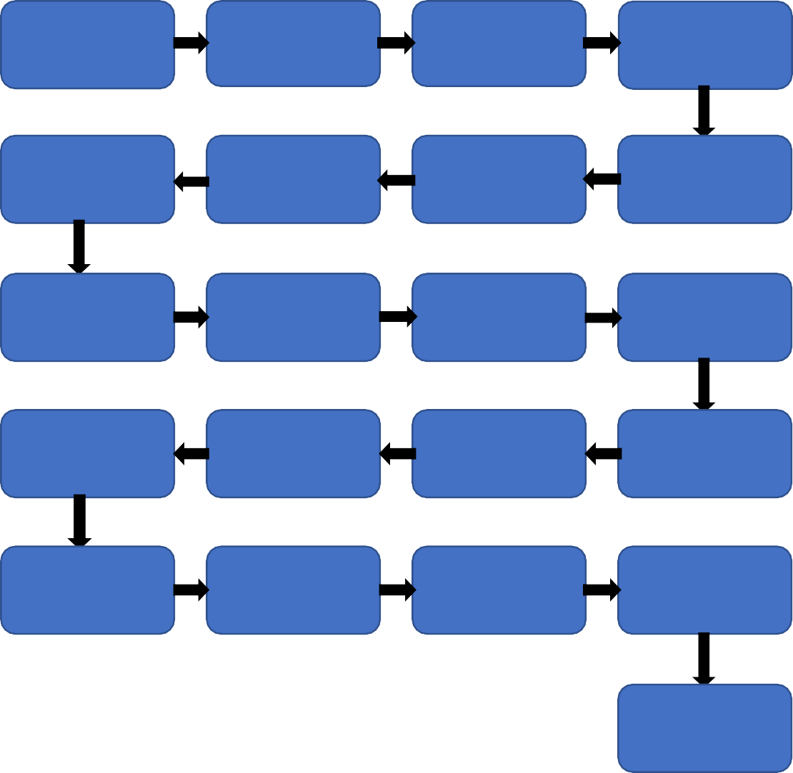

Start

Data for

Recommendation

Web

Scrapping

Data

Transformation

NLP Techniques

Data

Preprocessing

Export Data

from Database

Data Insertion

Into Databases

Data Clustering

Model Building

Cloud Setup

Pushing app to

cloud

Data Insertion

into Database

Data Validation

Data from User

Application

Start

Data Clustering

Model Call for

Specific Cluster

Recipe

Recommendation

Saving Output

at Database

End

# Architecture Description

# Data Description

# The dataset consists of 10000+ rows and 11 columns. The dataset is available in xlsx format and has various features which impacts the price of the flights

# Data Insertion into Database

1. Database Creation and connection - Create a database with name passed. If the database is already created, open the connection to the database.
2. Table creation in the database.
3. Insertion of files in the table
   1. Export Data from Database

Data Export from Database - The data in a stored database is exported as a CSV file to be used for Data Pre-processing and Model Training.

* 1. Data Pre-processing

In Data pre-processing we use handling missing values, handling outliers, data type of features, handling datetime, categorical features, standardization, and onehotencoder

* 1. Model Building

Machine Learning models are passed with best parameters derived from Gridsearch CV . Best model is selected based on their performance metrics such as R2score, MSE, MAE, Adjusted R2 score, RMSE. The best model is than saved for further use.

* 1. Data from User

Here we will collect data from user such as Airline, Date of Journey, Source, Destination, Route, Departure Time, Arrival Time, Duration, Total Stops, and Additional Info

* 1. Data Validation

We will perform data validation for the data provided by the user.

* 1. User data insertion in Database

Collecting the data from the user and storing it into the database

* 1. Model Call

The model will be loaded to predict the flight fare under various circumstances provided by the user.

* 1. Saving Output in Database

The output will be saved in Database and it will be used to show the same Output if other users provide the same data.

## Deployment

We will be deploying the model to Azure.