SYSTEM ARCHITECTURE · 2 SEPTEMBER 2026
How Preckon is built
A construction intelligence platform: five deployable planes, 83 tables, a nine-stage preconstruction chain, and one rule that decides where every number comes from. Written from the running system, not from intent.
PLANES  host · tenant · worker · cad · desktop | SURFACE  91 API routes · 188 modules | EVIDENCE  77 test files · 28 migrations

THE SPINE
Two rules the whole system turns on
Almost every structural decision below follows from these. They are worth stating before any diagram, because they explain the shape of the data model, the trust boundary, and the reason the AI worker is deliberately starved of everything except an API key.
RULE ONE  A model proposes. Arithmetic decides.  Anything a quantity surveyor could be asked to defend in a meeting — a critical path, a priced total, a measured area — is computed by deterministic code from stated inputs. The model reads documents and drafts structure. It never nominates the answer to a question that has a calculable one. | RULE TWO  A model never writes production state.  AI output lands as a proposal, in its own row, in its own status. Only a human action moves it into project data. Undo is not the same thing as consent, and the ten drawing tools a model may call are all read-only — it can measure and count, and cannot draw.

DEPLOYMENT
Five planes, one deliberately starved
The platform splits into five deployable pieces. Four are ordinary web or service processes. The fifth — the AI worker — has no database access, no filesystem state, and zero npm dependencies. It is Node builtins and nothing else.
That is a trust boundary rather than an aesthetic. The worker is the process that talks to an external model provider, so it carries the largest supply-chain surface and is the one you least want holding a database credential. Giving it no packages to compromise and no connection to steal is cheaper than auditing the alternative.
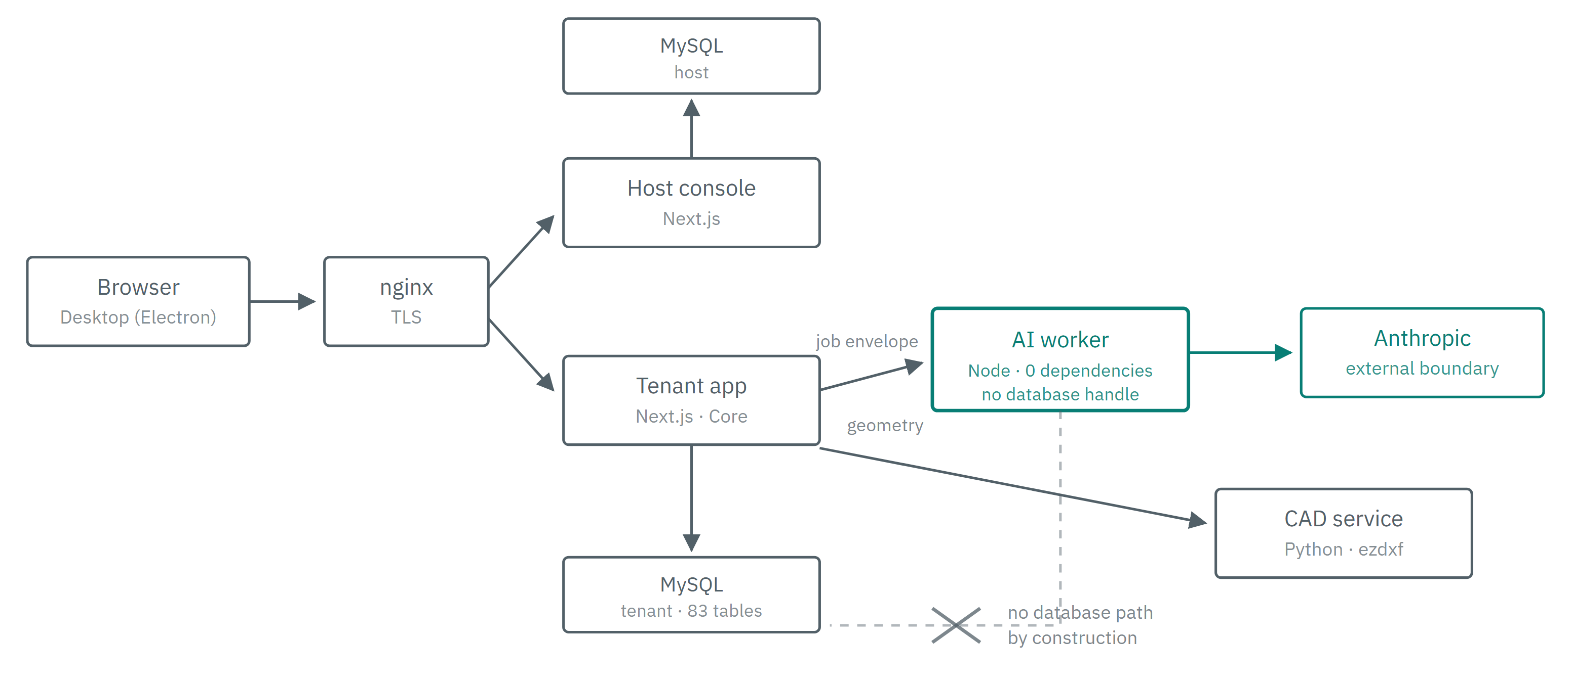
The crossed-out edge is the point. The worker holds the provider credential and reaches Anthropic; it has no route to either database, so a compromise there yields an API key and nothing else. Results return to Core in the job envelope, and Core — which owns the tenant, the project and the rate card — is what writes them down. Every plane binds to loopback; nginx is the only publicly reachable process.
The five planes, and what each is permitted to reach
PLANE | STACK | JOB | REACHES
Tenant app | Next.js 15 · React 19 | The product. Every surface, every API route, all governance logic. | MySQL, worker, cad
AI worker | Node 20, no packages | Runs agents. Holds the provider key, and nothing else. | Anthropic only
CAD service | Python · FastAPI | Reads and renders drawings: geometry, layers, blocks, dimensions. | Nothing outbound
Desktop | Electron 33 | The drawing studio, for people who work in CAD all day. | Tenant app
Host plane | Next.js 15 | Tenant provisioning, entitlements, licensing. | MySQL

THE PRODUCT
A nine-stage preconstruction chain
A project's tab bar is the chain. Each stage is a licensed module that consumes the stages before it and produces artifacts the stages after it depend on. An edition without CostLogix simply has no Estimate stage — the chain is derived from entitlements, never from a hardcoded list.
The column that matters is the third one. It records where the boundary between generated and computed falls, stage by stage.
Drafted by a model · computed by an engine and defensible in a meeting
STAGE | WHAT THE MODEL DRAFTS | WHAT ARITHMETIC DECIDES
Tender | Requirement register traced to clause; bid qualification; clarifications | Deadline arithmetic; completeness against the register
Drawings | Sheet index; takeoff proposals per element | All geometry. Areas, lengths, block counts and dimensions come from the DXF via ten read-only tools
Specs | Classification of a mixed pack; specification clauses with citations | Revision supersession; retention; transmittal numbering
BOQ | Line descriptions, trade grouping, unit selection | Quantities. Nine canonical units — a model's spelling is mapped, never trusted
Estimate | Rate reasoning and assembly selection | Every total. Extension, roll-up, margin
Schedule | Activity breakdown, sequencing logic, durations | The critical path. Four link types with lead and lag, computed from stated logic
Narrative | Technical narrative and proposal assembly | Citations; figures pulled from approved artifacts only
Procurement | Package boundaries and scope splits | Commitment arithmetic; coverage against the bill
Underwriting | Exposure and risk narrative | Pricing, limits, referral thresholds

THE CORE OBJECT
Everything is an artifact, and every artifact is answerable
A BOQ line, a requirement, a programme activity, a priced rate — all of them are rows in one artifact table with a type, a payload, a confidence, a version and a status. That uniformity is what makes one review interaction work across nine modules, and it is what makes provenance a property of the system rather than a feature of a module.
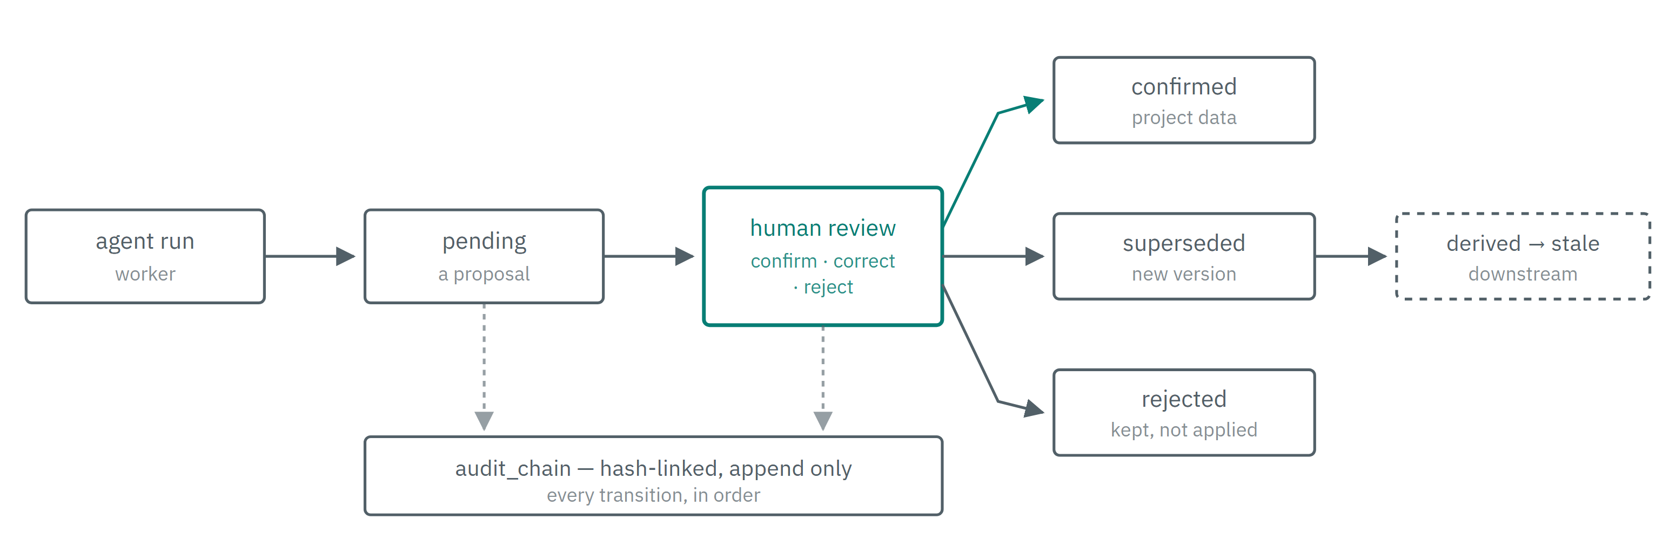
Nothing crosses into project data without the middle box. A correction supersedes rather than overwrites, and marks everything derived from it stale — so a changed quantity visibly invalidates the estimate that used it instead of silently disagreeing with it. A rejection is kept: rejecting real output is a decision, and the record of it is worth as much as an acceptance.
TABLES  83 | API ROUTES  91 | MODULES  188 | TEST FILES  77 | MIGRATIONS  28

THE AI LAYER
A fabric, not a set of prompts
No module calls a model provider. Every AI request passes through one governed path that answers four questions before a token is spent — may we, with what, at what cost, and has this been asked before — and records what happened after.
What sits on the path of every AI job
COMPONENT | QUESTION IT ANSWERS | WHERE IT LIVES
Tenant policy | May this data reach this boundary at all? Anything unclassified is treated as confidential | ai/policy.ts
Model registry | Which model does preckon-reasoning mean today, and what does it cost? Swapping a model is an UPDATE, not a deploy | ai/registry.ts
Budget | Token, cost, latency and tier ceilings. Estimated before, measured after | ai/budget.ts
Dispatch gate | Asks all three, in one place, on every job. Pure, so the whole matrix is testable without a database | ai/govern.ts
Prompt registry | Which prompt produced this output, and what changed between the run that was right and the one that was wrong | ai/prompt-store.ts
Response cache | Keyed on everything that could change the answer. Similarity alone is never enough | ai/cache.ts
Usage ledger | One row per attempt, not per job. A job that failed twice then succeeded is three rows, and the bill is the three | ai_usage_ledger

Execution classes
Every ledger row records how the work actually ran — deterministic, cache, local, preckon, external or stub. Grouping by that column rather than summing it away is what stops a stub row, which carries token counts and costs nothing, being folded in with real model calls and reporting usage that never happened.
Retrieval
Answers are grounded in indexed passages rather than whole documents. Retrieval is MySQL full-text with an identifier boost and a LIKE fallback — not a vector store, deliberately: construction questions are dominated by exact identifiers like A-201 and BOQ-CIV-001, and a literal match on those beats a passage that is merely about the same topic. Both registered document revisions and directly uploaded files are indexed, because most projects never run the formal register.
A RULE THE IMPLEMENTATION DOES NOT YET MEET
The governing specification says frontier inference is an escalation path, not the default. Eighteen of twenty-three registered task types resolve to the frontier tier, including extraction work whose brief is under 1,400 characters. This is recorded as a formal exception with an owner and an expiry rather than left as a silence, and it is not being closed by re-routing until the golden-project corpus can show whether quality held.

TENANCY AND TRUST
Isolation is stated, not inherited
MySQL has no row-level security, so there is no shared view to fall back on: every query names its tenant explicitly, and a static scan holds that line. A WHERE project_id = ? on its own reads naturally and is wrong only in what it omits — which is exactly why it is checked mechanically rather than by review.
A cross-tenant read by direct object id answers 404, not 403. A 403 confirms the id exists. The host plane is a separate identity pool from the tenant plane: staff accounts never appear in a customer workspace, and the two run as different applications against different databases.
CONTROL | HOW IT IS ENFORCED
Registration | Closed on both consoles. Neither product has a sign-up screen; the endpoint that existed by default is refused at the HTTP boundary, while in-process provisioning and invitation continue unaffected.
Throttling | Keyed per client address, read from the header nginx sets. A shared counter is worse than none — three attempts a minute across a whole firm means one script locks out every estimator.
Transport | HSTS, CSP, frame-ancestors, nosniff and Referrer-Policy on both planes. The CSP names no external script host, so an injected tag has nowhere to load from.
Exposure | Every published container port binds to 127.0.0.1. Docker writes its own iptables rules ahead of ufw, so the bind address is the control that works — a firewall rule on a published port reports success and leaves it open.
Audit | Hash-linked and append-only. Entries cannot be edited or deleted through any exposed path, and the chain verifies after a full project lifecycle.

GOVERNANCE
The specification is a repository, not a folder
The Preckon Engineering Bible holds 373 chapters across 22 volumes, each with a permanent identifier, each backed by a machine-readable quality record, all gated in CI. Its rules are the ones stated at the top of this document — AI proposes and governed commands execute; no material result loses its source or revision; deterministic engines own anything reliably computable.
Its most useful rule is procedural: material behaviour changes require specification, API, test and ADR updates together. That is what stops the specification and the running system drifting into two different products.

KNOWN GAPS
What this architecture does not yet do
Stated because an architecture document that lists only strengths is a brochure.
GAP | WHERE IT STANDS
Model routing | Frontier is the default for most task types, against the governing rule. Blocked on an evaluation corpus that scores extraction accuracy, because re-routing changes what the models return.
Prompt caching | Enabled and producing no hits. The cache breakpoint sits after a per-specialist persona, so the shared prefix is twelve characters and every call writes a fresh entry at a premium instead of reading one.
Evaluation | Retrieval and citation fidelity are scored deterministically and can gate a deploy. Extraction accuracy, BOQ completeness and schedule correctness need a golden project with known-correct answers, which does not exist yet.
Text extraction | Seven of 123 production files yield no readable text — scanned sheets bound in with vector ones. They are named rather than counted, but they need OCR.
Cost arithmetic | Cache reads and writes are priced as ordinary input tokens, so the ledger under-reports while caching is broken and would over-report the saving once it works.
Desktop parity | The Electron shell shares the drawing studio with the browser, but offline authoring and conflict resolution are not solved.

Compiled from the running system on 2 September 2026 — schema, route tree, module tree and test suite of the tenant plane, the deployed topology on the production host, and the Preckon Engineering Bible at techsmeinc/preckon-engineering-bible. Figures are counts taken from the repository, not estimates.

