Lab Procedure for Python
Play
Setup
- Hardware Preparation:
- Ensure that the QArm Mini is securely attached to the base.
- Verify that the manipulator is in the rest position.
- Confirm that the QArm Mini is connected to the PC and turn it ON (the light in the switch should be red).
- Check and update the latency setting as shown in Figure 1:
- Navigate to Device Manager > Ports
- Select the appropriate device - USB Serial Port (COMx) Make a note of the COM port Number.
- Go to Port Settings > Advanced > Latency
- Set the latency to 2 ms
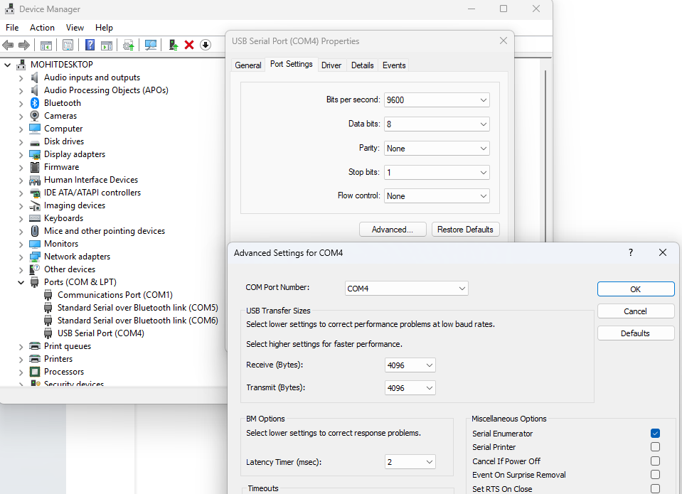
Figure 1. Latency Settings

Play
- Launch Visual Studio Code and browse to the lab directory via the File > Open Folder menu. Once in the correct directory, open play.py.
  - Update the id parameter in line 18 to match the COM port you noted during setup.
- Ensure the space around the QArm Mini is clear of any objects.
- Run the script using the button in the top-right corner.
- The manipulator starts in the home position. Note the following actions you can take.
  - Tap any of the 1 through 4 NUMBER keys on your keyboard once (not the NUMPAD keys). This selects the corresponding joint on the QArm Mini.
  - Press and hold the UP or DOWN ARROW keys to increase or decrease the selected joint’s position respectively.
  - At any point, holding the SPACE BAR will record the end-effector’s position for plotting and data logging.
Note: As the script only records points when the SPACE BAR is held, it is recommended that you try to maintain continuity in action. As such, always ensure the SPACE BAR is held before using any of the ARROW keys, and you can let the SPACE BAR go once the manipulator stops moving.
- Explore the manipular’s limits by moving it to various positions using the keyboard. Observe its range of motion.
Note: To reach the limits of some joints, you may have to maneuver other joints out of the way first.
- Starting at any position you find comfortable, hold the SPACE BAR, and move the arm joint after joint to cover the outer-most reaches of the arm’s workspace, for example, as seen in the image below.
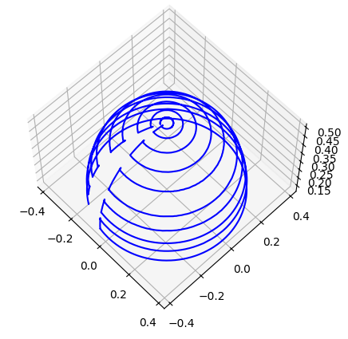
Figure 2. End Effector Positions Mapped
- When you are satisfied with the points collected, let the SPACE BAR go, and tap CTRL-C until the script outputs Received user terminate command.
The collected data is plotted for you in a 3D plot. Click and drag your mouse cursor to rotate the plot. Use the save button to save various views as image files. Make sure you record images representing the isometric view, XY planar view (from the top) as well as XZ planar view (from the left of the arm).
Close the 3D plot to complete the script.
- Repeat steps 6 and 7, but this time, limiting the motion of the arm in the vertical sagittal plane (joint 0 does not need to be moved at all).
- Turn off the arm and gently move it to its resting position (refer User Manual).

