Lab Procedure for Python
Play
Controller Introduction
A LogitechF710 wireless controller is used in the labs to control the QBot remotely. Before use, always make sure the switch on top is in the X position and that the LED next to the Mode button is off.
To be able to move the QBot, the left button (LB) will need to be pressed and held to arm the motors. Both joysticks are used to control the movement of the QBot. The A button is occasionally used to turn on and off additional features implemented in the application, such as line following. Finally, press the right button (RB) if you wish to terminate the application. Key bindings for the controller are shown in Figure 1.
Figure 1. Logitech Controller Keybindings
Setup
- It is recommended that you review Lab 1 – Application Guide before starting this lab.
- Turn on the QBot Platform by pressing the power button once. To ensure the robot is ready for the lab, check the following conditions.
  - The LEDs on the robot base should be solid red.
  - The LCD should display the battery level. It is recommended that the battery level is over $12.5$V.
  - The Logitech F710 joystick’s wireless receiver is connected to the QBot Platform as shown in Figure 2.
  - Make sure your computer is connected to the same network that the QBot Platform is on. If using the provided router, the network should be Quanser_UVS-5G.
  - Test connectivity to the QBot, using the IP displayed in the robot’s LCD display, enter the following command in your local computer terminal and hit enter: ping 192.168.2.x
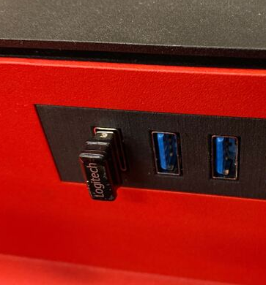
Figure 2. Controller Wireless Receiver connected to QBot Platform
Note: In steps 3 to 6, we will go through some key parts of the code that will run on the QBot Platform (play.py)
- Open play.py. In Section A of the code, change the value of the variable “ipHost” to the IP address of your local Windows machine. To get this IP, open a Command Prompt and enter ipconfig y. Your IP can be found under IPv4 address and should look like the one the QBot has, 192.168.2.X.
- In Section B, find and right click on LogitechF710() and select “Go to Definition”. This class processes the raw data coming from the controller.
- Go back to play.py, in Section B, right click on QBotPlatformDriver() and select “Go to Definition”. Observe how this object sends commands to the QBot and stores the sensor data from the QBot. The communication is executed through Quanser Stream API.
- In Section F of play.py, the relevant data is read from the controller, then converted to speed commands, arm command, and stop command. The code on section D sends these commands to the QBot.
Note: You will be coding on your local Windows machine and then transfer the code to the QBot Platform. You must go through step 8 – 11 every time a change is made in the code.
- Open WinSCP, enter the IP address of the QBot Platform for Hostname, and enter “nvidia” for both Username and Password, then click the login button.
- Transfer necessary files to the QBot via WinSCP. In the following steps, you may have to create new folders as necessary in case your QBot does not have them.
  - navigate to “~\Documents\Quanser\Mobile_Robotics” and create a new folder “Lab0”, as shown in Figure 3. Then copy the updated play.py to “Lab0”. In addition, copy the qbot_platform_driver_physical.rt-linux_qbot_platform over. (You can just drag the files over from your Windows file explorer).
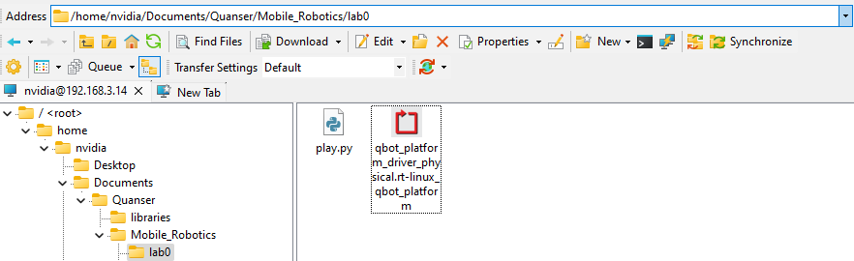
Figure 3. Correct directory for python script
  - navigate to “~\Documents\Quanser\libraries\python” on the QBot Platform as shown in Figure 4, create these directories if they don’t exist. Copy over the “hal” and “pal” folders from your local Windows machine, replacing existing files on QBot.
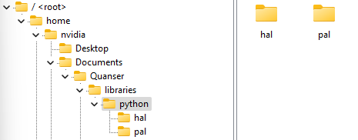
Figure 4. ‘hal’ and ‘pal’ folder in correct directory
- Run observer.py on your local Windows machine first to initiate receiving data feeds from the QBot Platform.
- Run play.py on the QBot Platform:
  - Open a PuTTY session by clicking in the top bars of the WinSCP window.
  - In the PuTTY terminal, enter the password “nvidia”.
  - Navigate to the python script directory as shown in step 8 by using the cd command.
  - Run the script using the following command:
sudo PYTHONPATH=$PYTHONPATH python3 play.py y
  - When the script is run successfully, User LEDs will turn blue.
Drive with Joystick
- Press and hold the left button (labelled LB) to arm the robot. Notice that the LEDs turn green. Keep this button pressed as you teleoperate the QBot for future labs as well.
Note: If your robot is ever in a position where it may collide with obstacles or people, disarm the robot by depressing the LB button (let go). The LEDs will turn blue again, indicating that the QBot Platform is disarmed.
- While armed, use the following joystick sticks to move the QBot.
  - move the left joystick left and right and determine the positive convention of the QBot body turn speed.
  - Move the right joystick up and down and determine the positive convention of the QBot body forward speed.
- Walk with the QBot. Combine the joystick commands and navigate the QBot to the direction you are walking towards.
- Investigate different sensors that the QBot is equipped with as you drive the QBot.
  - If observer.py is running on your Windows machine, it should output an RBG video feed from the front camera. Now try to navigate the QBot using only the video feed.
  - Uncomment observer display named “Downward Facing Image” in observer.py and the code for the downward camera feed in both section C and E in play.py to enable the camera feed. Make sure to copy the updated play.py to the QBot’s folder “Lab0” using Win SCP before running the scripts. Drive the QBot again with the RGB and downward facing camera feeds side by side and take notes on the differences in the video quality.
  - The QBot is also equipped with a LiDAR, and a depth camera. You can select data feed of interest to further investigate by uncommenting and commenting respective regions in both observer.py and play.py as done in the previous step (Section C deals with the connection and setup for each sensor that matches the observer.py file and section E deals with reading and sending the sensors at different rates). Analyse the LiDAR sensor and depth camera output and document your observations.
  - Explore driving QBot with different combinations of data feeds. Reflect on your experience and take notes of the usefulness and limitations of each data type in navigation.
- Stop your script using the RB button. Ensure that you save a copy of your completed files for review later.
- Turn OFF the robot by single pressing the power button (do not keep it pressed until it turns off). Post shutdown, all the LEDs should be completely OFF.

