**Project Report**

**on**

**ScanKaro**

**Submitted as partial fulfillment for the award of**

**BACHELOR OF TECHNOLOGY**

**DEGREE**

**Session 2021-22**

**in**

**Name of discipline**

**By**

**Divya**

**1803210050**

**Hrithik Gupta**

**1803210065**

**Under the guidance of**

**Prof. Sandhya Avasthi**

**ABES ENGINEERING COLLEGE, GHAZIABAD**

|  |  |  |
| --- | --- | --- |
| Description: C:\Users\es00952\Desktop\Logo.jpg | APJAK logo |  |

**AFFILIATED TO**

**DR. A.P.J. ABDUL KALAM TECHNICAL UNIVERSITY, U.P., LUCKNOW**

**(Formerly UPTU)**

**STUDENT’S DECLARATION**

We hereby declare that the work being presented in this report entitled “**ScanKaro**” is an authentic record of our own work carried out under the supervision of “SANDHYA AVASTHI.” The matter embodied in this report has not been submitted by us for the award of any other degree.

**Dated:** **Signature of students(s)**

**(Name(s): Divya, Hrithik Gupta)**

**Department:**

**Computer Science and Engineering**

## This is to certify that the above statement made by the candidates is correct to the best of my knowledge.

|  |  |
| --- | --- |
|  | Signature of Supervisor(Name: Sandhya Avasthi)(Designation)(Computer Science & Eng. Department) |

## 

## CERTIFICATE

This is to certify that Project Report entitled “**ScanKaro**” which is submitted by **Divya, Hrithik Gupta** in partial fulfillment of the requirement for the award of degree B. Tech. in the Department of **Computer Science and Engineering** of Dr. A.P.J. Abdul Kalam Technical University, formerly Uttar Pradesh Technical University, is a record of the candidate's own work carried out by him/them under my supervision. The matter embodied in this thesis is original and has not been submitted for the award of any other degree.

**Supervisor**

**Date**

**ACKNOWLEDGEMENT**

*It gives us an enthusiastic sense of pleasure to present the report of the B. Tech Project undertaken during B. Tech. Final Year. We owe special debt of gratitude to Professor Sandhya Avasthi, Department of Computer Science & Engineering, ABESEC Ghaziabad for his constant support and guidance throughout the course of our work. His/Her sincerity, thoroughness and perseverance have been a constant source of inspiration for us. It is only his cognizant efforts that our endeavors have seen light of the day.*

*We also take the opportunity to acknowledge the contribution of Professor Dr. Divya Mishra, Head, Department of Computer Science & Engineering, ABESEC Ghaziabad for his full support and assistance during the development of the project.*

*We also do not like to miss the opportunity to acknowledge the contribution of all faculty members of the department for their kind assistance and cooperation during the development of our project. Last but not the least, we acknowledge our friends for their contribution in the completion of the project.*

*Signature:*

*Name : Divya*

*Roll No.: 1803210050*

*Date :*

*Signature:*

*Name : Hrithik Gupta*

*Roll No.: 1803210065*

*Date* *:*

**ABSTRACT**

This **“ScanKaro”** plans have been developed to replace the old and traditional systems used by most restaurants with new and more efficient ordering systems. Traditional ordering systems can be a disadvantage for employees and customers because they require a large workforce. Employee labor will result in some defaults, such as invalid customer invoices. The server script is invalid. Wrong order These human flaws will irritate customers and restaurants.

Therefore, this **“ScanKaro”** is created and developed for better restaurant safety management. This booking system shortens the booking time. There is no need for customers to serve them at the restaurant for dinner. Customers are satisfied with this booking system.

The methodology used to develop this system is the prototyping methodology. This methodology was chosen because the system is developed in an abbreviated time compared to other methodologies. Throwaway's prototyping methodology also allows developers to listen to end-user feedback to further develop it to meet end- user requirements.

**TABLE OF CONTENTS** Page

DECLARATION ................................................................................................... ii

CERTIFICATE……....................................................................................................iii

ACKNOWLEDGEMENTS .................................................................................. iv

ABSTRACT ........................................................................................................... v

LIST OF FIGURES................................................................................................ viii

CHAPTER 1 (INTRODUCTION )........................................................................ 9

1.1. Problem Introduction ………………………………………………………… 9

1.1.1 Motivation ……………………………………………………………… 9

1.1.2 Project Objective ………………………………………………………. 9

1.1.3 Scope of the Project…………………………………………………… 10

CHAPTER 2. (LITERATURE SURVEY) .............................................................. 12

2.1. Literature Survey……………………………………………………………… 12

CHAPTER 3 (SOFTWARE REQUIREMENT SPECIFICATION)...................... 13

3.1. Technologies Used ………………………………………………………….. 14

3.1.1 Spring Boot API………………………………………………………. 14

3.1.2 Flutter…...………………………………………………………………. 15

3.1.3 MySQL………………………………………………………………. 16

3.2. Hardware Required…………………………………………………………... 17

CHAPTER 4 (SYSTEM DESIGN) ......................................................................18

4.1 Architecture diagrams………………………………………………………….18

4.2 Flow Chart………………………………………………………………………19

4.3 Class Diagram …………………………………………………………………20

4.4.1 DFD-0………………………………………………………………...……….21

4.4.2 DFD-1……………………………………………………….………………...21

4.5 ER-Diagram……………………………………………………………………22

4.6 Use Case Diagram……………………………………………………………23

4.7 Gantt Chart…………………………………………………………………….24

CHAPTER 5 (IMPLEMENTATION AND RESULTS) ………………………………25

5.1 Implementation Details………………………………………………………...25

5.1.1 Snapshots Of Interfaces……………………………………….……25

5.1.2 Working and Test Cases……………………………………………26

CHAPTER 6 (CONCLUSIONS) ......................................................................27

6.1 Performance Evaluation…………………………………………………...27

6.2Comparison with existing State-of-the-Art Technologies………………27

6.3 Future Directions ………………………………………………………….28

APPENDIX………………………………………………………………………………29

REFERENCES... .................................................................................................30

**LIST OF FIGURES**

Fig 3.1 Spring Boot API Logo

Fig 3.2 Flutter Logo

Fig 3.3 MySQL Logo

Fig 4.1 Architecture diagrams

Fig 4.2 Flow Chart

Fig 4.3 Class Diagram

Fig 4.4.1 DFD-0

Fig 4.4.2 DFD-1

Fig 4.5 ER-Diagram

Fig 4.6 Use Case Diagram

Fig 4.7 Gantt Chart

Fig 5.1 Homepage

Fig 5.2 Homepage

Fig 5.3 Result Page

**CHAPTER 1**

**INTRODUCTION**

**1.1 Problem Introduction**

**ScanKaro** Is an interactive mobile application that helps hotel managers manage and control their hotels. Numerous opportunities are provided to enable the users of the application to receive effective services. This application helps the hotel more accurately and faster. All you must do is scroll through the list and tap to order. The current system uses the traditional paper storage system and uses paper to record customer orders. In fact, a command generates a QR code, and the table is used to find the code and send the order to the kitchen.

Therefore, one of the benefits of a QR code ordering system is customer satisfaction. The hotel's overall approach to order processing is based on QR codes to improve efficiency, save energy, and time, and eliminate many of the steps of traditional food ordering without a waiter at the table. All menu information is stored in a database, allowing administrators to manage menu items anytime, anywhere.

**1.1.1 Motivation**

Personally, I do not like to wait long in the store or must call the store for a single message, especially during the day or in the afternoon. Because of Covid-19, no one wants to start a menu (paper) because everyone starts. So, we think the menu is now in the wallet (in the app in the phone).

**1.1.2 Project Objective**

This project helps clients maintain social isolation. This project saves time because no one needs to order food. This project also helps customers identify what foods are best and which are not.

**1.1.3 Scope of the Project**

1. Menu request

The first step is to scan the QR code on the smart dining room desk with a smartphone together with the customer. .

2.Menu Confirmation

This time can be considered as a continuation of the first step. This step is to access the Manager / Admin menu at the request of the client. This makes the menu available to the buyer and takes it to the next level.

3. Ordered food

The list that opens in this step orders the buyer’s food according to his needs. This rule belongs to the Administrator section.

4. Order confirmation

This condition can be seen as a continuation of the third stage. At this point, the customer asks for approval of the menu.

5. Food list

The customer has no direct connection to the kitchen. But with the manager, in this case the ordered food is transferred from manager / manager to the kitchen.

6. Food Hand over

This is a small step. At this stage, the food is delivered from the kitchen to the "smart robot" section according to the customer's wishes. The smart robot is an excellent feature of the smart eating system.

7. Food delivery

Today, smart robots and customers are connected. This process ends with the delivery of food to customers invited from kitchen.

8. Billing

This is the last step. At this point the manager / supervisor transfers the invoice based on the customer's flow and delivers to customer.

9. Payment

This is the largest building. This step can be considered a response to level eight. This consumer pays the bill.

**1.1.4 Previous Related Work**

1. One2 Menu

Overview: This is a menu maker for restaurants. It also offers touch menu creation that promises to create casual menus for restaurant owners in 30 minutes. The touch menu uses the QR code on the desktop table and the button's function button to direct customers to the tablet's online restaurants. It's also safe and easy for visitors to use, while giving owners an effortless way to update and change their menu, and it's also an online startup for people looking for a site or social networking site. It also automatically updates the restaurant's Google My Business account every time the menu is updated, has a language definition and links built into the existing site.

Price: $99 – $299 per month

1. My Menu

Overview:  It provides digital programs with QR codes for digital production facilities - and it's free for the safety of the coffee industry and to prevent the spread of COVID-19. Its anonymous feature can also be added to your online menu and command set to create individual events. Restaurants can create online menus that can be integrated into their website, allowing them to order dinners on the floor or in a restaurant and pay for them with the command of a browser, smartphone, or iOS / Android app. These extra features are not available in the free product.

Price: Free

**CHAPTER 2**

**LITERATURE SURVEY**

**2.1 Wireless Food Ordering System**

The Internet is becoming increasingly popular. People use the internet to chat with family and friends, chat with colleagues, search for information and more. Used to perform daily activities such as. The internet is good for people because you can do anything with the internet. Communication and the Internet are evolving. There are some companies that have started using this technology in their business. This will help them make more money in their business.

The user can access the information and services from a remote server that allows access to the file over a network or the Internet. Many mobile devices that support this technology are no longer used because they allow users to access information that can be retrieved. Today, people use mobile devices to gather and access information. This is because mobile devices are cheaper and smaller. The PDA is a unique digital assistant and a commercially successful mobile device. They have information and remote information (Hayrunnis, K et al., 2009).

In this procurement process, employees receive customer orders via a PDA. The operator then sends the order to the kitchen via the wireless network device. Customer instructions are displayed on a computer screen in the kitchen. The kitchen staff will update the lists when the food is ready. Employees are informed about the PDA. They then deliver the food to the table. This system increases the efficiency of the service, as employees do not have to accept paper orders.

**2.2 Point of Sale System**

The sales system, also known as the POS system, is a combination of tools and software that allows employees to perform certain tasks. The system is used by many companies in daily activities, including restaurants, hospitals, and hotels.

The POS system includes small devices such as displays, printers, portable devices, terminals, and cash registers. The indicator is used to show the price of the product when you scan the product.

Customers use printers to print receipts after payment. The device uses portable credit card charges from customers. Limit to the main screen to complete the transaction details. Cash register to deposit your money. When employees receive money from customers, they deposit the money on the board ("Software Test Support", 2018).

When customers enter the restaurant, they place an order at the first counter or wait for the waiter to serve. If a restaurant needs customers to order first, they have to queue at the counter to place the order. Then they can only find a seat in the restaurant. Another way is for customers to find seats when they arrive at the restaurant. Waiters serve customers and help with their orders.

**CHAPTER 3**

# SOFTWARE REQUIREMENT SPECIFICATION

### 3.1 Technologies Used

**3.1.1 Spring Boot API**

Boot Market makes it easy to do the same, product market you can do now. We have a unique look at Spring Platform and other libraries so you can get started with small issues. Many start-up programs require at least some configuration. If you're looking for information on a particular issue or ways to improve it before you publish it, check out on [￼](https://github.com/spring-projects/spring-boot/wiki" \l "release-notes)￼ on our wiki.

## Features

* Create independent spring applications.
* Install Tomcat, Jetty or Undertow directly (no need to install WAR file).
* Set dependencies "Beginner" to simplify planning your build.
* If possible, organize your spring and third-party libraries.
* Provide turnkey equipment such as measurement, medical inspection and external configuration
* There is absolutely no code output and no XML configuration required.

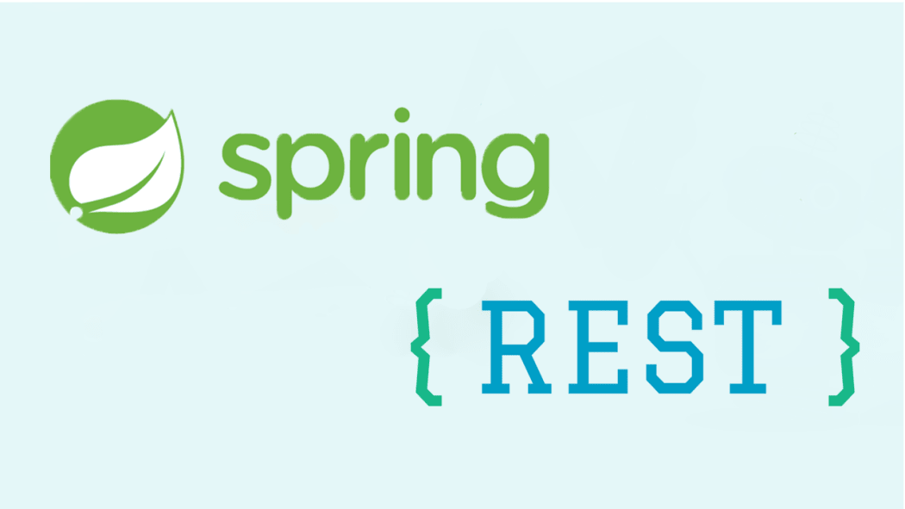

Fig - 3.1 Spring Boot Logo

**3.1.2 Flutter**

This article is for Android developers who want to use their knowledge of Android to build mobile apps using Flutter. If you understand the importance of Android, you can use this document as a starting point for developing Flutter. Because Flutter relies on many features and designs of mobile operating systems, Android knowledge and expertise is essential to making Flutter. Flutter is a new way to create a mobile UI, but it also has a plug-in system for Android (and iOS) to communicate non-UI functions. If you're an Android expert, you don't need to relearn everything to use Flutter. You can check out this article to find the question that best suits your needs and use it as a recipe.



Fig 3.2 Flutter Logo

**3.1.3 MySQL**

* MySQL is a database system used by the web
* MySQL is a database system that runs on a particular server
* MySQL is ideal for both small and large applications for managing the data.
* MySQL is very fast, reliable, and easy to use for everyone.
* MySQL uses standard SQL (Structured Query Language).
* MySQL is free to use.

Databases are useful for storing data. A company may have a database with the following tables:

* Employees / Member
* Products / Legacy
* Client
* Order information's



Fig 3.3 MySQL Logo

**3.2 Hardware Required**

1. Laptop

2. 8 GB RAM

3. Windows 10

4. Single CPU Core

5. 24 GB SSD Storage

# 

# CHAPTER 4

# SYSTEM DESIGN

# 4.1 Architecture diagrams

# 

Fig 4.1 Architecture diagrams

# 4.2 Flow Chart

# 

# Fig 4.2 Flow Chart

# 4.3 Class diagrams

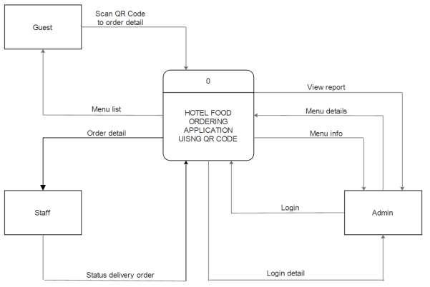

Fig 4.3 Class Diagram

**4.4. Data Flow Diagram**

1. **Zero Level DFD**

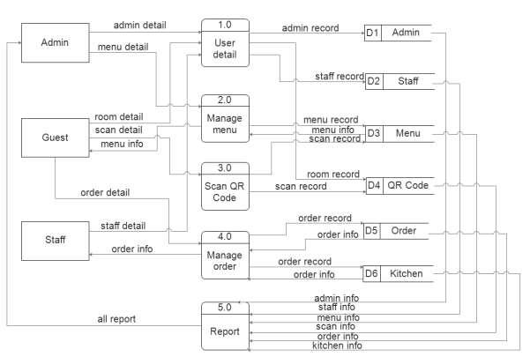

**Fig 4.4.1 Zero Level DFD**

1. **First Level DFD**

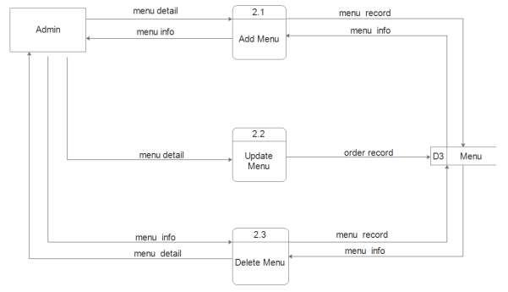

**Fig 4.4.2 One Level DFD**

# 4.5.ER Diagrams

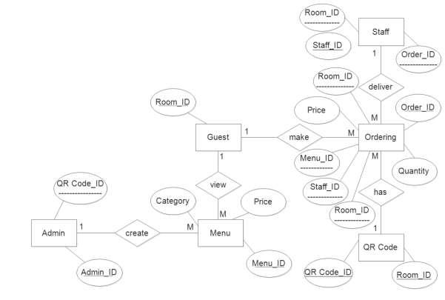

**Fig 4.5 ER Diagram**

# 4.6 Use Case Diagram

# 

Fig 2.4 Use Case Diagram

**4.7 Gantt Chart**

# 

Fig 4.7 Gantt Chart

**CHAPTER 5**

# IMPLEMENTATION AND RESULTS

**5.1 Implementation Details**

**5.1.1. Snapshots Of Interfaces**

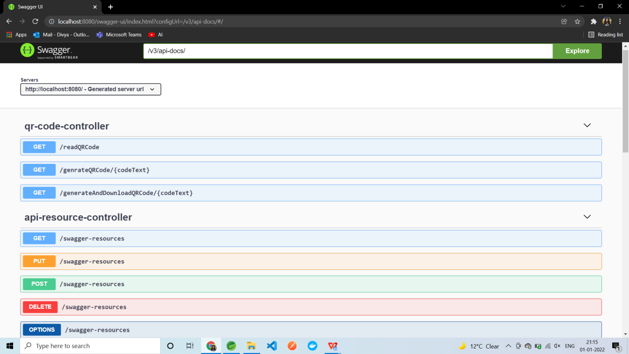

**Fig 5.1 Home Page**

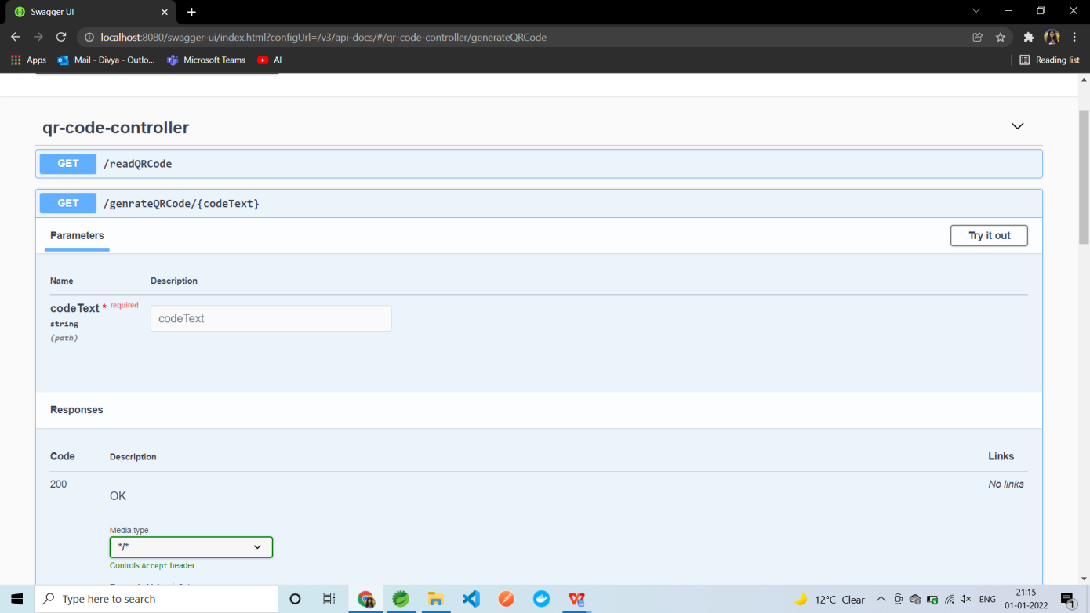

**Fig 5.2 Home Page**

**5.1.2. Results**

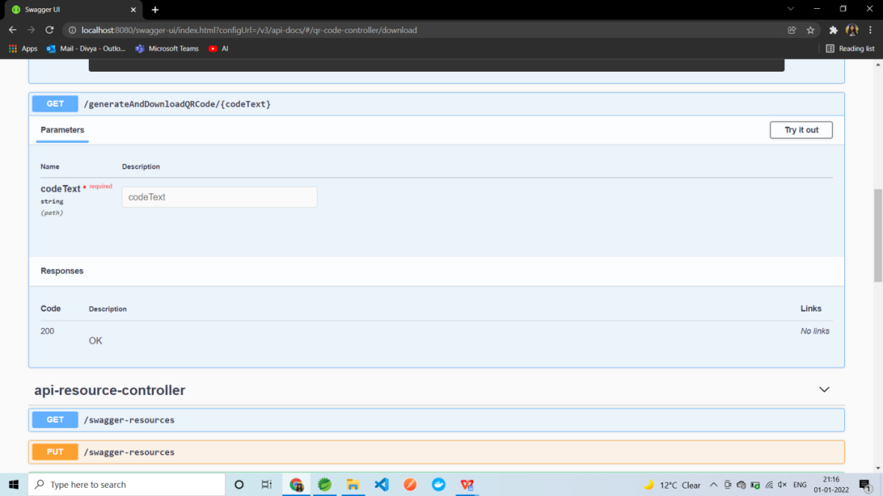

**Fig 5.3 Result Page**

**CHAPTER 6**

# CONCLUSION

**6.1. Performance Evaluation**

Although there is a certain charm and nostalgia attached with the traditional system of restaurants and face to face interactions the times and conditions today demand a change in the system. With almost everyone in the world using a smartphone and rapid technological advancement, restaurants should make use of technology to replace or better the traditional system.

There are many improvements that can be made in the app itself for example adding some entertainment system for customers while they wait, still the use of such technology can greatly improve the customer’s as well as staff's experience. There is room for improvement in the system which will breed innovation and help the restaurant managers make the experience of both customers and staff much better.

**6.2. Comparison with existing State-of-the-Art Technologies**

This system allows customers to click a button to cancel an order. If cooking is not yet ready, customers can cancel the order. This will increase customer satisfaction.

Furthermore, the third goal of the system is to create an easy-to-use system that provides customers with up-to-date information. Staff and chefs can customize the menu based on the availability of food references. Having a user-friendly system is also important as it affects the image of the restaurant brand. The user interface of the restaurant ordering system is simple and clear. The table and chef are also clean and tidy.

.

**6.3. Future Directions**

The researchers were able to use QR codes to create a restaurant information system to improve the service quality of standard restaurants in terms of fast ordering and payment. Then answer the question. You can avoid mistakes. Systematic reports also help management to develop marketing and marketing strategies and plans.

**References**

**[1]** Abel, E.E. & Obuten, E. 2015, ‘Restaurant customer self-ordering system: a solution to

reduce customer/guest waiting time at the point of sale’, International Journal

Computer Applications, vol. 111, no. 11. Available from: https://pdfs.semanticscholar.org/cd71/e791e1265bcc78738af7c6cf3094402e88ab.pdf [10 March 2019].

**[2]** Adithya, R., Singh, A., Pathan, S. & Kanade, V 2017, ‘Online food ordering system’,

*International Journal of Computer Applications*, vol. 180, no. 6. Available from:

https://www.ijcaonline.org/archives/volume180/number6/adithya-2017-ijca-

916046.pdf [10 March 2019].

**[3]** Bora, P.R. & Gupta, E 2012, ‘Application on order management system in restaurants’,

*International Journal of Application or Innovation in Engineering & Management***,**

vol. 1, no. 2. Available from: http://www.ijaiem.org/volume1Issue2/IJAIEM-2012-

10-15-027.pdf [10 March 2019].

**[4]** Khairunnisa, K., Ayob J., Mohd. Helmy A. Wahab, M. Erdi Ayob, M. Izwan Ayob & M. Afif Ayob 2009, ‘The application of wireless food ordering system’, *MASAUM Journal of Computing*, vol. 1, no. 2. Available from:

http://eprints.uthm.edu.my/5726/1/Wireless_Food_Ordering_System.PDF [10 March

2019].

**[5]** Malviya, S.G., Deshpande, N.D., Mahalle, S.G. & Tantarpale, S 2016, ‘A review paper on smart restaurant ordering system’, *International Journal of Scientific & Engineering*

*Research*, vol. 7, no. 2. Available from: https://www.ijser.org/researchpaper/A

Review-Paper-on-Smart-Restaurant-Ordering-System.pdf [10 March 2019].

**[6]** Nur Hanis Ihsan 2011, ‘Restaurant ordering system using mobile application’. Available from: http://umpir.ump.edu.my/id/eprint/4297/1/NUR_HANIS_BINTI_IHSAN.PDF

[10 March 2019].

**[7]** Salnath, R.K., Chaitanya, K.G.K., Abhinav, M. & Feiroz K.T.H. 2016, ‘An online food court ordering system’, *Journal of Information Technology & Software Engineering.*

Available from:

https://pdfs.semanticscholar.org/843b/6b72eec51a2a2fb1c59a8f2364fc9ae1df8e.pdf

[10 March 2019].

**[8]** Samsudin, N.A., Khalid, S.K.A., Kohar, M.F.A.M., Senin, Z. & Ihkasan, M.N. 2011, ‘A customizable wireless food ordering system with realtime customer feedback’, *IEEE*

*Symposium on Wireless Technology and Applications*. Available from:

https://core.ac.uk/download/pdf/12007817.pdf [10 March 2019].

**[9]** Software Testing Help 2018, *How to Test Point of Sales (POS) System – Restaurant POS Testing Example.* Available from: <https://www.softwaretestinghelp.com/how-to-test

point-of-sale-pos-system/>. [10 March 2019].

**[10]** Tanpure, S.S., Shidankar, P.R. & Joshi, M.M. 2013, ‘Automated food ordering system with real-time customer feedback’, *International Journal of Advanced Research in*

*Computer Science and Software Engineering*, vol. 3, no. 2. Available from:

https://pdfs.semanticscholar.org/ee9c/d43c9705bdaaaa34b9532493c079041fc2ac.pdf

[10 March 2019].