**ScanKaro: An QR code-based menu application for restaurants**

Hrithik Gupta, Sandhya Avasthi, Divya Chaturvedi

ABES Engineering College, Ghaziabad, India

hrithikg90@gmail.com

sandhya_avasthi@yahoo.com

divyachaturvedi13@gmail.com

**Abstract**

As the usage of information technology has amplified, people have become dependent on their mobile phones. In this recent outbreak of covid-29, due to government guidelines of social distancing and a customer apprehension in touching a paper menu card, the restaurant owners have opted for QR code-based menu application. A customer can order food through touchless scanning of the menu and paying for the bills. Another advantage for the owner is an easy update of the menu without wasting paper, so this is environment friendly. The menu card is one of the most important forms of communication tool. Not only does it show hospitality to your customer and offers food, but it also reinforces the idea and style of your brand. But for it to be useful it must be done peculiarly. Customers view the menu for only 109 seconds (about 2 minutes) before selecting an order. Therefore, designing a restaurant menu not only affects the customer experience, but also the quality of the restaurant but some problem occurs with paper menu card like no updating in the menu, in attention to detail, wrong pricing, etc.

**Keywords:** QR code, covid-19, paperless menu, contactless payment

1. **Introduction**

Although the coronavirus pandemic ushered in the quick and widespread use of QR codes, restaurant industry experts believe the technology will endure long after the health problem is resolved. Rapid response codes were invented in 1994 by a Japanese engineer to make tracking car parts easier. Years later, as cellophane with cameras took over, quick response codes became mainstream. However, it was not until the ongoing pandemic compelled businesses to step up the sanitization efforts that they became a ubiquitous sight inside bars and restaurants throughout the United States, eventually displacing paper menus. This research paper presents a QR code-based restaurant menu application “ScanKaro”. **“**ScanKaro**”** is developed to replace the previous old-fashioned system with our new system which is highly effective, saves time, and is a green technology. This opens up a whole lot of possibilities. For example, you could use less paper to share documents with your audience. Employee labor will result in common mistakes such as invalid customer invoices. All these make a customer unhappy and irritated. Therefore, the application **“**ScanKaro**”** is a better solution and can be used for efficient order processing and safety management in restaurants. It reduces the booking time. There is no need for customers to serve them at the restaurant for dinner. Customers are satisfied with this booking system. Prototyping methodology is used to develop this system and this is chosen because the system is developed in an abbreviated time compared to other methodologies. Throwaway's prototyping methodology also allows developers to listen to end-user feedback to further develop it to meet end-user requirements.

This is one of the major challenges facing many businesses based on customer orders, product preparation, and delivery. Order registration is the time of delivery to the customer. It reducing this time leads to customer satisfaction and as a result businesses are good. Now, this cycle in our country is traditional in restaurants. This means that after the customer is sitting at the table and the waiter brought a list of products and returned after a while minutes to receive orders. If the client does not decide the waiter must return after a certain time to receive its order (some restaurant customers place an order self-complaining to themselves). after receiving communication and delivery with hotel staff, customers you have to wait according to the time it takes to place your order prepare. The time it takes to place an order is very important to treat conditions as they are directly related to customer satisfaction. waiter after ordering bring it to the recipient's table. After dinner, customers refer to funds used to pay bills and stop operations. Increase restaurant orders QR code-based efficiency with reduced energy and time there are no servers in the table eliminating multiple steps from the traditional order.

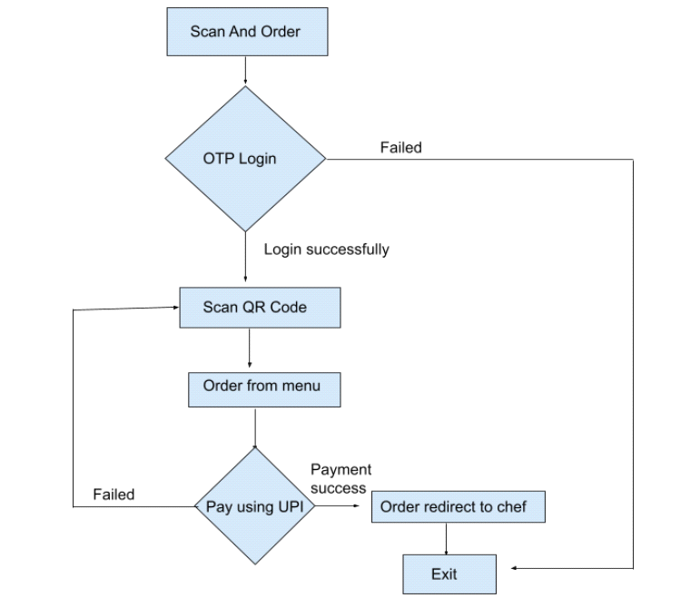

**Figure1**. Flow chart of Steps in QR code scanning process

**2 Literature Review**

Self-service is a business strategy that can automate customers and can enhance user experience [1]. Provide tools or services to serve the needy myself. Here are some examples of self-service technology. Bank ATMs, vending machines, mobile applications, Websites. Other applications that provide customer service. The potential benefits of self-service technology [2]. The satisfaction of business employees can eliminate this. The price that can prolong life - can do more Efficiency that reduces and increases backup time Security. There is a restaurant called La Frame Blanche Asian Ding Zung Zhang Wali Apps increase customer satisfaction. He left her customers should view photos of the food before ordering. Which one the app helps customers make the right choice Choose the right path for them [3]. It could be good Images of certain foods may prompt customers to purchase these items Discrimination. The self-catering menu also allows the restaurant service Faster than usual. Verified using self-service, an application that does not need to add a host to the floor to provide superior services [4].

One of the most common restaurant mistakes is finding or finding serving food that the customer did not order. According to an article entitled "The Most Common Restaurant" Complaints are among 1,003 people. A common complaint about restaurant services is explored. The highest percentage is “not food you obey” This means that 62% of orders are often incorrect which slows down the service process. It also affects hygiene Sales reports, which can affect accounting for the restaurant. It may be time for a restaurant order by hand [5]. When customers are still trying to call the waiters to decide on orders. Some guests want to change their decision at the last minute. Manual command hosts need to repeat it all the host ordered the guest to confirm everything is fine. Manual ordering can be risky and errors due to manual download. Administration of it will be easier to order through the restaurant. The paper discusses order processing and arrival in the kitchen automatically [6].

Ordering through the QR scanner application saves time, money, and customer and restaurant efforts. Therefore, a QR code is included in the system. Developed by researchers, QR code is a popular technology that is easy to use even for the first-time users [7]. It is possible to scan QR codes for information and engage with customers [8]. Scanning the guest QR code a table can be an uncomplicated way to get to the restaurant menu instead of typing through the phone browser. Most smartphones are built into QR Code scanners today direct them to the website. Although not the application is limited to smartphones with QR code scanners [9-11].

**3 QR code technology background**

**3.1 History of QR**

In the 1970s, IBM developed a 13-hole UPC signal that could be automatically converted into a computer. UPC codes are still widely used in point of sale (POS) devices. Code 39 was developed in 1974 and can encode 30 alphanumeric characters. Then, in the late 1980s, multi-level code characters were developed that could store 100 to 16,000 codes and 49-character codes[14]. The development process has been extremely fast in recent years, with increased memory capacity and the addition of more languages. A total of QR codes created in 1994 can contain 7,000 characters [15].

**3.2 Backdrop of QR**

The QR (quick response) code is a scanned code. In the case of QR codes, the data is converted into a single two-dimensional square structure (of different shapes). If a QR code scanner is installed in these boxes, it will decode the rating into the original data format.

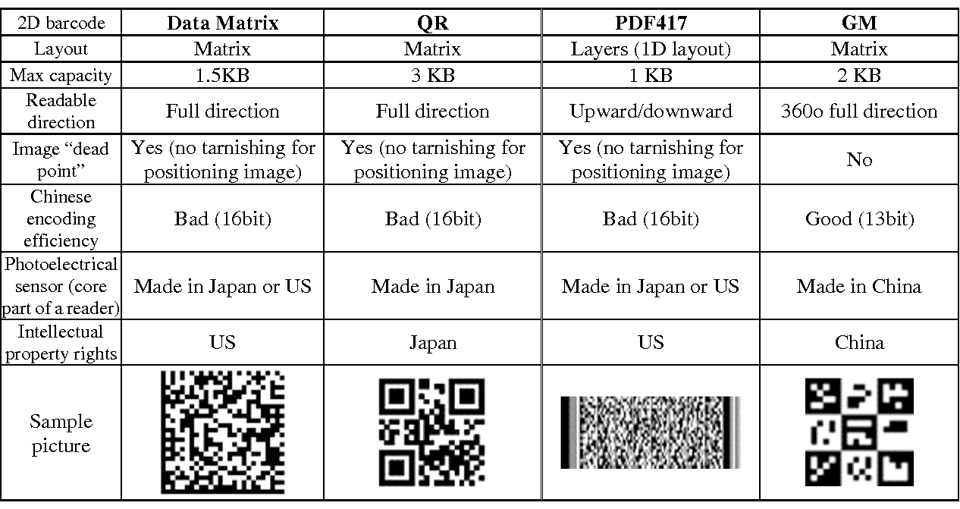

**Figure 2**. A summarized comparison between various QR code in four countries.

**3.3 Elements of a QR code**

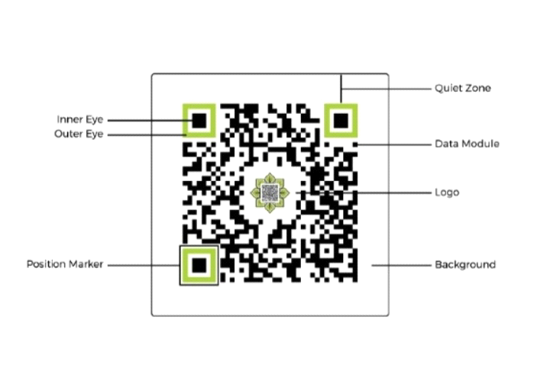

**Figure 3.** Elements of QR code

* Data Modules: A simple black rectangle on a white background (color composition may vary). Most QR codes contain these data module settings.
* Position Marker: Each QR code consists of three placeholders, The purpose of the detector is to assist in locating the code detector data mode. There are internal and external eye features.
* Quiet Zone: The Quiet Zone area is empty, including the location and media information. It also aims to find easy code with a scanner.

**4 QR Code Methodology**

The QR code-based application system is a mobile application, to use this application a user needs a mobile phone and internet connection. These applications have been developed with React.js, java, and Mongo DB database. On each table, there is a different QR code by which users can scan QR codes from the application and make order their food. When users land on the home page they get three different main components ADMIN LOGIN, USER LOGIN, and KITCHEN ADMIN LOGIN.

Once the user has made an account, they can access the menu, cart, and other features of the site. By selecting the desired dish, the user will then proceed to the checkout step. The admin can log in to their account to access all the details of the site, including the current orders, past orders, and pending orders. They can also modify the order details, remove users, and mark them as complete.

1. The customer module is an application that enables the customer to order a meal. It displays the details of the food, including its price, nutritional value, and visual display. The customer module allows the restaurant manager to modify or replace any special dishes or items in the food item. It is run on any smart device and can be easily implemented.
2. The server module is a web-based component that is used by the restaurant admin to control the entire system, including the database, order details, and bill status. It allows the admin to modify the prices, menus, and special offers that the restaurant offers.
3. The kitchen module is a graphical interface that the chef can use to prepare the food. It displays the food item's order on a first-come-first-served basis.

**4.1 Placing order without a waiter**

Each table in the restaurant has a unique QR code for that restaurant. The Guardian requires your phone and the Scan & Messaging application to be displayed on your phone. Security can use the application to scan the QR code. After scanning the code, a menu will appear in the application. Users can find details about different foods, prices, and so on and then post products from within the app. Chefs and customers have direct contact, saving time by shooting in the middle. Chefs also receive orders on time, reducing the likelihood of invalid orders.

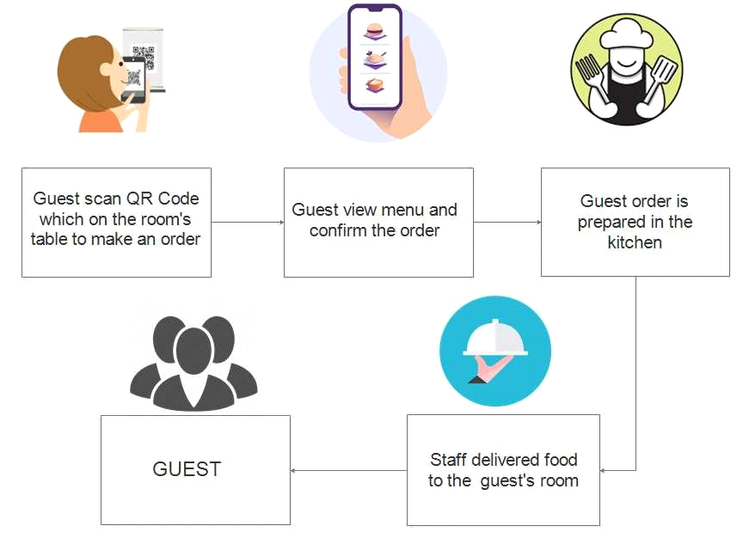

**Figure 4**. The process flow of QR Method

**4.2 Payment without cash**

Customers can enjoy their meal after ordering. The last part of the cycle is the payment. The "ScanKaro" app also controls the payment of orders. With UPI, users automatically receive an invoice for the application, including direct payments from the application.

**5 Advantages and limitations of the method**

Restaurants, implementing QR code technology in restaurants. The owners benefit from several benefits such as the elimination of the traditional ordering phase which is the main factor of waiters are wasting time. There are more details on this. The reason why menus with pictures compared to paper menus customers have a better and more favorable option. There is no pressure on the customer to issue the order and he can place his order with peace of mind. Another strength of this scheme is to pay bills electronically which promotes touchless currency exchange between the customer and the host. Because of the flexibility of a QR Code, you may store as much information as you like. It is possible to convert printed papers to digital ones by scanning QR Codes in them. It also has one significant impact on protecting the environment due to non-use paper bills. Another feature of the electronic menu for the restaurant has to remove or disable the order click of food if its row content is not available. a better and easier. Manage shop during peak hours and avoid overcrowding this model has other advantages over the checkout counter. This model prevents any error that can be caused by the waiter in processing orders or error due to bill calculation.

**6 Conclusion**

While there is a certain glamour and nostalgia for traditional dining room styles and face-to-face relationships, modernity and circumstances require a change in the organization. Everyone in the world uses a smartphone, and with the rapid development of technology, it is necessary to replace or improve the traditional restaurant system with technology in providing menus on customers’ mobile phones making the whole experience paperless and touchless. Therefore, the research paper proposes QR code-based applications to provide a menu to customers in a hotel or restaurant. Many improvements can be made to the application such as adding some entertainment settings while customers are waiting, but using such technology enhances the customer and staff experience. There is room for improvement in the system that promotes innovations and helps restaurant managers improve the experience of customers and staff.

**References**

1. Abel, E.E. & Obuten, E. 2015, ‘Restaurant customer self-ordering system: a solution to reduce customer/guest waiting time at the point of sale,’ International Journal Computer Applications, vol. 111, no. 11. Available from: [ht HYPERLINK "https://pdfs.semanticscholar.org/cd71/e791e1265bcc78738af7c6cf3094402e88ab.pdf"tps://pdfs.semanticscholar.org/cd71/e791e1265bcc78738af7c6cf3094402e88ab.pdf](https://pdfs.semanticscholar.org/cd71/e791e1265bcc78738af7c6cf3094402e88ab.pdf).
2. Adithya, R., Singh, A., Pathan, S. & Kanade, V 2017, ‘Online food ordering system’, *International Journal of Computer Applications*, vol. 180, no. 6. Available from <https://www.ijcaonline.org/archives/volume180/number6/adithya-2017-ijca>-
3. Bora, P.R. & Gupta, E 2012, ‘Application on order management system in restaurants’, *International Journal of Application or Innovation in Engineering & Management***,** vol. 1, no. 2. Available from: <http://www.ijaiem.org/volume1Issue2/IJAIEM-2012>-
4. Khairunnisa, K., Ayob J., Mohd. Helmy A. Wahab, M. Erdi Ayob, M. Izwan Ayob & M. Afif Ayob 2009, ‘The application of wireless food ordering system’, *MASAUM Journal of Computing*, vol. 1, no. 2.
5. Malviya, S.G., Deshpande, N.D., Mahalle, S.G. & Tantarpale, S 2016, ‘A review paper on smart restaurant ordering system’, *International Journal of Scientific & Engineering Research*, vol. 7, no. 2.
6. Nur Hanis Ihsan 2011, ‘Restaurant ordering system using mobile application’. Available from: <http://umpir.ump.edu.my/id/eprint/4297/1/NUR_HANIS_BINTI_IHSAN.PDF>
7. Salnath, R.K., Chaitanya, K.G.K., Abhinav, M. & Feiroz K.T.H. 2016, ‘An online food court ordering system’, *Journal of Information Technology & Software Engineering.*
8. Samsudin, N.A., Khalid, S.K.A., Kohar, M.F.A.M., Senin, Z. & Ihkasan, M.N. 2011, ‘A customizable wireless food ordering system with realtime customer feedback’, *IEEE Symposium on Wireless Technology and Applications*.
9. Software Testing Help 2018, *How to Test Point of Sales (POS) System – Restaurant POS Testing Example.*
10. Tanpure, S.S., Shidankar, P.R. & Joshi, M.M. 2013, ‘Automated food ordering system with real-time customer feedback’, *International Journal of Advanced Research in* Computer *Science and Software Engineering*, vol. 3, no. 2. <https://pdfs.semanticscholar.org/ee9c/d43c9705bdaaaa34b9532493c079041fc2ac.pdf>
11. Avasthi, S., Chauhan, R., & Acharjya, D. P. (2021). Processing large text corpus using N-gram language modeling and smoothing. In *Proceedings of the Second International Conference on Information Management and Machine Intelligence* (pp. 21-32). Springer, Singapore.
12. Avasthi, S., Chauhan, R., & Acharjya, D. P. (2021). Techniques, applications, and issues in mining large-scale text databases. In *Advances in Information Communication Technology and Computing* (pp. 385-396). Springer, Singapore.
13. Yan, L. Y., Tan, G. W. H., Loh, X. M., Hew, J. J., & Ooi, K. B. (2021). QR code and mobile payment: The disruptive forces in retail. *Journal of Retailing and Consumer Services*, *58*, 102300.
14. Buenaventura, R. U., Ignacio, A. E., & Laspoña, J. A. S. (2021). Mobile Ordering Application for a Generic Fast-Food Restaurant. *International Journal of Multidisciplinary: Applied Business and Education Research*, *2*(5), 371-380.
15. Dr. B. Shadaksharappa, Kotra Chaithanya ,Suresh .J, Mahesh R & Deepak Kumar (2018). International Journal of Engineering Research in Computer Science and Engineering (IJERCSE), ISSN (Online) 2394-2320.