HTML
Head
We have 4 important elements in head element
- Title
- Link
- Script
- Meta
- Title:
- Browser will use this html title element in search page title message.
- It will be displayed as title bar.
- It will be used as name for making page as favourites.
Title bar:
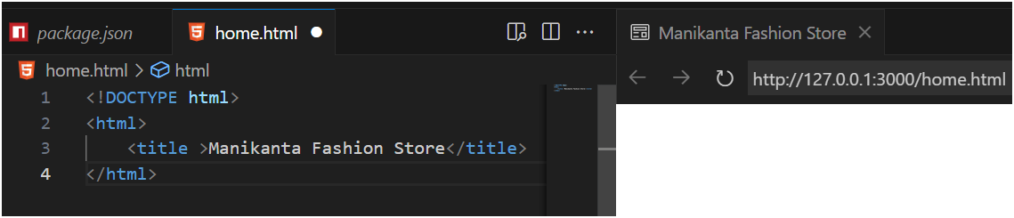
Favourites:
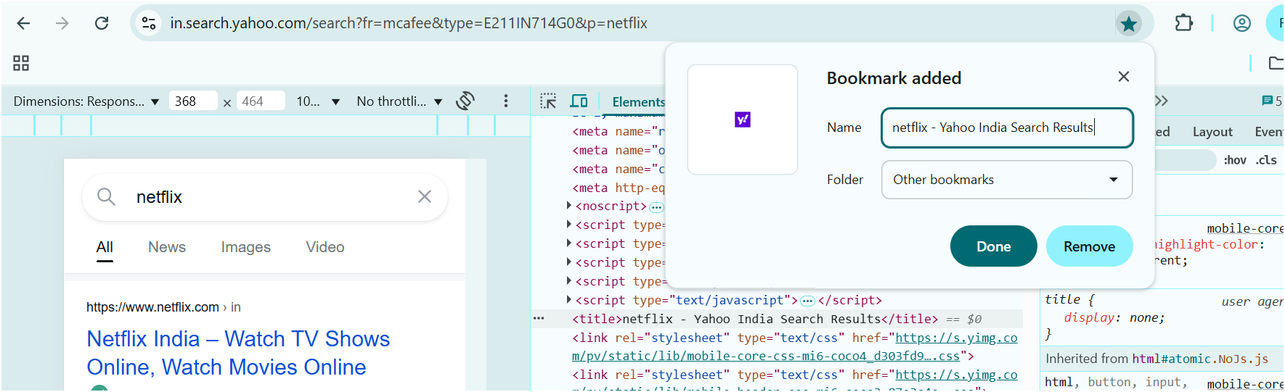
2. Link element:
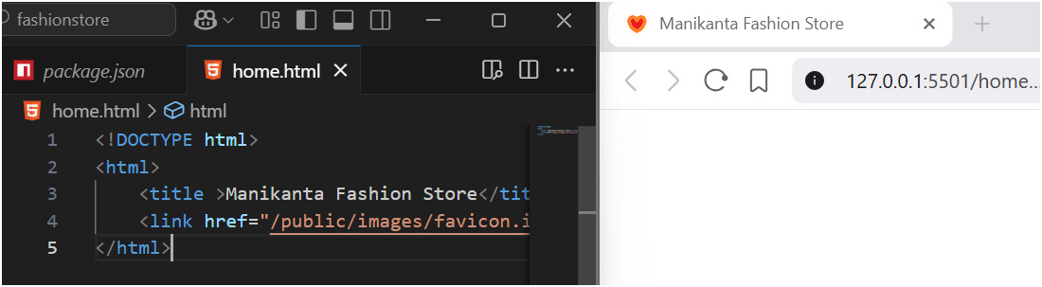
- Favicon size should be in range of 16 – 32 px.
- This element contains 2 attributes.
- One attribute is href (hyper reference) and another is rel (relation).
- Standard Icon image name should be in favicon.ico.

Meta Element:
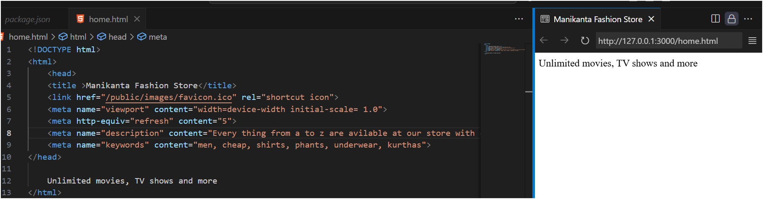
- Meta is data about data, which means amazon order box having handle instructions.
- It was mainly used for SEO friendly and responsive design.
- To make web-page SEO friendly below attributes are used.
  - Name = keywords. – for SEO
  - Content = …content to keep…
  - Name = description. – for SEO
  - Content = something about our website
  - http-equiv = refresh – for responsive
  - Content = 5.no of seconds in which page should be reloaded.
  - Name = viewport – for responsive.
  - Content = width = device-width initial-scale = 1.0
Example:
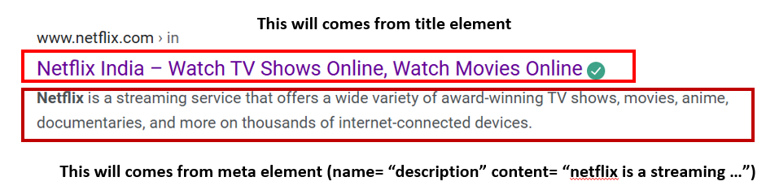

BODY
- What we see in webpage is body content.
- Below are the body attributes
  - bgcolor: it changes the background color
  - background: it sets image in background. We can control the image using html
  - align: it sets the alignment of text
  - text: it sets the color of text
  - rightmargin: it sets right space between the page and the text content
  - leftmargin : it sets left space between the page and the text content
  - topmargin : it sets top space between the page and the text content
  - bottommargin: it sets bottom space between the page and the text content
body semantics for layout design:
- nav: it is used for navigation purpose
- header
- section
- footer
- dialog
- figure
- figcaption
- aside
- article
- div
- span

