Video Link: <https://drive.google.com/file/d/1oq1yfjc_cIejuZmxoyGJHBASIv5AodJe/view?usp=sharing>

Git hub:

1. Use a python code to display the following star pattern using the for loop

rows = 5

for i in range(0, rows):

for j in range(0, i + 1):

print("*", end=' ')

print("\r")

for i in range(rows, 0, -1):

for j in range(0, i - 1):

print("*", end=' ')

print("\r")

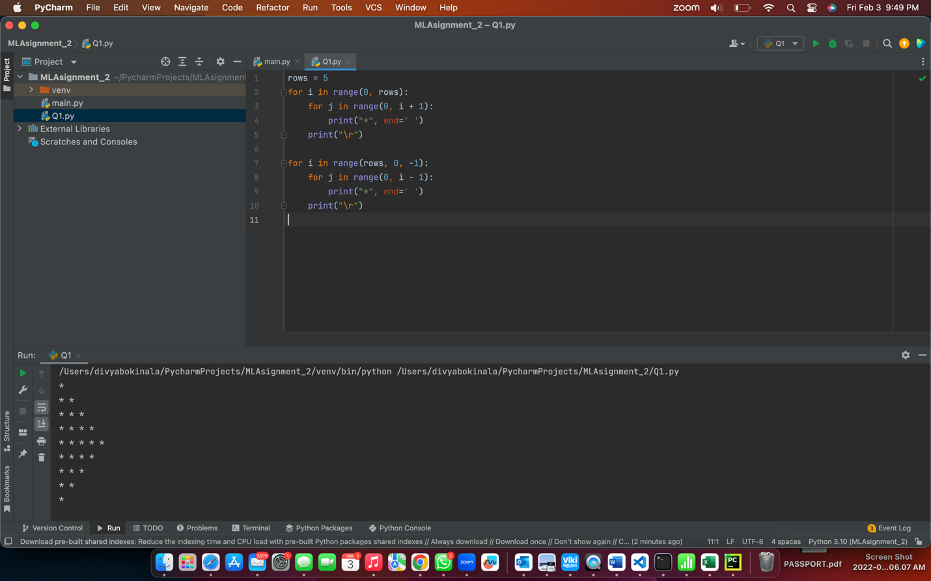

2. Use looping to output the elements from a provided list present at odd indexes.

my_list = [10, 20, 30, 40, 50, 60, 70, 80, 90, 100]

# stat from index 1 with step 2( means 1, 3, 5, an so on)

for i in my_list[1::2]:

print(i, end=" ")

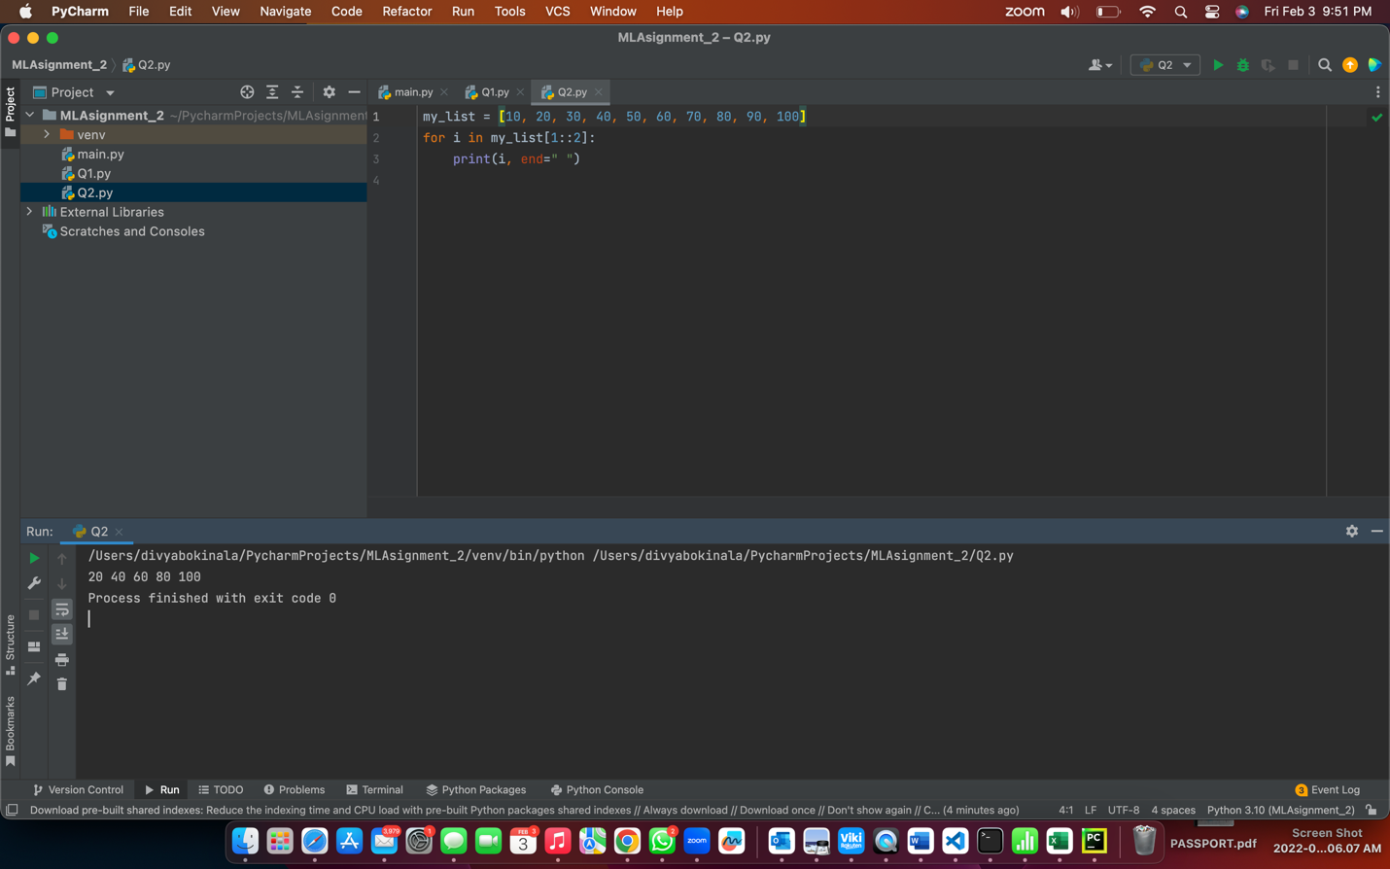

3.Write a code that appends the type of elements from a given list.

Input x= [23, 'python', 23.98]

Expected output

[23, 'Python',23.98]

[<class 'int'>,<class 'str'>,<class 'float'>]

x = [23,'Python', 23.98]

n = []

for i in range(len(x)):

n.append(type(x[i]))

print(n)

print(x)

4.Write a function that takes a list and returns a new list with unique items of the first list.

Sample list :[1,2,3,3,3,3,4,5]

Unique List:[ 1,2,3,4,5]

def unique_list(l):

x = []

for a in l:

if a not in x:

x.append(a)

return x

print(unique_list([1,2,3,3,3,3,4,5]))

5.write a function that accepts a string and calculate the number of upper-case letters and lower-case letters.

Input String:'The quick Brow Fox'

Expected Output:

No.of Upper-case characters:3

No.of lower-case Characters:12

def string_test(s):

d={"UPPER_CASE":0, "LOWER_CASE":0}

for c in s:

if c.isupper():

d["UPPER_CASE"]+=1

elif c.islower():

d["LOWER_CASE"]+=1

else:

pass

print ("Original String : ", s)

print ("No. of Upper case characters : ", d["UPPER_CASE"])

print ("No. of Lower case Characters : ", d["LOWER_CASE"])

string_test('The quick Brown Fox')

