**INDEX**

Problem Statement 3

Syntax of <img> 3

Syntax of <a> 4

Assumption 5

Test Cases(Valid) 4

Test Cases(Invalid) 4

Lex Source Code 5

YACC Source Code 7

How to Compile 9

Outputs 11

References 12

# Problem Statement

To create a parser using lex and yacc to parse the HTML tags <img> and <a>

*Syntax of HTML Tags*

**<img> Tag**

**Syntax:**

**<****img src="image_name.jpg" alt="text" >**

The <img> tag is used to embed an image in an HTML page.

The <img>  tag has two required attributes:

* src - Specifies the path to the image
* alt - Specifies an alternate text for the image, if the image for some reason cannot be displayed

Some attributes of <img> are:

* [src](https://www.geeksforgeeks.org/html-img-src-attribute/)
* [alt](https://www.geeksforgeeks.org/html-img-alt-attribute/)
* crossorigin
* [height](https://www.geeksforgeeks.org/html-img-height-attribute/)
* [width](https://www.geeksforgeeks.org/html-img-width-attribute/)
* [ismap](https://www.geeksforgeeks.org/html-img-ismap-attribute/)
* loading
* longdesc
* referrerpolicy
* sizes
* srcset
* [usemap](https://www.geeksforgeeks.org/html-img-usemap-attribute/)

**<a> Tag**

**Syntax:**

**<a href="https://www.xyzz.com">Visit xyzz.com</a>**

### The <a> tag defines a hyperlink, which is used to link from one page to another.

### If the <a> tag has no href attribute, it is only a placeholder for a hyperlink.

### Some attributes of <a> are:

* [**charset**](https://www.geeksforgeeks.org/html-a-charset-attribute/)
* [**download**](https://www.geeksforgeeks.org/html-a-download-attribute/#:~:text=The%20download%20attribute%20is%20used,name%20of%20the%20downloaded%20file.)
* [**hreflang**](https://www.geeksforgeeks.org/html-a-hreflang-attribute/)
* [**media**](https://www.geeksforgeeks.org/html-a-media-attribute/)
* [**name**](https://www.geeksforgeeks.org/html-a-name-attribute/)
* [**rel**](https://www.geeksforgeeks.org/html-a-rel-attribute/)
* [**shape**](https://www.geeksforgeeks.org/html-a-shape-attribute/)
* [**type**](https://www.geeksforgeeks.org/html-a-type-attribute/)
* [**target**](https://www.geeksforgeeks.org/html-a-target-attribute/)
* [**rev**](https://www.geeksforgeeks.org/html-a-rev-attribute/)
* **ping**

# Assumptions

1. Assuming tags and attributes names are in lower case only for simplicity.
2. Required attribute should come before non-required attribute.
3. Attribute values must be in either double quotes or single quotes.
4. The case of nested tags is covered here.
5. <a> tag can have any number of nested <a> or <img> tags.

**Test Cases for <img> tag (Valid)**

1. A img tag used with all required/compulsory attributes and other attributes.

Eg:

<img src=”abc.png” alt=”abc” height=”100” width=”100”>

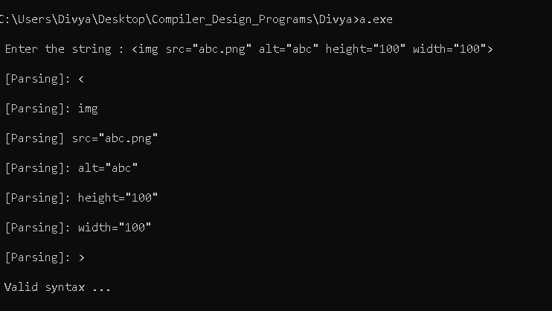

1. A img tag with only compulsory attribute.

Eg:

<img src=”abc.png” alt=”abc” > </img>

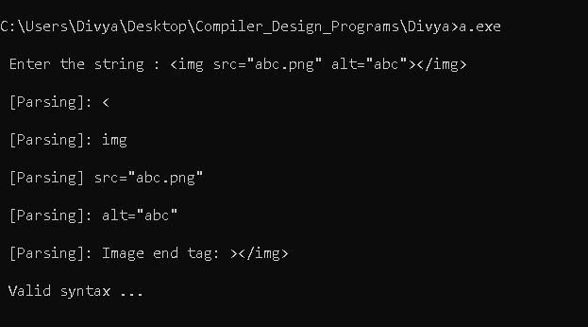

1. A img tag can end in three ways :-
2. End with “></img>”

Eg. <img src=”abc.png” alt=”abc” height=”100” ismap=”1”> </img>

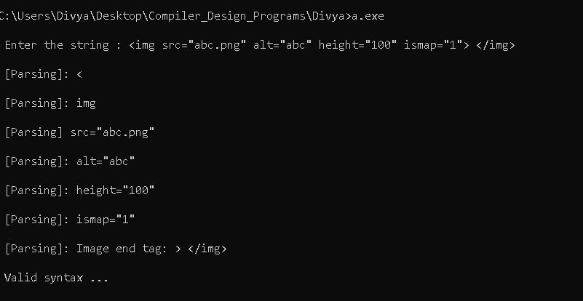

1. End with “/>”

Eg. <img src=”abc.png” alt=”abc” height=”100” ismap=”1”/>

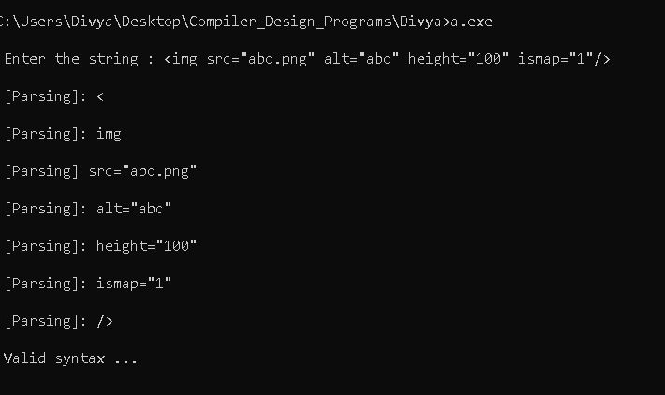

1. End with “>”

Eg. <img src=”abc.png” alt=”abc” height=”100” ismap=”1”>

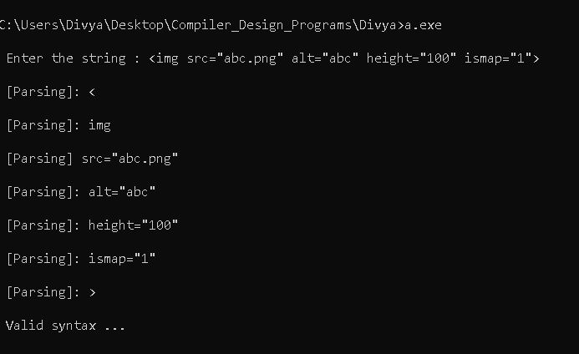

#### 

#### Test Cases for <img> tag (Invalid)

1. A img tag with no attribute.

Eg:

<img>

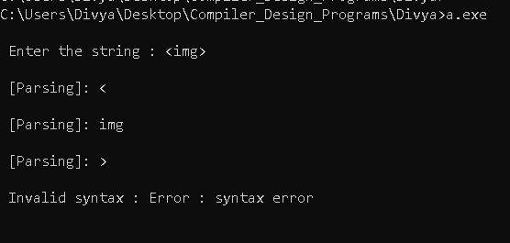

1. A img tag with compulsory attribute missing.

Eg:

<img height=”100” weight=”100”>

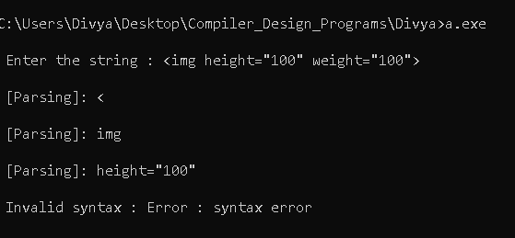

1. A img tag with one compulsory attribute missing

Eg:

<img src=”abc”>

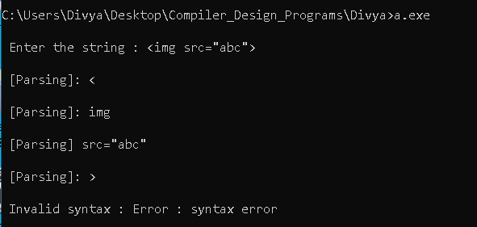

1. A img tag with all compulsory or optional attributes but invalid ending

Eg : End tag is not matched with starting tag

<img src=”abc.png” alt=”abc” height=”100” width=”100”> </b>

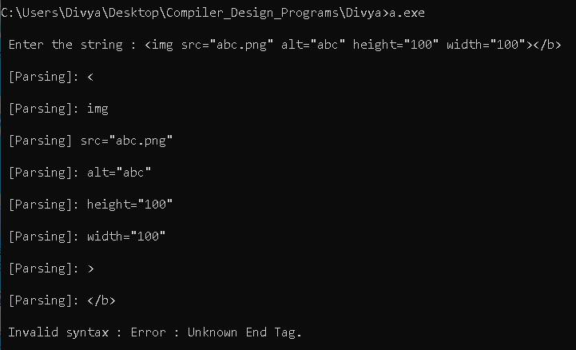

1. A img tag with missing attribute values.

Eg:

<img src= alt=>

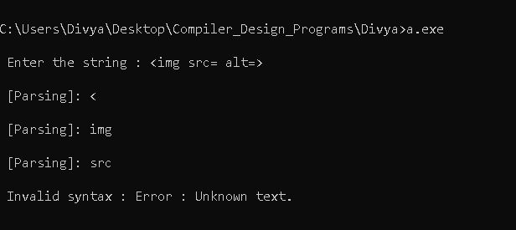

1. A img tag with missing attribute names.

Eg:

<img src="img1.png" ="img" >

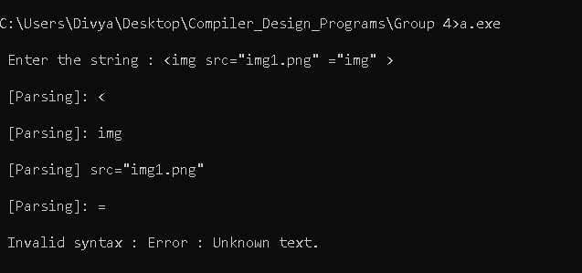

1. A img tag with content inside tags.

Eg:

<img src=”abc.png” alt=”abc”>Hello</img>

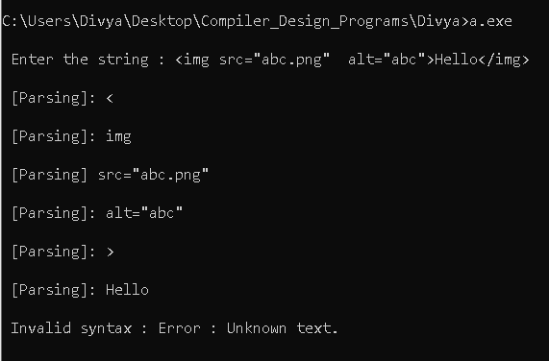

**Test Cases for <a> tag (Valid)**

1. A <a>tag used with attributes and same start and end tag.

Eg:

<a href=”www.google.com”> </a>

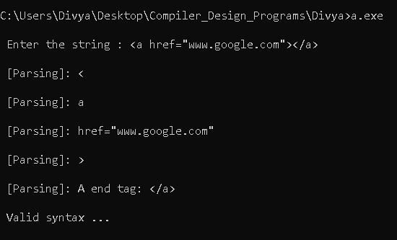

1. A <a>tag with no attribute.

Eg:

<a > </a>

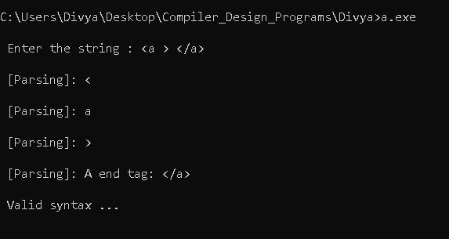

1. A <a> tag can have content in it.

Eg:

<a href=”www.google.com”>Google</a>

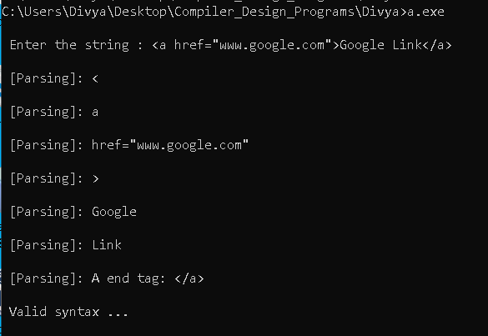

1. A <a> tag with different attributes in any order.

Eg: <a download=”pqr” href=”www.hi.com” target=”abc”> </a>

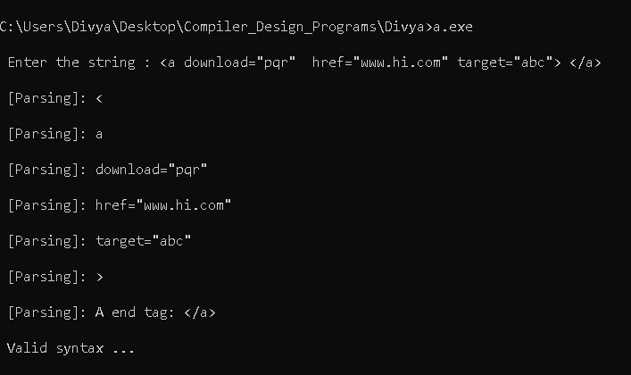

#### Test Cases for <a> tag (Invalid)

1. A <a> tag with or without attributes but invalid ending.

Eg

* 1. End tag is not mached with starting tag.

Eg: <a href=”www.google.com”></b>

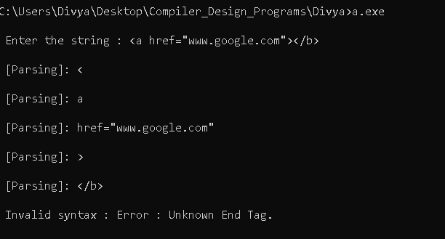

* 1. Missing endtag.

Eg: <a>

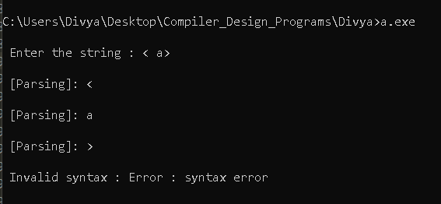

1. A <a> tag with unknown attributes.

Eg: <a ref="www.google.com"></a>

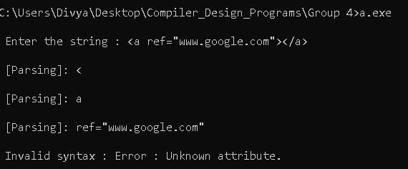

#### Test Cases for Nested Tags (Valid)

1. <a> tag enclosing <a> tags.

Eg:

<a href=”www.google.com”> <a>hello</a> </a>

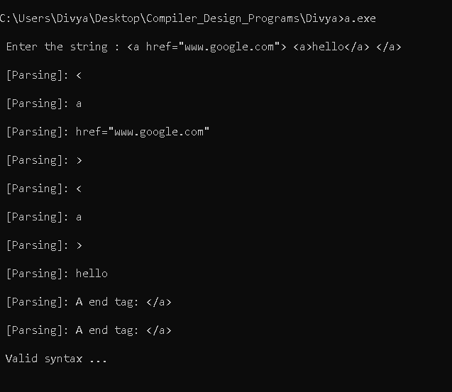

1. A nested tag enclosing <img> tags

Eg:

<a href=”www.google.com”> <img src=”d” alt=”o” height=”12”/> </a>

#### 

1. A nested tag enclosing both <a> and <img> tags in any order.

Eg:

<a href=”www.google.com”>

<a>

In inner first a_tag

</a>

<a>

In inner second a_tag

<img src=”d” alt=”o” height=”12”/>

</a>

</a>

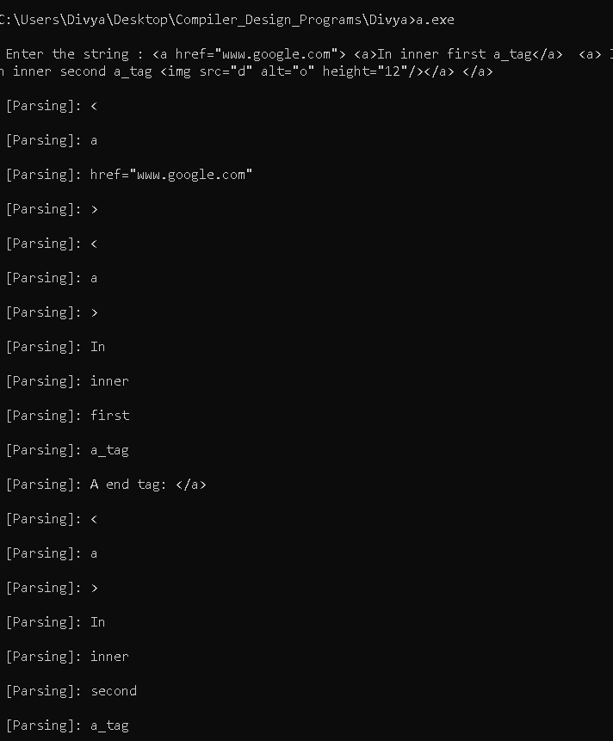

#### 

#### Test Cases for Nested Tags (Invalid)

* 1. A nested tag enclosing tags other than <a> or <img> tags.

Eg:

<a href=”www.google.com”> <div>hello</div> </a>

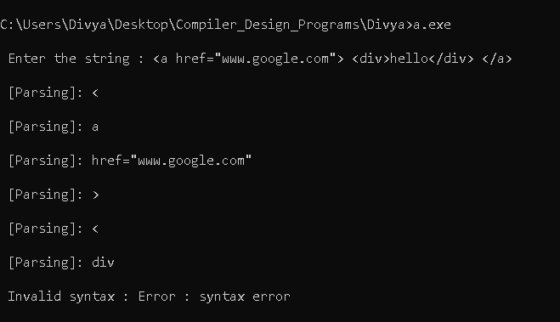

* 1. A nested tag enclosing other <a> or <img> tags without ending.

Eg:

<a href=”www.google.com”> <a>hello </a>

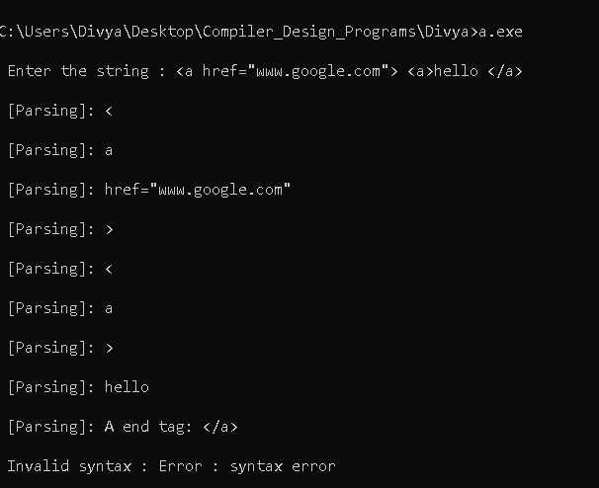

**LEX Code**

/* Lex Program. */

%{

/*contains declaration of all the tokens in the yacc program*/

#include "y.tab.h"

/*variables used while validation*/

int a_valid = 0,end_tag1=0;

%}

/*Regular expressions to be matched while performaing lexical analysis*/

/*RE for whitespaces*/

Ws ([ \t]+)

/*RE for letters*/

Letter [A-Za-z]

/*RE for digits*/

Digit [0-9]

/*RE for identifiers*/

Name {Letter}({Letter}|{Digit}|[_])*

/*RE for content inside <a> tag*/

Content {Name}|{Digit}

/*attributes of <a> tag*/

AAttrList "download"|"href"|"hreflag"|"media"|"ping"|"referrerpolicy"|"rel"|"target"|"type"

/*attribute list for <a> tag*/

AAttr {AAttrList}

/*attributes of <img> tag*/

ImgAttList "height"|"width"|"crossorigin"|"use-credentials"|"ismap"|"loading"|"longdesc"|"referrerpolicy"|"no-referrer-when-downgrade"|"origin"|"origin-when-cross-origin"|"unsafe-url"|"sizes"|"usemap"

/*attribute list for image tag*/

ImgOtherAtt {ImgAttList}

/*RE for attribute value*/

AttValue (\"[^<>"]*\")|(\'[^<>']*\')

//end of declaration section

%%

/*translation rules

pattern {

action

}

*/

/* "<"" will be matched here.*/

[<] { printf("\n [Parsing]: %s\n", yytext);

return START_ANGLE_BRACKET;}

/* "a" will be matched here.*/

"a" { /*a_valid is used for validating content of <a> tag.*/

a_valid =1;

printf("\n [Parsing]: %s\n", yytext);

return A_TAG;}

"img" { printf("\n [Parsing]: %s\n", yytext);

return IMG_TAG;}

{Ws} {;}

/*anchor tag's attribute is matched here*/

{AAttrList}{Ws}?[=]{Ws}?{AttValue}{Ws}? {

//valid attribute for a tag

printf("\n [Parsing]: %s\n", yytext);

return A_ATTRIBUTE;

}

">" { /*end_tag1 is used for validating content of <a> tag.*/

end_tag1=1;

printf("\n [Parsing]: %s\n", yytext);

return END_TAG1;}

/*End tag for </a> is matched here*/

"<"{Ws}?"/"{Ws}?"a"{Ws}?">" {

//valid endtag

printf("\n [Parsing]: A end tag: %s\n", yytext);

return A_END_TAG;

}

/*Unlnown End tags matched here*/

"<"{Ws}?"/"{Ws}?{Name}{Ws}?">" {

//valid endtag

printf("\n [Parsing]: %s\n", yytext);

yyerror("Unknown End Tag.");

}

/*content inside <a> tag is matched here.*/

{Content} {

if(a_valid==1 && end_tag1==1)

{

printf("\n [Parsing]: %s\n", yytext);

return A_CONTENT;

}

else

{

printf("\n [Parsing]: %s\n", yytext);

yyerror("Unknown text.");

}

}

/*attribute src of image tag with attribute value is matched here.*/

"src"{Ws}?"="{Ws}?{AttValue}{Ws}? {

printf("\n [Parsing] %s\n", yytext);

return IMG_SRC;

}

/*attribute alt of image tag with attribute value is matched here.*/

"alt"{Ws}?"="{Ws}?{AttValue}{Ws}? {

printf("\n [Parsing]: %s\n", yytext);

return IMG_ALT;

}

/*all other valid img attributes is matched here*/

{ImgOtherAtt}{Ws}?"="{Ws}?{AttValue}{Ws}? {

//valid attribute for img tag

printf("\n [Parsing]: %s\n", yytext);

return IMG_OTHER_ATTRIBUTE;

}

/*all other attributes which are invalid are matched here*/

{Name}{Ws}?"="{Ws}?{AttValue}{Ws}? {

//attribute list doesnot content this attribute

printf("\n [Parsing]: %s\n", yytext);

yyerror("Unknown attribute.");

}

/*End tag for image "/>" is matched here*/

"/"{Ws}?">"{Ws}? {

//valid endtag for img

printf("\n [Parsing]: %s\n", yytext);

return IMG_END_TAG2;

}

/*End tag for image "></img> is matched here*/

">"{Ws}?"<"{Ws}?"/"{Ws}?("img"){Ws}?">"{Ws}? {

//valid endtag

printf("\n [Parsing]: Image end tag: %s\n", yytext);

return IMG_END_TAG3;

}

/*newline character*/

[\n] { return NL; }

/*Everything else is matched here.*/

. { printf("\n [Parsing]: %s\n", yytext);

yyerror("Unknown text.");}

%%

int yywrap()

{

return 1;

}

**YACC Code**

/*

Y File

Implementing parser using lex and yacc to validate <img> and <a> tag of html

*/

%{

#include<stdio.h>

#include<stdlib.h>

int yyerror();

%}

//tokens generated by lexical analyzer and passed to parser.

%token START_ANGLE_BRACKET NL A_TAG A_ATTRIBUTE SYNTAX_ERROR EQUAL ATTR_VALUE END_TAG1 A_CONTENT A_END_TAG IMG_TAG IMG_ALT IMG_SRC IMG_OTHER_ATTRIBUTE IMG_END_TAG2 IMG_END_TAG3

%%

//Grammer rules.

//if stmt is reached msg valid syntax is printed.

stmt : S NL { printf("\n Valid syntax ...\n\n");

exit(0);}

;

//start symbol(S) goes to <img> tag or <a> tag.

// START_ANGLE_BRACKET = "<".

S : START_ANGLE_BRACKET A_TAG anchor_attrs

| START_ANGLE_BRACKET IMG_TAG img_comp_attr img_other_attr img_ending

;

img_comp_attr : img_comp_attr_1

| img_comp_attr_2

;

img_comp_attr_1 : IMG_SRC IMG_ALT

;

img_comp_attr_2 : IMG_ALT IMG_SRC

;

img_other_attr : IMG_OTHER_ATTRIBUTE img_other_attr

|

;

//img can have three type of end tag >, /> or </img>.

img_ending : IMG_END_TAG3

| IMG_END_TAG2

| END_TAG1

;

anchor_attrs : A_ATTRIBUTE anchor_attrs

| END_TAG1 anchor_rem A_END_TAG

;

//Tags nesting is done here in <a> tag.

anchor_rem : content S anchor_rem

| content

;

content : A_CONTENT content

|

;

%%

void main()

{

printf("\n Enter the string : ");

yyparse();

}

int yyerror(char *msg)

{

printf("\n Invalid syntax : Error : %s\n\n",msg);

exit(0);

}

##### References

Compilers, principles, techniques, and tools / Alfred V. Aho, Ravi. Sethi, Jeﬀrey D. Ullman. 1986. ISBN 0-321-48681-1

<https://www.geeksforgeeks.org/> for tag syntax

THANK YOU