Category: Hospital Furniture

Product: Dressing Trolley

Specifications:

* Size: 76 X 51 X 90 cm
* Tubular frame powder coated with two heavy S. S. shelves
* Mounted as four castors 20 cm
* Protective railing on four sides on both shelves
* Available with Bowl & Bucket

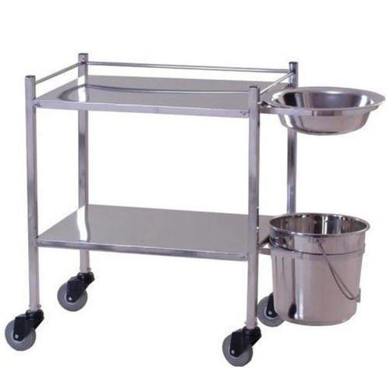

Category: Hospital Furniture

Product: Lifting Pole

Specifications:

* S. S. Tubular pole fitted with hand grip
* Easily fitted backside of the head bow
* Pole can be mounted on either side of the bed and allows the occupant to reposition

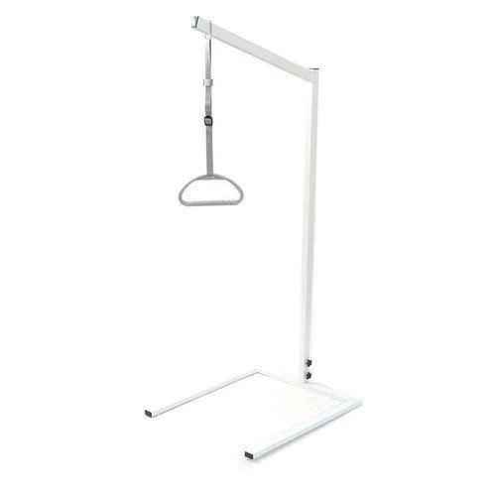

Category: General

Product: Surgical Tapes

Specifications:

* Used for dressing and general medical applications
* Made from a cotton blended fabric
* Uniformly coated with hypoallergenic, non-toxic, non-irritant adhesive
* Easy to peel off without causing discomfort or skin irritation
* Thermosensitive adhesive activates better when it comes in contact with warm human skin
* Manufactured as per British Pharmacopoeia (BP) United State Pharmacopoeia (USP) guidelines

Packaging: Packed in Paper Box and Plastic Spool on Plastic Cores in the form of rolls.

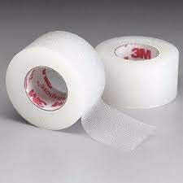

Category: General

Product: Face Shield

Specifications:

* Transparent
* Soft foam pad
* Adjustable elastic
* Face shield size: 11″× 10″
* Sheet thickness: 0.5mm

Packaging: Sterile, Individually packed in a peelable pouch.

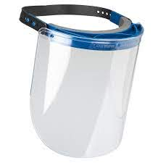

Category: General

Product: PPE Kits

Specifications:

P.P.E Kit consists of

1. Coverall Suit – 1Pc.

2. Nitrile Gloves – 1 Pair

3. Face Shield OR Plastic Goggles – 1 Pc.

4. Disposable Mask (3 Layers) – 1Pc.

5. Long Shoe Cover – 1 Pair

6. Waste/ Disposable Bag – 1Pc.

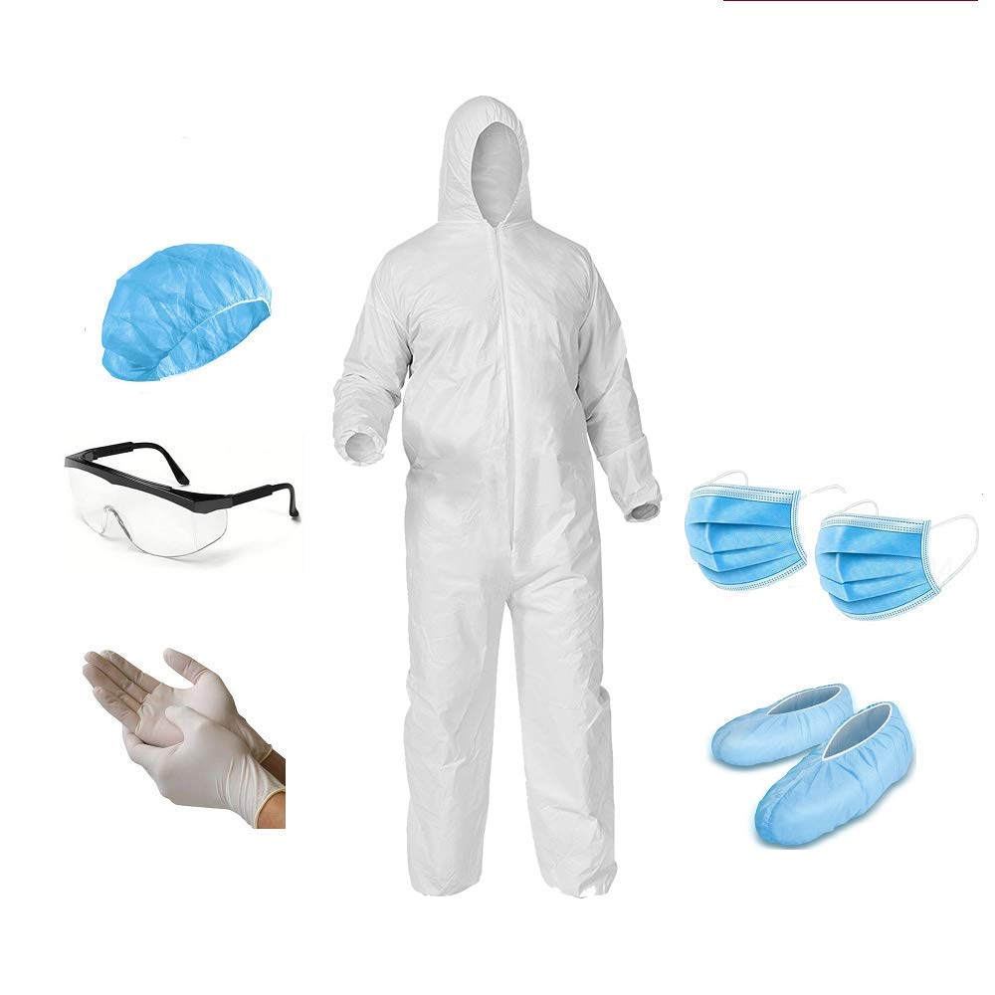

Category: Dental

Product: DENTAL ALBRECHT

Description: • ALBRECHT FORCEPS Used for dental extraction (also referred to as tooth extraction, exodontia or exodontics): the removal of teeth from the dental alveolus (socket) in the alveolar bone.

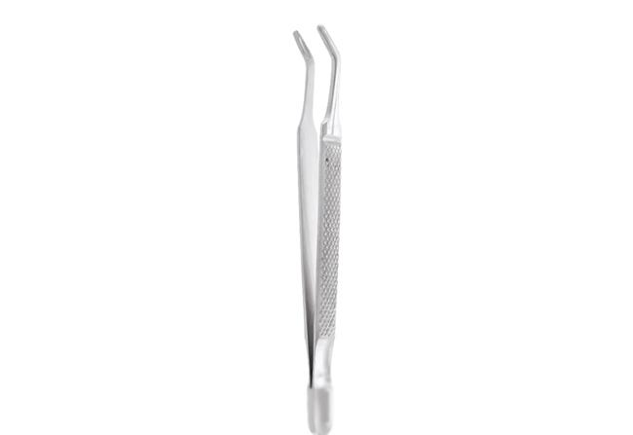

Category: Dental

Product: UPPER ROOT

Description: Upper Roots, Used for dental extraction (also referred to as tooth extraction, exodontia or exodontics): the removal of teeth from the dental alveolus (socket) in the alveolar bone.

