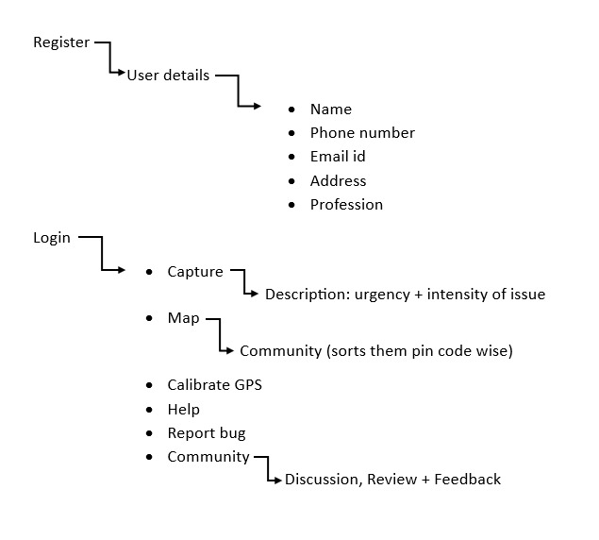

Register

User Details

* Name
* Phone Number
* Email id
* Address
* Username
* Password

Login (phone number)

* Capture

Photo + description

* Map

User’s location

* Community

V

1. map is displaying incorrectly

2. it is not capturing a picture

3. user location is not shown on map