Game Design Document

Fill up the following document

1. Write the title of your project.

4 Player Pong Game

1. What is the goal of the game?

The main aim of the game is to engage friend to play games together during this pandemic as the  **lockdown** has started again in many places .

1. Write a brief story of your game.

In this game there are 4 friend playing . In this they can move the players .

It is a game like 24 friends are playing **catch-catch**.

1. Which are the playing characters of this game?

* Playing characters are the ones who respond to the user based on the input from the user.
* Cars, monkeys, dinos, wizards, etc., are the playing characters in the game.

|  |  |  |
| --- | --- | --- |
| Number | Character Name | What can this character do? |
| 1 | Player1 | *Can hit the ball  *Can move right and left! |
| 2 | Player2 | *Can hit the ball  *Can move up and down ! |
| 3 | Player3 | *Can hit the ball  *Can move right and left ! |
| 4 | Player4 | *Can hit the ball  *Can move up and down ! |
| 5 |  |  |
| 6 |  |  |
| 7 |  |  |
| 8 |  |  |

1. Which are the Non-Playing Characters of this game?

* Non-Playing characters are the ones that don't have an action or behavior when the user interacts with the game.
* Hurdles, stones, bananas, coins, etc., are non-playing characters in the game.

|  |  |  |
| --- | --- | --- |
| Number | Character Name | What can this character do? |
| 1 | Ball | Can move in all the directions .  Be hit by the 4 players |
| 2 |  |  |
| 3 |  |  |
| 4 |  |  |
| 5 |  |  |
| 6 |  |  |
| 7 |  |  |
| 8 |  |  |

Draw your imagination of this game. What does this game look like?

* Draw the game either on your computer or on paper.
* Add images of the game scenes to show each of the playing and non-playing characters at least once.

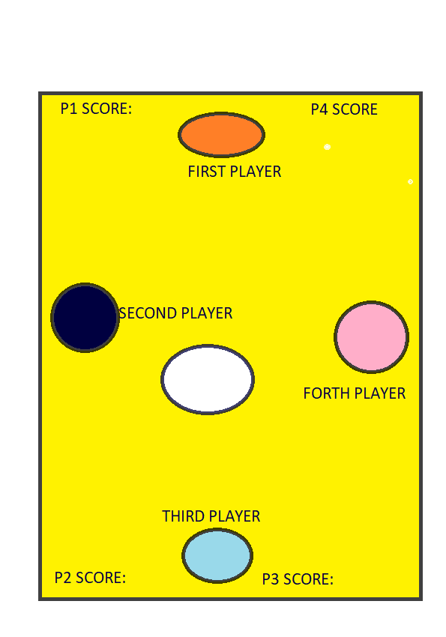

How do you plan to make your game engaging?

To make it engaging sound and score is added and some anomations are also there .