Game Design Document

Fill up the following document

1. Write the title of your project.
2. What is the goal of the game?

The main aim of the game is to engage friend to play games together during this pandemic as the  **lockdown** has started again in many places .

1. Write a brief story of your game.

In this game there are 4 friend playing . In this they can move the players .

It is a game like 24 friends are playing **catch-catch**.

1. Which are the playing characters of this game?

* Playing characters are the ones who respond to the user based on the input from the user.
* Cars, monkeys, dinos, wizards, etc., are the playing characters in the game.

|  |  |  |
| --- | --- | --- |
| Number | Character Name | What can this character do? |
| 1 | Player1 | *Can hit the ball  *Can move right and left! |
| 2 | Player2 | *Can hit the ball  *Can move up and down ! |
| 3 | Player3 | *Can hit the ball  *Can move right and left ! |
| 4 | Player4 | *Can hit the ball  *Can move up and down ! |
| 5 |  |  |
| 6 |  |  |
| 7 |  |  |
| 8 |  |  |

1. Which are the Non-Playing Characters of this game?

* Non-Playing characters are the ones that don't have an action or behavior when the user interacts with the game.
* Hurdles, stones, bananas, coins, etc., are non-playing characters in the game.

|  |  |  |
| --- | --- | --- |
| Number | Character Name | What can this character do? |
| 1 | Ball | Can move in all the directions .  Be hit by the 4 players |
| 2 |  |  |
| 3 |  |  |
| 4 |  |  |
| 5 |  |  |
| 6 |  |  |
| 7 |  |  |
| 8 |  |  |

Draw your imagination of this game. What does this game look like?

* Draw the game either on your computer or on paper.
* Add images of the game scenes to show each of the playing and non-playing characters at least once.

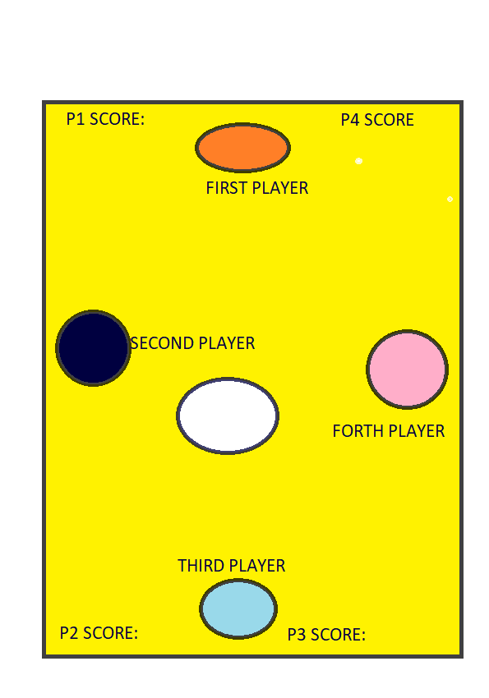

How do you plan to make your game engaging?

To make it engaging sound and score is added and some anomations are also there .