Advanced Task 3 – SSRS Reports

15. Given suburb and city, display median rental value, median yearly income, and value changes of the property within 1 km radius

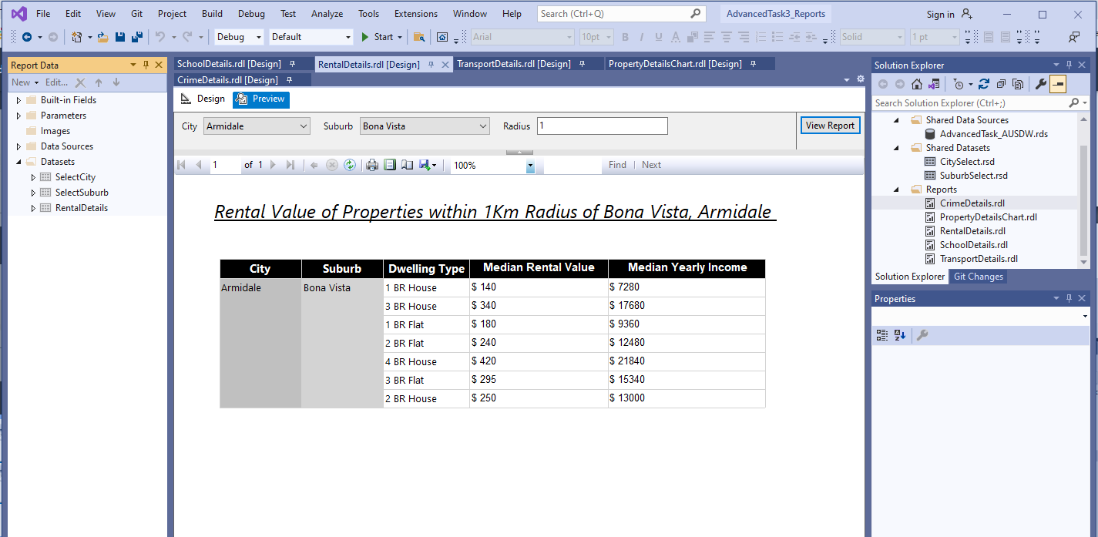

16. Given suburb and city, display local public transport within 1km radius - update data sets

18. Given suburb and city, display property value of the area in Column chart and line chart of 1 year, 5 years and 10 years value

18. Given suburb and city, display crime rate within 1 km radius

