**Problem Statement 01**

Create a table with the schema as specified below and load the data.

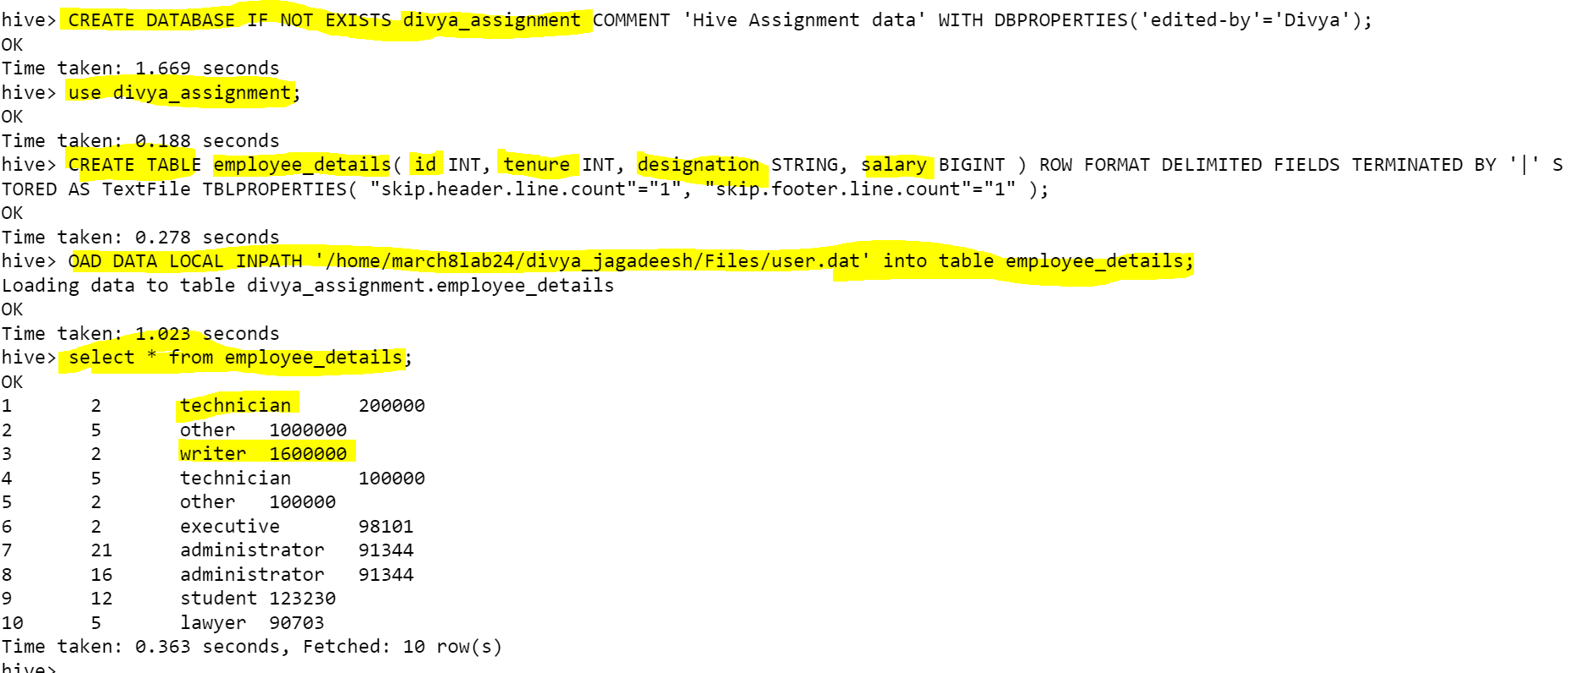

Write a query to derive a new column extra_vacation based on the tenure served, the logic is as given below.

1. If tenure < 2, Then 20

2. If tenure is 2-10 then 30 days

3. If tenure > 10 then 40 days

**Problem Statement 02**

Create a table “temperature” to store the dataset as mentioned in the schema and load the data

Write a query to calculate the maximum temperature of each state.

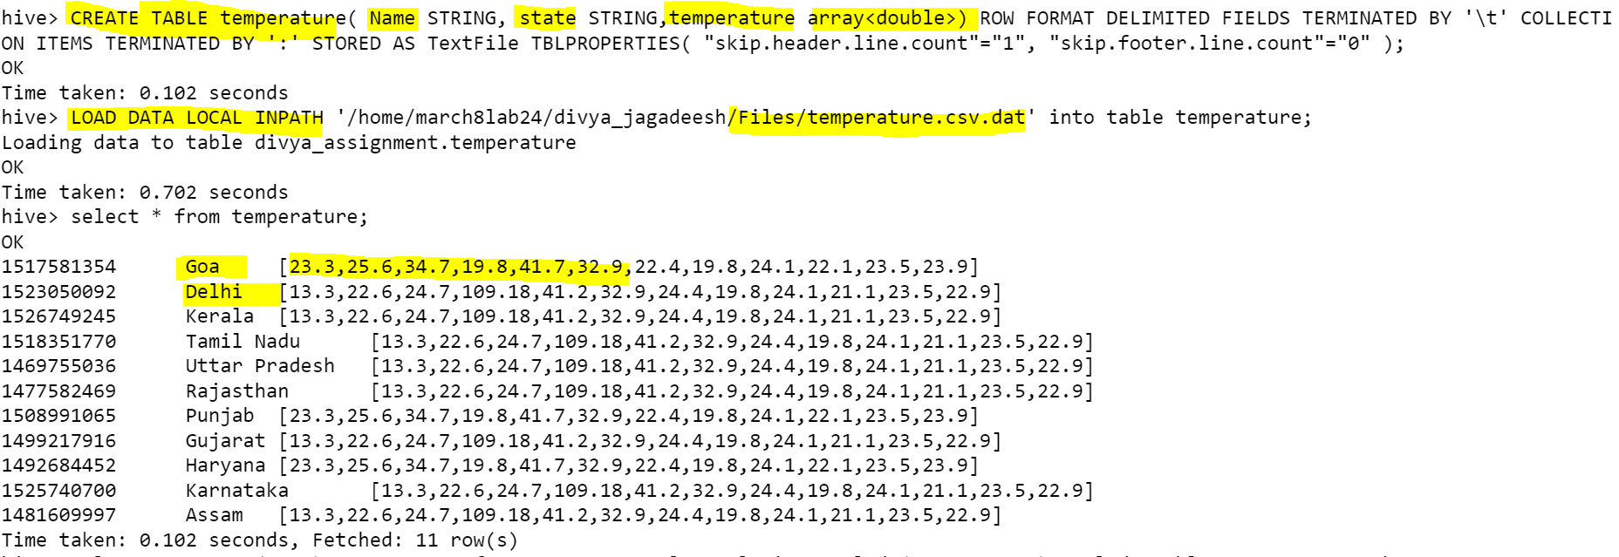

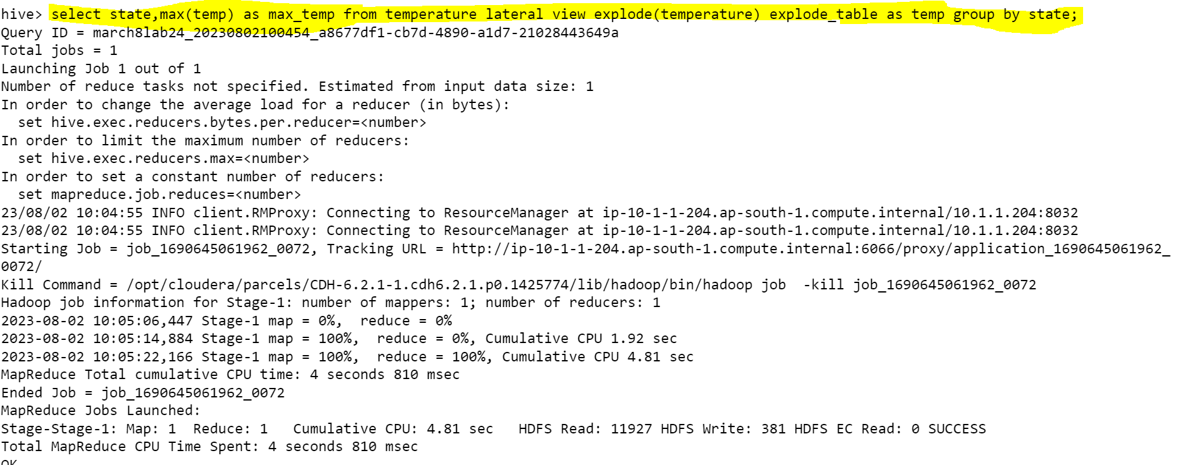

**Problem Statement 03**

Create a table 'student_marks' with schema as shown above and load the data into the 'student_marks' table.

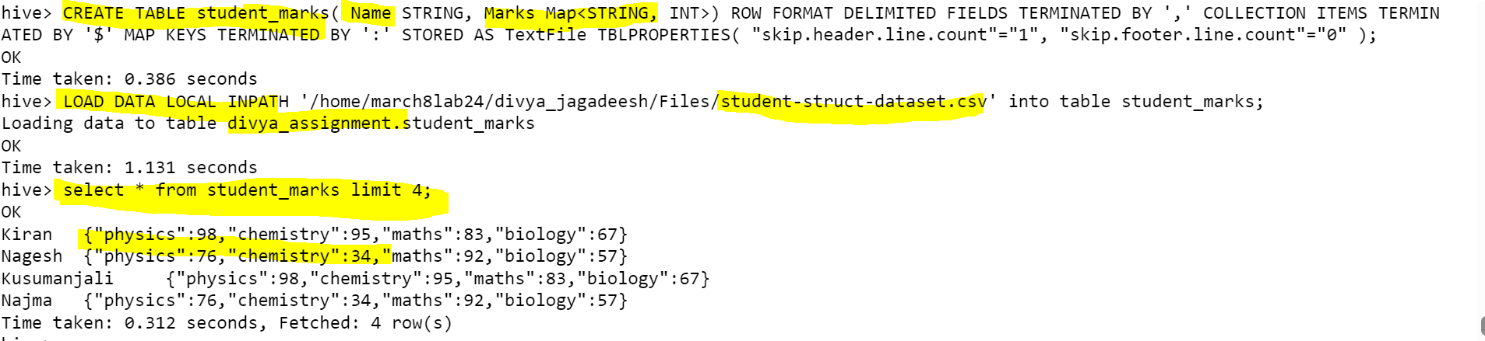

Write a query to perform below mentioned tasks:

Display NAME who have scored more than 90 in subject Maths subject

Added limitation on displaying the records.

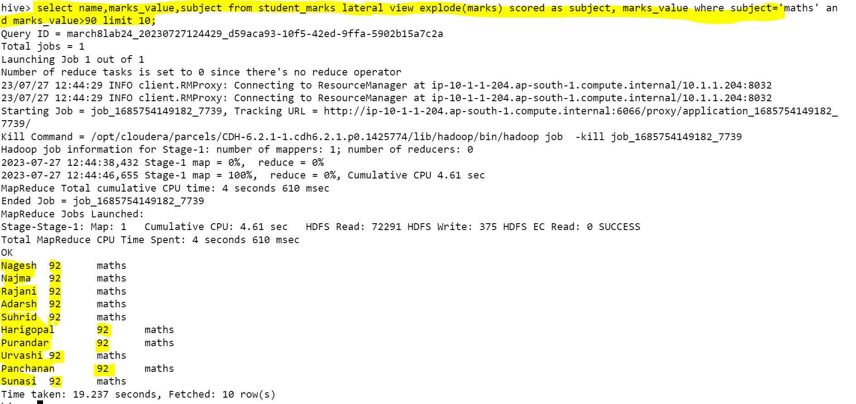

Display NAME and marks scored in physics subject.

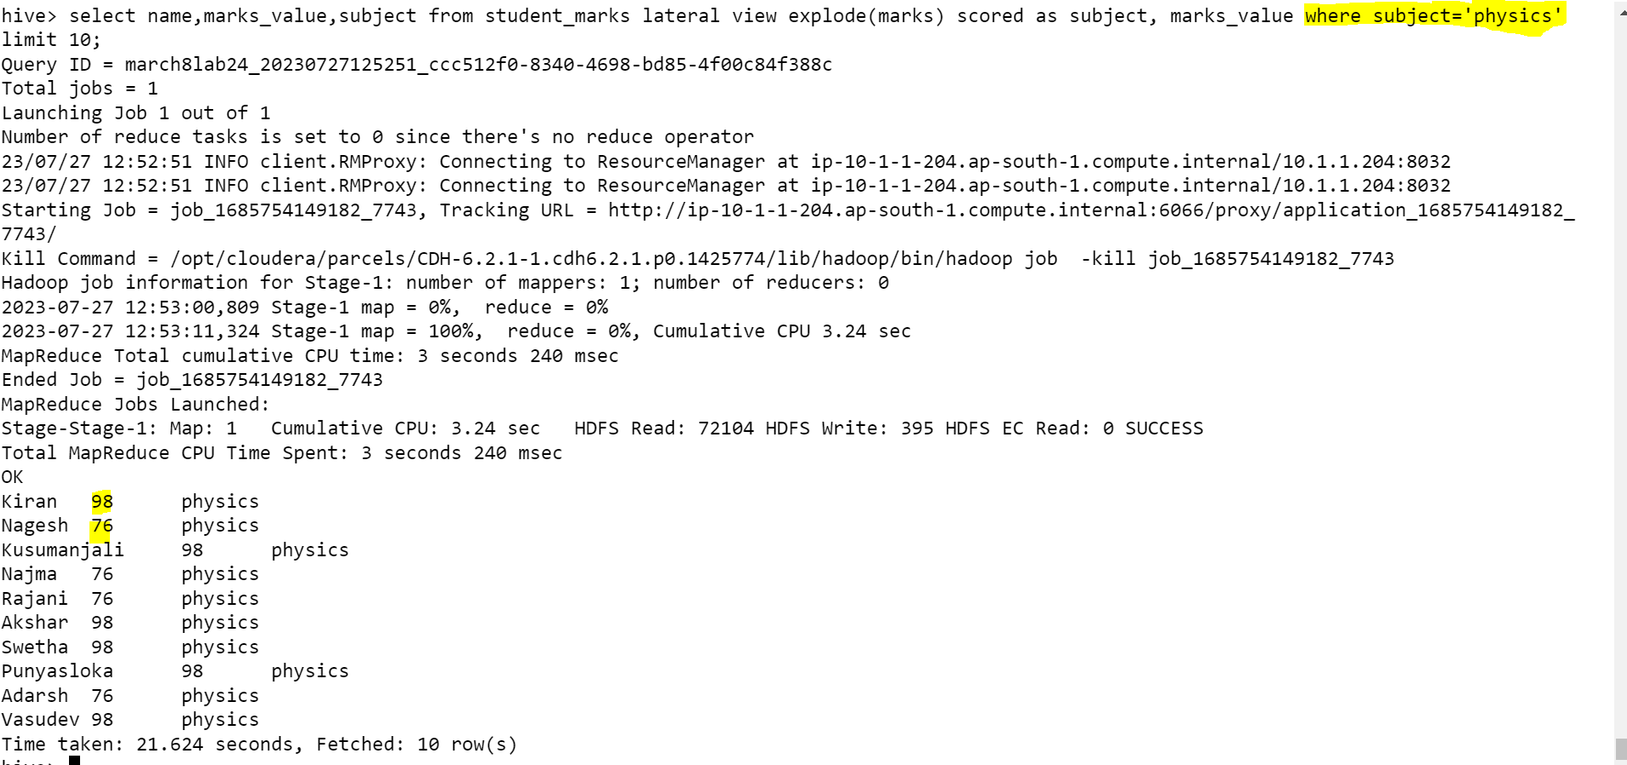

Display NAME, and <Maximum-Subject-Marks>

Display NAME, and <average -Subject-Marks>

Display NAME and percentage of marks

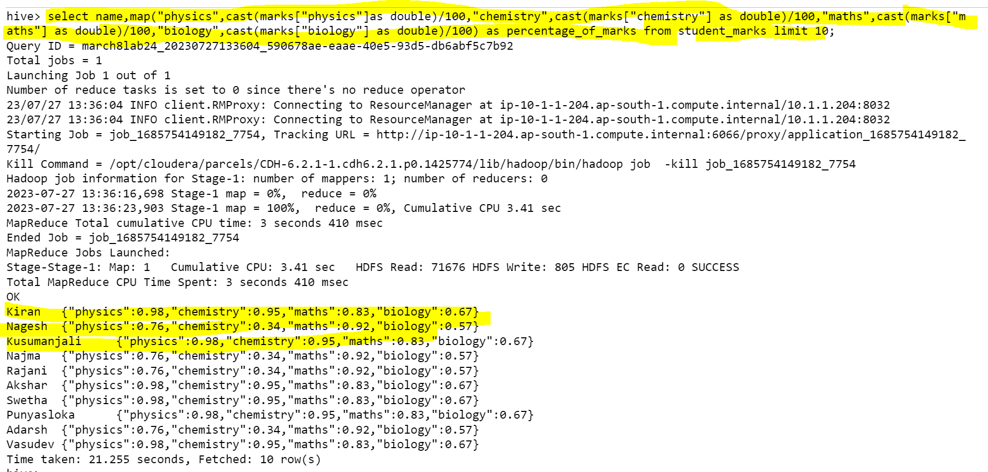

**Problem Statement 04**

Create a table “student_info” with schema as show below and load the data

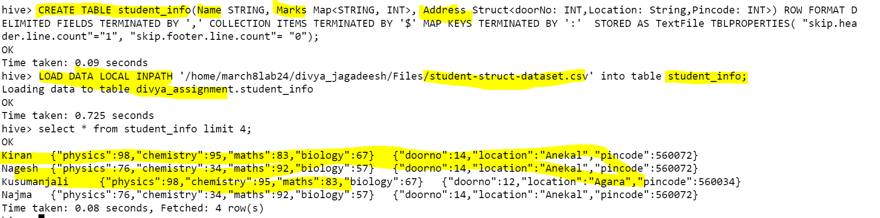

1. Display all “NAME” who is located in Banashankari

1. Calculate the total count who is staying in pin code 560001

