# **Mobile Application Development - Project Report**

# **HouseCall M.D**

**Introduction**

House Call M.D. is a Healthcare mobile application designed to provide medical services for the patients right at the doorstep. It provides mobile access for the patients to be able to book appointments with doctors & nurses specialized in various fields. It provides provision to gain acute medical attention to patients or specialized treatment as required. The application was inspired by ideology from applications like ZocDoc and DispatchHealth.

**Features**

1. **House Call:** Provides for House Call facility to patients by Doctors and Nurses. The application collects the user location to provide this facility and using this the Doctor / Nurse can get to the patient location to administer treatment as needed. These services come at a cost:
   1. **Doctors**: Services cost relatively more as they are specialized practitioners in specific fields of medicine.
   2. **Nurses**: Services cost lesser as they are not specialized in any field of medicine. Provide general care to patients.
2. **User Category:** This Application has three user levels in it. These can be classified as a service provider and service consumer. The user level roles are as follows:
   1. Patient
   2. Doctor
   3. Nurse
3. **Registration Page:** that allows users with a different role to be able to register with our application which is based on the service provider and service consumer:
   1. **Doctor / Nurse:** If Doctor or Nurse is selected; the user will be taken to an electronic form where they will fill out
      1. Name
      2. Occupation
      3. Specialization
      4. Address
      5. Email
      6. Contact
   2. **Patient:** The user will be taken to an electronic form where they will fill out:
      1. Personal Information
      2. Name
      3. Address
      4. Date of Birth
      5. Email
      6. Phone
      7. Gender
      8. Marital Status
      9. Insurance Provider
      10. Insurance Group Name
      11. Insurance Account Number
      12. Emergency Contact Information: Name, Phone, Relationship
      13. Medical History
      14. Family History
      15. Lifestyle

**Main Functionality**

1. **Registration:** The application provides registration functionality for different account types: Patients, Nurses and Doctors
2. **Listing:** The application provides for patients (registered patients) with a list of doctors/nurses (registered) that are available to provide service in the same location.
   1. The listing is shown based on records of doctors and nurses who signed up for the app and the patient location
   2. Lists the doctors with the following information:
      1. Name
      2. Occupation (For Example Doctor or Nurse)
      3. Specialty: Based on skill set of doctor or nurse
      4. Rates: Based on hours
3. **Confirmation** **of** **Service**:

This provides for the user (patient) to review the information of doctor/nurse and provides an additional layer to request or decline service from doctor/nurse owing to information provided.

This Functionality ensures that when a doctor or nurse is chosen from the list:

* 1. The listing of available doctors and nurses in the patients’ area is displayed
  2. Once a doctor or nurse is selected from the list, the confirmation page will show the details of the doctor or nurse selected
  3. The user then must verify the details and needs to choose a request or cancel. In case of cancel, patient would be redirected to listing of doctors and nurses so that they can choose another doctor or nurse
  4. If doctor/nurse is available to provide service for the requested slot, a confirmation message shall be displayed indicating confirmation of appointment

**Future Enhancements**

Future enhancements to the existing functionality to improve the application and its features are listed as below:

1. **Login Page:**

Forgot password functionality – To be able to reset the password of a user in case the user forgets the password.

1. **Registration Page:**

Be able to integrate with ZocDoc so forms would be filled automatically.

1. **Main Hub Page:** 
   1. **Availability**: Patients can check if the doctor or nurse is available during a time window
   2. **Zip code**: Users can check the availability of doctors/nurses at different locations by filling in the Zip code field that would display a list of doctors/nurses for that specific Zip code.
2. **Confirmation of Service:**

Refusal Message - If medical professional is not available, then a refusal message would be displayed, and the control would be provided back to the user back to choose another doctor or nurse

1. **Insurance accepted by the doctors/nurses:**

We would like to indicate the insurances accepted by the doctors and nurses so that the patient can choose the doctor or nurse in their network.

**Revenue Stream**

The major revenue generated is with the commission received after providing services to the patients and doctor/nurse. We would also like to incorporate the provision to advertise various insurances in order to generate revenue.

**Application Functionality Backend**

The application uses SQLiteDatabase to manage its own private database. SQLiteDatabase has methods to create, delete, execute SQL commands, and perform other common database management tasks.

There are two tables that are being used in the application:

1. patient
2. doctor_nurse

The DatabaseHandler class in the application takes care of creating tables, inserting and fetching the patients, doctors/nurses information stored in the database using SQL commands.

A list of doctors/nurses and patients in the Atlanta and Austin areas are inserted into the database when the application is loaded.

Usernames and passwords for initial login:

1. Username: [divya@gmail.com](mailto:divya@gmail.com) Password: divya
2. Username: [teja@gmail.com](mailto:teja@gmail.com) Password: teja
3. Username: [ravi@gmail.com](mailto:ravi@gmail.com) Password: ravi

The first user belongs to Atlanta area, so the list of doctors/nurses registered in Atlanta area are shown to the users.

The second user belongs to Austin area, so the list of doctors/nurses registered in Austin area are shown to the users.

When there are no doctors/nurses available in the patients’ location (For example, the third user), a message is shown to the user that there are no doctors/nurses available and the user is asked to check back later.

**Github link of the project:**

<https://github.com/divyaaligireddy/Mobile-App-Development>

**Screenshots**

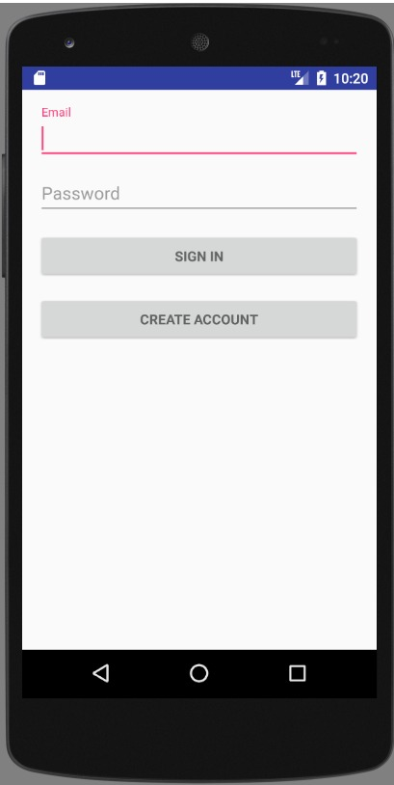 **A screenshot of a cell phone

Description generated with very high confidence** 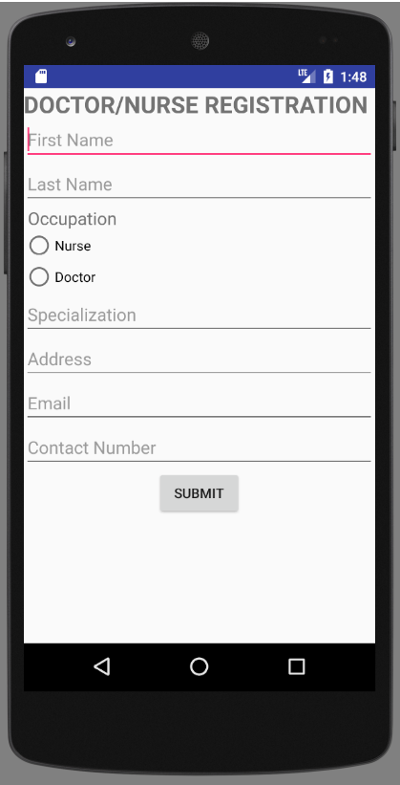 A screenshot of a cell phone

Description generated with very high confidence 