**Shipt - QA Engineer - Interview Exercise**

Upon completion of this exercise, push all your files into github and send us a link.

1. Navigate to www.shipt.com. Choose a feature of the site and write a description or test case to describe how to test the feature.

**Forgot Password link?**

**Notes:** Looks like there is no error check and no password complexity implemented for Forgot Password feature

**Pre-Condition: Click on Log In button to navigate to Forgot Password link?**

|  |  |  |  |  |
| --- | --- | --- | --- | --- |
| **Test Case** | **Actual** | **Expected** | **Bug** | **Notes** |
| Click on Forgot Password link | It navigates to Reset Password page which should have Shipt logo a text field and a button | It navigates to Reset Password page which should have Shipt logo a text field and a button |  |  |
| Shipt logo is clickable | Navigates to www.app.shipt.com | Navigates to www.app.shipt.com | As a user I would expect it to navigate to Home page (www.shipt.com) | Not sure if this is an expected behavior but it navigates to <https://app.shipt.com/> where it does not have any content in it |
| Empty text field and click on Reset Password button | Please fill out the field | Please fill out the field |  |  |
| Enter only numbers in text field and click on Reset Password button | Check your email for Password reset instructions | It should say something like Incorrect email address | Incorrect messaging which might misguide users | It shows as red message in the same page |
| Enter only letters and click on Reset Password button | Check your email for Password reset instructions | It should say something like Incorrect email address | Incorrect messaging which might misguide users | It shows as red message in the same page |
| Enter only special characters(!@#$%^&*())and click on Reset Password button | Check your email for Password reset instructions | It should say something like Incorrect email address | Incorrect messaging which might misguide users | It shows as red message in the same page |
| Enter only @ and click on Reset Password button | Check your email for password reset instructions | It should say something like Incorrect email address | Incorrect messaging which might misguide users and navigates to new page which would tell a user that it was successful | It navigates to app.shipt.com and shows **Check your email for password reset** **instructions** message in green color |
| Try successful email immediately (For e.g. try@) | You cannot request to reset your password again so soon. Please wait 5 minutes | You cannot request to reset your password again so soon. Please wait 5 minutes |  |  |
| Enter valid email address | It navigates to app.shipt.com with a message Check your email for password reset instructions | It navigates to app.shipt.com with a message Check your email for password reset instructions |  |  |
| Once successful user should navigate to their email address to see if they received a reset password email | Reset Your Shipt Password email | Reset Your Shipt Password |  |  |
| Click on Create or Reset Password button from email | It should navigate to https://app.shipt.com/password_resets/NYPQLoozkpcFfCxHRYUu/edit where user can enter password | It should navigate to https://app.shipt.com/password_resets/NYPQLoozkpcFfCxHRYUu/edit where user can enter password |  |  |
| New password page | Should have Shipt logo, Title, Email Address, Password, Password confirmation field and a Update password button | Should have Shipt logo, Title, Email Address, Password, Password confirmation field and a Update password button |  |  |
| Enter only1 character(either number, letter or special character) | Validation failed: Password must be between 6 and 71 characters long | Validation failed: Password must be between 6 and 71 characters long |  |  |
| Enter 5 characters(either number, letter or special character) | Validation failed: Password must be between 6 and 71 characters long | Validation failed: Password must be between 6 and 71 characters long |  |  |
| Enter 6 or more characters(either number, letter or special character) | Password was successfully updated | Password was successfully updated |  |  |
| Enter more than 71 characters(either number, letter or special character) | Validation failed: Password must be between 6 and 71 characters long | Validation failed: Password must be between 6 and 71 characters long |  |  |

1. Locate one bug or bad workflow within the app

Broken links on website

1. http://credits.shipt.com/
2. https://www.shipt.com/home/

(https://www.shipt.com/wp-content/themes/shipt/assets/video/hiw-video-1.mp4

https://www.shipt.com/wp-content/themes/shipt/assets/video/hiw-video-3.mp4)

1. Explain the behavior you are seeing

* Host not found🡪 http://credits.shipt.com/
* 404 not found🡪 https://www.shipt.com/home/

There are some videos that are not loading when navigated to https://www.shipt.com/home/

1. Include any useful errors or screenshots

**Please find screenshots attached at the end of the document. For some reason I could not attach them here.**

Host not found🡪 <http://credits.shipt.com/>

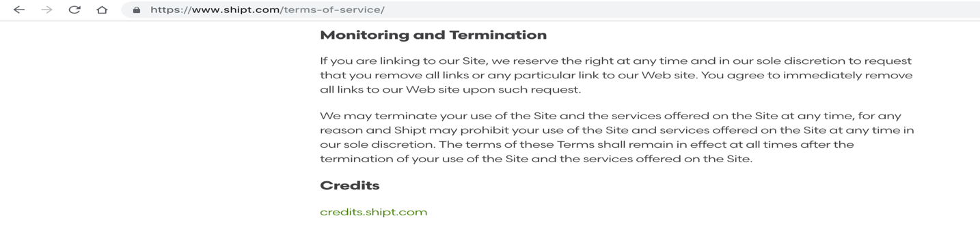

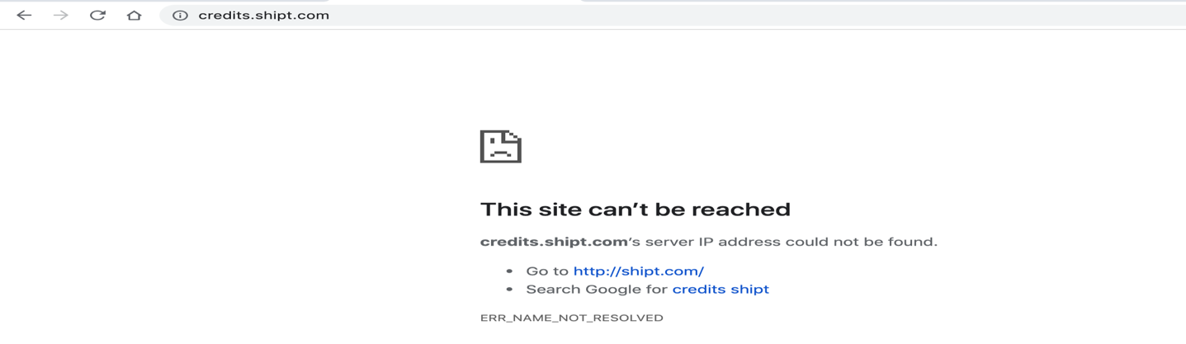

Not found🡪 https://www.shipt.com/home/

(https://www.shipt.com/wp-content/themes/shipt/assets/video/hiw-video-1.mp4

https://www.shipt.com/wp-content/themes/shipt/assets/video/hiw-video-3.mp4)

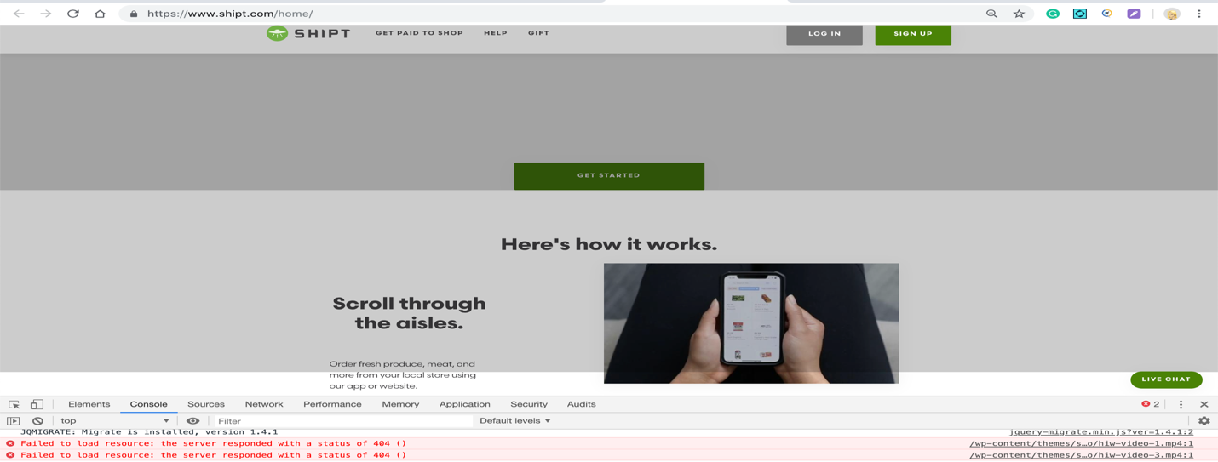



1. Explain why and how it needs to be corrected

These are the links that are on website and it looks awful when user tries to link on any of the links as they are broken.

1. What are the steps you would take to report the issue?

I would write a bug which includes Summary, Priority, Severity, Screenshots/videos, Steps, Actual Result, Expected Result, assigning it to respective person and assigning a QA owner to verify it once it is resolved.

1. What priority would you give this bug (Scale of 1-5, 1 being highest) and why?

Above mentioned bugs are not BLOCKERS or CRITICAL as they are not blocking any of the existing/main functionality where it blocks Shipt business or blocks any of the users.

But I would still consider them as MAJOR as they exists on website where I would expect new users to check it out and it is important to fix them.

1. What are the possible reasons for the following defect? How would you go about debugging the problem and gathering more information?

On a web application, a user adds a phone number to their account. The user then changes the phone number. Upon trying to re-enter the first phone number, the user is allowed to click Save, and it seems to work, but the saved number remains the second number rather than updating to the more recently entered number. A page refresh does not change the result.

**Reasons:** update userProfileapi is not being called **or** backend api is not giving correct information(May be they are caching it?? or caching is not refreshed) **or** client UI is not fetching latest data from api.

**Debugging:** Open console on my browser

I assume Phone number is saved in User Profile. But whenever I try to make a change in Phone Number field I would expect **update userProfile api** to be called with the fresh phone number and data base where all the information is saved should be updated with latest as well.

**More Information:** Possible would 3 scenarios

1. update userProfile api and database return correct value but when page is refreshed it returns old value. That could possible a client issue.
2. update userProfile api returns with correct value and database is still saved with old value then it could be cache refresh issue on backend
3. update userProfile api returns old value and database is saved with new value then it could be cache refresh issue on backend

**SQL**  
Using the following schema, write SQL statements to answer the questions below:

create schema interview;

Create table interview.stores (

id integer,  
name text,  
allowed_alcohol boolean

);

Insert into interview.stores values (1,'Gettar',true);

Insert into interview.stores values (2,'Waysafe',false);

Create table interview.products (

id integer,  
name text,  
upc text,

created_at date

);

Insert into interview.products values (1,'Apple', '123', '2018-01-01');

Insert into interview.products values (2,'Banana', '456', '2018-01-02');  
Insert into interview.products values (3,'Grapes', '789', '2018-01-03');  
Insert into interview.products values (4,'Golden Banana', '456', '2018-02-04');

Insert into interview.products values (5,'Bouquet Flowers', '9213123', '2018-02-05');

create table interview.store_prices (

id integer,  
product_id integer,  
store_id integer,

price numeric

);

Insert into interview.store_prices values (1,3,1,2.59);

Insert into interview.store_prices values (2,2,1,3.32);

Insert into interview.store_prices values (3,4,1,3.59);

Insert into interview.store_prices values (4,3,2,2.34);

Insert into interview.store_prices values (5,1,2,1.56);

create table interview.order_lines (

id integer,  
product_id integer,  
store_id integer,

qty integer,

line_total numeric

);

Insert into interview.order_lines values (1,1,2,3,NULL);

Insert into interview.order_lines values (2,2,1,50,NULL);

Insert into interview.order_lines values (3,2,1,1,NULL);

Insert into interview.order_lines values (4,3,2,4,NULL);

1. List me the stores allowed to sell alcohol

select * from interview.stores where allowed_alcohol= true;

1. Give the product name of the 2 most expensive items based on their price at store id 1

**Just an observation:** numeric is changed as decimal(10,0) but I have changed to decimal(10,2) to get the precision.

select * from interview.store_prices sp, interview products p where sp.store_id= 1 and sp.product_id= p.id ORDER by sp.price DESC limit 2;

1. List the products that are not sold in the store id 2

select p.*, sp.* from interview.products p left outer join

interview.store_prices sp on p.id=sp.product_id and sp.store_id= 2

where sp.product_id is null;

1. What is the most popular item sold?

select ol.qty, p.name from interview.order_lines ol inner join interview.products p on

ol.product_id = p.id order by qty asc limit 1;

1. Write a SQL statement to update the line_total field

update interview.order_lines ol, interview.store_prices sp set ol.line_total=(sp.price*ol.qty)

where sp.product_id=ol.product_id and sp.store_id=ol.store_id;

**Automation Assessments**  
We recommend you choose from the following languages/tools. Feel free to use other tools if you feel they lend better to this type of testing. Please try to do both automation assessments listed below. Partial completion still counts for something, so please do what you can for both parts.

UI Automation

Write an automated test which accomplishes the following

1. Access ​www.shipt.com​ in the browser
2. Using the feature you chose for step 1, write an automated test
3. The test should validate the feature works as expected

We recommend you choose from the following languages/tools. Feel free to use other tools if you feel they lend better to this type of testing.

* Selenium
* Calabash
* Typescript/JavaScript
* Ruby

I have used Selenium Webdriver-Java to automate Forgot Password Happy Path Flow.

**API Automation**

Using the Star Wars API ​https://swapi.co/documentation​ write a test that does the following:

* Assert that Obi-Wan Kenobi was in the film A New Hope
* Assert that the Enterprise is a starship (yes, this should fail)
* Assert that Chewbacca is a Wookie
* Assert that the /starships endpoint returns the fields below:
* name
* model
* crew
* hyperdrive_rating
* pilots
* films
* Assert that the /starships count returned is correct by paging through the results

Feel free to use any language or helper package, but refrain from using tools such as Postman. Please provide documentation on executing your automation and setting up any dependencies. Recommended languages we use are below:

* Python/Pytest
* Ruby/Rspec
* Go/Testify

I have used Python/Pytest for API testing

Good assessments will have:

* Dependency management
* How to run documented in a readme
* Clear test failure messages
* Some reusable code on common actions (ex, logging or sending the HTTP request, interacting with browser)
* A GitHub repo

Above and Beyond for API:

* Setup a mock server that uses the same request/response schemas as the real API and run the same tests

**Automation Assessment Follow Up Questions**

1. If you chose to use a tool or language other than the recommended, briefly explain why?

None

1. How did you go about locating the elements for your tests?

For UI testing: I have used various things using inspect element and ChroPath(chrome extension)

By using XPath, Classname, LinkText and ID

1. What do you believe are the most common causes for instability in UI automation?

UI changes, Not following error standard codes.

1. How do you make your tests consistent and easy to debug?

**Tests are Consistent:** No hard coding, Execution based on schema version or UI version & pointing to isolated automation environment, setup and tear down of test data approach for every execution.

**Easy to Debug:**

Appropriate log files will be set and each execution of test suite/test case will be captured in the log files.