TECHNICAL SPECIFICATION
FOR
ATE for RFU
(BEL P/N: C409 020 144 44)


Applicability: Development & Manufacturing

Prepared By  Mr. M Karthik Kumar  ATE Engineer | Verified By  Mr. Krishnaprasad C  Principal Engineer | Checked By  BEL Rep
Reviewed By

Approved By

REVISION RECORD

Revision | Description | Date
00 | Original | 13.08.2026
AMENDMENTS RECORD

This document supersedes all earlier documents issued on the subject acceptance test procedure. All the previous record references are as below

DOCUMENT DISTRIBUTION LIST

Control Copy No. | Issued to
1 | RFMW
2 | D&E-EWAS
3 | TS-EWAS
4 | QM/EWAS
5 | OIC, ORDAQA, BEL Wing, Bengaluru

TABLE OF CONTENTS
List of Abbreviations: 8
1 Introduction 9
1.1 Scope 9
1.2 Applicable/Reference Documents 9
2 System Specifications 9
2.1 Description of the system 9
2.2 Hardware Composition 11
2.2.1 Interface Unit with Interface Cables (Looms) 11
2.2.2 ATE Rack 13
2.2.3 Heat Sink 13
2.2.4 Test Controller PC 14
2.2.5 LAN to GPIB Converter 14
2.2.6 Printer 15
2.2.7 Switch Matrix 15
2.3 System Operational Capability 16
2.3.1 Software Capability 16
2.3.2 Hardware Capability 16
2.4 Interface Specifications 16
2.4.1 Power Supply Interface 16
2.4.2 Bus Interface 16
2.4.3 Loom Interface 16
2.4.4 D sub interface 17
2.4.5 Human Machine Interface (HMI) 17
2.4.6 Discrete/Digital Output Specifications 17
2.4.7 RF Input Parameters Specifications 18
2.4.8 RF Output Parameters Specifications 18
2.5 System Health check Specifications 18
2.6 Memory specification 18
2.7 Compliance to standards 18
3 Custom DIO specifications 18
3.1 Centralized Control Logic (MAX 10 FPGA) 19
3.2 UUT Control and Signal Monitoring 19
3.3 Loom Integrity Testing 19
3.4 Power Distribution and Safety Interlocks 19
3.5 Signal Switching Matrix (RF and Analog) 19
3.6 Status Indication 19
4 Emergency Module 20
4.1 System Operation 20
4.2 Component Part Numbers 20
5 Physical characteristics 21
5.1 Dimensions 21
5.2 Weight 21
5.3 Mounting 21
5.4 Type of the Connectors of Interface Unit 21
5.5 Finishing 21
6 Growth Potential 21
7 Maintenance Specification 21
APPENDIX A: INTERFACE UNIT FRONT AND BACK PANEL 22
APPENDIX B: EMERGENCY MODULE FRONT AND BACK PANEL 23
APPENDIX C: SWITCH MATRIX BLOCK DIAGRAM 24
APPENDIX D: LIST OF LRU AND CARD LEVEL TESTS 25

List of Tables:

Table 1: List of Abbreviations | 8
Table 2: Applicable/Reference Documents | 9
Table 3: Interface Unit with Interface Cables (Looms) Parameters | 11
Table 4: ATE Rack Parameters | 12
Table 5: Heat Sink Parameters | 13
Table 6: Test Controller PC Parameters | 13
Table 7: LAN to GPIB Converter Parameters | 14
Table 8: Printer Parameters | 14
Table 9: Switch Matrix Parameters | 14
Table 10: UUT Controls Pin Mapping | 16
Table 11: Discrete/Digital Output Signals | 17
Table 13: Dimensions | 20
Table 14: Weight | 20
Table 15: Card Level Tests | 24

List of Figures:
Figure 1: Interface Unit External In/Out Naming | 10
Figure 2: Custom DIO Block Diagram  Figure 3: Emergency Unit Block Diagram | 18  19
Figure 4: Interface Unit Front Panel | 21
Figure 5: Interface Unit Back Panel  Figure 6: Emergency Unit Front Panel  Figure 7: Emergency Unit Back Panel | 21  22  22
Figure 8: Switch Matrix Block Diagram | 23

List of Abbreviations:
Acronym | Definition
AC | Alternating Current
ANT | Antenna
ATE | Automatic Test Equipment
AWG | American Wire Gauge
BEL | Bharat Electronics Limited
BITE | Built-In Test Equipment
BNC | Bayonet Neill-Concelman
CFM | Cubic Feet per Minute
CRO | Cathode Ray Oscilloscope
DC | Direct Current
DIO | Digital Input/Output
DVD | Digital Versatile Disc
ESD | Electrostatic Discharge
FPGA | Field Programmable Gate Array
GB | Gigabyte
GPIB | General Purpose Interface Bus
GUI | Graphical User Interface
HDMI | High-Definition Multimedia Interface
IEEE | Institute of Electrical and Electronics Engineers
LAN | Local Area Network
LED | Light Emitting Diode
LRU | Line Replaceable Unit
MB | Megabyte
MCB | Miniature Circuit Breaker
NC | Normally Closed
OS | Operating System
PCB | Printed Circuit Board
PCI/PCIe | Peripheral Component Interconnect / PCI Express
PDF | Portable Document Format
PN | Part Number
PRI | Pulse Repetition Interval
PW | Pulse Width
RAM | Random Access Memory
RF | Radio Frequency
RFU | Receiver Frontend Unit
RS-422 | Recommended Standard 422
RTN | Return
RW | Read/Write
SMA | SubMiniature version A
SSD | Solid State Drive
TTL | Transistor-Transistor Logic
USB | Universal Serial Bus
UUT | Unit Under Test
VAC | Volts AC
Table 1: List of Abbreviation

1 Introduction
The Automatic Test Equipment (ATE) Rack for the Receiver Frontend Unit (RFU) / Switch Filter Assembly (SFA) is a custom-designed test system developed to carry out functional and performance testing of the RFU/SFA of Tarang (BE PN: 4556 109 201 15) and RFU/SFA of R118 Project (BE PN: 4556 111 101 38) as per respective ATPs. This enhanced system provides a single, GUI-driven, computer-controlled environment where a Test Controller PC automatically sequences programmable test instruments, applies stimuli, captures responses, and generates standardized reports with pass/fail status. ATE is also built with capabilities of TTL Pulse generation, Control signal generation, signal monitoring and self-check.

1.1 Scope
This specification establishes the broad functional, technical, and design requirements for the ATE designated for the testing of RFUs. The system is strictly intended for use as ground-support equipment for testing of the RFUs, in accordance with the applicable Acceptance Test Procedures (ATPs)

1.2 Applicable/Reference Documents

Sl. No. | Document Reference No | Description
1 | Doc No: C40902013086 | Requirement Specification for ATE for RFUs
Table 2: Applicable/Reference Documents

2 System Specifications

2.1 Description of the system
The ATE-RFU is a customized test system used for functional and performance testing of the RFU variants. The ATE comprises an Interface Unit with Interface Cables (Looms), an ATE Rack, a Heat Sink, Power Supplies, a Switch Matrix, a Test Controller PC, a LAN-to-GPIB Converter, a printer and a specific suite of RF/test instruments (Signal Generator, Spectrum Analyzer, Power Meter, CRO, Digital Multimeter).
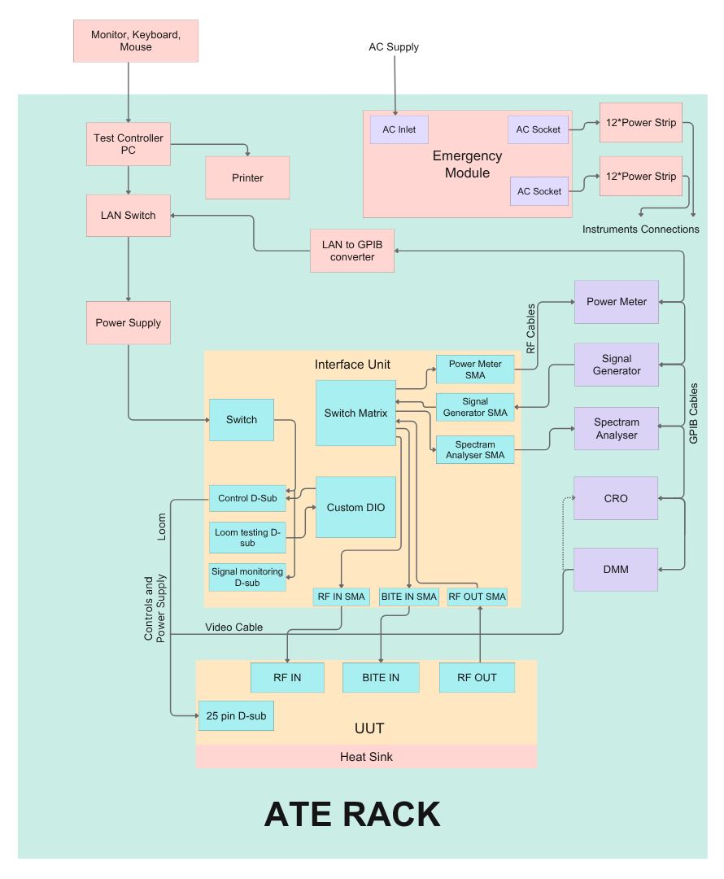
Figure 1: Interface unit external In/Out naming

2.2 Hardware Composition
This section describes each hardware component that forms the ATE – RFU system.

2.2.1 Interface Unit with Interface Cables (Looms)
The Interface Unit is the central interconnect and control element of the ATE. The UUTs, test instruments, power supplies, and control signals are routed through the Interface Unit. It generates control signals, routes power supply lines to the UUT, and routes RF inputs/outputs to/from the UUT to the appropriate test and measuring instruments based on the active test sequence.
Sl. No. | Parameter | Technical Specification
2.2.1.1 | Function – Signal Routing | Generate control signals; route power supply lines to UUT; route Video/RF input/output to/from UUT to test instruments as per test setup
2.2.1.2 | TTL Pulse Output – Pulse Width (PW) | 1 µs
2.2.1.3 | TTL Pulse Output – PRI | 10 µs
2.2.1.4 | TTL Pulse Output – Rise Time | <5 ns
2.2.1.5 | TTL Pulse Output – Tolerance | ±0.05%
2.2.1.6 | I/O Voltage Range – DC Voltage | −20 V to +20 V DC
2.2.1.7 | I/O Voltage Range – No. of I/O Lines | 25
2.2.1.8 | Front Panel – Voltage Monitoring Terminals | 25 (one per I/O / control signal)
2.2.1.9 | Front Panel – LED Indicators | 25 LED indicators for signal status  3 LED for power supply  1 LED for power supply status
2.2.1.10 | Front Panel – Toggle Switches | 3 toggle switches for manual ON/OFF of UUT DC power supply
2.2.1.11 | Engraving | ATE for RFU-Interface Unit and version name depicted
2.2.1.12 | RF Termination | All unused RF ports, switches, and power dividers terminated with 50 Ω
2.2.1.13 | Grounding | Common ground pin access in the panel
2.2.1.14 | Component Grade | Industrial grade
2.2.1.15 | Mechanical Size – Rack Compatibility | Fits inside 19" rack
2.2.1.16 | Mechanical Size – Height | 3U
2.2.1.17 | Cable Grade | Industrial grade; sleeved and labelled
2.2.1.18 | Cable Length | 1 meter
2.2.1.19 | Operating Temperature – Interface Unit | 0 °C to +50 °C
2.2.1.20 | Operating Temperature – Interface Cable | −40 °C to +75 °C
2.2.1.21 | Storage Temperature – Interface Unit | 0 °C to +70 °C
2.2.1.22 | Storage Temperature – Interface Cable | −55 °C to +90 °C
2.2.1.23 | Impedance | 93/95Ω
Table 3: Interface Unit with Interface Cables (Looms) Parameters

2.2.2 ATE Rack
The ATE Rack houses all hardware components of the system in a 19-inch, 42U floor-standing enclosure.
Sl. No. | Parameter | Specification
2.2.2.1 | Rack Size | 42U height, width 19"
2.2.2.2 | Material & Construction | Four vertical aluminum pillars connected to two welded steel end-frames
2.2.2.3 | Doors & Panels – Front | Perforated steel removable front door
2.2.2.4 | Doors & Panels – Rear | Perforated steel removable rear split door
2.2.2.5 | Doors & Panels – Side Panels | Lockable side panels included
2.2.2.6 | Wheels – Castor Wheels | 4*Medium-duty castor wheels with foot brake
2.2.2.7 | Wheels – Load Capacity | 400 kg capacity
2.2.2.9 | Cable Management | Vertical 42U channels with PVC cable loops
2.2.2.10 | Tray | Heavy Duty, 575mm, customizable positioning, qty12
2.2.2.11 | Equipment Support Angles | 20 No., customizable positioning
2.2.2.12 | AC Power Panel – Rating per Plug Point | 15A
2.2.2.13 | AC Power Panel – No. of Plug Points | 24
2.2.2.14 | AC Power Panel – Circuit Breaker | 32 A MCB with indicator
2.2.2.15 | AC Power Panel – Power Cable Length | 3 m
2.2.2.16 | ESD Protection | Grounding accommodated via included Earthing Kit
2.2.2.17 | Copper Earthing Bar | 16 x 3 x 485 mm (Tol: ± 1mm)
2.2.2.18 | Colour / Finish | Black
2.2.2.19 | Rack Weight | 100 kg (Tol: ± .5kg)
2.2.2.20 | Weight Handling Capacity | 1000kg static load
2.2.2.21 | Cooling System – Fans | Fan housing unit equipped with 4 fans (90 CFM, 230 VAC)
Table 4: ATE Rack Parameters

2.2.3 Heat Sink
The Heat Sink provides thermal management for the UUT during testing. It ensures the UUT operates within safe thermal limits by dissipating heat generated during test execution.
Sl. No. | Parameter | Specification
2.2.3.1 | Dimensions (L × W × D) | 250 × 200 × 50 mm (Tol: ± 10mm)
2.2.3.2 | Clamp – Type | Clamp-based with rubber material (scratch-free)
2.2.3.3 | UUT Fixing | ESD-safe mechanical clamping system
2.2.3.4 | UUT Fixing – Mounting Surface Coating | Chromite conversion coating
2.2.3.5 | Material – Alloy | Aluminium alloy 63400 (HE9)
2.2.3.6 | Material – Construction | Extruded
2.2.3.7 | Thermal Resistance | 1.2 °C/W
2.2.3.8 | Heat Dissipation Capacity | Up to 100 W continuous from UUT
Table 5: Heat Sink Parameters

2.2.4 Test Controller PC
The Test Controller PC is an industrial-grade computer that runs the ATE test software, controls all programmable test instruments via GPIB/LAN, and manages data acquisition, storage, and report generation.
Sl. No. | Parameter | Specification
2.2.4.1 | Processor | Intel Core i7-14700K
2.2.4.2 | Memory (RAM) | 16 GB DDR4
2.2.4.3 | Storage | 500 GB internal SSD
2.2.4.4 | I/O Ports – USB 3.0 | 8 × USB 3.0
2.2.4.5 | I/O Ports – USB 2.0 | 6 × USB 2.0
2.2.4.6 | I/O Ports – Ethernet | 1 × Gigabit Ethernet (RJ-45)
2.2.4.7 | I/O Ports – Display Outputs | DisplayPort×1, HDMI×2
2.2.4.8 | I/O Expansion Slots | 3 × PCI/PCIe slots
2.2.4.9 | Optical Drive | 1 × External DVD RW
2.2.4.10 | Operating System | Microsoft Windows 11 Pro, 64-bit
2.2.4.11 | Office Suite | MS Office 2021 Professional – lifetime licensed
2.2.4.12 | Monitor | MSI PRO MP251, 24.5" IPS panel, FHD 1920×1080, 100Hz
2.2.4.13 | Graphics | MSI GeForce RTX 3050 Ventus 2X 6G OC
2.2.4.14 | Weight | 16 kg (Tol±.5kg)
2.2.4.15 | Power Supply | 200–240 V AC, 50–60 Hz
2.2.4.16 | Operating Temperature | 0 °C to 50 °C
Table 6: Test Controller PC Parameters

2.2.5 LAN to GPIB Converter
The LAN to GPIB Converter (NI GPIB-ENET/1000) bridges the Test Controller PC's Ethernet interface to the GPIB bus, enabling communication with instruments that support GPIB only.
Sl. No. | Parameter | Specification
2.2.5.1 | LAN Connector – Type | RJ-45 with integrated LEDs
2.2.5.2 | LAN Connector – Standards | 1000Base-T / 100Base-TX / 10Base-T
2.2.5.3 | GPIB Connector – Standard | IEEE 488 standard 24-pin
2.2.5.4 | OS Compatibility | Windows 10 and above
2.2.5.5 | Instrument Connections | Up to 14 instruments simultaneously
2.2.5.6 | Power Supply – AC Input | 220–240 V AC, 50–60 Hz
2.2.5.7 | Power Supply – Alternate | DC via adapter
2.2.5.8 | Operating Temperature | 0 °C to 50 °C
Table 7: LAN to GPIB Converter Parameters

2.2.6 Printer
The Printer provides hardcopy output of test reports generated by the ATE software.
Sl. No. | Parameter | Specification
2.2.6.1 | Print Resolution | 600 × 600 dpi
2.2.6.2 | Print Colour | Black & White
2.2.6.3 | Print Speed (A4) | 20 pages per minute
2.2.6.4 | Memory | 128 MB RAM
2.2.6.5 | Connectivity | USB 2.0 High Speed, Ethernet 10/100, Wi-Fi 802.11b/g/n (2.4 GHz)
2.2.6.6 | OS Compatibility | Windows 11, Windows 10
2.2.6.7 | Dimensions (L × W × D) | 364 × 249 × 199 mm (Tol: ± 5mm)
2.2.6.8 | Operating Temperature | 15 °C to 32.5 °C
2.2.6.9 | Storage Temperature | -20 °C to 60°C
2.2.6.10 | Power Supply | 220–240 V AC, 50–60 Hz
Table 8: Printer Parameters

2.2.7 Switch Matrix
The Switch Matrix provides automated signal routing within the ATE, eliminating the need for manual cable reconnection between tests. It consists of SP2T (Single Pole Double Throw) and SP4T (Single Pole Four Throw) RF switches configured to connect the appropriate signal paths according to the test being executed. Standalone RF Switches placed inside the interface unit
Sl. No. | Parameter | Specification
2.2.8.1 | Switch Types | SP2T (Single Pole Double Throw) and SP4T (Single Pole Four Throw) RF switches
2.2.8.2 | Switch Control | Automatically set by test software via Interface Unit based on active test sequence
2.2.8.3 | RF Termination | All unused ports terminated with 50 Ω loads to prevent signal reflections
Table 9: Switch Matrix Parameters

2.3 System Operational Capability

2.3.1 Software Capability
The ATE is operated via a PySide6-based graphical user interface (GUI), which provides the following operational capabilities

- Admin and User login with password
- UUT type selection (BE Part Number & Vendor)
- UUT SL NO and operator details entry
- Individual or all tests selection
- Live I/P and O/P status display during test
- PASS/FAIL summary display
- Out-of-spec value prompt with repeat/continue option
- Power supply ON/OFF sequencing control (-Ve/+Ve)
- Test input parameters and PASS/FAIL criteria storage (admin-only)
- RF path loss and instrument calibration data storage (admin-only)
- Cumulative UUT test data logging
- ATE self-test for hardware and instrument connectivity check
- Built-In loopback testing of Interface Unit with Looms
- Test report generation in PDF and Excel format
- Capturing Running hours of application

2.3.2 Hardware Capability
The Interface Unit includes dedicated hardware features for status indication, voltage monitoring, loom continuity verification, and safety protection. Together, these capabilities improve system reliability while ensuring safe and accurate testing of the UUT
- DC Supplies input with Toggle switch control
- SMA Connections for Input/Output from/to test instruments and UUT
- LEDs: to indicate status of signals to the DUT
- Loom Testing: Automated loopback continuity testing
- Signal Monitoring: Dedicated terminals for monitoring the signals to the DUT
- Safety Interlocks: Power Supply cutoff in case of failure
- Common Ground point

2.4 Interface Specifications

2.4.1 Power Supply Interface
The ATE Rack distributes 230 V AC to all system components via an internal Power Panel. The DC Power Supplies from standard power supply instrument, which provide necessary UUT voltages, are routed through the Interface Unit using software-controlled sequencing (negative rail first, then positive rail).

2.4.2 Bus Interface
The Test Controller PC and LAN-enabled instruments connect to a central Gigabit LAN Hub. GPIB-only instruments interface via a LAN-to-GPIB Converter. The printer connects via USB, while the Interface Unit’s Custom DIO module communicates via an RS-422 serial interface.

2.4.3 Loom Interface
Both the TARANG and R118 looms share the following baseline specifications:
- Connectors: Two female D-sub connectors (PN: 1757820-8) with protective hoods to mate with the DUT and Interface Unit.
- Wiring: Sleeved 26 AWG wire.
- Identification: All assemblies are explicitly labeled.
Routing & Terminations:
- TARANG: Includes a 95-ohm cable terminated with a BNC connector (PN: 112116) for CRO interfacing, and a BNC-to-banana adapter (PN: CT2939) for the digital multimeter.
- R118: Includes a 1-meter, 93-ohm video cable utilizing identical BNC and a BNC-to-banana adapter (PN: CT2939) for the digital multimeter. and adapter terminations as the TARANG assembly.

2.4.4 D sub interface

2.4.4.1 D sub 1 - UUT Controls

Pin | R118 | TARANG
1 | +12V DC | +12V DC
2 | -12V DC | -12V DC
3 | NC | N.C.
4 | /A0 | /A0
5 | /A1 | /A1
6 | /A2 | /A2
7 | /MS0 | /ENABLE
8 | NC | NC
9 | +8V DC | NC
10 | NC | NC
11 | +12V RTN | +12V RTN
12 | -12V RTN | -12V RTN
13 | NC | NC
14 | A1 - Band selection control | A1 - Band selection control
15 | A0 - Band selection control | A0 - Band selection control
16 | A2 - Band selection control | A2 (ANT/BITE) – Input port selection
17 | NC | NC
18 | +8V RTN | NC
19 | NC | NC
20 | NC | NC
21 | MS1 (ANT/BITE) – Input port selection | NC
22 | /MS1 | NC
23 | VIDEO OUT – Detector output | VIDEO OUT – Detector output
24 | VIDEO RTN | VIDEO RTN
25 | MS0 (RF EN/DIS) – Input port selection | ENABLE - Operating Mode Selection
Table 11: UUT Controls Pin Mapping

2.4.4.2 D sub 2 - Loom testing
To verify loom continuity, the loom is connected between the UUT controls D-sub and the loom testing D-sub. A loopback test is then executed to confirm end-to-end electrical continuity. All pins from the loom testing D-sub connector are routed as inputs to the FPGA. The power supply signals are routed to the monitoring IC, whose outputs are then interfaced to the FPGA for monitoring

2.4.4.3 D sub 3 - Signal monitoring
All control lines are routed to the signal monitoring D-sub connector, allowing the user to directly probe and verify the signals.

2.4.5 Human Machine Interface (HMI)
Operators interact via the Controller PC GUI. The Interface Unit front panel includes a Power Supply ON-Off toggle switch, status LEDs, and three D-sub connectors for Control signals, Voltage Monitoring, and Loom Testing.

2.4.6 Discrete/Digital Output Specifications
The following discrete/digital output signals are generated by the Interface Unit.

Sl. No. | Parameter | Destination | Range | Tolerance | Pulse/Signal Detail | Interface/Routing
2.4.6.1 | TTL Pulse Output | UUT | 0-3.3 V | ± 10% | PW: 1 µs, PRI: 10 µs, Rise < 5 ns | DIO Module
2.4.6.2 | Discrete Control Lines | UUT | 0-3.3 V | ± 10% | Digital Control Signals | D-Sub Pins
Table 12: Discrete/Digital Output Signals

2.4.7 RF Input Parameters Specifications
RF IN Port: The RF IN port on the UUT is connected to the Interface Unit. During test execution, the required input stimulus for this specific port is routed through the Switch Matrix from the designated test instruments (such as the Signal Generator).
BITE IN Port: The BITE IN port on the UUT is connected separately to the Interface Unit. When specific BITE port tests are executed, the required input signal is routed through the Switch Matrix to the test instruments.

2.4.8 RF Output Parameters Specifications
RF OUT Port: The RF OUT port on the UUT is connected to the Interface Unit. Depending on the specific test being executed, the RF output signal is routed through the Switch Matrix to the corresponding measuring instruments

2.5 System Health check Specifications
- Loom testing: One end of the loom is connected to the UUT control D-Sub and the other to the loom testing D-Sub; the connectivity status of each line is displayed in the GUI.
- Self-test: All switches in the switch matrix are tested.
- Instrument connectivity: Can be tested through the GUI.

2.6 Memory specification
Test Controller PC — 512GB SSD, DDR4 16 GB

2.7 Compliance to standards
The software includes a database and configuration backup system with GUI-based recovery tools, supporting traceability and data integrity compliance. The hardware complies with the mechanical and electrical specifications detailed in the RS document

3 Custom DIO specifications
This section details the hardware architecture and signal routing for the Custom Digital I/O (DIO) assembly. Driven by a centralized MAX 10 FPGA, the DIO subsystem manages the control logic, safety interlocks, and automated signal switching for the TARANG and R118 Units Under Test (UUT). To ensure modularity and proper assembly, all external connections from the front panel are routed to dedicated mating connectors on the internal PCB, establishing reliable communication pathways to the FPGA.
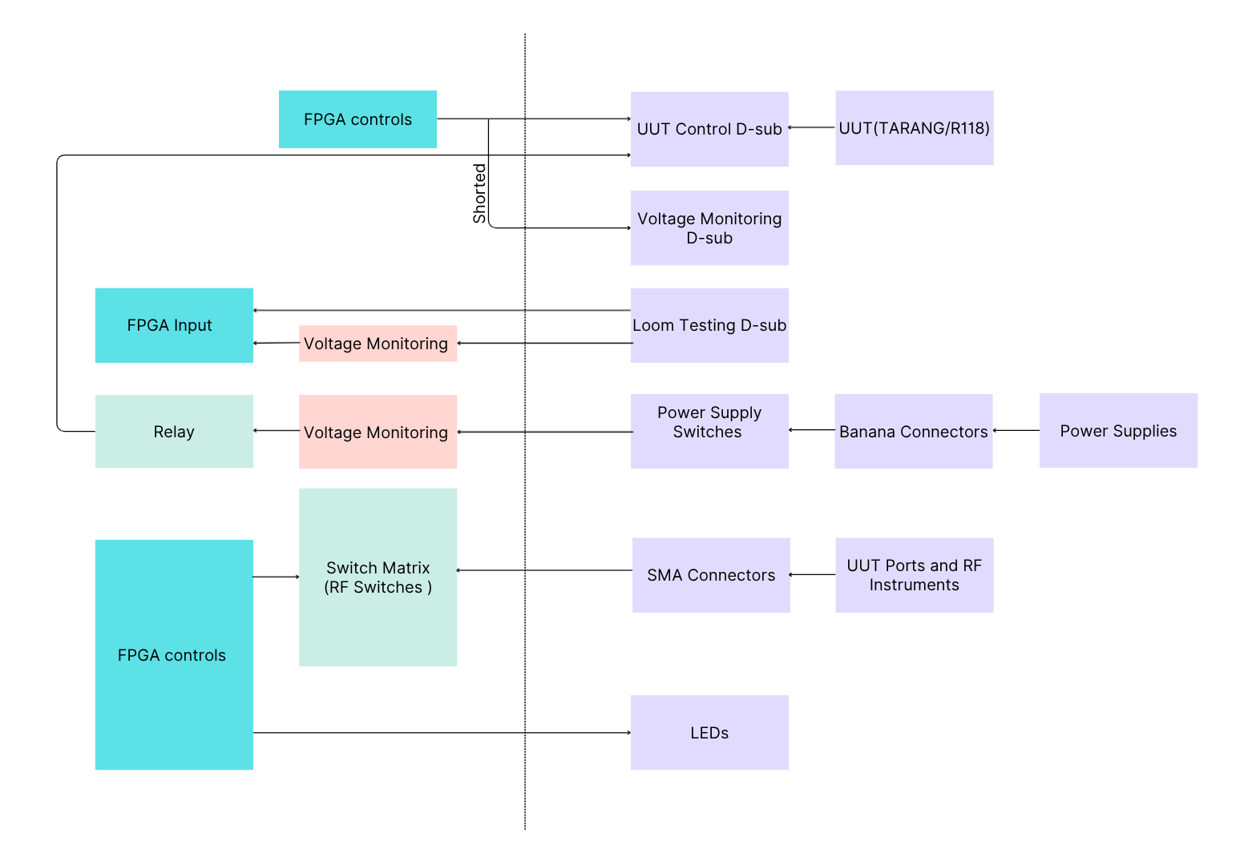
Figure 2: Custom DIO Block Diagram

3.1 Centralized Control Logic (MAX 10 FPGA)
A MAX 10 FPGA acts as the core controller residing on the PCB, governing all digital I/O, safety monitoring, and matrix switching operations.

3.2 UUT Control and Signal Monitoring
- Control Routing: The FPGA routes operational control signals to the UUT (TARANG/R118) via the front-panel UUT Control D-sub.
- Monitoring Bypass: These control lines are internally shorted and routed in parallel to a Voltage Monitoring D-sub. This allows operators to manually probe and verify signals in real-time without disrupting the active UUT connection.

3.3 Loom Integrity Testing
- Loopback Verification: Automated cable continuity checks are facilitated by a Loom Testing D-sub. Signals loop from this front-panel connector, through a voltage monitor, and back to the FPGA via the PCB connectors, verifying harness integrity before test execution.

3.4 Power Distribution and Safety Interlocks
- Power Routing: External power enters through front-panel Banana Connectors and passes through manual Power Supply Switches.
- Protection Circuitry: Before powering internal electronics, lines pass a voltage monitor and an FPGA-controlled Relay, acting as a safety interlock to isolate power during fault conditions.

3.5 Signal Switching Matrix (RF and Analog)
- Matrix Control: The FPGA actively configures an internal Switch Matrix (containing both RF and analog switches) based on test requirements.
- Instrument Interfacing: RF signals are routed to RF instruments via SMA Connectors, while Video output measurements are routed to a DMM and CRO via BNC Connectors.

3.6 Status Indication
- Visual Feedback: The FPGA drives front-panel LEDs to display real-time operational status, power states, and test results to the user.

4 Emergency Module
The Emergency Breaker Module is the AC power entry and protection stage of the rack. It takes incoming mains power from the wall, switches it, monitors it, and safely distributes it to the equipment mounted in the rack. The module is built around a small set of panel-mounted components that together give the operator full control over the AC supply and real-time visibility of how much power is being drawn.
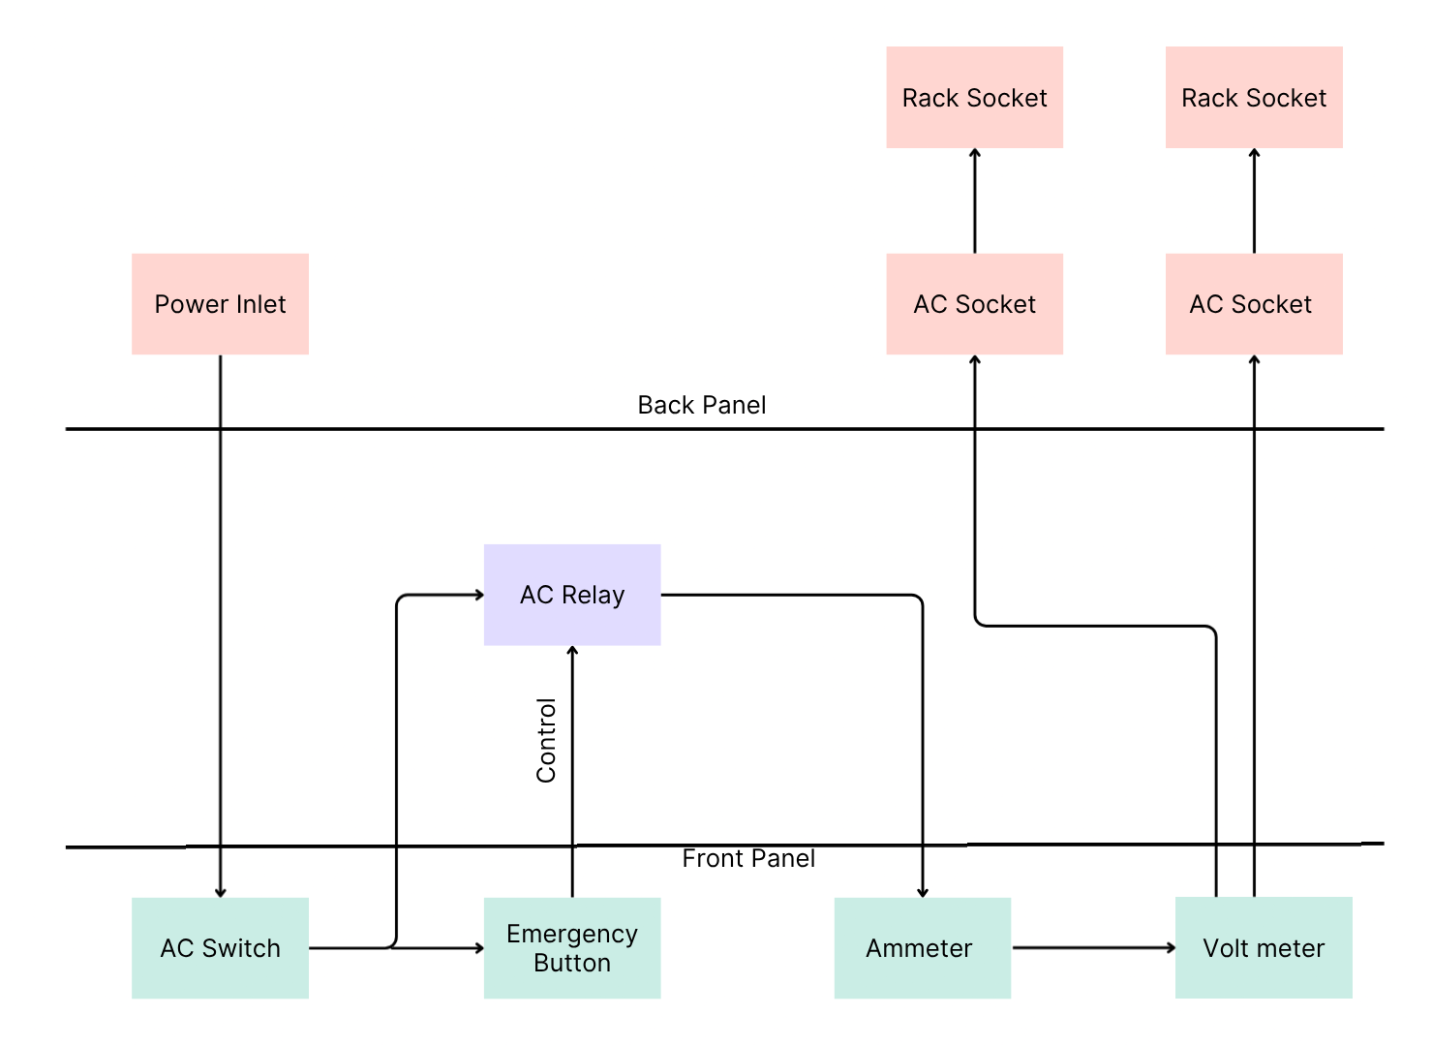
Figure 3: Emergency Module Block Diagram

4.1 System Operation
- AC mains power enters the back panel through the Power Inlet and routes to the primary manual ON/OFF control, the AC Switch on the front panel.
- From the switch, power flows to the Emergency Button; together, these dictate whether the AC Relay is allowed to close.
- Pressing the emergency button instantly opens the relay, cutting all downstream power regardless of the switch position.
- When the relay is closed, power routes in series through the front panel's Ammeter and Volt Meter, allowing the operator to continuously monitor current and voltage.
- The monitored power returns to the back panel, splitting to feed two AC Sockets.
- Each AC Socket connects via an internal extension cord to a Rack Socket, which ultimately powers the plugged-in rack equipment.

4.2 Component Part Numbers
- Power Inlet - 5130.0000.21
- AC Switch - C6003ALBR2-G74
- Emergency Button - 51-256.025
- AC Relay - 84138013N
- Ammeter - DLA20-ACA-G-2
- Volt Meter - DMR20-1-ACV-R-C
- AC Socket - 2CMA101947R1000
- Rack Socket - 2CMA193170R1000

5 Physical characteristics

5.1 Dimensions
Component | Dimensions | Tolerance
Interface Unit | 482.6 × 327 × 132.55 mm | ±.8mm
ATE Rack | 19-inch width x 42U height | N/A
Heat Sink | 250 x 200 x 50 mm | ±10mm
LAN-to-GPIB Converter | 210 × 127 × 35 mm | ±5mm
Emergency Module | 482.6×150.20×132.55mm | ±.8mm
Table 13: Dimensions

5.2 Weight

Component | Weight | Tolerance
ATE Rack | 100 kg | ±2kg
Test Controller PC | 18 kg | ±.5kg
LAN-to-GPIB Converter | 394 g | ±10g
Table 14: Weight

5.3 Mounting
The ATE Rack is a floor-standing enclosure fitted with four heavy-duty castor wheels with foot-brake locking. the UUT is mounted on the Heat Sink using scratch-free ESD compliant clamps.

5.4 Type of the Connectors of Interface Unit
- 6×SMA Connector, PN - 2933-6004
- 1×BNC Connector: PN - 031-7059
- 2×Male 25 pin D-sub, PN - CN-DSUB25PIN0-000
- 1×Female 25 pin D-sub, PN - 5-747913-2
- 1×9-Pin D-Sub Connector, PN - L77SDE09S
- 3×Banana Connectors Red, PN - CT4397-02-2
- 3×Banana Connectors Black, PN - CT4397-02-0
- 1×IEC C14 Power Inlet, PN - 6100.31

5.5 Finishing
The ATE Rack features a black colour finish. The Heat Sink (Aluminium alloy 63400/HE9) features a chromite conversion coating on the UUT mounting surface and an anodic coating on the balance area.

6 Growth Potential
The ATE Rack's 42U height provides physical space for future expansion. The Interface Unit have an BNC connector to inject pulses for future purpose and the Test Controller PC includes 3 spare PCI/PCIe expansion slots. The LAN-to-GPIB converter can support up to 14 instruments simultaneously.

7 Maintenance Specification
Maintenance includes periodic calibration of the RF test instruments (Signal Generator, Spectrum Analyzer, Power Meter). Cable-loss calibration routines must be re-executed periodically; the resulting Excel files are saved, and compensation values are automatically applied by the GUI. To ensure data integrity, the system automatically syncs database and configuration backups to a separate storage drive, enabling immediate GUI-based recovery of accidentally deleted files.

APPENDIX A: INTERFACE UNIT FRONT AND BACK PANEL
NOTE: Yellow colour is used for visibility purposes only
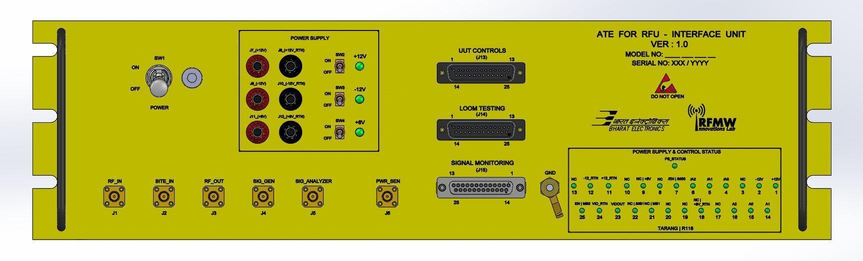
Figure 4: Interface Unit Front Panel

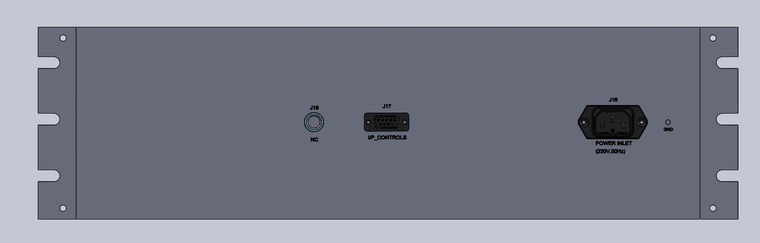
Figure 5: Interface Unit Back Panel

APPENDIX B: EMERGENCY MODULE FRONT AND BACK PANEL

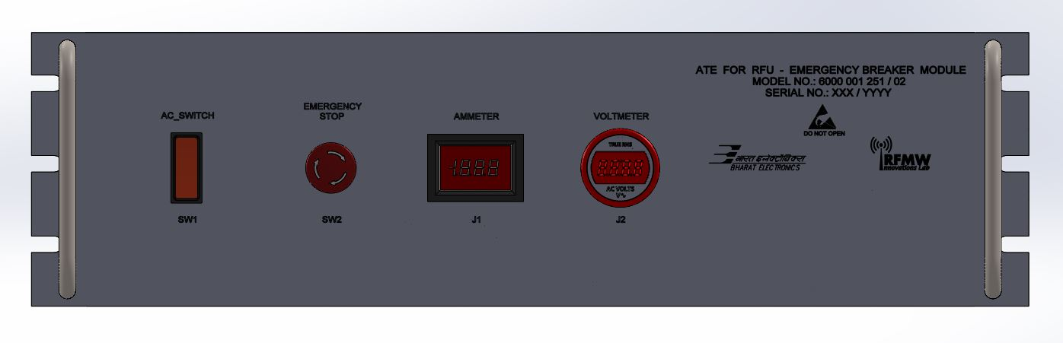
Figure 6: Emergency Module Front Panel

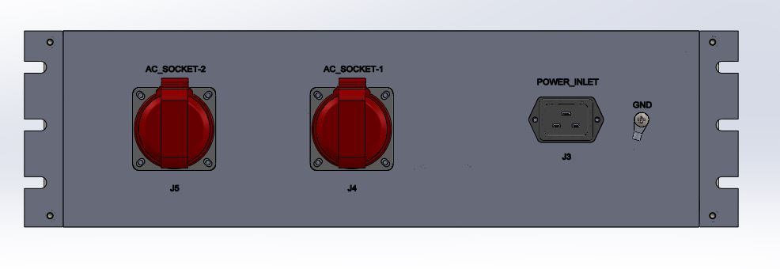
Figure 7: Emergency Module Back Panel

APPENDIX C: SWITCH MATRIX BLOCK DIAGRAM
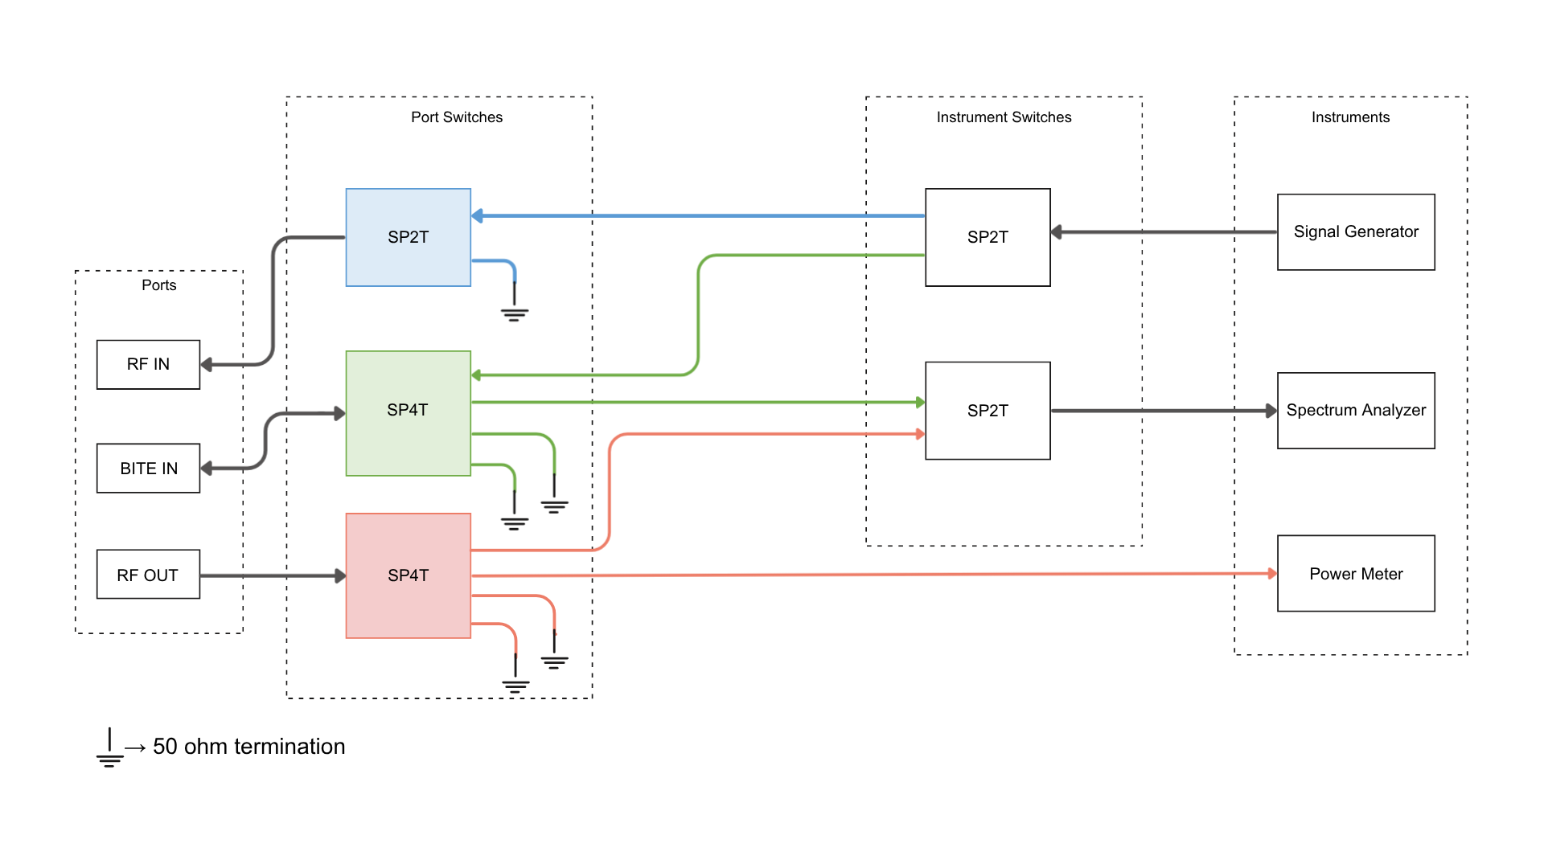
Figure 8: Switch Matrix Block Diagram

APPENDIX D: LIST OF LRU AND CARD LEVEL TESTS
The following table lists the tests to be performed on each LRU variant under the ATE – RFU system.
SFA R118 Tests | SFA TARANG Tests
POWER CONSUMPTION MEASUREMENT | POWER CONSUMPTION MEASUREMENT
GAIN MEASUREMENT | GAIN MEASUREMENT
NOISE POWER MEASUREMENT | MAXIMUM POWER MEASUREMENT
SNR MEASUREMENT | NOISE POWER MEASUREMENT
HARMONICS MEASUREMENT | SNR MEASUREMENT
CHANNEL TO CHANNEL ISOLATION MEASUREMENT | HARMONICS MEASUREMENT
ANTENNA TO BITE PORT ISOLATION MEASUREMENT | CHANNEL TO CHANNEL ISOLATION MEASUREMENT
TRANSFER RESPONSE MEASUREMENT | ANTENNA TO BITE PORT ISOLATION MEASUREMENT
RISE TIME MEASUREMENT | TRANSFER RESPONSE MEASUREMENT
 | SENSITIVITY MEASUREMENT
 | DUTY CYCLE AND RISE TIME MEASUREMENT
 | VIDEO NOISE MEASUREMENT
Table 15: Card Level Tests

