**Lab 2 Assignment**

**Divya Battu-12389400**

The existing application has been modified. The text file includes information on Time, Acceleration, Gyroscope and humidity. On modifying the connectionService.java. The output has been generated for these four activities.

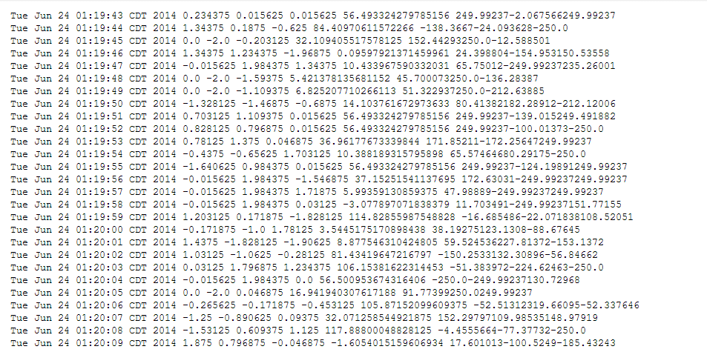

The following figure shows the changes made and the logging out of the data.

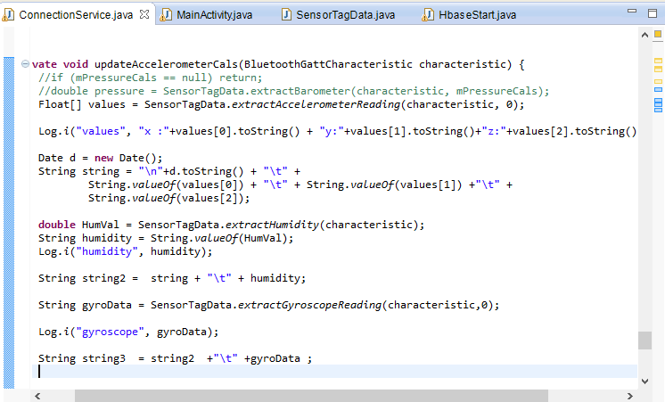

HBase client application has been implemented. Table has been created by using the createtable() method.

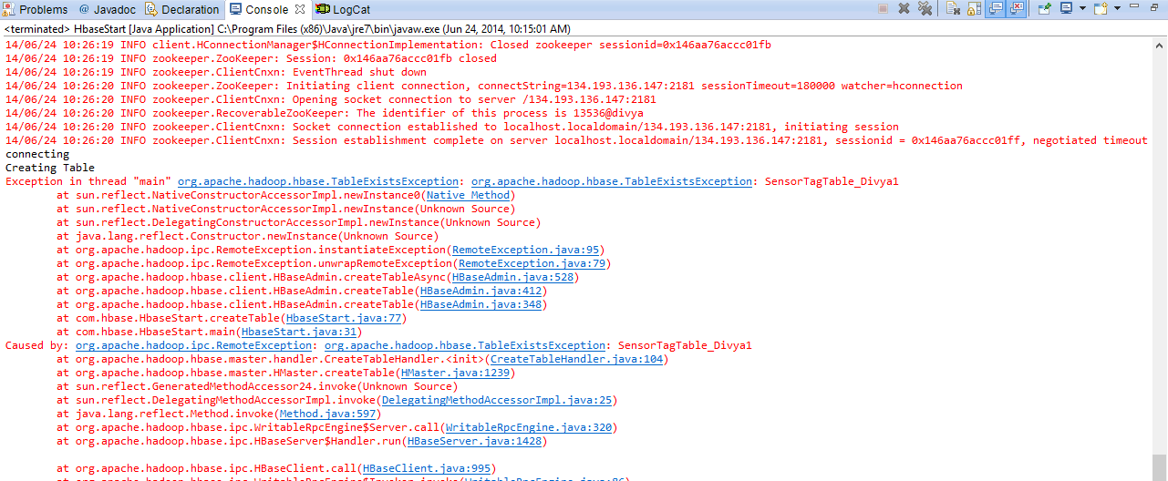

The following figure shows the table created

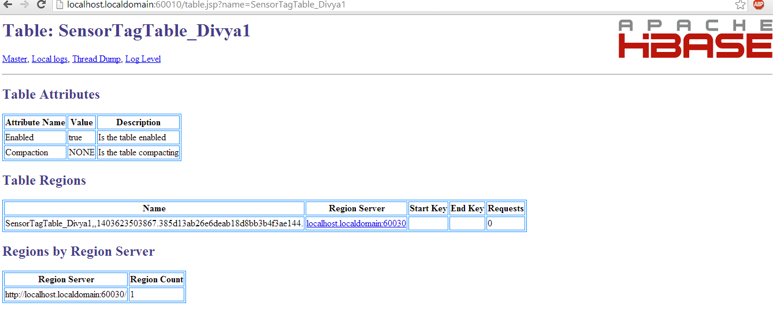

HBase client application has been implemented to insert the data to HBase.

