**CS-5551: Advance Software Engineering**

**Project plan**

**2nd October, 2014**

|  |  |  |  |
| --- | --- | --- | --- |
| Vidhi Shah | Sai Pramodh Parimisetty | Divya Battu | Daniel Robison |

**Introduction**

As per survey held by “nationmaster” website, following shows the crime index and safety index in different countries. From which we can find out that in numbers of country crime rates are at dangerous level.

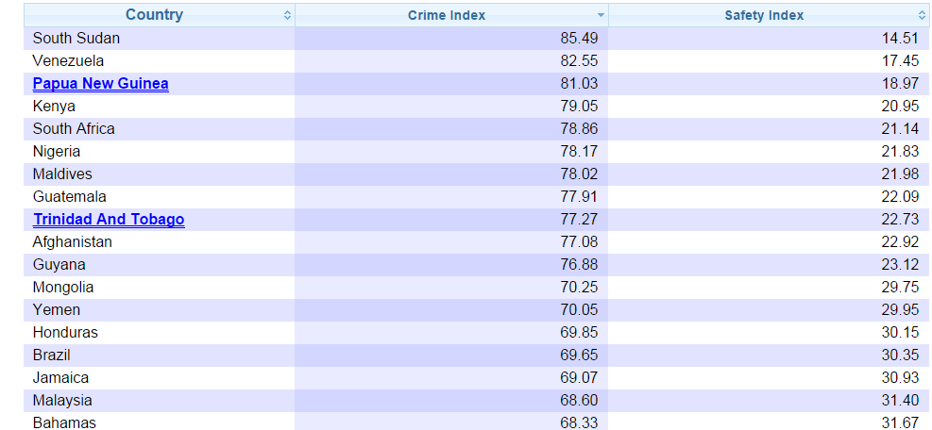

Figure: Crime rate in different countries

Moreover, if we conder United States data, National surveys shows the result that thousand of crimes are not reported. There are several reasons for not reporting crime. They can be victim think like it’s a personal matter(for example fight between friends and family member) or victim can think that the issue cannot be resolved by force enforcement ( a case where to get property back or the arrest of the offender is unlikely. So, in order to solve the crime related issues National Institute of Justice collects some data from households and individuals to have a clear idea about crime and reporting. As per survey 50% violent crimes and 40% of property crimes are not reported. this rate is even higher in some other countries.

So, in order to make a significant crime management system, reporting must be available 24/7. There are some other option exists but online reporting system makes the process quick, easy and it make it possible to access from remote locations at any time of day.It also helps people to be aware about the safety level in different areas based on the past record of crimes of a particular area. Thus, it increases public safety.

**Project Goal**

The aim of the project is to develop a mobile application for crime management and faster transformation of information from crime spot to police station which can be accessed by police and people. This system is intended for use in community to help people interact with each other. Moreover, it encourages people to fire a reporting of suspicious behaviour or crime. This system registers the online complaints from people and helps police department in catching criminals faster and also helps to maintain all the records in easy way which can be operated from remote location irrespective of time.

**Objectives**

The objective of the proposed system is to develop a better crime management system. This system can overcome so many limitation of existing system. It must provide security and avoid the manual work. This system applies to Police station and general public in order to crime prevention, detection, conviction of criminals depending on a highly responsive backbone of Information Management. The efficiency of the cops and effectiveness of crime tackles by cop depends on how fast the information is derived and how fast cop is reacting. Our proposed system’s objective is to increase the efficiency and effectiveness of police.

**Significance**

Crime prevention is the attempt to decrease and find crime and criminals. This can be applied to governments to reduce a crime, maintain justice and enforce the law. This provides many societal and individual benefits. In a current crime management system, almost all operations are done manually. For example, report complains, status of FIR, taking action against crime. Thus, we have to go through police and by doing manual work so many mistakes can be done. Through internet based crime management system above problems can be solved. Moreover, in case of emergency just by clicking emergency button or by sending image of crime, we can notify an emergency situation to the police station within a fraction of minute. one can also get notification about safety level of a given area. Thus, this application helps in reducing crime and to take an action against criminal quickly.

**Project Background and Related Work**

One project titled as “Online Crime file Management “is a web based application. This software provides facility for reporting online crimes, complaints, missing persons, show most wanted person details mailing as well as chatting. Any Number of clients can connect to the server. Each user first makes their login to server to show their availability. The server can be any Web Server. An SMTP Server must be maintained for temporary storage of emails and chat jar files for enable the chatting facilities. This project is having following features:

•Send a video or photograph for easy tip submission.

•Find the nearest police station using GPS and receive turn by turn directions.

•Check the status of submitted tips.

Another project is mobile application developed for android and apple mobile. This application is given a name CrimeReports. CrimeReports gives you real-time access to neighborhood level crime and sex offender information. The CrimeReports app is your window into the largest crime mapping and sex offender website in the world. The CrimeReports app gives you access to official crime information for over 1200 participating law enforcement agencies across North America and sex offender data for all 50 US states. As a bonus, if your local police agency is participating, you can sign up for free, automated email crime updates directly from your Apple device. Please note that if your local law enforcement agency is not currently sharing data with CrimeReports, you will only see registered sex offender data. Your agency can partner with CrimeReports for free, so let them know you'd like to see local crime data on CrimeReports. More agencies are joining every day, so please check back often. The CrimeReports app allows you to search the National Crime Map for information about crimes near your home, a relative's home, your child's school, or a work location. Reports are customizable by address, crime type, and date range. All of our crime information comes directly from participating law enforcement agencies, ensuring you get the information you need to keep you and your family safe. This application is having the following features:

Filter crime data by location, date, and crime type

View recent crime down to the neighborhood level

View US sex offender data right along side crime data

Sign up for free, automated email crime updates

One more projects is titled as ONESolution Records Management System (RMS). ONESolution Records Management System (RMS).The ONESolution Records Management System (RMS) allows public safety agencies to collect, store and access critical information gathered during the course of an incident or investigation. Records management software provides analytical resources for your administrative, field and investigative staff. A standardized **interface**, comprehensive database and superior data searching capabilities allow users to quickly retrieve records and manage multiple involvements.

ONESolution is a true enterprise public safety software solution. Our solution increases efficiency by making critical information and data accessible across all ONESolution public safety software suites. Powerful technology that keeps information connected, investigators on track and personnel productive.

Work done by others: main similarities and differences between what we propose and each of the related project.

|  |  |  |  |
| --- | --- | --- | --- |
| **Online Crime file Management** | **CrimeReports** | **ONESolution Records Management System (RMS)** | **Proposed System by our Team** |
| Send a video or photograph for easy tip submission. But location of crime is entered manually. | Filter crime data by location, date, and crime type | Allows public safety agencies to collect, store and access critical information | Send photograph for emergency situation. Crime place will be automatically detected. |
| Find the nearest police station using GPS and receive turn by turn directions. | View recent crime down to the neighborhood level | Data searching capabilities | View recent crime down to the neighborhood level |
| Check the status of submitted tips. | View US sex offender data right along side crime data  Sign up for free, automated email crime updates | Keeps information connected, investigators on track and personnel productive | Record searching features which gives records of crimes, criminals, FIR status and secure registration for users through facebook |

**Proposed System**

**Requirement Specification:**

**Functional:**

* Crime and criminal report forms and discussion forums
* Allow users to attach a photo to the report
* Allow users to send their current location via GPS along with the crime report
* Can report missing citizens and valuables
* secure registration for users through facebook
* Displaying the crime rate in the nearby areas based on your location on google maps
* Emergency button to send just the location
* Record searching features which gives records of crimes, criminals, FIR status

**Non-Functional:**

* Access of information which is confidential
* 24*7 services
* Better design to achieve higher performance during peak time

**Technological and architectural requirements:**

Android Studio

SQlite

Restful Web Service: visual studio

Services: Google maps API, Google places API, facebook login API for android, crime report API

**Class Diagram (Draft)**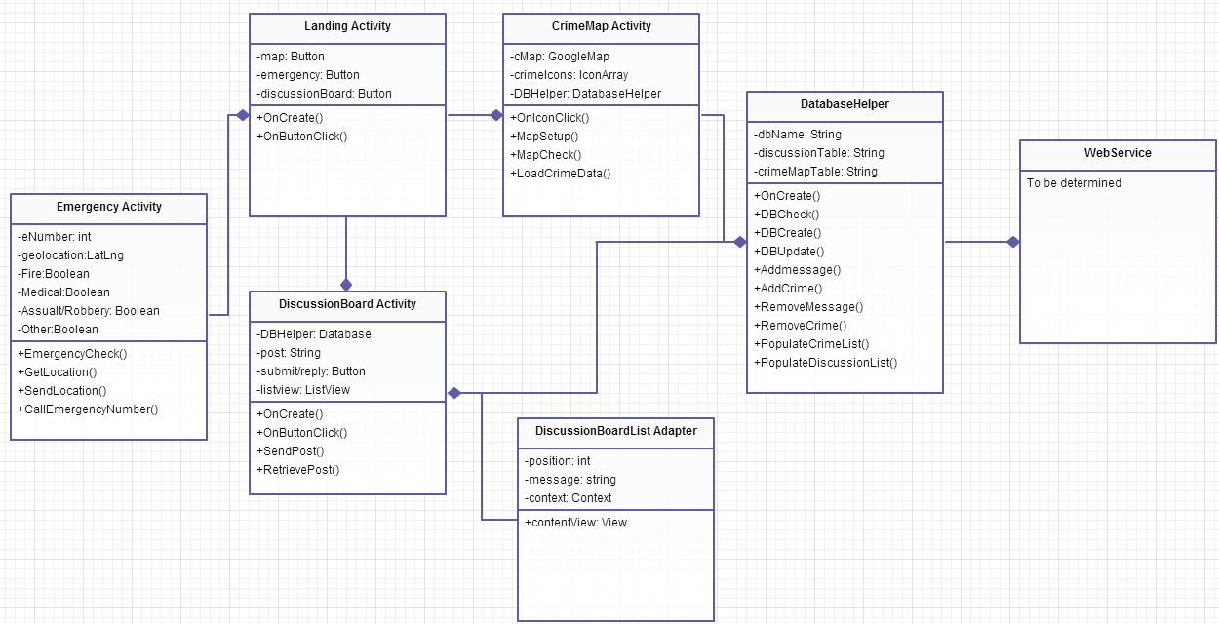

**Activity Diagram (Draft):**

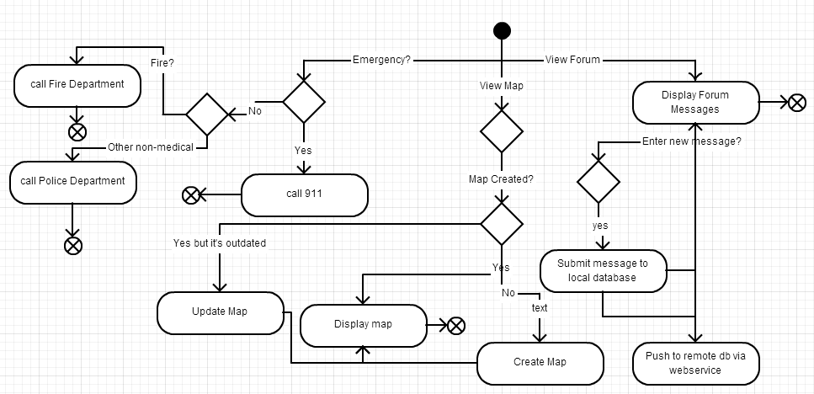

**System Model:**

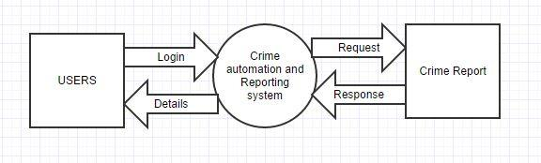

**System Architecture Diagram:**

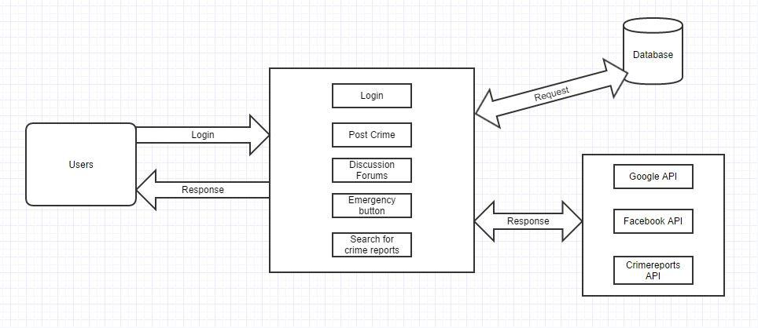

**Risk Management:**

**Technological and architectural requirements:**

* The user should be having a smart phone
* The GPS should be turned ON to get real time data and to send the current location in case of any emergency
* It is compatible with Android phones and should be extended to be compatible with windows and IOS as well

**Bibliography**

<http://www.way2know.com/projects/e-crime-file-management-system>

<https://play.google.com/store/apps/details?id=com.CrimeStoppersHouston.android>

<https://itunes.apple.com/us/app/crimereports/id343636598?mt=8>

<http://www.sungardps.com/solutions/onesolution/public-safety-justice/rms/>