**Increment 1:Replica Island**

**Group 9:**

**Praneeth Paruchuri**

**Divya Battu**

**Mounika Karampudi**

**Gireshbabu Yemparala**

**Introduction**

Touch based games are drastically being replaced by motion sensing games worldwide. An android game, Replica Island, which is touch based is being implemented by enabling motion sensing in this project.

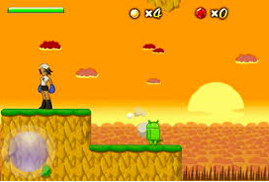

**Devices/Sensors used:**

The sensor tag is being used in our project. The following sensors are being used:

* Accelerometer sensor
* Gyroscope

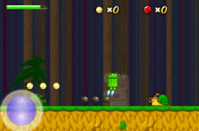

**Proposed System:**

Accelerometer sensor is being used in order to determine the angle in which the person in the game moves whereas the gyroscope is being used to determine the movements. The rightward movement is used to enable the person move forward continuously whereas the movement towards the left is being used to enable the person move backwards continuously and the upward movement is used to enable the person jump continuously whereas the downwards motion is used to enable the person move downwards continuously. Any of these continuous movements can be broken by the changing the movement. Motion event is being enabled using the various gestures.

The data generated using the sensor tag from the above movements is then stored in Hbase, a database which is on top of HDFS.

The relevant data obtained from solr is displayed by using the Web services.

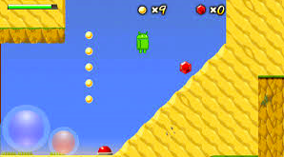

**Project Background**

We are changing the existing open source code of an android game, Replica Island to make our desired changes.

**Technologies:**

● Hadoop

●Cloudera virtual machine

● HBase

● Solr’s RESTful services

●Mahout

**Bibliography**

* [http://processors.wiki.ti.com/index.php/SensorTag\_User\_Guide#SensorTag\_Software](http://processors.wiki.ti.com/index.php/SensorTag_User_Guide" \l "SensorTag_Software" \t "_blank)
* <https://code.google.com/p/replicaisland/source/browse/>
* <https://groups.google.com/forum/#!forum/replica-island-coding-community>