**INCREMENT 3: MSNAKE**

**Work Done(In brief):**

For Increment 3, as we were unable to achieve accuracy in gestures and because of few limitations in source code in Replica Island Game, we decided to move to MSNAKE game. we made necessary changes to the source code of MSNAKE. There are five motions in this game: Up, Down, Left, Right and Pause. We made necessary changes to the code so that the movements of the snake in the game depends on the sensor tag motion. We tested each gesture 50 times for better accuracy. We took five motions as training data, 50 times each. Now, it can detect if it’s up, down, left, right or pause gestures.

Fly indicates upward movement, stomp for downward movement, left for left movement, right for right movement and back to pause the game.

**Source Code Changes**

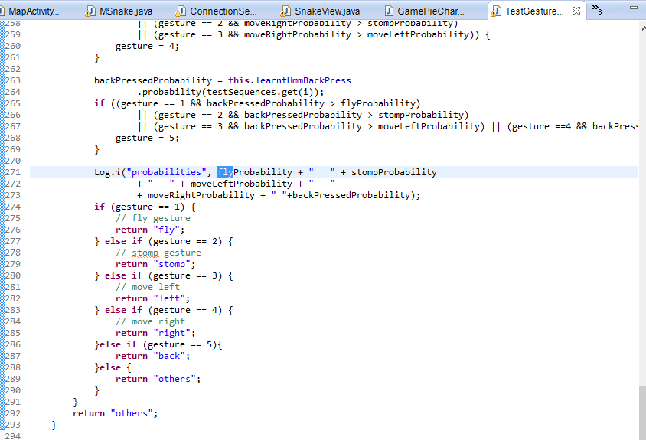Integrated the Sensor Tag data generation to the MSNAKE project and to evaluate and detect if the accelerometer data from the ongoing gesture to perform the appropriate action in the game.

Here we want to use move up, move down, left, right and pause gestures to trigger the events.

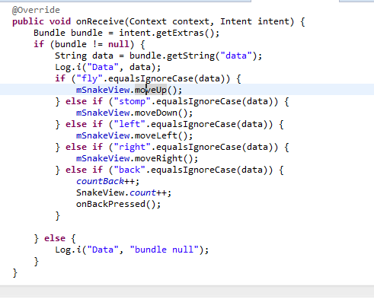

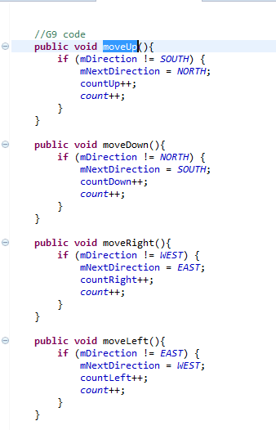

**Activity Recognition & Big Data Analytics**

For the third increment we also spent our time on activity recognition. HMM model was used to detect the different gestures. K means clustering is used to detect the activity. We start with k as 10 and if there is no error, k is 10, but if there’s an error the value of k is decreased and so on. We collected the data for five gestures using hand movements, trained the data for 50 times. We deployed the HMMWS war file into our local glassfish and converted the txt files into sequence files with the recognition of the start and end of every gesture.

**Sequence file for backpress:**

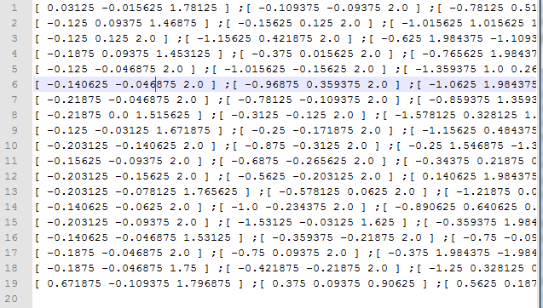

**Sequence file for stomp:**

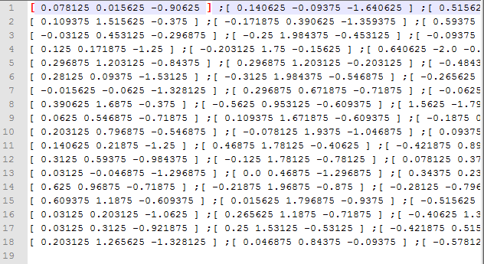

**Sequence file for right:**

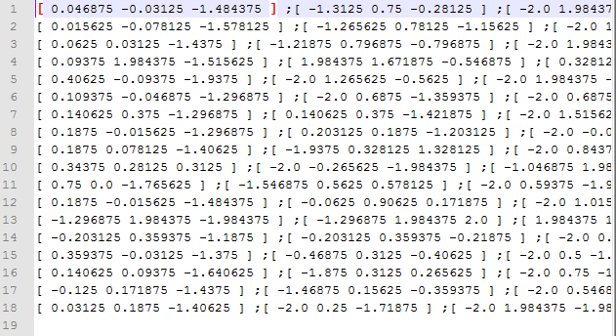

**Sequence file for fly:**

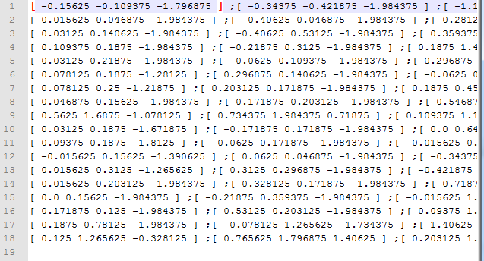

**Sequence file for left:**

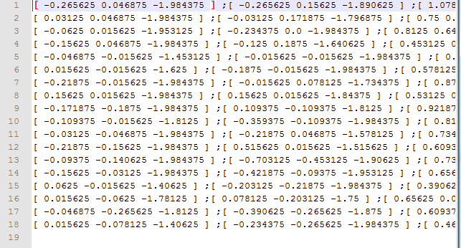

We generated a test file with all the gestures and when we applied the test sequence file on all the trained data sequence files, we got the desired output. Next step is integration of the live sensor data to detect the gesture and perform the appropriate action in the game.