**Lab 3 – Report**

**Submitted by:**

**Divya Battu**

The text file generated by running the ConnectionService.java is as follows:

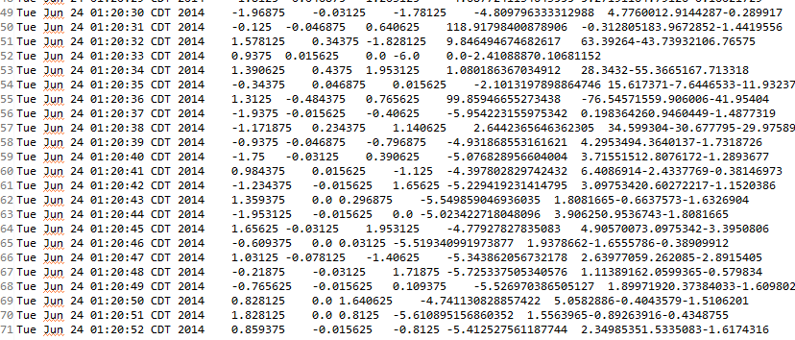

To transfer the text file from the local machine onto cloudera, the following changes have been done to the Operations.java class. Changes have been implemented on Connbean and ssh.uploadSingleDataToServer methods.

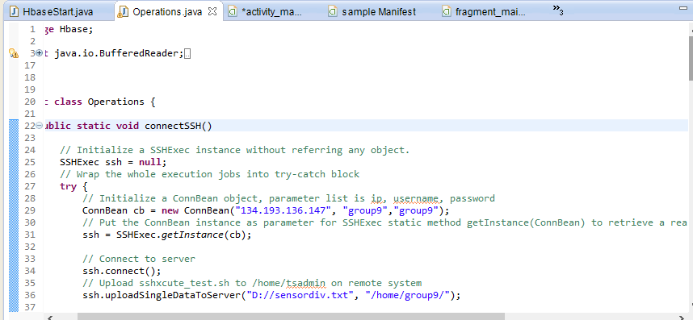

In order to invoke connectSSH method, we are making the necessary changes in the main method.

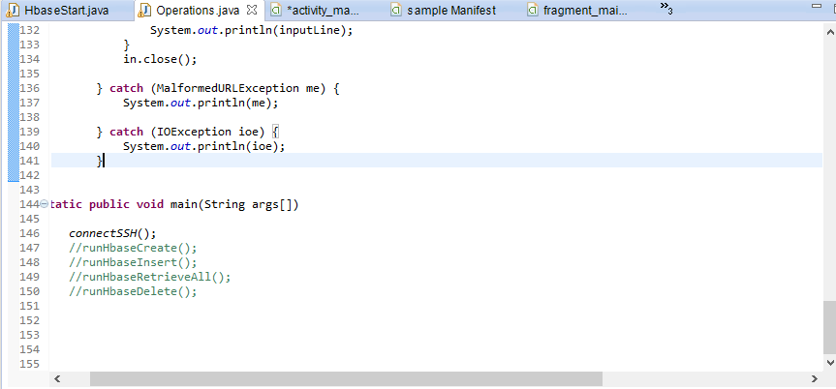

The output generated is as follows:

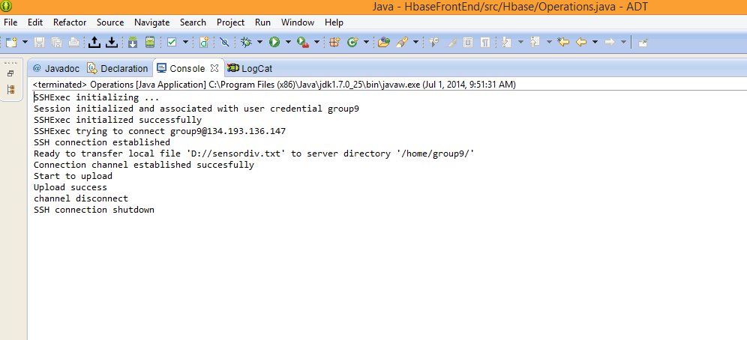

We can see that the text file sensordiv.text has been added into group9.

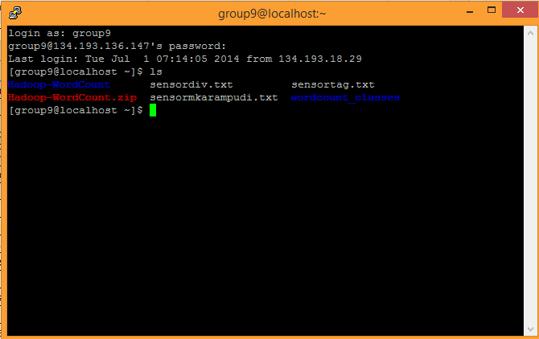

The following changes were done in order to create buttons for the various operations.

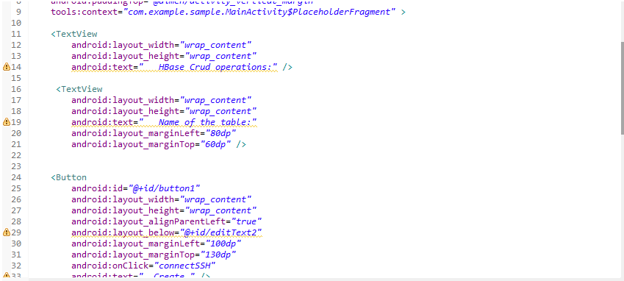

The buttons created are as follows. In order to perform the various crud operations like create, insert, etc, just click on the buttonds created.

