**Lab 4**

**Submitted by:**

**Divya Battu- 12389400**

1. The android application developed in lab3 was enhanced by adding a save file button so that the file is saved once the HBase retrieval operation is invoked.

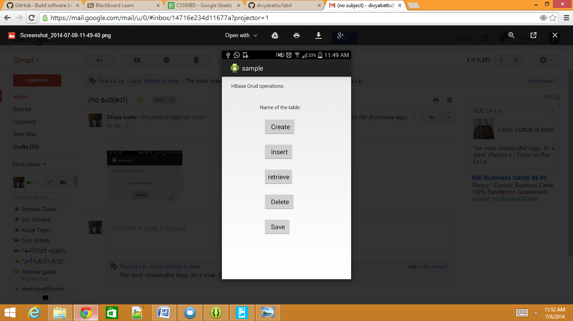

1. Three files were generated for the following motions using the sensor tag: punching, right to left and left to right.

Once the files are generated they are converted to sequence files using the references provided.

The following figure is the training file for left to right:

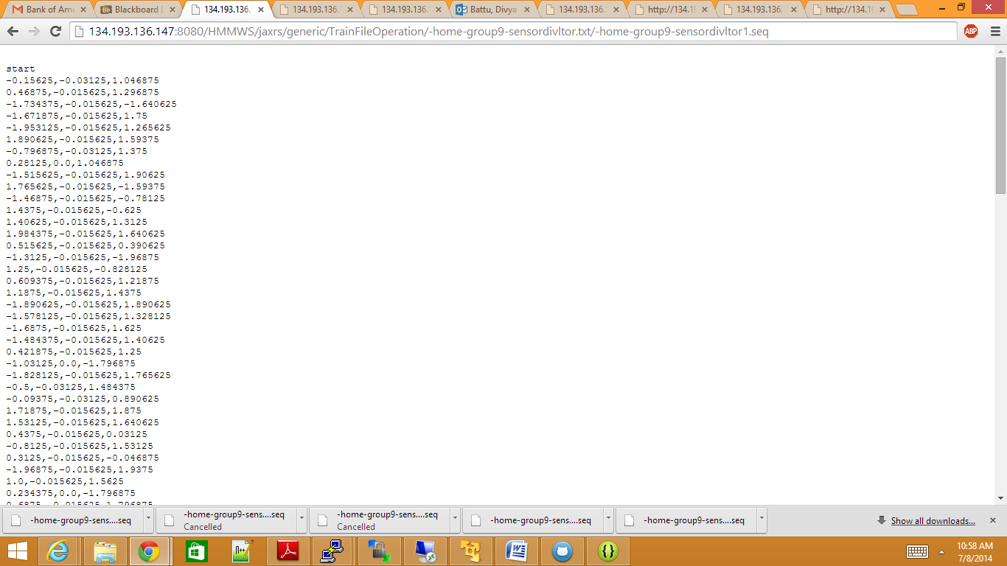

The following figure is the training file for punching:

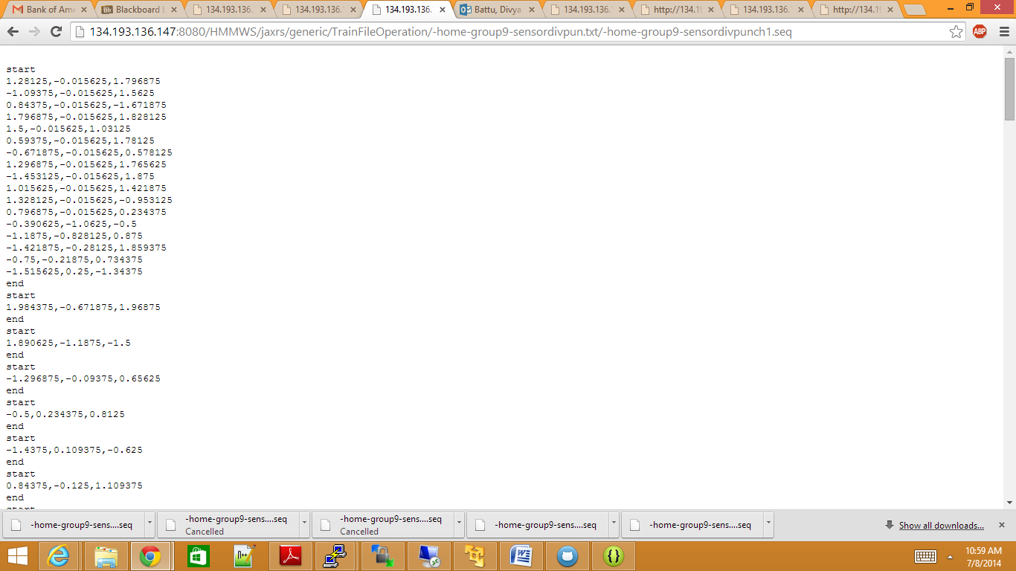

The following figure is the training file for right to left:

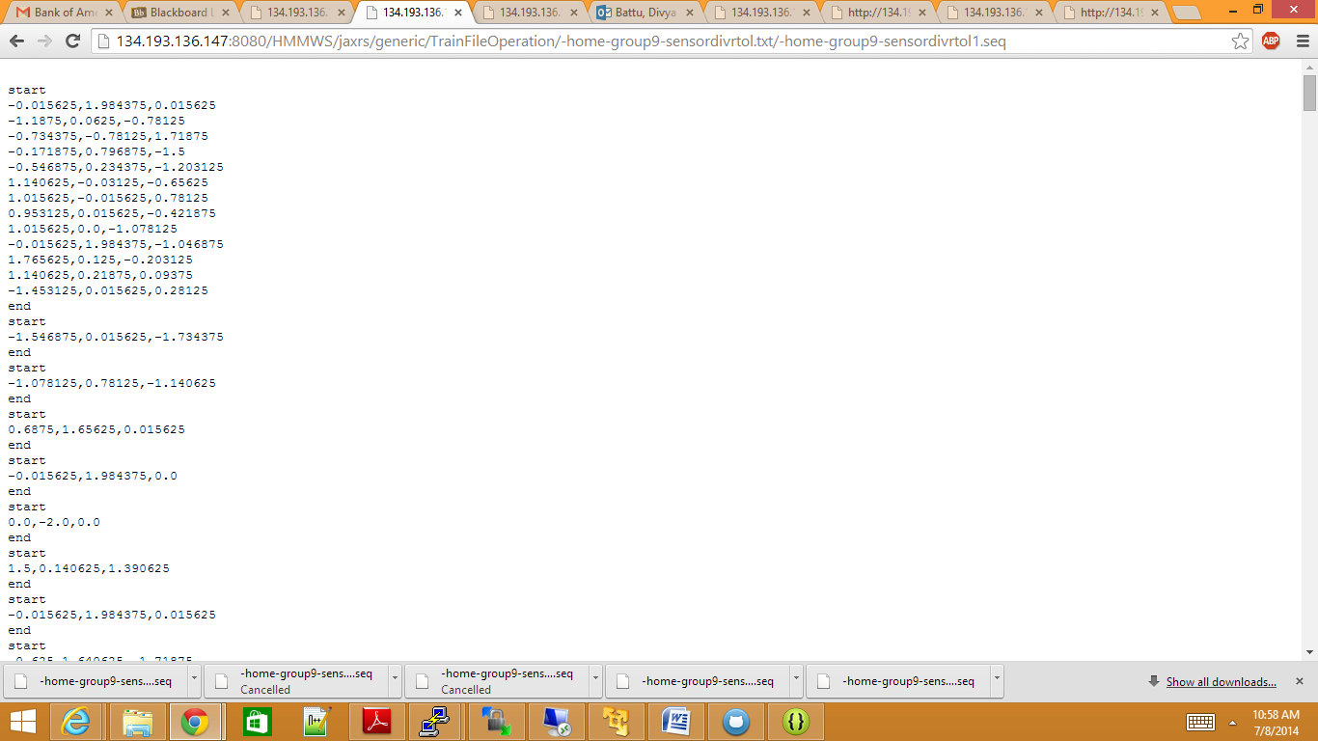

The following figure is the testing file:

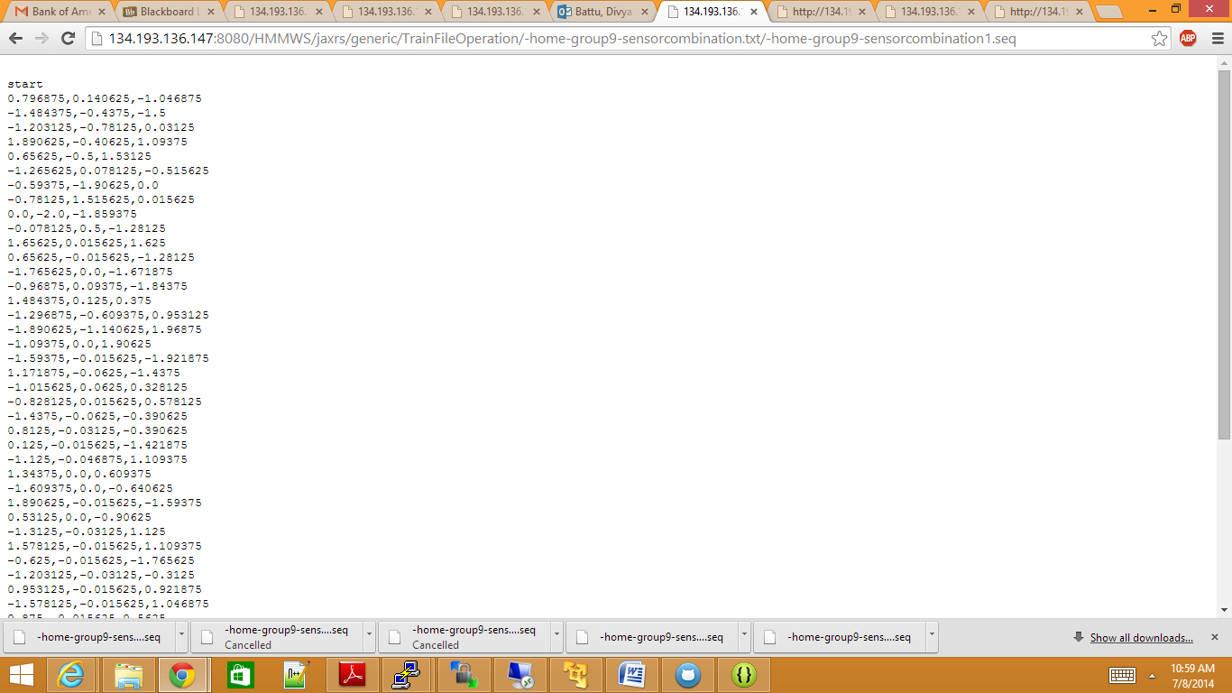

While trying to both train and test, the server wasn’t getting connected.