SIMATS ENGINEERING
ASSESSMENT TOOL 1: Analytical Problem Solving
COURSE NAME: Cloud Computing and Big Data Analytics | COURSE CODE: CSA15

COURSE OUTCOME COVERED
CO2: Analyze virtualization architectures to identify performance and security issues in cloud computing environments. (BL3)
Dave's Taxonomy: Manipulation (Level 2) Total Marks: 50
Question Count: 5 Duration: 60 Minutes

Code of Conduct
I C. Divya Charan (192525113) (Name / Reg. No.) certify that this submission is my original work and that I have adhered to the guidelines specified for this assessment.
I understand that any violation of academic integrity rules will result in disciplinary action.
Signature of the student: C. Divya Charan
Assessment Tasks
Analytical Problem Solving
- Compare Type-1 and Type-2 hypervisors for a cloud datacentre hosting mission-critical applications. Analyze performance, security, and manageability, then justify the better choice.
- A cloud provider must isolate workloads belonging to finance, healthcare, and student portals on the same hardware. Analyze how virtualization architecture supports isolation and identify two major attack surfaces.
- Study the following VM host utilization snapshot and recommend corrective actions: CPU 92%, memory 88%, storage I/O latency 35 ms, average VM boot time 170 s. Explain the likely bottlenecks.
- Analyze how Software Defined Data center architecture improves agility compared with a traditional datacenter. Support your answer with compute, storage, and network virtualization considerations.
- A multi-cloud federation project fails due to identity mismatches between providers. Analyze the issue and propose a secure identity and privacy design using federation concepts.
Equivalent Steps in VMware Workstation Pro
- Library pane showing multiple VMs = multiple instances/regions.
- VM → Snapshot → Take Snapshot, then Snapshot Manager = backup/versioning demonstration.
- Edit → Virtual Network Editor to show NAT/Host-only/Bridged networks = hybrid or multi-cloud connectivity.
- VM → Manage → Clone = replica/auto-scaling demonstration.
1. Compare Type-1 and Type-2 hypervisors for a cloud datacenter hosting mission-critical applications. Analyze performance, security, and manageability, then justify the better choice.
A) A hypervisor is the software layer that creates and runs virtual machines (VMs) by dividing the physical resources of a server (CPU, memory, storage, network). A Type-1 (bare-metal) hypervisor is installed directly on the physical hardware. A Type-2 (hosted) hypervisor is installed as an application on top of a host operating system.
Comparison of Type-1 and Type-2 hypervisors:
Parameter | Type-1 (Bare-metal) | Type-2 (Hosted)
Architecture | Hardware → Hypervisor → VMs | Hardware → Host OS → Hypervisor → VMs
Performance | Direct access to CPU, memory and I/O, so overhead is very low and performance is near-native. Supports hardware-assisted virtualization and large VM density. | Every request passes through the host OS, adding an extra layer, so latency and overhead are higher. Host OS also competes for resources.
Security | Small code base (small attack surface). No general-purpose OS, no browsers or user applications. Strong VM isolation and secure boot support. | Large attack surface because it inherits the host OS vulnerabilities, drivers, malware and user applications. A host OS compromise exposes all VMs.
Manageability | Centralized management of many hosts (clusters, live migration, HA, automated resource scheduling, monitoring and policy control). | Managed per machine through a desktop interface. Limited clustering, no native HA or large-scale automation.
Reliability | High availability and fault tolerance features. | Depends on the host OS stability; host reboot or patching stops all VMs.
Examples | VMware ESXi, Microsoft Hyper-V, Xen, KVM | VMware Workstation, Oracle VirtualBox, Parallels
Typical use | Cloud datacenters and enterprise servers | Testing, development, training and desktops

Analysis:
- Performance: mission-critical applications need predictable low latency and high throughput. Type-1 removes the host OS layer, so it gives better CPU scheduling, memory management and I/O.
- Security: fewer components means fewer vulnerabilities. Type-1 isolates tenants more strongly, while Type-2 depends on the security of the host operating system.
- Manageability: Type-1 supports live migration, high availability, load balancing and automation, which are essential for thousands of VMs in a datacenter.
Justification of the better choice:
Type-1 hypervisor is the better choice for a cloud datacenter hosting mission-critical applications because it provides higher performance, a smaller attack surface, stronger isolation, and enterprise-level manageability and availability. Type-2 is suitable only for development, testing and learning.
Conclusion: Type-1 hypervisor is the most suitable architecture for a mission-critical cloud datacenter because it combines near-native performance, strong security and enterprise-grade management.
Architecture flow:
Physical hardware
↓
Type-1 hypervisor (ESXi / KVM / Hyper-V)
↓
VM 1 | VM 2 | VM 3 (mission-critical applications)

VMware Workstation Pro:
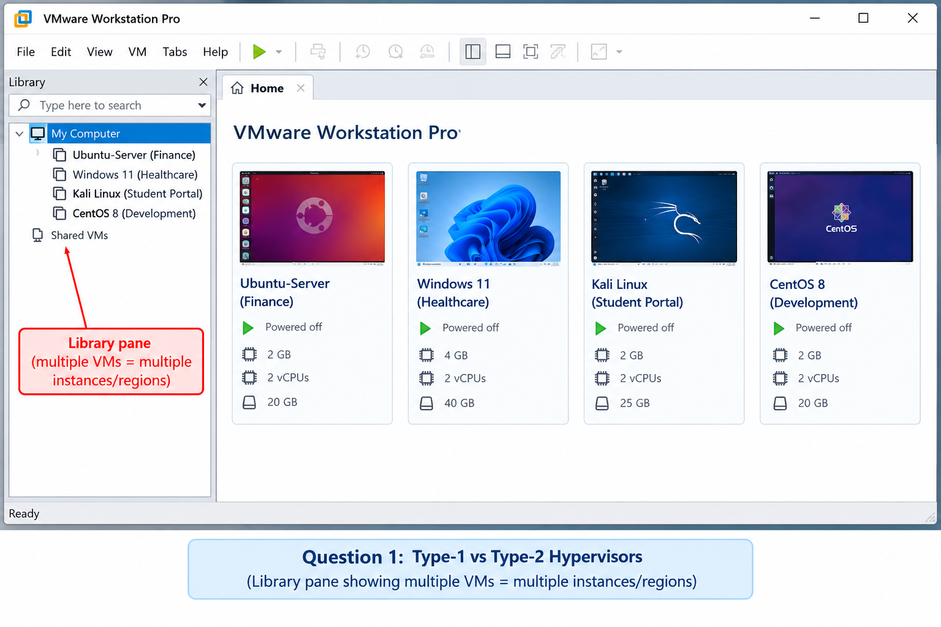
.
2. A cloud provider must isolate workloads belonging to finance, healthcare, and student portals on the same hardware. Analyze how virtualization architecture supports isolation and identify two major attack surfaces.
A) The three portals belong to different tenants with different compliance needs (finance: PCI-DSS, healthcare: HIPAA, student: privacy of education records). They share the same physical host, so the virtualization layer must make each workload behave as if it runs on its own separate machine (multi-tenancy with isolation).
How virtualization architecture supports isolation:
- VM-level isolation: each portal runs in its own VM with its own guest OS, kernel and applications. A crash or compromise inside one VM does not directly affect another.
- Hypervisor mediation: the hypervisor controls all access to CPU, memory and devices, so a VM cannot access hardware directly.
- Memory isolation: the hypervisor uses separate memory address spaces (hardware-assisted paging such as Intel EPT / AMD NPT) so one VM cannot read another VM's memory.
- Network isolation: separate virtual switches, VLANs / VXLAN segments, virtual firewalls and security groups keep finance, healthcare and student traffic apart.
- Storage isolation: separate virtual disks, datastores or LUNs with access control and encryption of data at rest for each tenant.
- Resource isolation: CPU, memory and I/O reservations, limits and shares prevent the "noisy neighbour" problem.
- Policy-based placement: anti-affinity rules or dedicated clusters/hosts for highly regulated workloads such as healthcare and finance.
Workload | Recommended isolation
Finance portal | Dedicated VLAN, encrypted disks, strict firewall rules, audit logging
Healthcare portal | Dedicated host/cluster if possible, encrypted storage and network, access control and logging for patient data
Student portal | Separate VM and network segment with resource limits, lower sensitivity but still isolated

Two major attack surfaces:
1. Hypervisor and management plane. The hypervisor is a single point of control. A vulnerability can allow a VM escape (an attacker breaks out of one VM to the hypervisor and then reaches other tenants) or a hypervisor takeover. The management console, APIs and hypercalls are also targets for unauthorized access.
Mitigation: patch hypervisor regularly, use a minimal Type-1 hypervisor, secure boot, role-based access control and MFA for the management interface, and separate the management network.
2. Shared hardware and virtual network. Tenants share CPU caches, memory and the virtual switch. Attackers can use side-channel attacks (cache timing, Spectre/Meltdown type) to steal data across VMs, or use VLAN hopping, ARP/MAC spoofing and traffic sniffing on the virtual network. VM images and snapshots that are not encrypted can also leak data.
Mitigation: CPU microcode and hypervisor patches, dedicated hosts for sensitive tenants, micro-segmentation, virtual firewalls, encrypted VM disks and snapshots, and network traffic monitoring.
Conclusion: the hypervisor, together with virtual networks, separate storage and resource controls, isolates the three portals on shared hardware. Securing the hypervisor and the shared resources is the key to keeping that isolation reliable.
Isolation model:
Physical hardware (shared)
↓
Hypervisor (enforces isolation)
↓
Finance VM | Healthcare VM | Student VM
↓
Separate virtual networks and storage per tenant

VMware Workstation Pro:
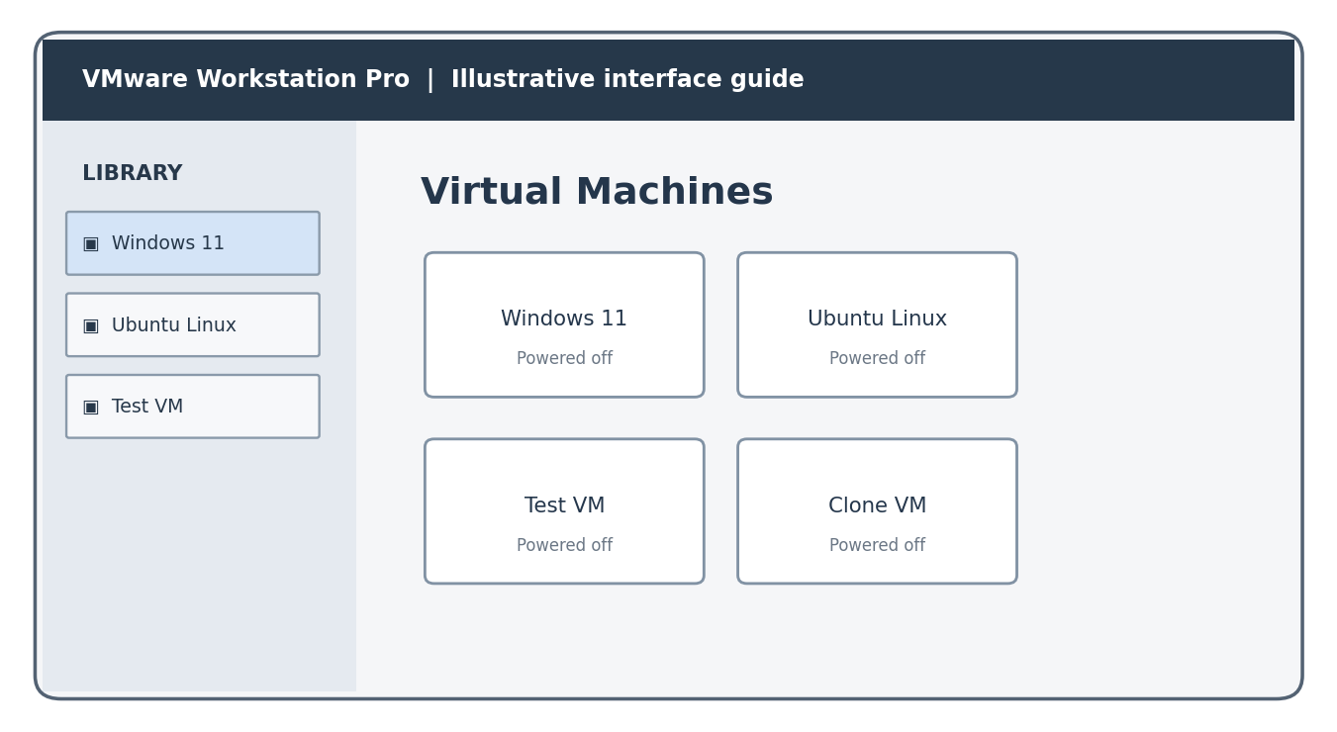
3. Study the following VM host utilization snapshot and recommend corrective actions: CPU 92%, memory 88%, storage I/O latency 35 ms, average VM boot time 170 s. Explain the likely bottlenecks.
A) The snapshot shows that the host is overloaded on all major resources at the same time. The values are compared below with commonly used guideline levels (healthy CPU is generally below about 70-80%, memory below about 80-85%, storage latency below about 10-20 ms, and VM boot of roughly 30-60 s).
Metric | Observed | Healthy guideline | Interpretation
CPU utilization | 92% | < 75-80% | Near saturation. VMs wait for CPU time (high CPU ready / contention), so CPU is over-committed.
Memory utilization | 88% | < 80-85% | High pressure. Hypervisor may use ballooning, compression or swapping, which slows VMs and adds disk activity.
Storage I/O latency | 35 ms | < 10-20 ms | Storage is slow, caused by too many VMs sharing the datastore, swapping or slow disks.
Average VM boot time | 170 s | 30-60 s | Very slow. Result of CPU and memory contention and high disk latency (boot storm).

Likely bottlenecks (cause-effect analysis):
- CPU bottleneck: too many vCPUs are allocated on the host (over-commitment) and some VMs are oversized, so VMs queue for physical CPU.
- Memory bottleneck: memory is almost full, so the hypervisor reclaims memory by ballooning or swapping to disk.
- Storage I/O bottleneck: swap activity plus normal VM traffic overloads the shared datastore, so latency rises to 35 ms.
- Boot time effect: booting needs CPU, memory and many disk reads. With all three constrained, boot takes 170 s. Simultaneous VM startups (boot storm) make it worse.
Root cause chain: high memory usage → swapping → more disk I/O → high latency → slow VM boot, together with CPU contention that slows every operation.
Corrective actions:
Area | Recommended action
CPU | Right-size VMs (reduce unused vCPUs); use live migration (vMotion) / DRS to move VMs to less loaded hosts; add hosts to the cluster; set CPU limits/shares for non-critical VMs.
Memory | Reduce VM memory over-allocation; enable memory page sharing/compression; reserve memory for critical VMs; add RAM or move VMs to other hosts.
Storage | Move disks to SSD/NVMe or a faster tier; spread VMs across multiple datastores; use storage I/O control; enable caching; avoid swapping to slow disks.
Boot time | Stagger VM power-on; use templates or linked clones; keep boot images on fast storage; remove unnecessary startup services.
Monitoring | Use monitoring and alerts (CPU ready, ballooning, datastore latency); set thresholds; plan capacity and use auto-scaling.

Conclusion: the host is overloaded (resource contention). Load balancing, right-sizing, adding capacity and faster storage will bring the utilization and boot time back to normal.
VMware Workstation Pro:
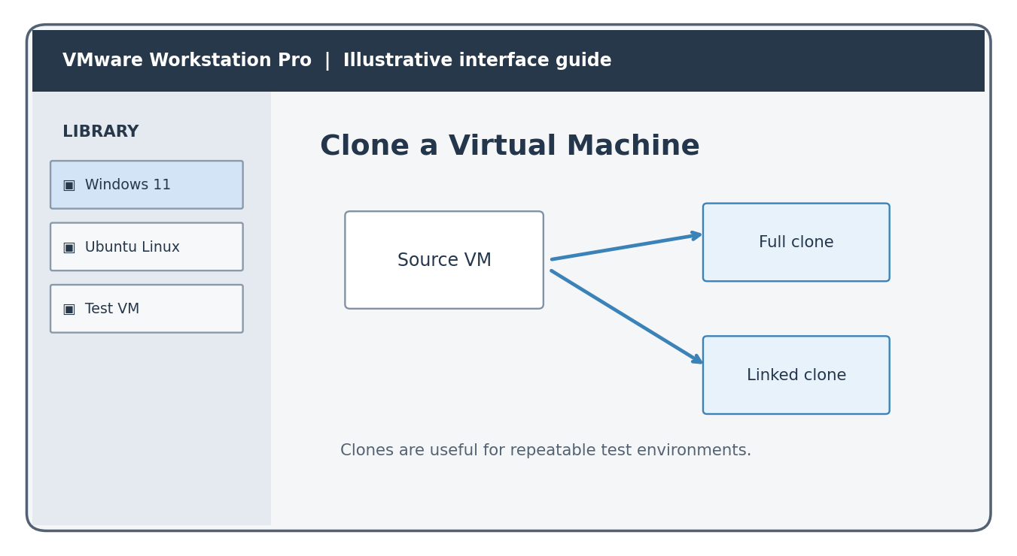
4. Analyze how Software Defined Datacenter architecture improves agility compared with a traditional datacenter. Support your answer with compute, storage, and network virtualization considerations.
A) A Software Defined Datacenter (SDDC) is a datacenter in which all infrastructure (compute, storage, networking and security) is virtualized and delivered as a service, and the entire environment is controlled by software through policies, automation and APIs. In a traditional datacenter, hardware is dedicated, configured manually and managed separately by silos (server, storage and network teams).
Traditional datacenter vs SDDC:
Parameter | Traditional datacenter | Software Defined Datacenter
Provisioning | Days or weeks (order, install, cable, configure) | Minutes (self-service, templates, automation)
Control | Hardware-specific, manual | Software-based, policy-driven and API-driven
Scalability | Add physical devices; slow | Scale up or out by software; elastic
Resource utilization | Low (dedicated servers) | High (pooled and shared resources)
Cost | High CAPEX and operations | Commodity hardware, lower OPEX
Management | Separate tools per silo | Single unified management and orchestration
Change and recovery | Slow, error-prone | Fast, using snapshots, templates and automated failover

Virtualization considerations:
1. Compute virtualization: the hypervisor abstracts the physical servers into VMs (or containers) that are created, cloned, moved (live migration) and scaled in minutes. Resource pools allow dynamic CPU and memory allocation, which improves agility and utilization.
2. Storage virtualization: physical disks are pooled and presented as virtual volumes (software-defined storage such as vSAN). Policies define capacity, performance and protection; thin provisioning, snapshots and tiering are done in software, so storage is allocated on demand without manual LUN configuration.
3. Network virtualization: networks are created in software (virtual switches, VLAN/VXLAN overlays, virtual routers, firewalls and load balancers; SDN controller). New networks, subnets and security rules are created without re-cabling, and micro-segmentation improves security.
How agility improves:
- Faster deployment of applications and environments through automation and orchestration.
- Rapid scaling up or down as demand changes (elasticity).
- Consistent configuration using templates and policies, reducing human error.
- Easier backup, migration and disaster recovery through snapshots, replication and live migration.
- Better utilization and lower cost since hardware is pooled and vendor-independent.
Conclusion: by virtualizing compute, storage and network and controlling them through software, an SDDC provisions, scales and recovers infrastructure far faster than a traditional datacenter, giving much higher agility.
SDDC architecture:
Management, automation and orchestration layer (policies / APIs)
↓
Compute virtualization | Storage virtualization | Network virtualization
↓
Physical commodity hardware (servers, disks, switches)

VMware Workstation Pro:
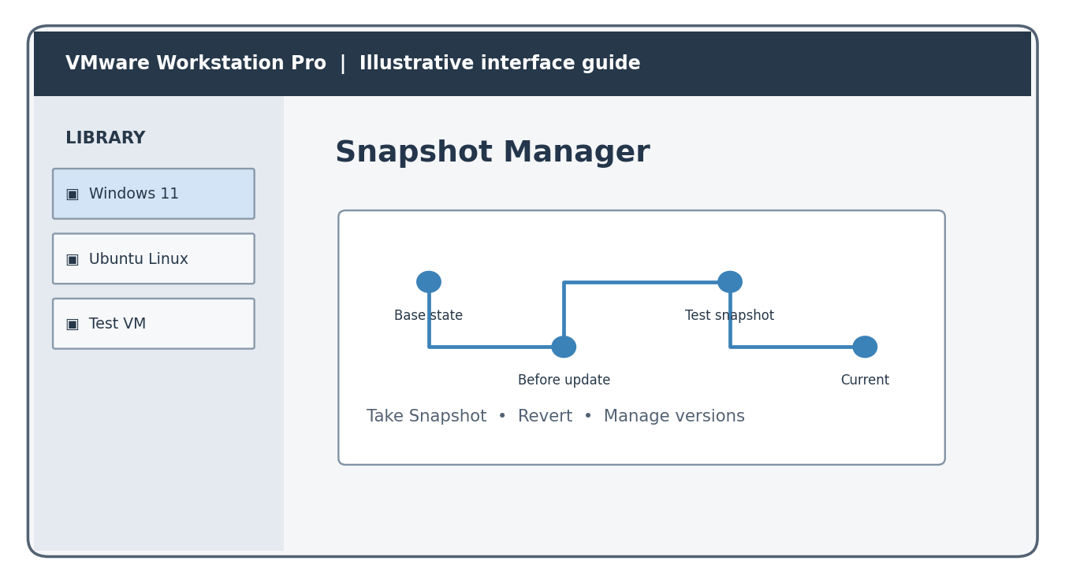
5. A multi-cloud federation project fails due to identity mismatches between providers. Analyze the issue and propose a secure identity and privacy design using federation concepts.
A) In a multi-cloud federation, several cloud providers cooperate and share services. Each provider usually has its own identity system (user IDs, roles, attribute names, authentication method and token format). When these are not aligned, a user authenticated in one cloud is not recognized or correctly authorized in another, so the federation fails.
Analysis of the identity mismatch problem:
Cause of mismatch | Effect
Different identity providers and separate user directories | The same user has different accounts or IDs in each cloud; no single identity.
Different protocols and token formats (SAML, OAuth2/OIDC, proprietary) | Tokens issued by one cloud are not understood by another; SSO fails.
Different attribute and role naming (e.g. "admin" vs "Owner") | Wrong or denied access (authorization errors) or excessive privileges.
No common trust relationship or metadata exchange | Providers do not trust each other's assertions or certificates.
Inconsistent policies, time sync and token lifetime | Token rejection, expired sessions, security gaps.
Privacy conflicts (sharing too many attributes, different regional laws) | Data leakage and compliance risk (GDPR, etc.).

Proposed secure identity and privacy design (federation concepts):
- Trusted identity provider / identity broker: use a central or trusted Identity Provider (IdP) with each cloud acting as a Service Provider (SP). A trust relationship is created by exchanging metadata and certificates (federation trust).
- Standard protocols: use SAML 2.0 or OpenID Connect / OAuth 2.0 so that all providers understand the same assertions and tokens, giving Single Sign-On (SSO) across clouds.
- Common identity schema and attribute mapping: define a unified user ID and map roles and attributes of each provider to common roles (RBAC/ABAC). Use SCIM for automatic user provisioning and de-provisioning.
- Strong authentication: multi-factor authentication (MFA), short-lived signed tokens, token validation, and time synchronization (NTP).
- Least privilege and authorization: each provider enforces local policies using the mapped roles, with only the minimum required permissions.
- Privacy protection: release only the minimum attributes needed (data minimization), use pseudonymous or opaque identifiers per provider to prevent user tracking, obtain user consent, and follow data residency and regulations such as GDPR.
- Secure communication and storage: TLS for all exchanges, encryption of tokens and sensitive attributes, and protection of private keys with an HSM or key vault.
- Audit, logging and revocation: centralized logging of authentication events, and quick revocation of tokens or accounts when a user leaves or a compromise is detected.
Federated identity flow:
User requests service in Cloud B
↓
Cloud B (Service Provider) redirects to trusted Identity Provider
↓
IdP authenticates user (MFA) and issues signed token / assertion with minimal attributes
↓
Cloud B validates token, maps roles and grants access (SSO)

Conclusion: the failure is caused by incompatible identities, protocols and attribute models. A federated identity design with a common trust framework, standard protocols, attribute and role mapping, strong authentication and privacy-preserving attribute release solves the mismatch securely.
VMware Workstation Pro:
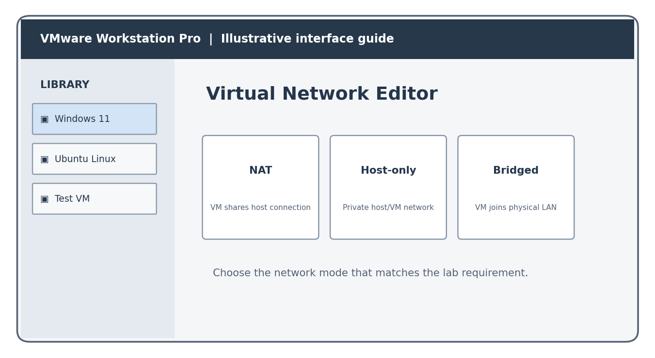

Analytical Problem Solving Rubric
Criteria | Weightage | Level 4 - Exemplary | Level 3 – Proficient | Level 2 - Developing | Level 1 - Beginning
Problem Interpretation | 20% | Interprets all technical requirements accurately | Interprets most requirements correctly | Partial interpretation | Misinterprets the problem
Analytical Reasoning | 25% | Strong reasoning with clear cause-effect analysis | Good reasoning with minor gaps | Basic analysis only | Weak or no analysis
Method Selection | 20% | Chooses highly appropriate virtualization and security concepts | Chooses mostly suitable concepts | Partially suitable concepts | Inappropriate approach
Solution Quality | 20% | Provides feasible and technically sound solution | Reasonable solution with minor issues | Basic solution with limitations | Unclear or invalid solution
Presentation of Analysis | 15% | Well-structured and technically precise | Generally clear | Somewhat unclear | Difficult to follow
Total Marks Awarded:

