Emergency Room Operations & Patient Experience Analytics
Final Data Analytics / Business Intelligence Submission Report
BharatCares × IBM SkillsBuild × AICTE Data Analytics with AI Internship 2026

1. Executive Summary
This project analyzes 9,216 emergency-room visit records across 01 Apr 2023 to 30 Oct 2024. The analysis focuses on operational demand, admission patterns, waiting time, referral categories, age groups, and patient satisfaction. The BI storyline follows Data → Information → Insight → Risk / Opportunity → Action.
Headline KPIs: 9,216 ER visits, 50.0% admission rate, 35.3 minutes average wait, 4.99/10 average satisfaction among recorded responses, and 27.3% satisfaction response coverage.

2. Business Problem
Emergency-room management requires timely visibility into patient demand, admissions, waiting-time pressure, referral workload, and patient experience. The project converts visit-level records into a compact BI view that helps identify operational patterns and data-quality gaps without overstating causal conclusions.

3. Objectives
- Measure ER visit volume and admission rate.
- Identify monthly and hourly demand patterns.
- Analyze wait time across hours and recorded referral categories.
- Compare admission rates across age groups.
- Evaluate patient satisfaction with explicit response-coverage reporting.
- Translate observations into risks, opportunities, and management actions.

4. Dataset Description
Metric | Value
Records | 9,216
Date range | 01 Apr 2023 – 30 Oct 2024
Original columns | 12
Final analysis columns | 14
Missing department referral | 5,400 (58.6%)
Missing satisfaction | 6,699 (72.7%)
Dataset source: Hospital Emergency Dataset by Xavier Berge, Kaggle. The Kaggle dataset page lists the license as CC0: Public Domain. Source link: https://www.kaggle.com/datasets/xavierberge/hospital-emergency-dataset

5. Data Cleaning & Preparation
- Removed Patient ID, Patient First Initial, and Patient Last Name from the final analysis-ready/public dataset.
- Removed the redundant duplicate admission-status column.
- Standardized gender to M / F and admission status to Admitted / Not Admitted.
- Parsed the admission timestamp into datetime and converted numeric fields to numeric types.
- Represented missing department referral as Unknown / Not Recorded rather than treating it as a confirmed referral category.
- Retained missing satisfaction scores as missing; no values were fabricated.
- Checked exact duplicate rows; the source contained zero exact duplicates.
- Created month, hour, weekday, age-group, wait-time-group, and satisfaction-response-availability fields.

6. Exploratory Data Analysis

Monthly ER Visit Volume
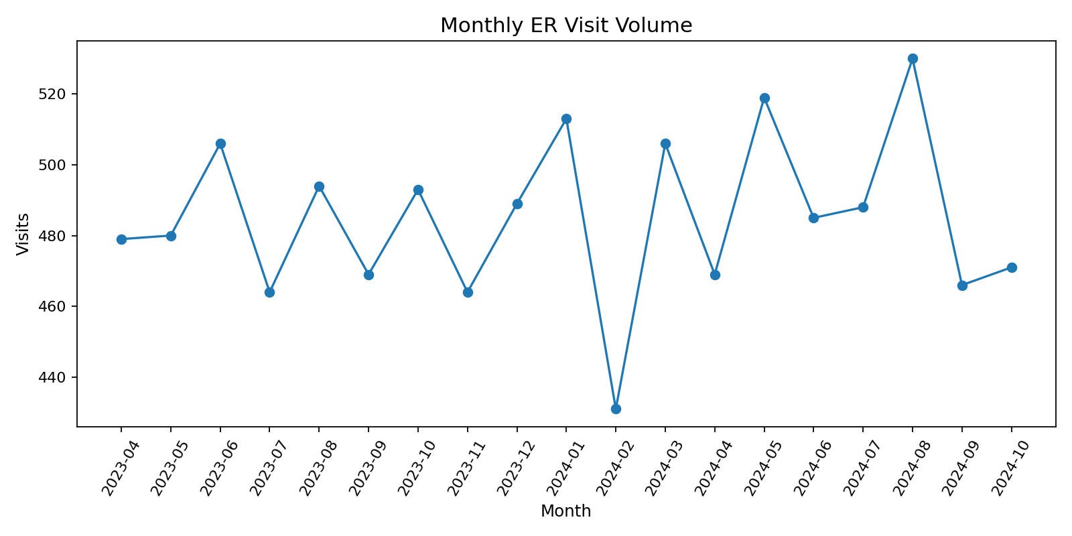
Shows how demand changes across the 19-month period.

Patient Volume by Hour
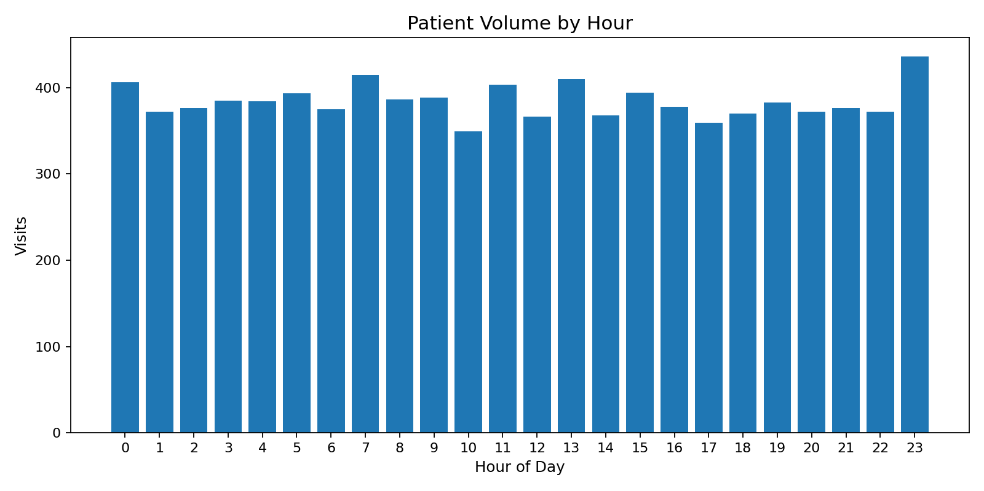
Identifies higher-volume hours for operational review.

Average Wait Time by Hour
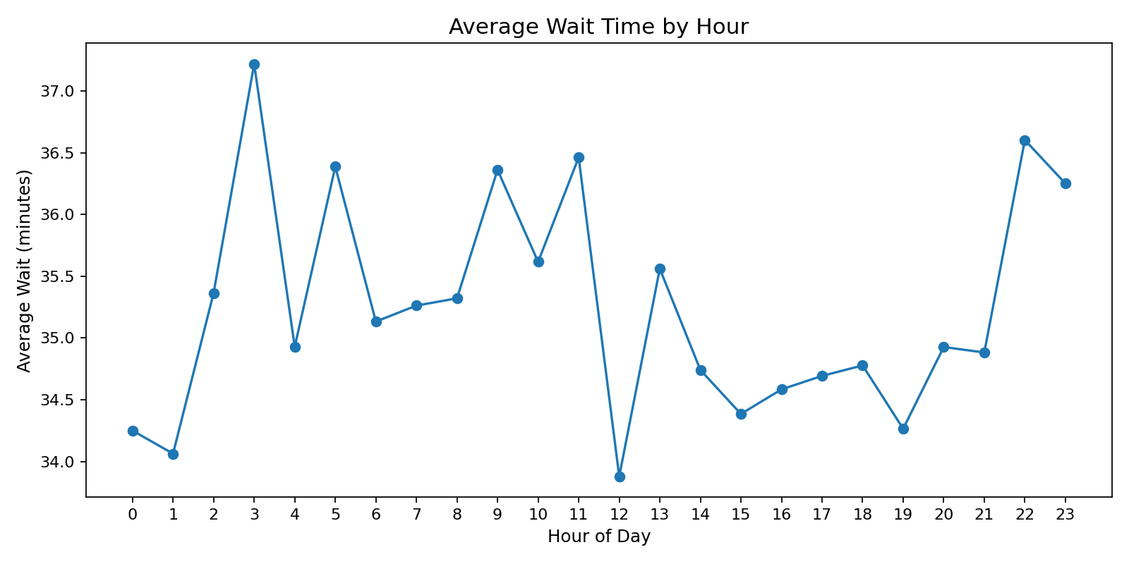
Shows hourly variation in observed waiting time.

Average Wait by Recorded Referral Department
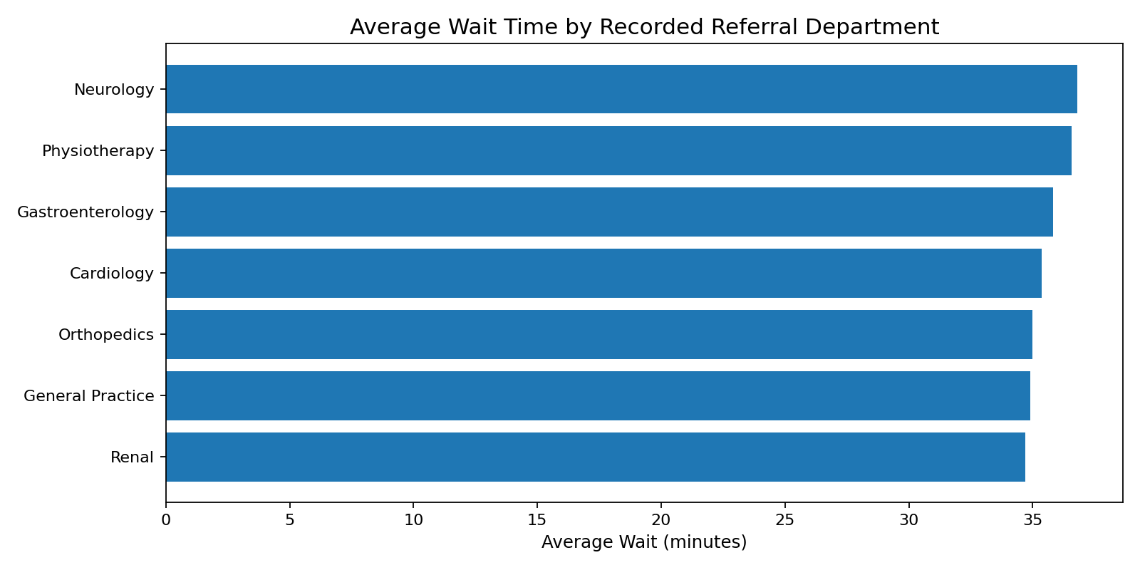
Compares wait time only among recorded referral categories.

Admission Rate by Age Group
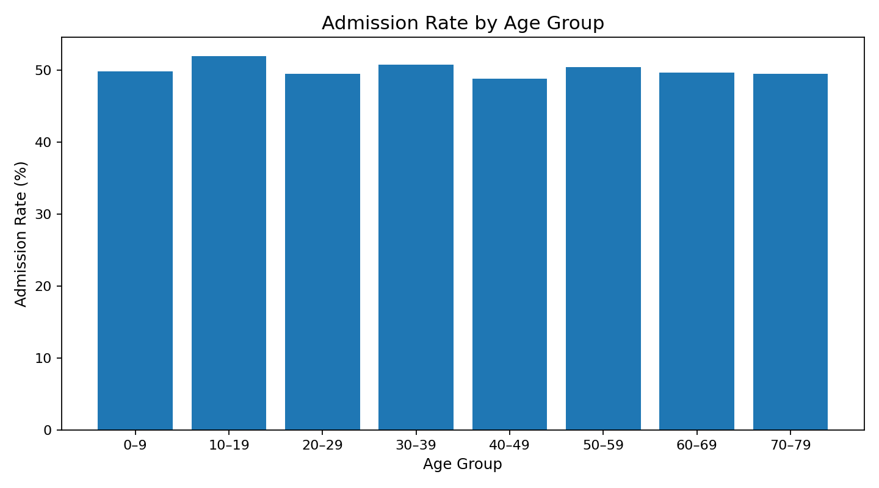
Compares observed admission rates across age groups.

Satisfaction Distribution
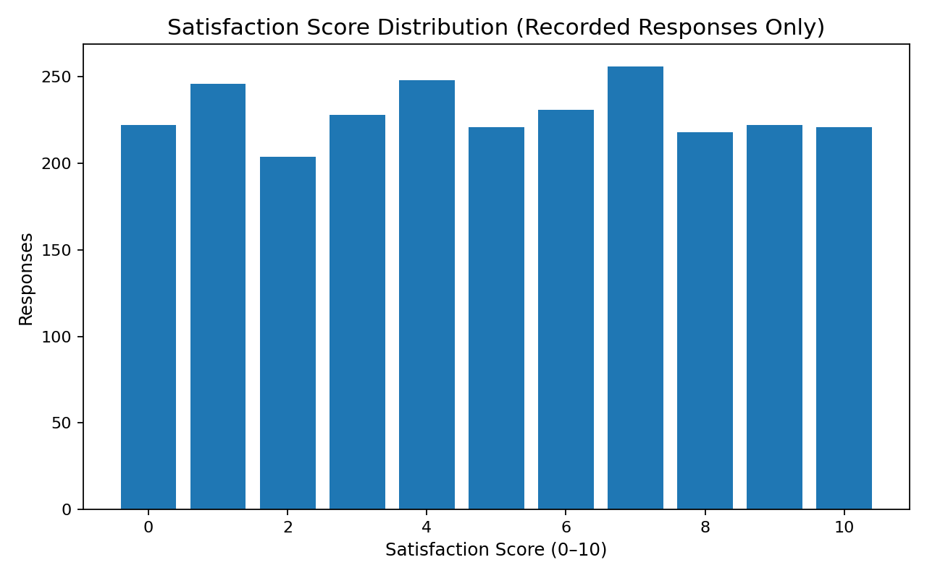
Shows satisfaction scores among records with a response.

Wait Time vs Satisfaction
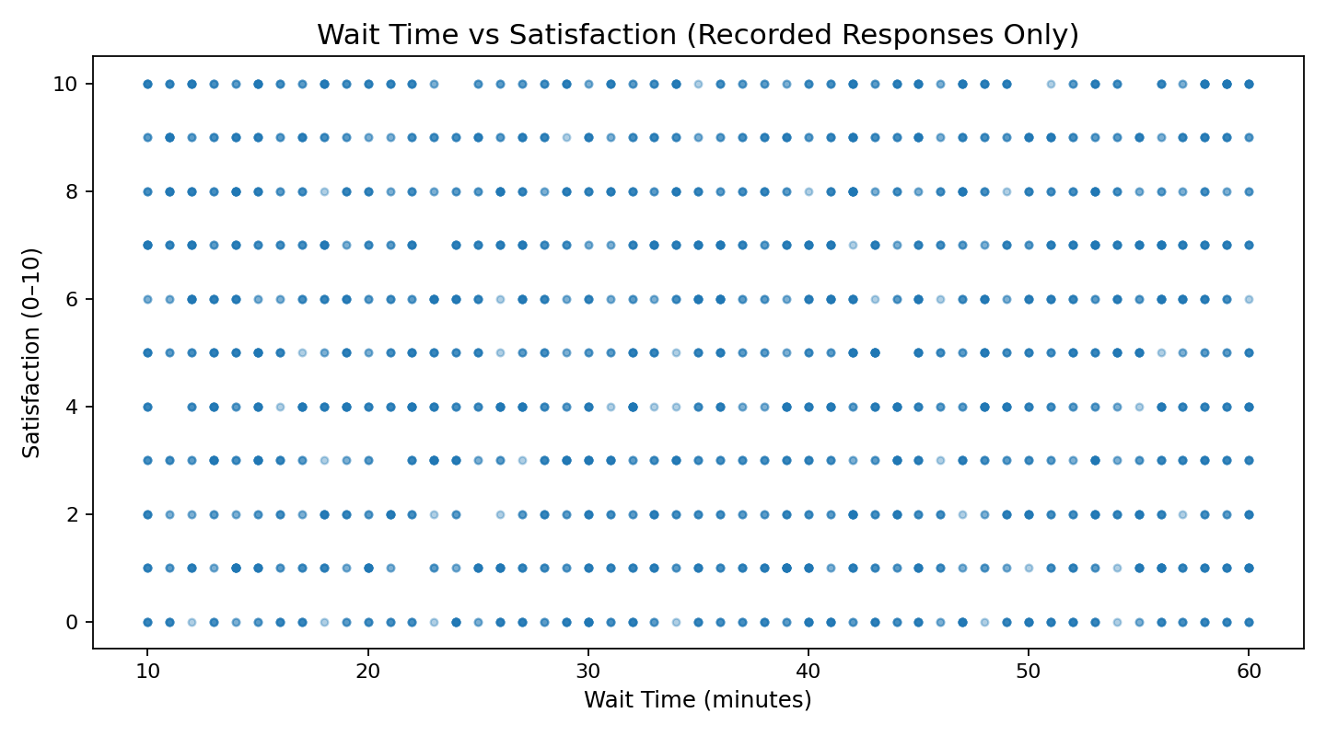
Explores the observed relationship among satisfaction respondents.

Satisfaction by Wait-Time Group
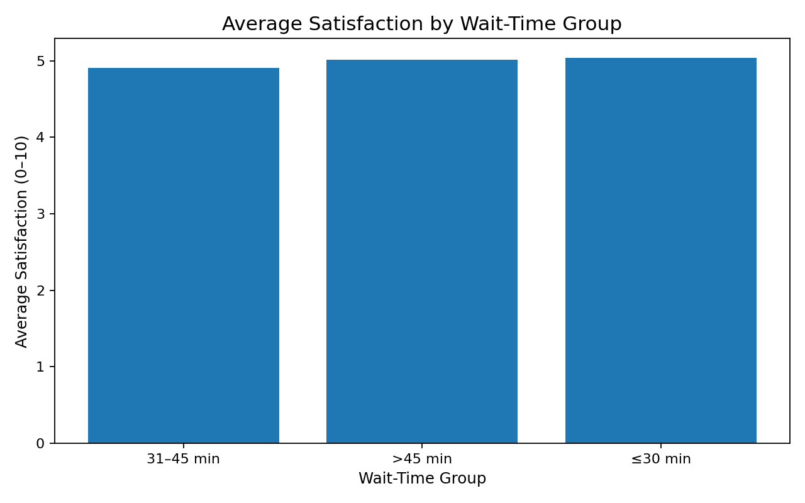
Compares average satisfaction across wait-time bands.

7. KPI Analysis
KPI | Value | Definition
Total ER Visits | 9,216 | Number of visit records
Admission Rate | 50.0% | Admitted visits ÷ all visits
Average Wait Time | 35.3 min | Mean recorded wait time
Average Satisfaction | 4.99/10 | Mean among recorded satisfaction responses
Satisfaction Coverage | 27.3% | Visits with recorded satisfaction ÷ all visits

8. Key Insights
- The dataset contains 9,216 visits with an observed admission rate of 50.0%.
- The highest-volume hour is 23:00 with 436 visits.
- The 30–39 age group has the highest visit volume with 1,200 visits.
- General Practice is the largest recorded referral category with 1,840 visits; 5,400 records have no recorded referral.
- Average satisfaction is 4.99/10 among the 2,517 records with a response. Satisfaction coverage is only 27.3%.
- The wait-time/satisfaction correlation is weak (r = -0.021). This is an observed association and does not establish that wait time causes satisfaction changes.

9. Dashboard / Visualization
The Streamlit dashboard preserves the project’s BI concept while adding the minimum views needed for the final submission: executive KPIs, monthly volume, hourly volume, hourly wait time, referral analysis, age-group admission rate, admission distribution, satisfaction distribution, wait-time vs satisfaction, and satisfaction by wait-time group. Filters allow date, gender, race, and referral exploration.
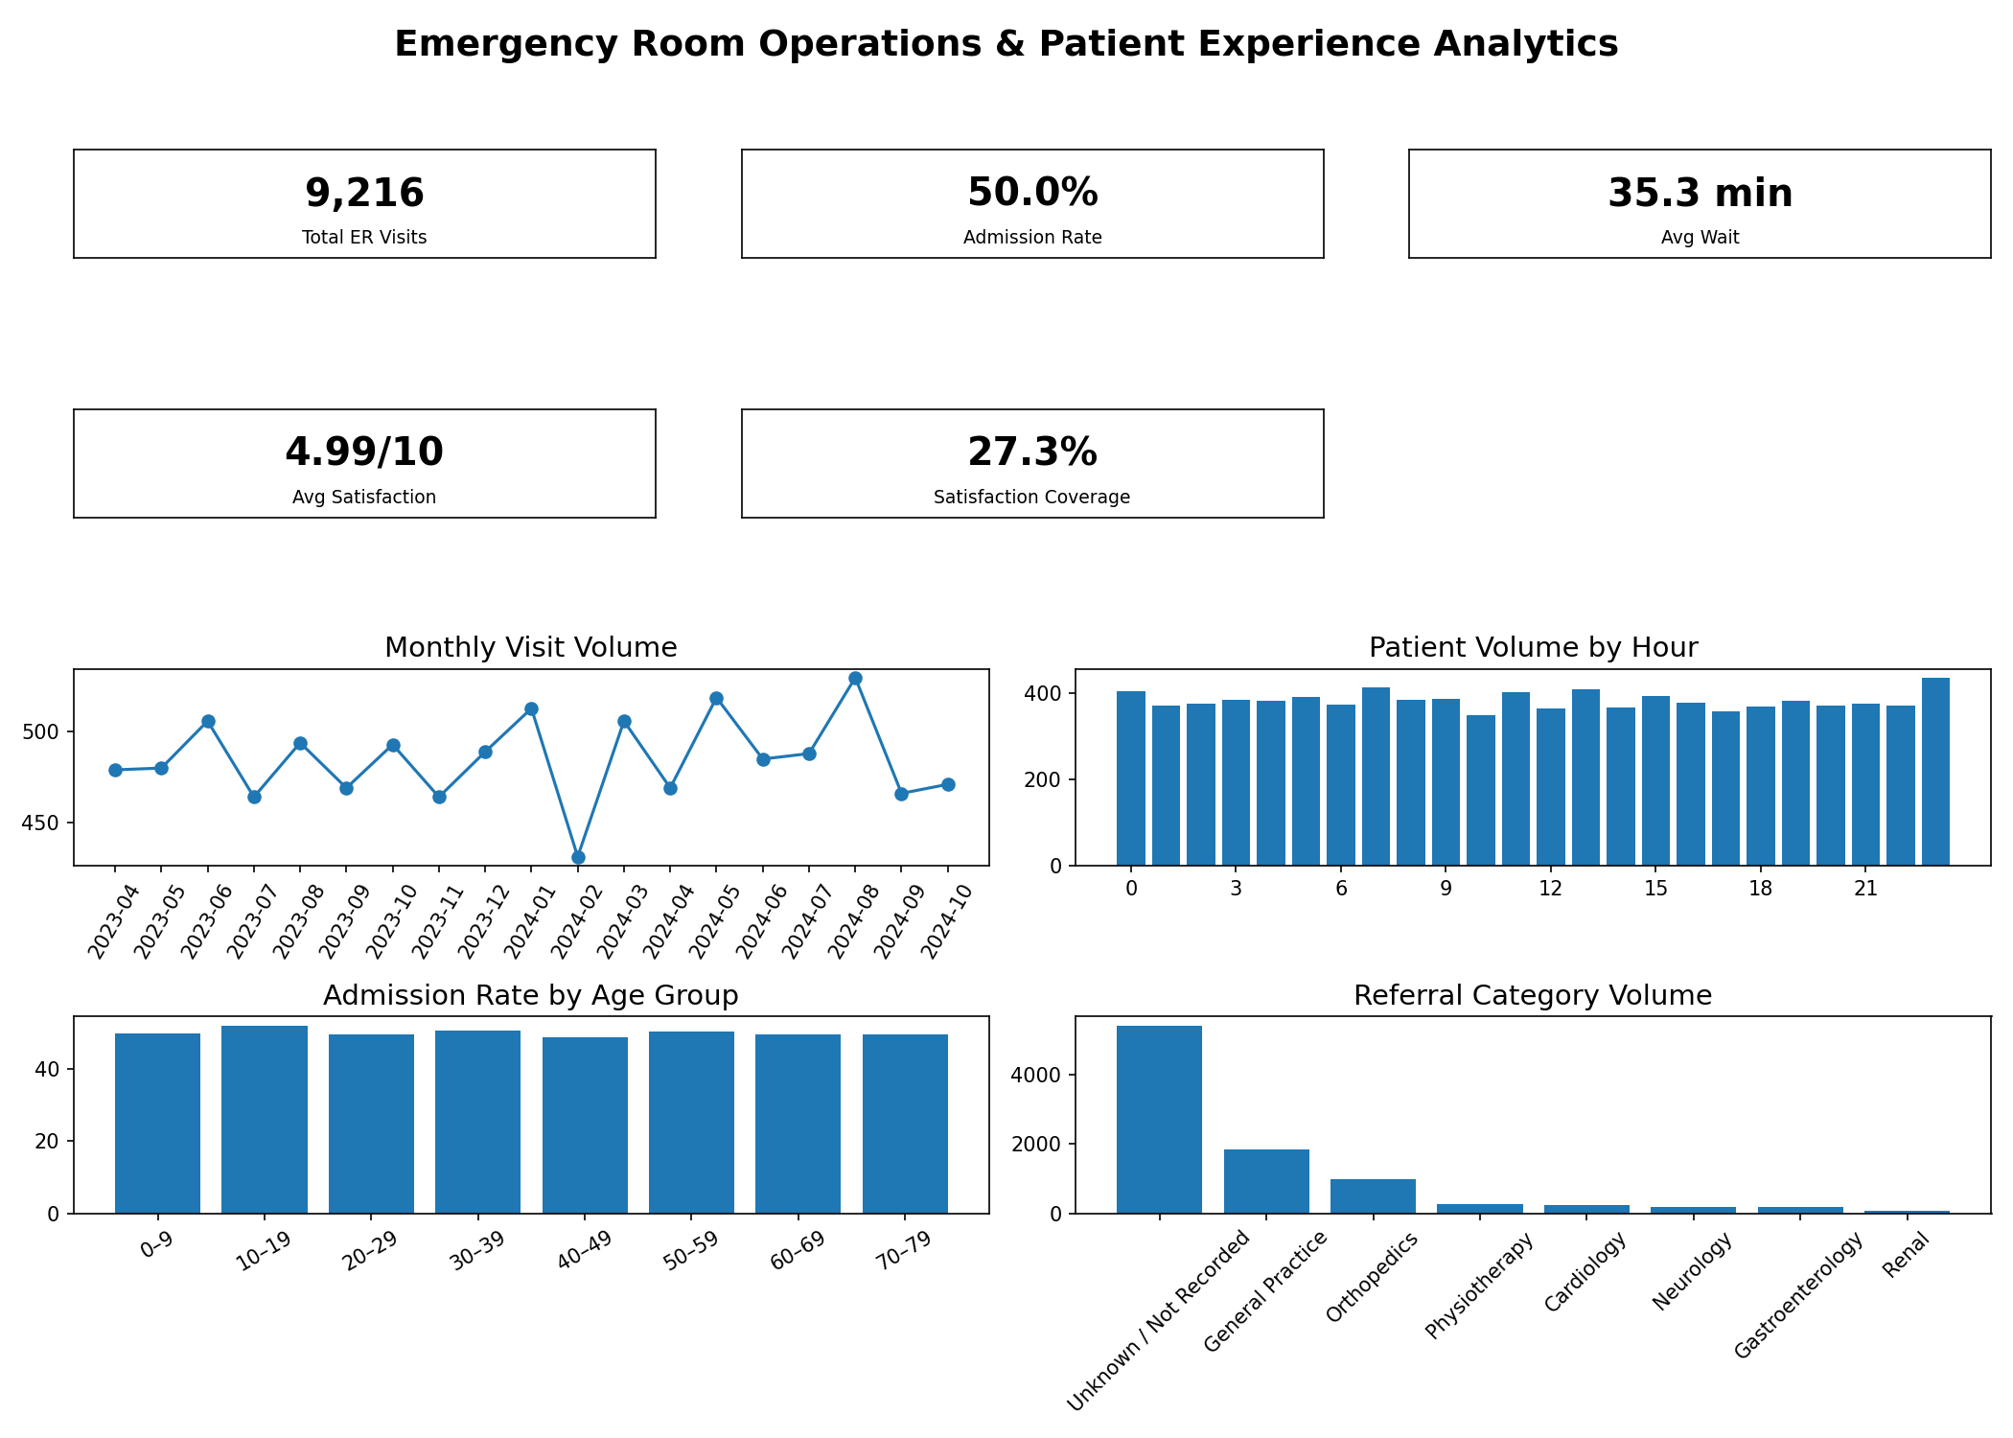

10. Risks & Data Limitations
- Satisfaction scores are missing for 6,699 records (72.7%). Satisfaction findings therefore represent only respondents.
- Department referral is missing for 5,400 records (58.6%). Referral analysis distinguishes these records as Unknown / Not Recorded.
- The dataset does not include staffing, queue size, triage severity, provider availability, or treatment timestamps, limiting root-cause analysis.
- The data is observational; relationships should not be interpreted as causal effects.
- The final public dataset removes direct patient identifiers to reduce privacy risk.

11. Opportunities
- Improve satisfaction survey completion and monitor response coverage as a data-quality KPI.
- Standardize referral documentation and track the Unknown / Not Recorded rate.
- Use peak-hour volume and wait-time patterns together for operational review.
- Add staffing, triage, queue, and treatment-timestamp data to support deeper root-cause analysis.

12. Recommended Actions
- Review peak-volume hours alongside observed wait times before adjusting staffing or workflow coverage.
- Investigate higher-wait referral categories while considering their case volume and data completeness.
- Improve patient-experience survey capture so the satisfaction KPI represents a larger share of visits.
- Establish referral-data quality monitoring and reduce Unknown / Not Recorded entries where operationally feasible.
- Use future enriched data for evidence-based capacity and process planning rather than relying on the current dataset alone.

13. Prediction / ML Assessment
Machine learning was intentionally not added to the final submission. The project objective is practical BI, and the current dataset lacks important operational predictors such as staffing, queue length, triage severity, and provider availability. A future prediction model could be considered after those variables are available and validated.

14. Technology Stack / Tools
Python, Pandas, Streamlit, Plotly, CSV, and Microsoft Word for reporting.

15. Conclusion
The final project converts emergency-room records into a privacy-safe, reproducible BI workflow. It provides executive KPIs, operational trends, patient-experience analysis, transparent data-quality reporting, and practical actions while avoiding unsupported causal or predictive claims.

16. Dataset Source
Hospital Emergency Dataset — Xavier Berge, Kaggle (CC0: Public Domain). https://www.kaggle.com/datasets/xavierberge/hospital-emergency-dataset
Author: Divya Chauhan

