WEEK 1 — PROJECT PLANNING & SYSTEM ARCHITECTURE
ResQMeal
Food Waste & Surplus Sharing Platform

Project Planning • User Flows • Wireframes • Technical Architecture • Database Design

Project Type | Full Stack Web Application
Primary Goal | Reduce edible food waste by connecting surplus donors with nearby people and shelters
Target Users | Individuals, restaurants, grocery stores, NGOs / shelters
Week 1 Deliverable | Project brief and complete system architecture documentation
Intern Name | Divya
Company / Organization | Yuvaintern
Submission Date | 9 August 2026

1. Project Brief
ResQMeal is a proposed full stack web application that helps prevent edible surplus food from being discarded. Restaurants, grocery stores, and individuals can publish food that is still safe to consume but is approaching its expiry or pickup deadline. Nearby users and registered shelters can discover these listings and claim them before the available time expires.

Problem Statement
Food can become waste because of overproduction, unsold inventory, cancelled orders, excess household food, or short remaining shelf life. At the same time, many people and community organizations need access to affordable or donated food. ResQMeal addresses this gap by providing a simple, location-aware marketplace for surplus food.

Project Objectives
- Reduce avoidable food waste by making surplus food visible before disposal.
- Connect donors with nearby people, NGOs, and shelters.
- Make time-sensitive food listings easy to discover and claim.
- Provide a clear workflow for listing, discovering, claiming, and completing a pickup.
- Create a foundation that can later support notifications, maps, analytics, and moderation.

Core Features
Feature | Description
User registration & authentication | Users create accounts and select a role such as donor, recipient, or shelter.
Surplus food listing | Donors add food name, category, quantity, pickup location, expiry/pickup deadline and notes.
Nearby discovery | Recipients can browse available listings and filter by category, distance and availability.
Claim workflow | A recipient claims an available listing; the listing status changes to reserved/claimed.
Time-sensitive inventory | Listings show remaining time so users understand urgency.
Notifications | The future system can send alerts for nearby new food, claim confirmation and expiry reminders.
Role-based access | Donors manage their own listings while recipients manage their claims.
Admin moderation | An administrator can review reports, suspicious listings and user activity.

2. Target Users & Use Cases
Donor: A restaurant, grocery store, household, or individual who has edible surplus food to share.
Recipient: A nearby person who wants to discover and claim available surplus food.
Shelter / NGO: An organization that can claim larger quantities for community distribution.
Administrator: A moderator responsible for users, listings, reports and platform safety.

Representative User Stories
- As a donor, I want to create a food listing so that surplus food can reach someone who needs it.
- As a recipient, I want to see food near me so that I can choose something I can collect in time.
- As a recipient, I want to know when a listing expires so that I do not waste time on unavailable food.
- As a shelter, I want to claim multiple available portions so that I can distribute them to beneficiaries.
- As an administrator, I want to moderate listings so that unsafe or misleading content can be removed.

3. Functional & Non-Functional Requirements

Functional Requirements
- FR-01: The system shall allow users to register and log in.
- FR-02: The system shall allow donors to create, edit and remove their food listings.
- FR-03: The system shall display listing title, category, quantity, location, pickup window and expiry.
- FR-04: The system shall allow recipients to search and filter available listings.
- FR-05: The system shall allow an eligible user to claim an available listing.
- FR-06: The system shall prevent a listing from being claimed after its expiry or when its quantity is exhausted.
- FR-07: The system shall record claim status and timestamps.
- FR-08: The system shall generate notification records for important events.
- FR-09: The system shall support role-based access for donor, recipient, shelter and admin users.
- FR-10: The system shall allow admins to review and moderate reported content.

Non-Functional Requirements
- Responsive: the interface should work on desktop, tablet and mobile screens.
- Security: passwords must be stored using a secure hash; authenticated APIs should use tokens/sessions; HTTPS should be used in deployment.
- Performance: common browse requests should return quickly and listing queries should be indexed.
- Usability: important actions such as Claim and List Food should be visually clear.
- Reliability: expired listings should not remain claimable.
- Maintainability: frontend, API, business logic and database access should be separated into clear modules.

4. User Interaction Flowchart
The following flow represents the main recipient journey, while also showing the alternative path for a user who wants to donate surplus food.
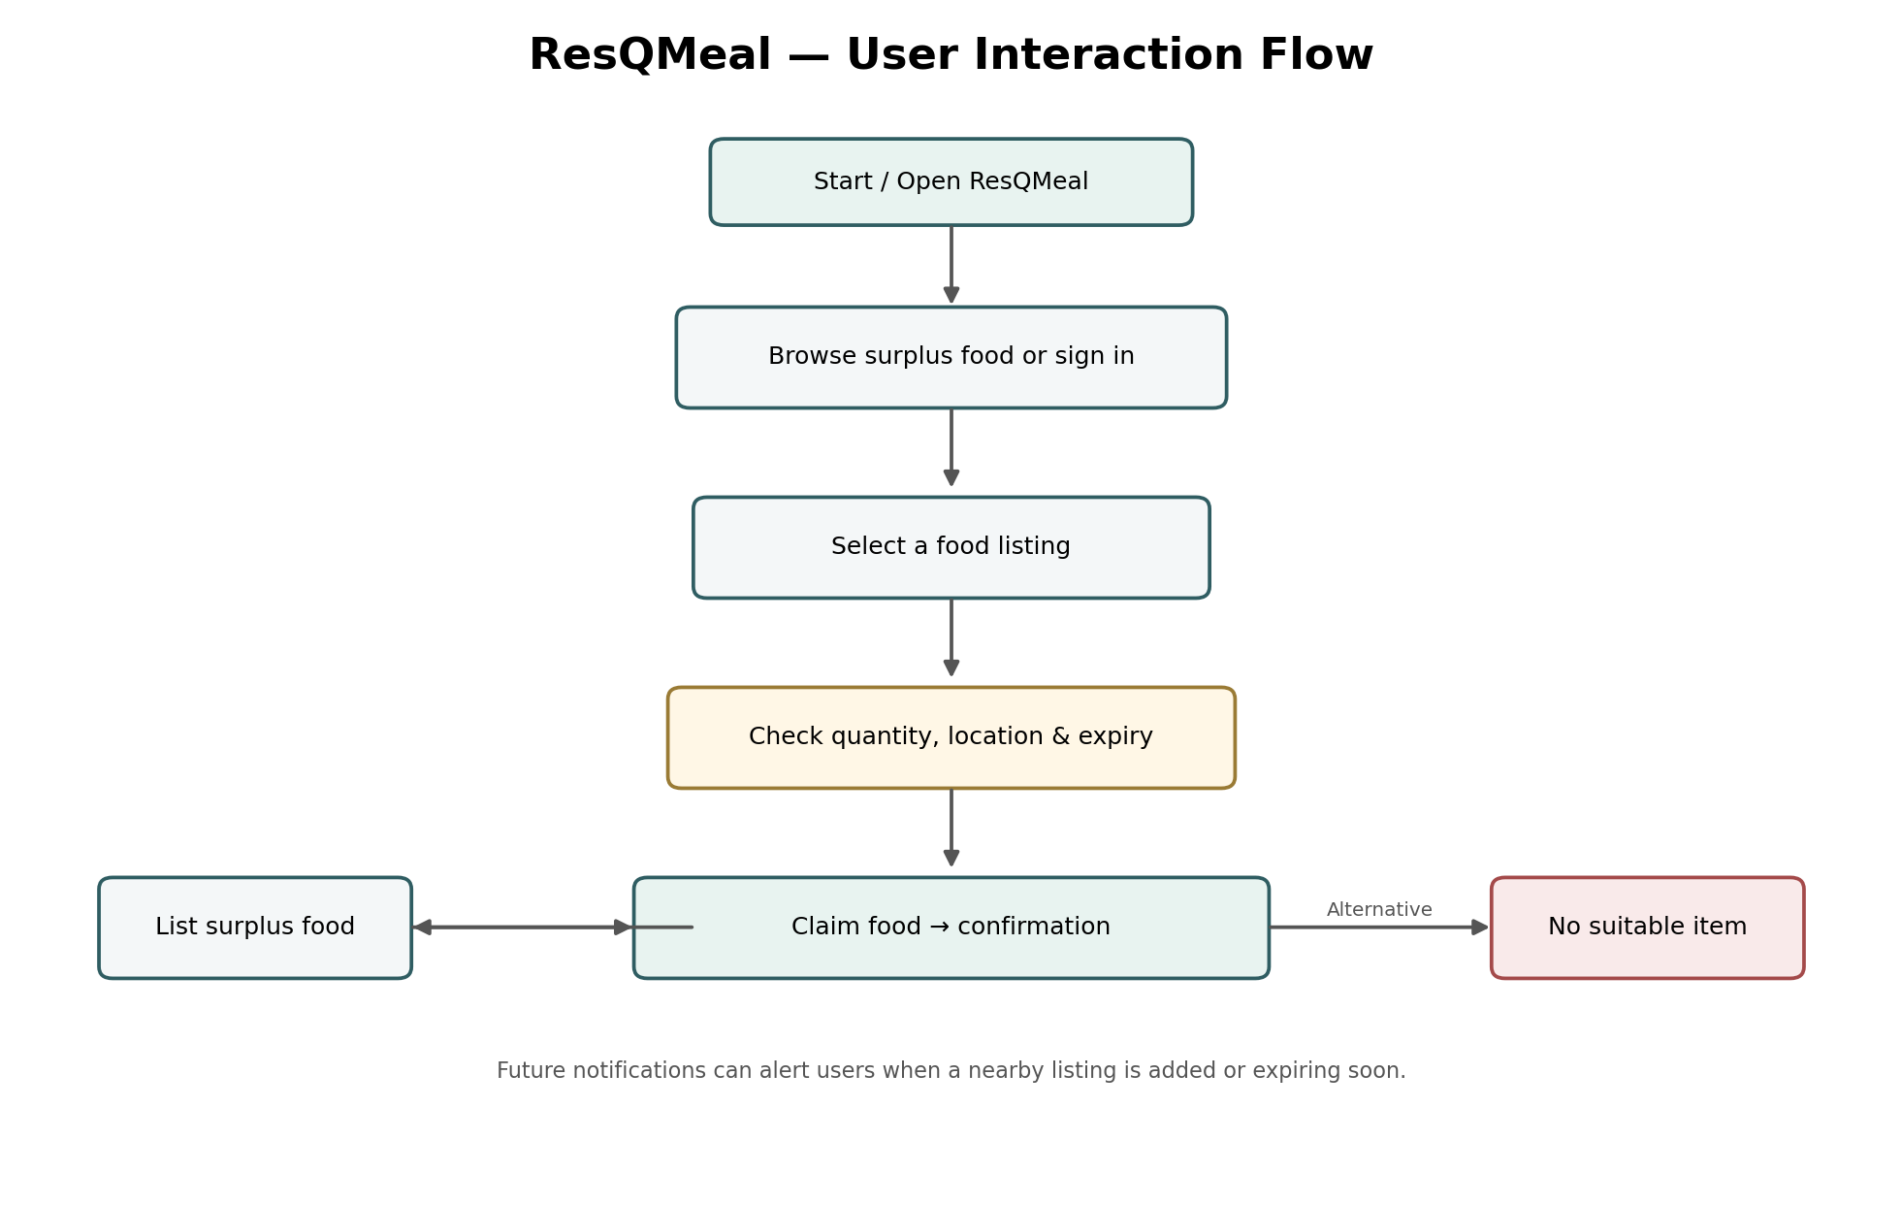

Flow Explanation
- 1. The user opens ResQMeal and can browse available food or sign in.
- 2. The user selects a listing and checks quantity, pickup location and expiry time.
- 3. If the item is suitable and still available, the user claims it.
- 4. The system records the claim and shows confirmation details.
- 5. A donor follows a separate path to create a surplus food listing.
- 6. Future versions can trigger notifications when a new nearby item is listed or an existing item is close to expiry.

5. Front-End Wireframe
The wireframe establishes page hierarchy before visual styling. It focuses on the homepage because the homepage is the primary discovery surface for this concept.
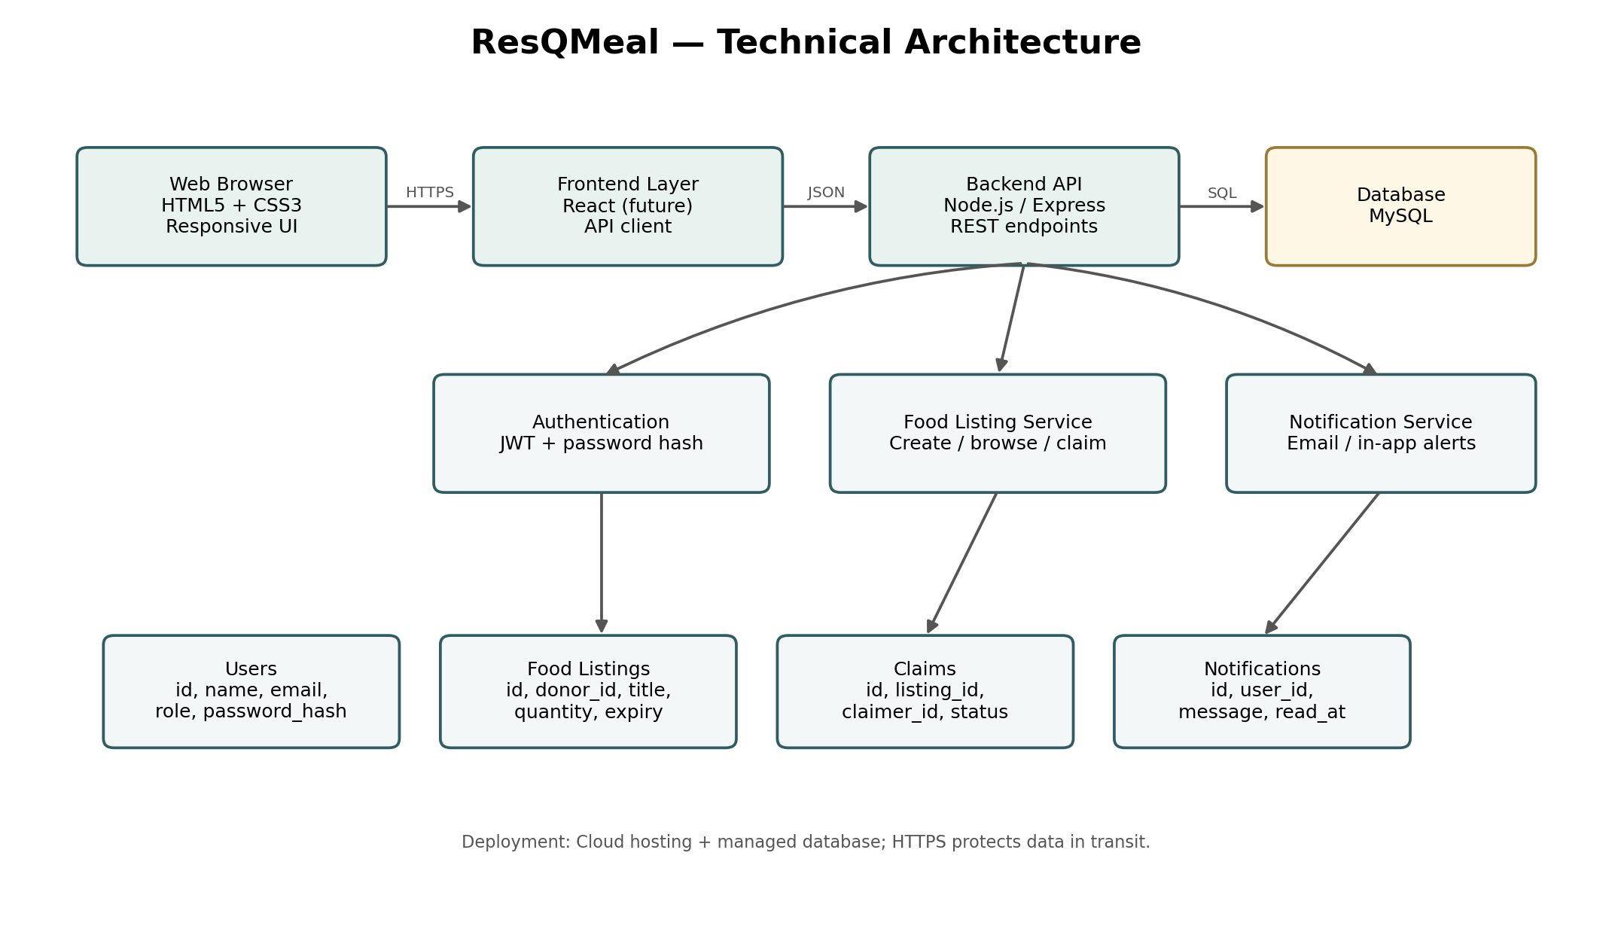

Wireframe Sections
- Navigation: brand, primary navigation links and a prominent List Food action.
- Hero: communicates the problem and offers two main actions — find food and donate food.
- Impact statistics: communicates social value and builds trust.
- Nearby surplus cards: gives users a fast view of available food, distance and time remaining.
- How it works: explains the simple List → Discover → Claim → Share journey.
- Footer: provides secondary navigation and basic company/contact information.

6. Technical Architecture
The architecture is designed as a conventional three-layer web application. The Week 1 design is intentionally technology-flexible, but the proposed implementation uses a responsive web frontend, a REST API backend, and MySQL for persistent data.
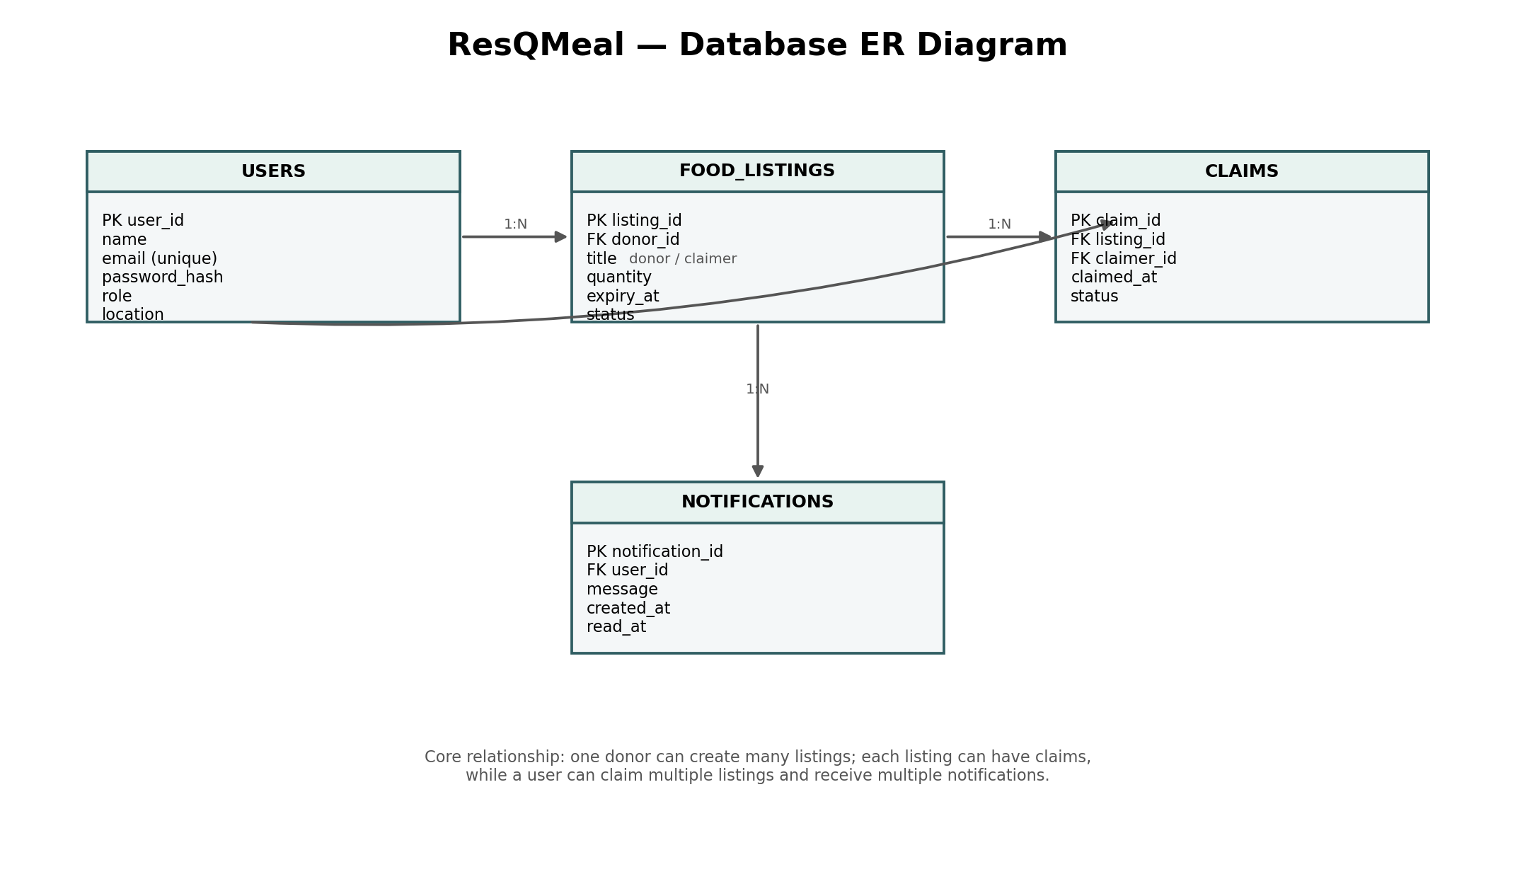

Architecture Components
Component | Responsibility
Presentation Layer | Responsive web interface. The static prototype can be built with HTML5 and CSS3; a production version can migrate to React.
API / Application Layer | Node.js + Express REST API. Handles authentication, validation, listing operations, claim transactions, notifications and admin actions.
Authentication | JWT or secure session-based authentication with password hashing and role-based authorization.
Database Layer | MySQL stores users, listings, claims and notifications with foreign-key relationships.
Notification Layer | Email or in-app notification service for claim confirmations, new nearby listings and expiry reminders.
Hosting / Infrastructure | Frontend and backend can be deployed to cloud hosting with HTTPS and a managed MySQL instance.

7. Proposed API Endpoints
Method | Endpoint | Purpose
POST | /api/auth/register | Create a user account
POST | /api/auth/login | Authenticate user and return access token/session
GET | /api/listings | Get active food listings with filters
GET | /api/listings/:id | Get one listing's details
POST | /api/listings | Create a surplus food listing
PUT | /api/listings/:id | Update a donor's listing
DELETE | /api/listings/:id | Remove or cancel a listing
POST | /api/listings/:id/claim | Claim an available listing
GET | /api/claims/me | Get current user's claims
GET | /api/notifications | Get current user's notifications
PATCH | /api/notifications/:id/read | Mark a notification as read
GET | /api/admin/reports | Admin-only moderation/report data

8. Database Schema & Relationships
The core data model separates users from food listings and claims. A donor can create multiple listings. A recipient can claim multiple listings over time. Notifications belong to users.
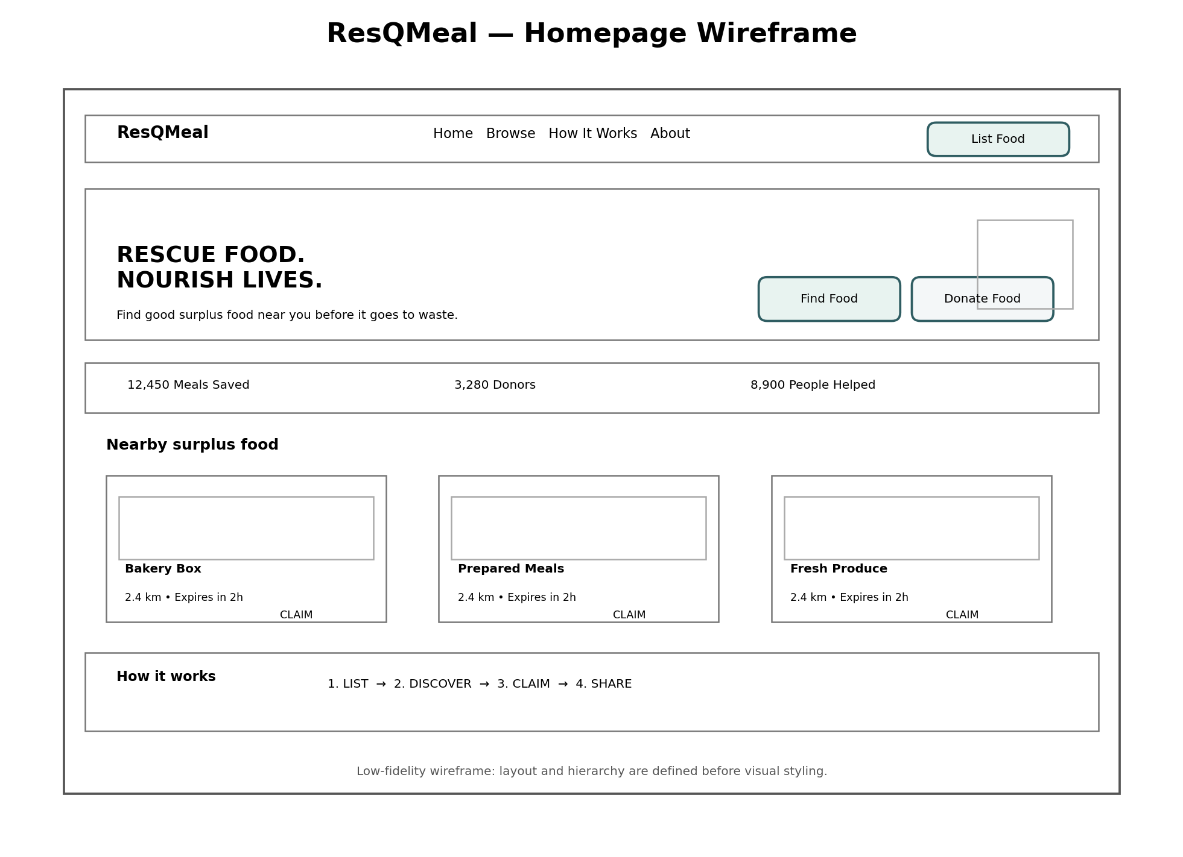

Core Tables
Table | Important Fields | Purpose
users | user_id, name, email, password_hash, role, location, created_at | Stores all platform accounts.
food_listings | listing_id, donor_id, title, category, quantity, expiry_at, pickup_location, status, created_at | Stores surplus food offered by donors.
claims | claim_id, listing_id, claimer_id, claimed_at, status | Stores reservation/claim transactions.
notifications | notification_id, user_id, type, message, created_at, read_at | Stores user notification events.

9. Design Decisions & Rationale
Time-sensitive cards: Expiry/pickup time is displayed prominently because surplus food loses value quickly and urgency affects user decisions.
Location-first discovery: Nearby availability is central to the concept because food generally needs to be collected within a practical travel distance.
Clear primary actions: Find Food and List Food are the two most important actions, so they are kept visually prominent.
Simple claim workflow: A short flow reduces friction and makes the concept understandable to first-time users.
Role-based access: Donors, recipients, shelters and admins have different responsibilities, so authorization is separated by role.
Relational database: Users, listings and claims have clear relationships and transaction history, making MySQL suitable for the initial design.
Responsive-first layout: Recipients may use phones while travelling to collect food, so mobile usability is a core requirement rather than an afterthought.

10. Expected Challenges & Solutions
Preventing expired claims: Validate expiry time on the server before creating a claim; expired listings are automatically treated as unavailable.
Concurrent claims: Use a database transaction/row lock or atomic update so two users cannot claim the same remaining quantity incorrectly.
Location accuracy: Start with city/area and approximate coordinates; a later version can integrate a map/geocoding provider.
Notification reliability: Store notification events in the database and process email delivery separately so a temporary email failure does not lose the event.
Food safety: The platform should require donors to provide accurate food details and pickup/expiry information, while terms and moderation rules clarify responsibility.
Responsive design: Use CSS Grid/Flexbox and breakpoints to adapt cards, navigation and spacing for mobile screens.

11. Future Scope
- Interactive map view with distance-based search.
- Push notifications and real-time alerts for nearby surplus food.
- QR-based pickup confirmation.
- Donor reputation and recipient feedback.
- Analytics dashboard showing meals saved and estimated waste reduction.
- Integration with NGOs and community kitchens.
- Image upload and moderation for food listings.
- Multi-language support and accessibility improvements.

12. Conclusion
ResQMeal demonstrates how a real-world social problem can be translated into a structured full stack application concept. The proposed system combines a simple discovery experience with time-sensitive inventory, user roles, claim transactions, notifications and a relational database. The wireframe and architecture separate user experience decisions from technical implementation, providing a practical foundation for later development.

End of Week 1 — Project Planning & System Architecture

