Task 1 :
When the page is loaded , Display the below header :

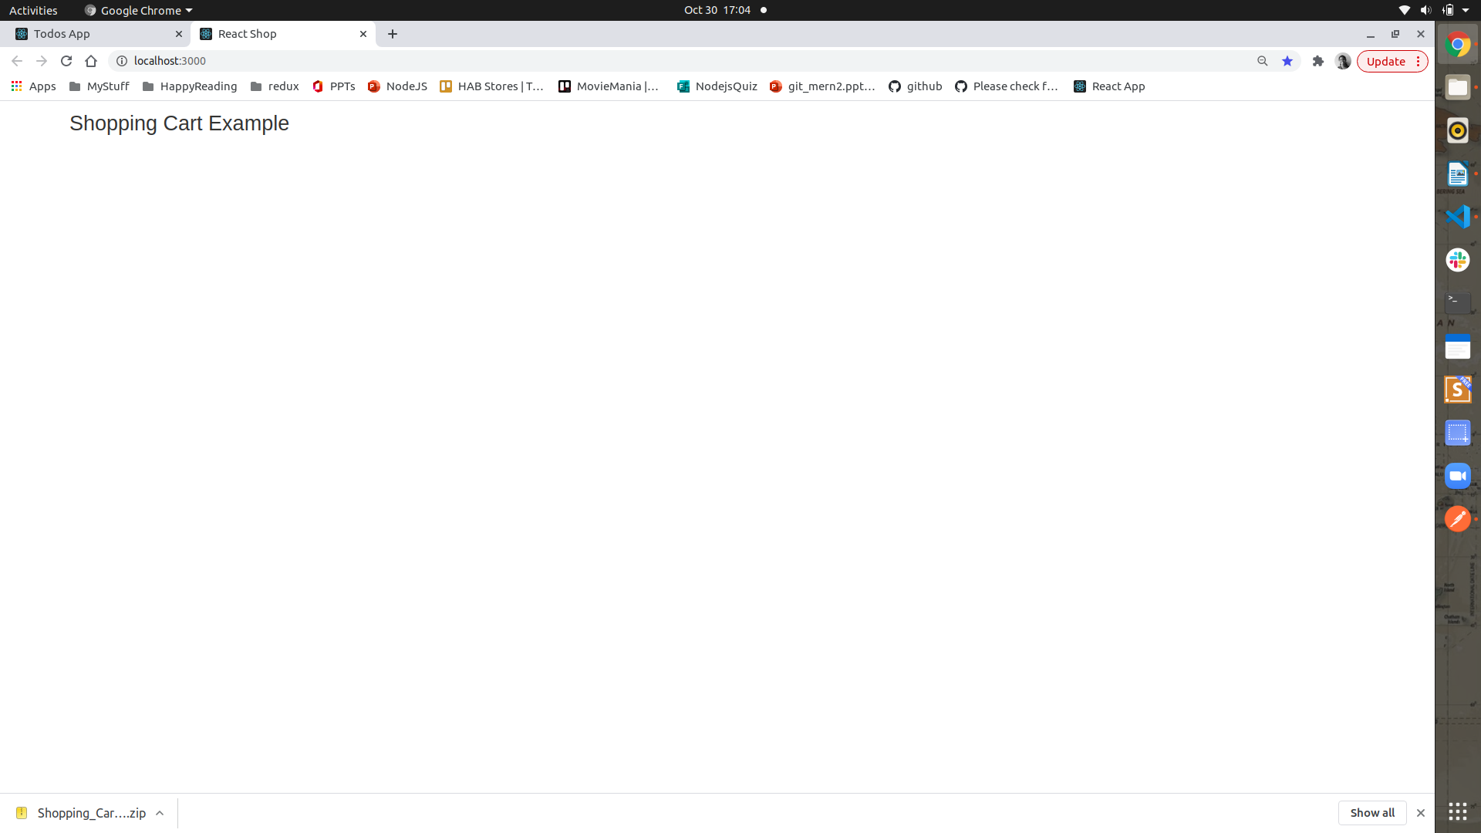

Task 2 : Display all the products by making a api call to
method: 'get',
url: 'http://localhost:8080/products',
headers: { }

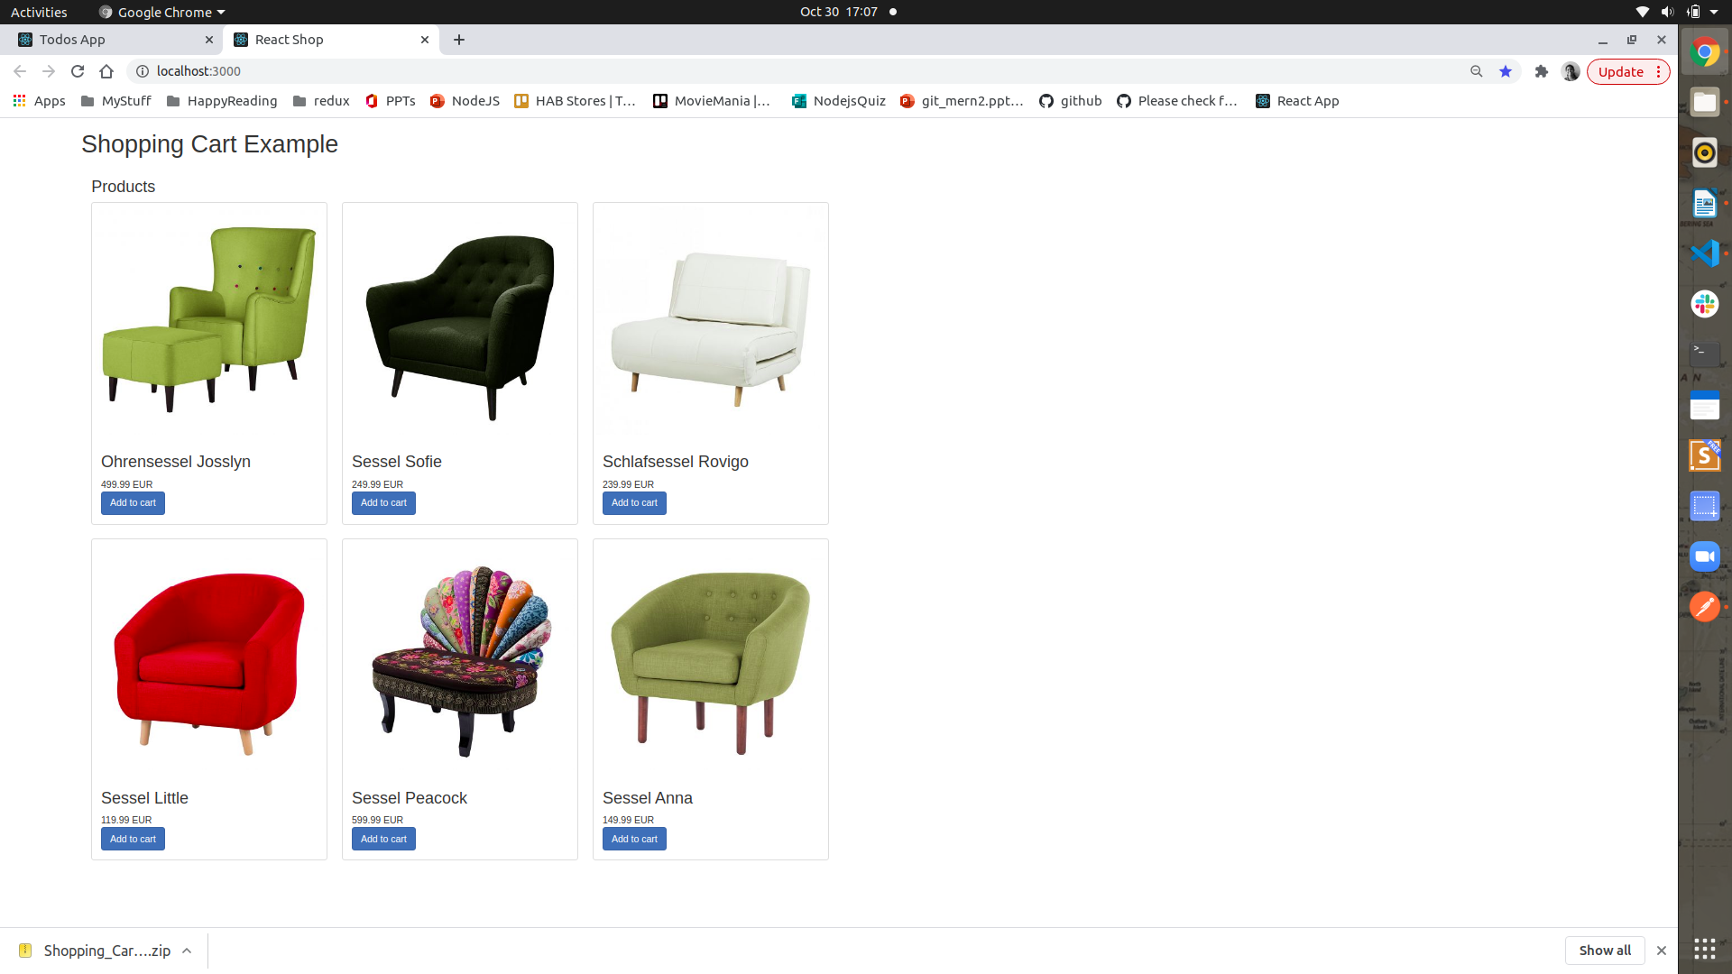

Task4 :
Using the same api to Display a cart component by filtering data based on weather Product has the isCart – isInCart:false

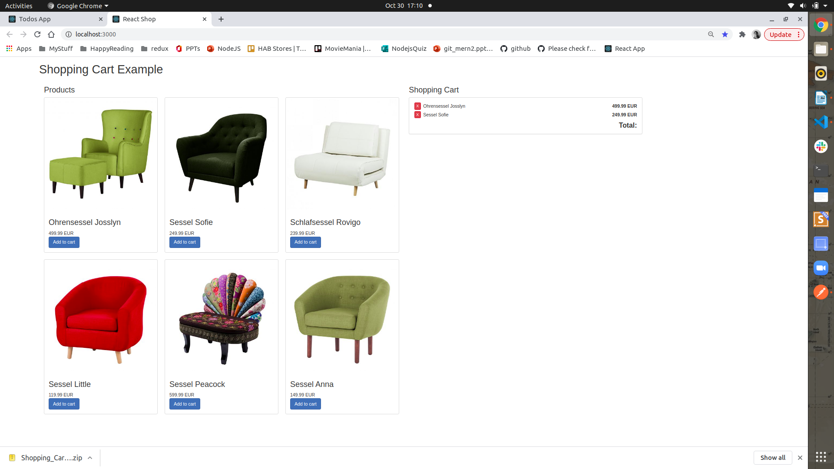

Task 5 : Whenever add to cart button is clicked , update the api of that particular item isInCart

to true.
var config = {
method: 'post',
url: 'http://localhost:8080/cart/add/${ProductId}',
headers: { }
};

Task 6: In the Products component, if the the item is added to the cart then , the instead of disaplying the button – Add to Cart , a red button remove must be displayed
var config = {
method: 'post',
url: 'http://localhost:8080/cart/remove/${ProductId}',
headers: { }
};

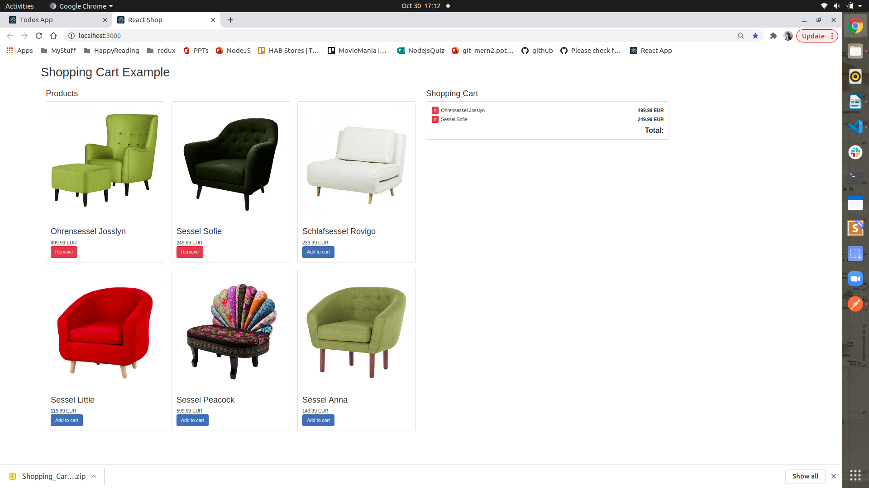

Task 7: In the cart the if any products has isInCart is set as true, then display those products in the cart, with the total amount calulated.

Task 8: When the Remove button is clicked, the item must be removed from the cart.

To see the demo : http://krzysu.github.io/reactjs-shopping-cart/

