Task 1 :
When the page is loaded , Display the below header :

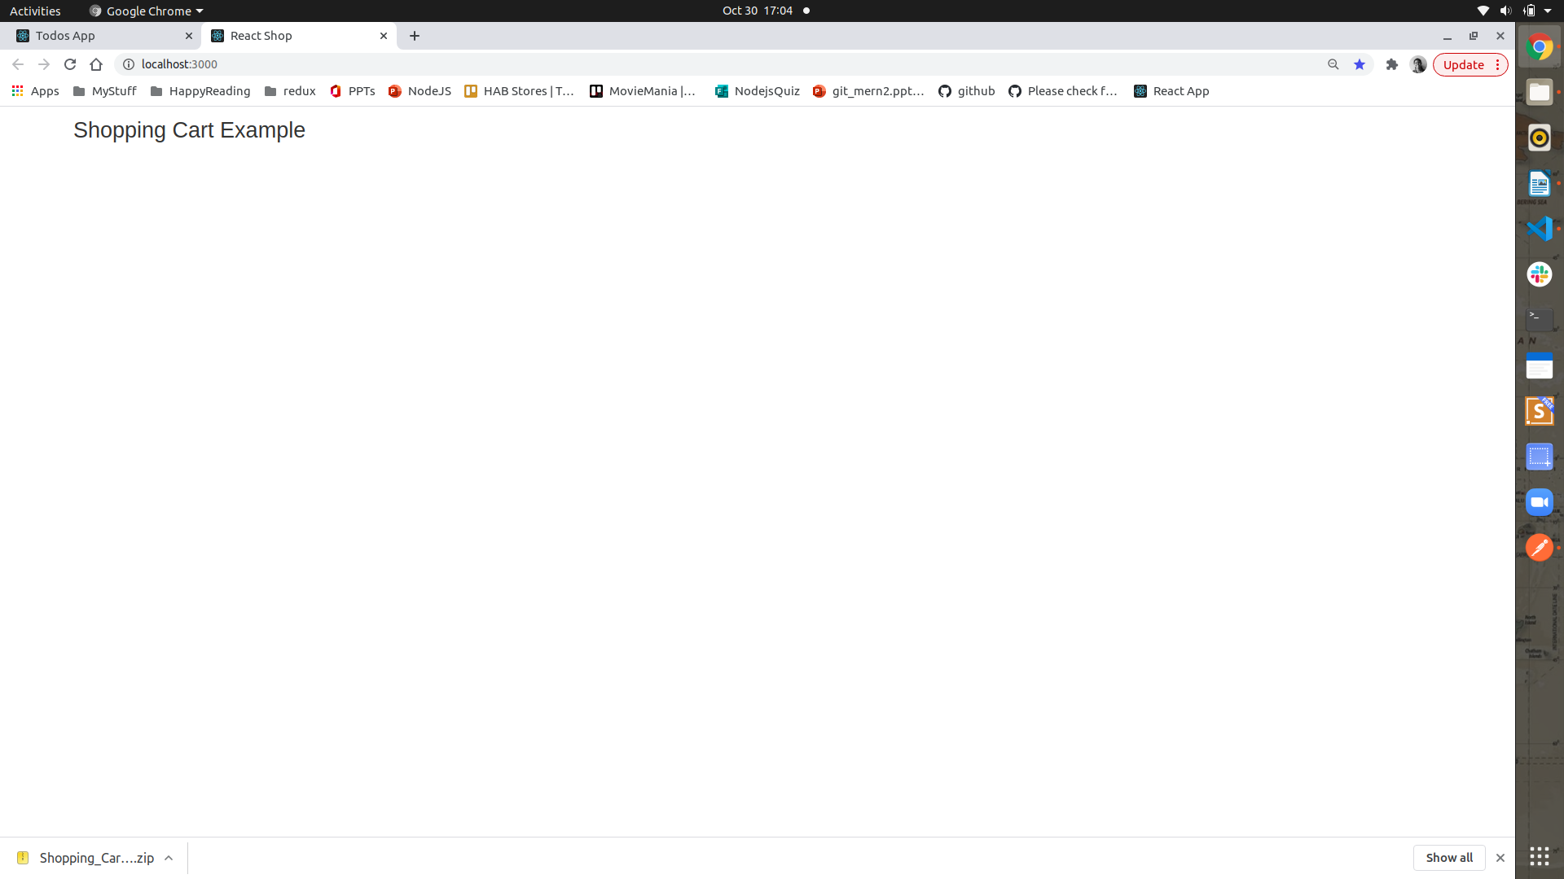

Task 2 : Set Up a redux store, which initiaiises the Produst list from src/data/products.js
into the redux store (Note : this loading should as done as the default value)

Task 3 : Connecting to this redux store display all the products, in the screen :

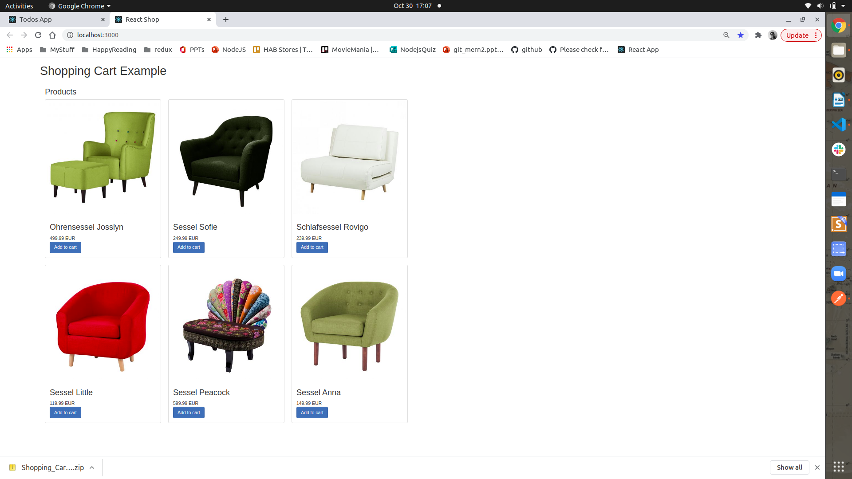
sdfgdfg

Task4 :
Using the same Redux store : display a cart component by filtering data based on weather Product has the isCart – isInCart:false

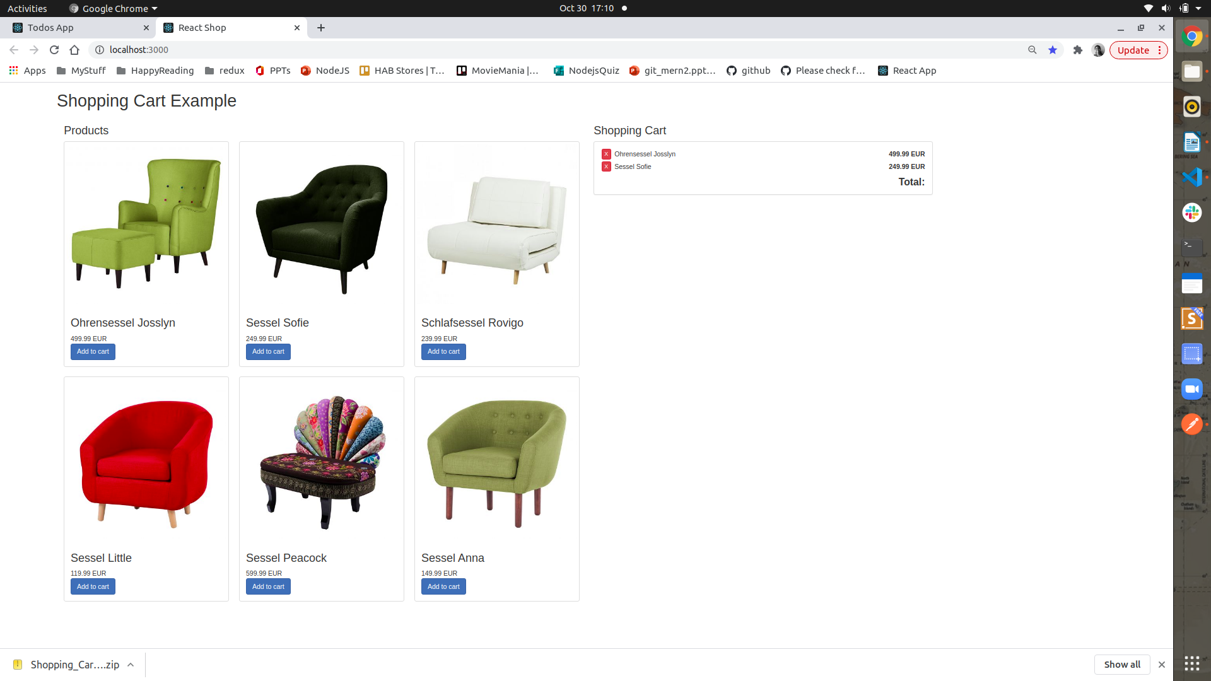

Task 5 : Whenever add to cart button is clicked , update the redux of that particular item isInCart

to true.

Task 6: In the Products component, if the the item is added to the cart then , the instead of disaplying the button – Add to Cart , a red button remove must be displayed
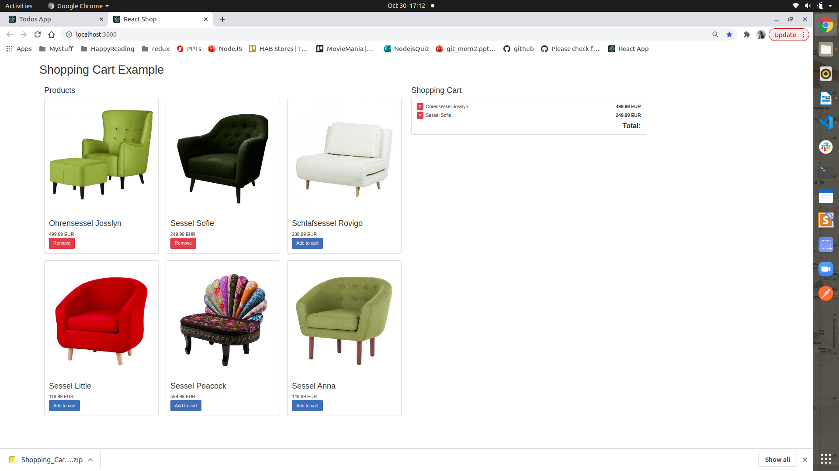

Task 7: In the cart the if any products has isInCart is set as true, then display those products in the cart, with the total amount calulated.

Task 8: When the Remove button is clicked, the item must be removed from the cart.

To see the demo : http://krzysu.github.io/reactjs-shopping-cart/

