Task1: When the page is rendered for the first time, the students components should be rendered, with the list of the sessions they have enrolled to :

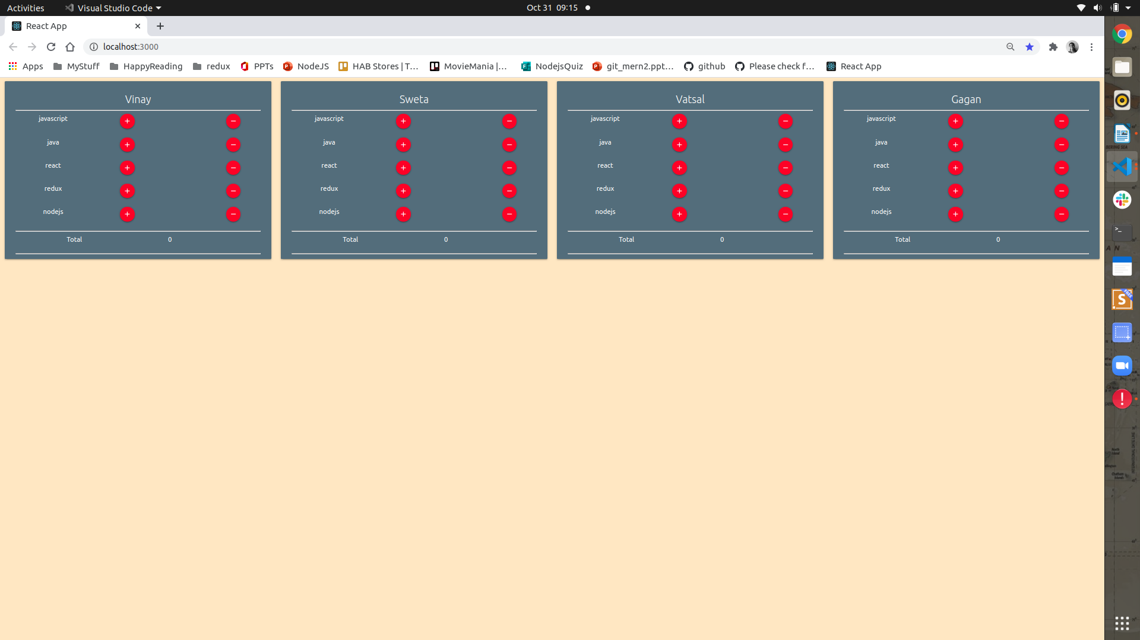
v

Task 2: Whenever the + is clicked the attendance of that student needs to imcremented.

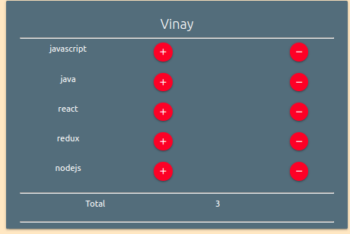

Task 3: Whenever – is clicked the attendance must be subtracted.

Task4 Whenever the total attendance of any particular student is equal or greater 5 then the student should be added to the gradudation list .
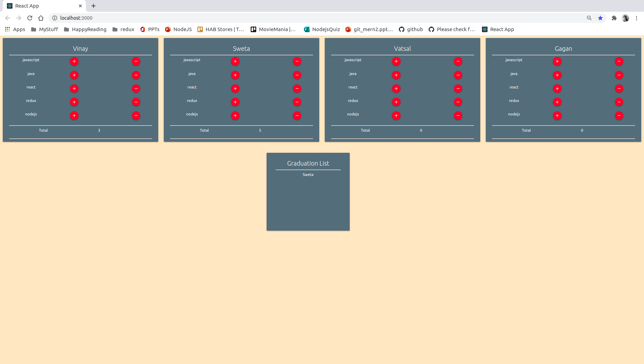
Thereafter is the attendance goes below 5 the students name should be removed from the Graduation List

