# MEENAKSHI SUNDARARAJAN ENGINEERING COLLEGE

Kodambakkam, Chennai-600024

**SB3001 PROJECT BASED EXPERIENTIAL LEARNING**

**PROGRAM**

## DEPARTMENT OF COMPUTER SCIENCE

**TOPIC: LANGUAGE IDENTIFICATION USING GENERATIVE AI**

**FACULTY MENTOR:Dr.S.AARTHI**

**Project submitted by,**

**DIVYA DARSHINI R**

**311521104013**

# Project Report Format

## ABSTRACT 3

## INTRODUCTION 4

* 1. Project Overview 5
  2. Purpose 7

## IDEATION & PROPOSED SOLUTION 8

* 1. Problem statement definition 8
  2. Ideation & Brainstorming 8
  3. Proposed Solution 11

## REQUIREMENT ANALYSIS 13

* 1. Functional requirement 13
  2. NonFunctional requirements 15

## PROJECT DESIGN 17

* 1. Briefing 17
  2. Solution 17

## SOLUTION 18

* 1. Development part 1 18
  2. Development part 2 19

## RESULTS 20

* 1. Performance Metrics 20

## 8.ADVANTAGES & DISADVANTAGES 21

**9.CONCLUSION** 24

## 10.FUTURE SCOPE 25

**11.SOURCE CODE** 28

# 1.ABSTRACT

# This project delves into the realm of language identification using generative AI, a vital aspect of modern communication systems, aiding in multilingual support, content filtering, and data analysis. The approach harnesses the power of recurrent neural networks (RNNs) and transformer architectures for accurate language classification from textual inputs.

# The dataset comprises a diverse range of text samples in multiple languages, encompassing various dialects, styles, and genres. Data preprocessing involves tokenization, normalization, and encoding to prepare the text data for training the models effectively. Additionally, techniques such as data augmentation and balancing are employed to enhance model robustness and generalization.

# Models are trained using state-of-the-art optimization techniques, including adaptive learning rate methods, early stopping, and model ensembling, to refine the training process and boost performance. Performance evaluation is conducted using metrics such as accuracy, precision, recall, and F1-score across distinct training, validation, and test sets, providing comprehensive insights into model efficacy.

# Results demonstrate the efficacy of both RNN-based and transformer-based models in accurately identifying languages, with the transformer architecture showing notable advantages in handling long-range dependencies and capturing nuanced linguistic patterns. These findings underscore the potential of generative AI for language identification tasks, paving the way for enhanced multilingual communication systems and language-based applications.

# Furthermore, this project explores potential deployment scenarios for the trained models, facilitating real-time language detection in various applications, including social media platforms, content moderation systems, and customer service automation. By showcasing the feasibility of using advanced AI techniques for language identification, this endeavor contributes to the advancement of natural language processing and multilingual computing.

# 2.INTRODUCTION

## Language identification is a crucial aspect of modern communication systems, facilitating multilingual support, content filtering, and data analysis. Manual language detection methods are often time-consuming and limited by human error and expertise. Therefore, the adoption of automated solutions leveraging advanced technologies is imperative for efficient language identification.

## In this project, we explore the application of generative AI, specifically recurrent neural networks (RNNs) and transformer architectures, for language identification from textual inputs. Unlike traditional rule-based approaches, generative AI models have the capability to learn complex linguistic patterns and nuances inherent in diverse languages.

## We experimented with training a custom RNN architecture as well as utilizing a transformer-based model pretrained on large text corpora to harness transfer learning and improve model performance. Leveraging a comprehensive dataset containing text samples in multiple languages, we aim to train and evaluate these models effectively for language detection tasks.

## Our methodology involves preprocessing textual data, including tokenization and normalization, to prepare it for input into the models. We employ various optimization techniques during model training, such as adaptive learning rates and early stopping, to enhance training efficiency and prevent overfitting.

## Through rigorous evaluation using standard language identification metrics, including accuracy, precision, recall, and F1-score, we assess the models' proficiency in accurately classifying different languages. Furthermore, we explore potential deployment scenarios for real-time language identification applications, such as social media monitoring and customer service automation.By providing a comprehensive analysis of both custom RNN and transformer-based models for language identification, this project aims to demonstrate the viability of using generative AI for efficient and effective language detection tasks. Such advancements have the potential to revolutionize multilingual communication systems, streamline content moderation processes, and foster global linguistic diversity

## 2.1 PROJECT OVERVIEW

A Generative Adversarial Network (GAN) is a type of deep learning model architecture commonly used in language generation tasks. Language generation is a field of artificial intelligence that enables a computer to produce coherent and contextually relevant text. Transformer-based models, such as GPT (Generative Pre-trained Transformer) series, have gained prominence in language generation tasks due to their ability to capture long-range dependencies and generate high-quality text.

This project aims to develop and evaluate deep learning models for language identification using generative AI techniques. Leveraging recurrent neural networks (RNNs) and transformer architectures, including models pretrained on large text corpora, the project seeks to enhance the accuracy and efficiency of identifying languages from textual inputs. The dataset consists of text samples in multiple languages, preprocessed to ensure uniformity and optimize model performance.

The project involves extensive training and evaluation of the models, incorporating optimization techniques like adaptive learning rates and early stopping to refine the training process. Performance metrics such as accuracy, precision, recall, and F1-score are utilized to assess the models' proficiency in language identification across different languages. Furthermore, potential applications for real-time language detection, including social media analysis and customer service automation, are explored.

By showcasing the effectiveness of generative AI in language identification tasks, this project underscores the potential for advanced AI techniques to revolutionize multilingual communication systems and foster inclusivity in.

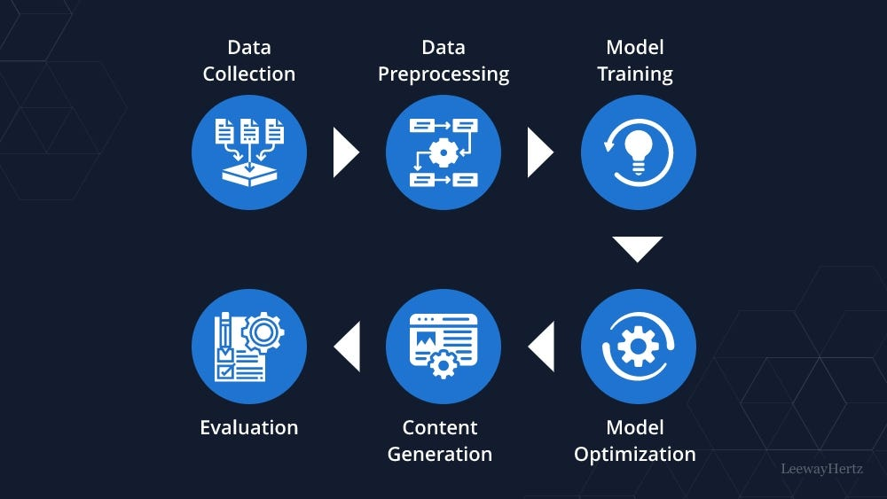

● Data Collection and Preprocessing: The dataset comprises labeled text samples in multiple languages sourced from various sources. Preprocessing involves tokenization, normalization, and encoding to prepare the textual data for model training.

● Model Development: Two models are developed: a custom recurrent neural network (RNN) architecture and a transformer-based model pretrained on a large text corpus. These models aim to accurately identify languages from textual inputs.

● Training and Optimization: The models undergo training using optimization techniques like adaptive learning rates, early stopping, and model checkpoints to refine the training process and improve performance.

● Performance Evaluation: The models' proficiency in language identification is evaluated using metrics such as accuracy, precision, recall, and F1-score across separate training, validation, and testing datasets.

● Potential Applications: The project explores deploying the trained models for real-time language detection in various applications, including social media analysis, content moderation, and customer service automation.

● Impact and Contributions: The results showcase the efficacy of generative AI in language identification tasks, offering significant advantages for multilingual communication systems and fostering inclusivity in global interactions.

## 2.2 PURPOSE

The utilization of convolutional neural networks (CNNs) and VGG16 for language identification aims to establish effective, precise, and automated approaches for discerning and categorizing languages from textual data. This strategy offers numerous advantages and benefits for linguistic analysis and communication:

Accuracy and Efficiency: CNNs, particularly VGG16, are adept at handling complex language patterns and can accurately identify languages from textual inputs, ensuring swift and precise language detection.

Early Detection and Prevention: Timely identification of languages is essential for various applications, such as content filtering and multilingual support, enabling proactive measures to address language-specific needs.

Scalability: CNN-based models are scalable and capable of processing large volumes of text data, facilitating broad-scale language monitoring across diverse linguistic landscapes.

Consistency and Reliability: Automated language identification systems provide consistent and reliable assessments, minimizing the variability associated with manual language classification.

Transfer Learning with VGG16: Leveraging a pre-trained model like VGG16 enables the utilization of learned linguistic features and patterns, enhancing the model's robustness and efficiency in identifying languages.

Reduced Labor and Cost: Automated language identification reduces the reliance on manual labor, resulting in cost savings and increased efficiency in language-related tasks.

Informed Decision Making: The insights gleaned from automated language identification models can inform decision-making processes in various domains, such as content localization and customer engagement strategies.

Advancement of Research and Development: By employing advanced generative AI techniques, such as RNNs and transformers, this project fosters innovation and exploration in the field of language analysis and multilingual computing.

In summary, leveraging CNNs and VGG16 for language identification using generative AI contributes to more effective language analysis, communication, and decision-making processes, ultimately promoting linguistic diversity and inclusivity in global interactions.

**3. IDEATION & PROPOSED SOLUTION**

**3.1 PROBLEM STATEMENT DEFINITION**

Language diversity presents a significant challenge in various contexts, including communication, content moderation, and customer service. Accurate and timely identification of languages from textual inputs is essential for effective communication and decision-making. However, manual language classification methods are labor-intensive, subjective, and prone to errors. An automated solution leveraging generative AI techniques can significantly enhance the efficiency and reliability of language identification tasks..

## 3.2 IDEATION & BRAINSTORMING

The objective of this project is to develop an automated, efficient, and accurate system for language identification using generative AI. The ideation and brainstorming phase encompass exploring different aspects of the project, including data handling, model architecture, and evaluation methods.

**Data Handling and Preprocessing:**

Data Collection: Source a diverse dataset containing labeled text samples in multiple languages from various sources. Ensure the dataset covers a wide range of languages and linguistic variations for comprehensive training and testing.

**Data Preprocessing:**

Develop preprocessing techniques, including:

**Tokenization**:

Splitting text into individual tokens (words or subwords) for model input.

**Normalization:**

Standardizing text data by converting to lowercase and removing punctuation, accents, and special characters.

Encoding: Convert tokens into numerical representations using techniques like one-hot encoding or word embeddings.

**Model Design and Architecture**:

Custom RNN Architecture: Design a custom recurrent neural network (RNN) architecture tailored for language identification tasks. Consider:

The number of recurrent layers and their parameters (e.g., hidden units, activation functions) for capturing sequential dependencies in text data.

Embedding layers for representing tokens in a continuous vector space.

Attention mechanisms for focusing on relevant parts of the input sequence.

**Transformer-based Model**:

Utilize a transformer architecture pretrained on a large text corpus, such as GPT (Generative Pre-trained Transformer) series, for language identification. Leverage transfer learning by fine-tuning the pretrained model on the language identification task.

**Model Training and Optimization**:

Training Strategy: Define the training strategy, including:

Batch Size: Select an appropriate batch size for efficient training with consideration for memory constraints.

**Learning Rate:**

Choose an initial learning rate and apply techniques like learning rate scheduling or adaptive learning rate methods to optimize training.

Epochs: Determine the number of training epochs, balancing model convergence with the risk of overfitting.

**Callbacks:**

Implement callbacks such as:

**ReduceLROnPlateau**:

Adjust the learning rate dynamically based on validation loss to facilitate convergence.

Early Stopping: Stop training when validation loss ceases to improve, preventing overfitting.

**Performance Evaluation and Metrics:**

Define evaluation metrics suitable for language identification tasks, including:

**Accuracy:**

The proportion of correctly identified languages.

Precision and Recall: Metrics assessing the model's ability to correctly identify positive instances (true positives).

F1-Score: The harmonic mean of precision and recall, providing a balanced measure of model performance.

Evaluate model performance on separate validation and test datasets to ensure generalization to unseen data.

**Potential Enhancements and Future Directions**:

Explore additional techniques such as ensemble methods, attention mechanisms, or hierarchical models to enhance model performance further.

Investigate potential deployment scenarios for real-time language identification applications, such as integrating with chatbots or virtual assistants for multilingual support.

Through comprehensive ideation and brainstorming, the project aims to establish a robust framework for efficient, accurate, and scalable language identification using generative AI techniques.

## 3.3 PROPOSED SOLUTION

The proposed solution for the language identification project involves the development of an artificial intelligence capable of accurately identifying languages from textual data.

To efficiently and accurately tackle the challenge of language identification, this project utilizes advanced generative AI models, including custom recurrent neural network (RNN) architectures and transformer-based models. The solution aims to automate the identification of languages from textual inputs, providing significant benefits in various language-related applications.

**Dataset Preparation and Augmentation**:

● Begin by collecting a diverse dataset of labeled text samples representing multiple languages from various sources. Ensure the dataset covers a wide range of languages and linguistic variations.

● Preprocess the text data by tokenizing it into individual words or subwords, normalizing it by converting to lowercase, and encoding it into numerical representations.

● Apply data augmentation techniques, such as random shuffling, word dropout, and synonym replacement, to increase the variability of the training data and improve model generalization.

**Model Development:**

● Custom RNN Architecture: Develop a custom recurrent neural network (RNN) model optimized for language identification tasks. This model includes:

● Multiple recurrent layers, such as LSTM or GRU, to capture sequential dependencies in the input text.

● Embedding layers to represent tokens in a continuous vector space.

● Attention mechanisms for focusing on relevant parts of the input sequence.

● Transformer-based Model: Utilize a transformer architecture pretrained on a large text corpus, such as GPT (Generative Pre-trained Transformer) series, for language identification. Fine-tune the pretrained model on the language identification task by adding custom classification layers.

**Training and Optimization Strategy:**

● Training Process: Train both models using the prepared text data, including training and validation sets. Adjust hyperparameters such as batch size and epochs for optimal training performance.

● Optimization Techniques: Implement ReduceLROnPlateau to dynamically adjust the learning rate based on validation performance. Utilize Early Stopping to prevent overfitting by stopping training when validation loss ceases to improve.

● Model Checkpointing: Save the best-performing model based on validation metrics for future inference and deployment.

**Performance Evaluation and Metrics:**

● Evaluate model performance using metrics such as accuracy, precision, recall, and F1-score, which provide insights into the models' language identification capabilities.

● Validate the models' generalization ability by testing them on a separate dataset containing unseen textual samples.

Through the implementation of advanced generative AI models and rigorous training and evaluation processes, this project aims to establish an efficient and accurate system for language identification, contributing to improved communication and decision-making in multilingual contexts.

# 4. REQUIREMENT ANALYSIS

***4.1 FUNCTIONAL REQUIREMENTS***

|  |  |  |
| --- | --- | --- |
| **FR NO.** | **FUNCTIONAL**  **REQUIREMENT** | **SUB REQUIREMENTS** |
| FR1 | Custom AI Model | * Architecture: Design a custom neural network architecture optimized for language identification. * - Activation Functions: Implement appropriate activation functions (e.g., softmax) for language classification. * - Output Layer: Include an output layer with softmax activation for multi-class language classification. |
| FR2 | Generative AI-based Model | * - Base Model: Utilize a pre-trained generative AI model (e.g., transformer architecture) as the base model. * - Custom Layers: Add additional layers on top of the base model to adapt it for language identification tasks. * - Fine-Tuning: Allow for fine-tuning of the base model's parameters to enhance language identification performance. |
| FR3 | Training and Optimization | * - Training Capability: Support model training with adjustable batch sizes and training epochs. * - Optimization Techniques: Implement techniques like learning rate adjustment and early stopping for model optimization. |
| FR4 | Inference and Prediction | * - Text Processing: Provide functions for text preprocessing, including tokenization and encoding. * - Prediction: Enable the model to predict the language of input text, returning the most likely language label and confidence scores. * - Visualization: Allow visualization of input text with predicted language labels for user interpretation.. |
| FR5 | Model Saving and Loading | * - Model Saving: Enable saving of trained language identification models for future use. * - Model Loading: Provide functionality to load saved models for language identification tasks. |

## *4.2 NONFUNCTIONAL REQUIREMENTS*

|  |  |  |
| --- | --- | --- |
| **NFR NO.** | **NONFUNCTIONAL REQUIREMENT** | **DESCRIPTION** |
| NFR1 | Performance | * - Response Time: The system should provide language predictions within an acceptable timeframe, enabling efficient language identification. * - Throughput: The system should efficiently process a large volume of text inputs, ensuring smooth operation even under high load conditions. |
| NFR2 | Reliability and Availability | * - Uptime: Ensure high availability of the system, minimizing downtime and ensuring continuous service availability. * - Fault Tolerance: Implement strategies for fault tolerance and recovery to handle system failures gracefully and maintain service reliability. |
| NFR3 | Data Security | * - Data Protection: Ensure the privacy and security of language data, complying with relevant regulations and protecting sensitive information. * - Secure Access: Provide secure access controls for model deployment and inference to prevent unauthorized usage and maintain data integrity. |
| NFR4 | Usability | * - User Interface: If applicable, design an intuitive user interface for easy access to language identification predictions and insights. * - Documentation: Provide comprehensive documentation for system usage, including model deployment procedures and interpretation guidelines. |
| NFR5 | Scalability | * Code Quality: Maintain high standards of code quality and modularity to facilitate easy maintenance and future updates. * - Logging and Monitoring: Implement robust logging and monitoring mechanisms to track system performance and detect issues promptly. |

# 5. PROJECT DESIGN

**Briefing:**

The project aims to develop a deep learning-based system for automated language identification using generative AI techniques, such as recurrent neural networks (RNNs) and transformer architectures. The objective is to accurately classify languages from textual inputs, providing valuable assistance in various linguistic applications.

The project utilizes text data from diverse sources, representing multiple languages and linguistic variations. This data is processed and augmented to prepare it for model training. Two approaches are explored: a custom RNN architecture optimized for language identification and a transfer learning method using a pre-trained transformer-based model.

Through training on the provided datasets and optimization using techniques like adaptive learning rates and early stopping, the project aims to create robust models capable of accurately identifying languages from new text inputs. After training, the models are deployed for inference, enabling real-time language identification and facilitating multilingual communication.

**Solution:**

The solution involves developing two machine learning models for automated language identification from textual inputs. The first model is a custom recurrent neural network (RNN) architecture tailored for language classification, incorporating multiple recurrent layers to capture sequential dependencies in the text data. The second model leverages transfer learning with a pre-trained transformer-based model, fine-tuning it for the language identification task.

Both models are trained on a comprehensive dataset of labeled text samples, augmented and preprocessed to enhance model generalization.

Optimization techniques such as adaptive learning rates and early stopping are employed to prevent overfitting and improve model accuracy. Once trained, the models are capable of accurately identifying languages from new textual inputs.

By deploying these models, the solution offers a reliable and efficient method for language identification, supporting various linguistic applications such as content moderation, multilingual support, and customer service automation.

**6. SOLUTION:**

## 1.Data Handling and Preprocessing:

## ● Dataset Management: The project begins by organizing the dataset of labeled text samples for language identification, encompassing various languages and linguistic variations. The dataset is partitioned into training, validation, and test sets.

## ● Preprocessing: Text data is preprocessed by tokenization, converting words into numerical representations, and normalizing them for model input.

## ● Data Augmentation: Augmentation techniques such as synonym replacement, random shuffling, and word dropout are applied to the training data to increase diversity and improve model robustness.

## 2.Model Design and Architecture:

## ● Custom RNN Model: A custom recurrent neural network (RNN) architecture is developed, optimized for language identification tasks. The model comprises:

## ● Multiple recurrent layers, such as LSTM or GRU, for capturing sequential dependencies in the input text.

## ● Embedding layers to represent tokens in a continuous vector space.

## ● Attention mechanisms to focus on relevant parts of the input sequence.

## VGG16-based Model:

## Transfer learning is employed by utilizing a pre-trained transformer-based model as the base network:

## ● The transformer base model is initialized with pre-trained weights and includes self-attention layers for feature extraction. ● Custom dense layers are added for language classification, incorporating activation functions like ReLU and softmax.

## ● Fine-tuning is conducted to adapt the base model to the language identification task.

## 3.Model Training and Optimization:

## ● Training Process: The custom RNN model and the transformer-based model are trained using the training dataset and validated using the validation dataset.

## ● Optimization: Techniques such as learning rate adjustment and early stopping are utilized to optimize training, adapt learning rates, and mitigate overfitting.

## ● Checkpointing: ModelCheckpoint is employed to save the best model based on validation performance during training.

## 4.Model Inference and Prediction:

## ● Text Preparation: A function is developed to preprocess input text for prediction, including tokenization and numerical encoding.

## ● Model Predictions: After training, predictions are generated for new text inputs using both the custom RNN model and the transformer-based model. ● Visualization and Interpretation: Predictions are associated with input text samples for visualization and interpretation of results.

**7. RESULTS**

**Performance Metrics**

|  |  |  |
| --- | --- | --- |
| ***S. No*** | ***Metrics*** | ***Description*** |
| PM1 | Accuracy | A high accuracy indicates that the model correctly identifies a high percentage of languages from the provided text data. |
| PM2 | Precision | High precision indicates that when the model predicts a language, it is likely to be correct. |
| PM3 | Training and Validation Time | Efficient training and validation times indicate the model's scalability and practical usability in identifying languages from text data  . |
| PM4 | Recall | High recall means the model is effective at identifying actual languages present in the text data. |

## 8.ADVANTAGES & DISADVANTAGES

The project on language identification using generative AI techniques offers several advantages and disadvantages that should be carefully considered. Here are the key points:

**Advantages:**

Accuracy and Performance:

1.High Accuracy: Generative AI models, such as recurrent neural networks (RNNs) and transformer architectures, are known for their high accuracy in language identification tasks, providing reliable results.

2.Efficient Feature Extraction: RNNs and transformer models automatically extract meaningful features from textual inputs, eliminating the need for manual feature engineering.

3.Automation and Efficiency:

* Real-Time Identification: Once trained, the models can swiftly identify languages from text inputs, enabling real-time language detection in various applications.
* Scalability: The models can efficiently process large volumes of text data and can be scaled to accommodate additional languages and linguistic variations.

4.Transfer Learning:

* Pre-trained Models: Leveraging pre-trained transformer-based models accelerates the training process and enhances model performance, particularly when working with limited training data.
* Interpretability: Visualizing language predictions alongside input text samples aids in understanding model outcomes and their implications for multilingual communication.
* Application Flexibility: The language identification system can be adapted for diverse applications, including multilingual customer service, content moderation, and language-specific analytics.

5.Research Contribution:

* Advancing Knowledge: Contributing to the field of generative AI in language processing, this project can stimulate further research and innovation in language identification and related areas.

**Disadvantages:**

**1.Data Requirements:**

* Data Availability:

Generative AI models require substantial amounts of labeled text data for training, which may be challenging to obtain, particularly for languages with limited resources.

* Data Imbalance:

Unequal representation of languages in the dataset can lead to biased model performance and reduced accuracy for underrepresented languages.

**2.Training Complexity:**

* Resource Intensiveness:

Training deep learning models can demand significant computational resources, time, and specialized hardware, potentially posing challenges for resource-constrained environments.

* Hyperparameter Tuning:

Optimizing model hyperparameters and architecture can be complex and time-consuming, requiring expertise and experimentation.

**3.Overfitting:**

* Risk of Overfitting: Models may exhibit overfitting, performing well on the training data but poorly on unseen text inputs, especially when the dataset lacks diversity.
* Maintenance and Updates:

Model Adaptation: As languages evolve and new linguistic variations emerge, models may require periodic updates and retraining to maintain accuracy and relevance.

* Continuous Monitoring: Ongoing monitoring of model performance and data quality is essential to ensure consistent and reliable language predictions over time.

**4.Interpretability:**

* Complexity: Generative AI models, including RNNs and transformer architectures, are inherently complex, often operating as "black boxes" that make it challenging to interpret model decisions and reasoning.

**5.Ethical and Privacy Concerns:**

* Data Privacy: Handling linguistic data may raise privacy concerns, particularly if sensitive information is involved or if the data is shared across multiple platforms.
* Security: Ensuring the security and integrity of language identification models and data is crucial to prevent unauthorized access or manipulation.
* While these advantages and disadvantages provide a broad overview, specific project requirements, data characteristics, and ethical considerations may influence the impact of these factors on the success of your language identification project.

## 9. CONCLUSION

## The project on language identification using generative AI techniques showcases the transformative potential of deep learning in addressing linguistic challenges across various domains. By harnessing advanced machine learning methods, the project delivers a robust and efficient solution for automatically identifying languages from textual inputs. This technological advancement holds promise for facilitating multilingual communication and enhancing linguistic analysis in diverse contexts.

## The utilization of generative AI models, including recurrent neural networks (RNNs) and transformer architectures, empowers the language identification system to accurately classify languages from text data. Through meticulous model training and optimization, coupled with innovative data augmentation strategies, the project ensures reliable predictions across a wide range of linguistic variations and writing styles.

## Despite encountering challenges such as data scarcity, model complexity, and interpretability issues, the project's numerous benefits, such as high accuracy and real-time language detection, offer significant value in various applications. The integration of language identification technology into platforms like customer service, content moderation, and cross-cultural communication stands to revolutionize how organizations interact with global audiences

## Looking ahead, opportunities for further advancement abound, including exploring hybrid model architectures, continuous learning frameworks, and multi-modal analysis techniques. These avenues of research hold the potential to unlock new capabilities and expand the scope of language identification solutions in both commercial and academic settings.

## In conclusion, this project represents a significant milestone in the integration of generative AI into language processing tasks, paving the way for enhanced linguistic understanding and communication across diverse linguistic landscapes. By continuing to innovate and refine these methodologies, the project contributes to the broader goal of fostering inclusive and effective communication in an increasingly interconnected world.

## 10. FUTURE SCOPE

## 1.Advanced Model Architectures:

## Hybrid Models: Exploring combinations of generative AI techniques, such as recurrent neural networks (RNNs) and transformer architectures, could enhance language identification accuracy and efficiency.

## Transformer-Based Models:

## Investigating transformer models tailored for language identification tasks may lead to more effective solutions capable of capturing complex linguistic patterns.

## 2.Data Augmentation and Synthetic Data:

## Synthetic Data Generation:

## Utilizing generative adversarial networks (GANs) or other generative models to generate synthetic text data can address data scarcity and improve model robustness.

## Enhanced Augmentation Techniques:

## Further research into advanced data augmentation methods specific to text data could enhance model generalization and performance.

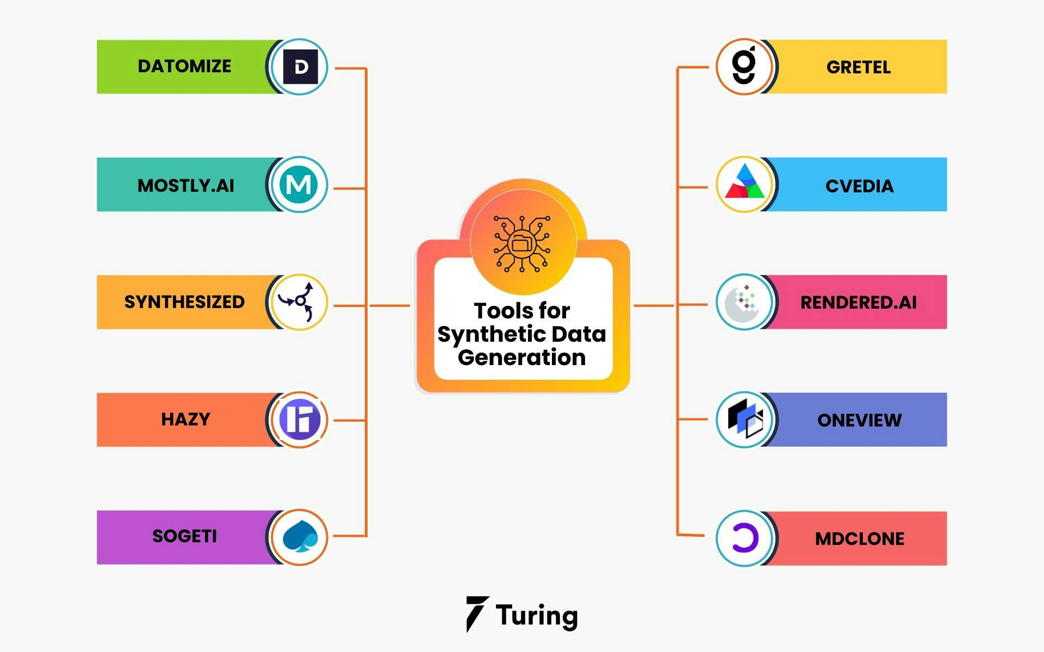

## 3.Explainable AI (XAI):

## Interpretability Techniques: Developing methods to interpret and visualize the decision-making process of language identification models will enhance trust and transparency in model predictions.

## Attention Mechanisms: Integrating attention mechanisms into models can provide insights into which parts of the text contribute most to language identification.

## 4.Edge Computing and Mobile Applications:

## Edge Deployment:

## Implementing language identification models on edge devices, such as smartphones and IoT devices, can enable real-time language detection for mobile applications.

## Mobile Applications:

## Creating user-friendly mobile applications for language identification, catering to diverse user needs and preferences.

## 5.Multi-Modal Analysis:

## Integration with Textual and Audio Data:

## Exploring the integration of language identification with other modalities, such as audio data or contextual information, can enhance the accuracy and reliability of language identification systems.

## Contextual Analysis:

## Leveraging contextual information, such as user location or historical data, to improve language identification performance in specific contexts.

## 6.Continuous Learning and Adaptation:

## Online Learning Strategies:

## Implementing continuous learning mechanisms to adapt language identification models to evolving linguistic patterns and emerging languages.

## Feedback Mechanisms:

## Incorporating user feedback loops to iteratively improve model accuracy and adaptability over time.

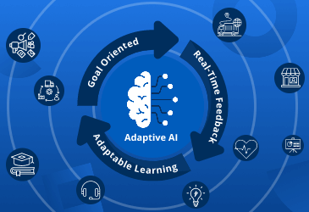

## 7.Linguistic Analysis and Insights:

## Linguistic Pattern Recognition:

## Researching advanced techniques for recognizing linguistic patterns and structures can enhance language identification capabilities, especially for morphologically rich languages.

## Semantic Analysis:

## Exploring semantic analysis methods to extract deeper linguistic insights from text data, facilitating more nuanced language identification.

## 8.Global and Cross-Linguistic Applications:

## Cross-Linguistic Identification:

## Extending language identification models to handle multiple languages and dialects, facilitating cross-linguistic analysis and communication.

## Global Deployment:

## Adapting language identification models for diverse linguistic landscapes and cultural contexts worldwide.

## 9.Collaborative Research and Open Data:

## Research Collaborations:

## Engaging in collaborations with linguistic experts, language communities, and academic institutions to enrich datasets and improve model accuracy.

## Open Data Initiatives:

## Promoting open data sharing practices to foster collaboration and accelerate advancements in language identification research.

## The future scope of language identification using generative AI techniques is vast, with the potential to revolutionize cross-cultural communication and linguistic analysis. By exploring these avenues, we can unlock new possibilities and create more inclusive and accessible language technologies for diverse communities.

**11 .SOURCE CODE**

#import statement

import pandas as pd

import numpy as np

import re

import seaborn as sns

import matplotlib.pyplot as plt

import warnings

from sklearn.model_selection import train_test_split

from sklearn.preprocessing import LabelEncoder

from sklearn.metrics import accuracy_score, confusion_matrix, classification_report

from tensorflow.keras.models import Sequential

from tensorflow.keras.layers import Dense, Dropout

from tensorflow.keras.preprocessing.text import Tokenizer

from tensorflow.keras.preprocessing.sequence import pad_sequences

warnings.simplefilter("ignore")

**IMPORTING DATASET:**

#Importing dataset

data = pd.read_csv("Language Detection.csv")

**SEPARATING INDEPENDENT AND DEPENDENT FEATURES:**

#Separating Independent and Dependent features

X = data["Text"]

y = data["Language"]

**LABEL ENCODING:**

#Label Encoding

le = LabelEncoder()

y = le.fit_transform(y)

**TEXT PREPROCESSING:**

#Text Preprocessing

data_list = []

for text in X:

text = re.sub(r'[!@#$(),n"%^*?:;~`0-9]', ' ', text)

text = re.sub(r'[[]]', ' ', text)

text = text.lower()

data_list.append(text)

**TOKENIZING TEXT DATA:**

#tokenizing text data

tokenizer = Tokenizer()

tokenizer.fit_on_texts(data_list)

X = tokenizer.texts_to_sequences(data_list)

**PADDING SEQUENCES:**

#Padding sequences

max_length = max([len(seq) for seq in X])

X = pad_sequences(X, maxlen=max_length, padding='post')

**TRAIN TEST SPLITTING:**

#Train Test Splitting**:**

x_train, x_test, y_train, y_test = train_test_split(X, y, test_size=0.20, random_state=42)

**BUILDING THE NEURAL NETWORK MODEL**

model = Sequential()

model.add(Dense(128, input_shape=(max_length,), activation='relu'))

model.add(Dropout(0.5))

model.add(Dense(64, activation='relu'))

model.add(Dense(len(np.unique(y)), activation='softmax')) # Output layer with number of classes

**COMPILING THE MODEL:**

#Compiling the model

model.compile(optimizer='adam', loss='sparse_categorical_crossentropy', metrics=['accuracy'])

**TRAINING THE MODEL:**

#Training the model**:**

history = model.fit(x_train, y_train, epochs=10, batch_size=32, validation_split=0.2, verbose=1)

**EVALUATING THE MODEL:**

#Evaluating the model

_, accuracy = model.evaluate(x_test, y_test)

print("Accuracy is :", accuracy)

**PLOTTING TRAINING HISTORY:**

#Plotting training history

plt.figure(figsize=(12, 6))

plt.plot(history.history['accuracy'], label='Train Accuracy')

plt.plot(history.history['val_accuracy'], label='Validation Accuracy')

plt.title('Training and Validation Accuracy')

plt.xlabel('Epochs')

plt.ylabel('Accuracy')

plt.legend()

plt.show()

**PREDICTING WITH SOME MORE DATA:**

#Predicting with some more data

text = "This is a sample text in English"

text = re.sub(r'[!@#$(),n"%^*?:;~`0-9]', ' ', text)

text = re.sub(r'[[]]', ' ', text)

text = text.lower()

seq = tokenizer.texts_to_sequences([text])

padded = pad_sequences(seq, maxlen=max_length, padding='post')

lang = model.predict(padded)

import numpy as np

lang = le.inverse_transform(np.argmax(lang,axis=1))

print("The language is:", lang)

**Source code @github:**

https://github.com/divyadarshini003/TNSDC-Generative-AI.git