CLS405( SBL Python)

Name:Divya Davane

SE – AIDS (Roll no_11)

**EXP NO 1** : I] Strings in Python

Code:

a **=** 'This is a string'

print (a)

b **=** "This is a string"

print (b)

c**=** '''This is a string'''

print (c

Output:

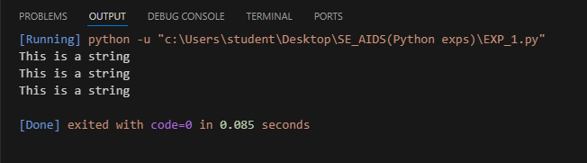

II] Lists in python

*# Declaring a list*

L **=** [1, "a" , "string" , 1**+**2]

print (L)

*#Adding an element in the list*

L**.**append(6)

print (L)

*#Deleting last element from a list*

L**.**pop()

print (L)

*#Displaying Second element of the list*

print (L[1])

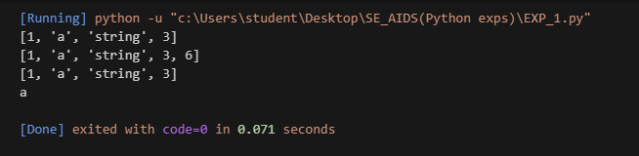

III]Tuples in python

tup **=** (1, "a", "string", 1**+**2)

print(tup)

print(tup[1])



**III ]Dictionaries in Python**

Code:

d **=** {1: 'Lorem', 2: 'Ipsum', 3: 'Dolerum'}

print(d)



* Create a dictionary

Code:

# create dictionary using { }

d1 = {1: 'Game', 2: 'of', 3: 'Thrones'}

print(d1)

# create dictionary using dict() constructor

d2 = dict(a = "House", b = "of", c = "Cards")

print(d2)



* Accessing Dictionary Items

Code:

d **=** { "name": "Alice", 1: "Python", (1, 2): [1,2,4] }

*# Access using key*

print(d["name"])

*# Access using get()*

print(d**.**get("name"))



* Adding and updating dictionary items

Code:

d **=** {1: 'Game', 2: 'of', 3: 'Thrones'}

*# Adding a new key-value pair*

d["age"] **=** 22

*# Updating an existing value*

d[1] **=** "Python dict"

print(d)

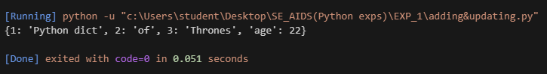

* Deletion dictionaries

Code:

# Creating a dictionary

my_dict = {'a': 1, 'b': 2, 'c': 3}

# Deleting the entire dictionary using del

del my_dict

# This will raise an error if you try to access 'my_dict' here, as it's been deleted.

# Uncomment the next line to see the error in action

# print(my_dict) # NameError: name 'my_dict' is not defined

# Recreating the dictionary for demonstration

my_dict = {'a': 1, 'b': 2, 'c': 3}

# Clearing the dictionary using the clear() method

my_dict.clear()

print("Dictionary after using clear():", my_dict) # Output: {}

output:

