**ABSTRACT:**

The social networking website is built is developed using HTML , CSS and JavaScript. JavaScript improves the Internet through the visibility of the MERN stack, with the ability to capture every user aspect and server dimension. Mern has 4 technologies: MongoDB, Express.js, React.js and Node.js.

The main objective of the social networking website is to manage the details of the users, sharing photos or videos and making friends. This is a place where people can put forth their ideas and talents and recognition from other people after getting recognition they can collaborate or make a group for any future ideas or projects.

**SCREENSHOTS OF THE OUTPUT:**

**HOME PAGE:**

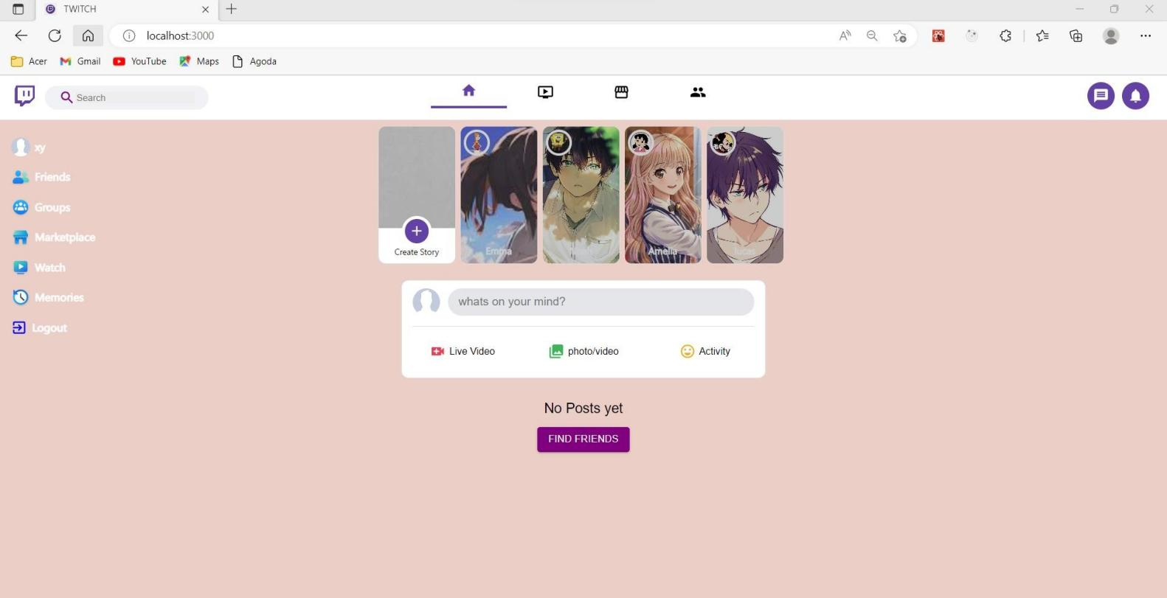

**CREATING POST:**

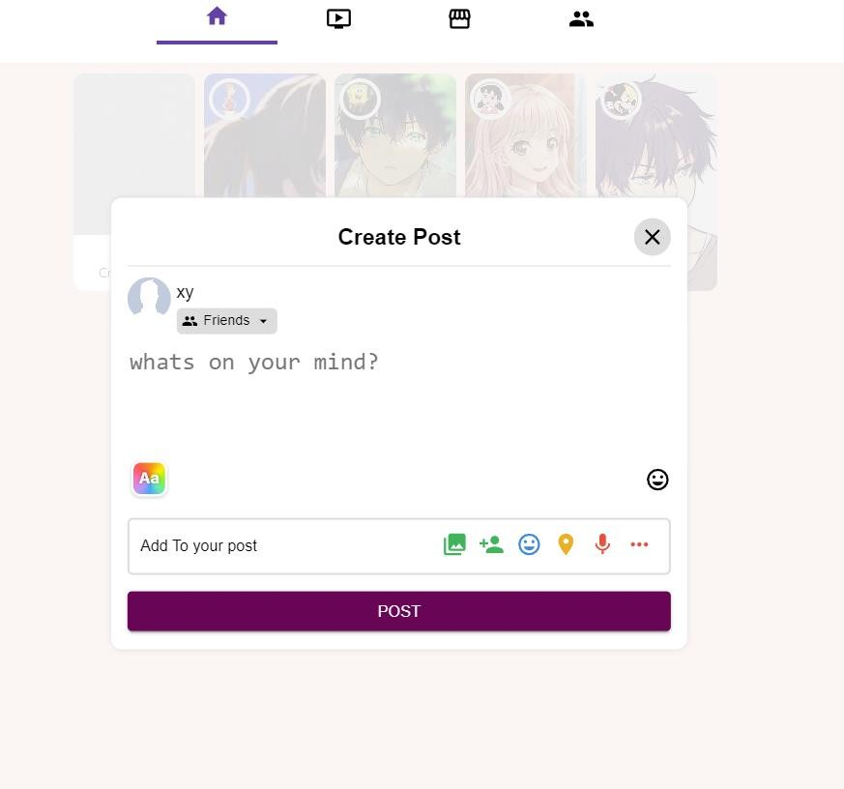

**HOME PAGE AFTER CREATING A POST**

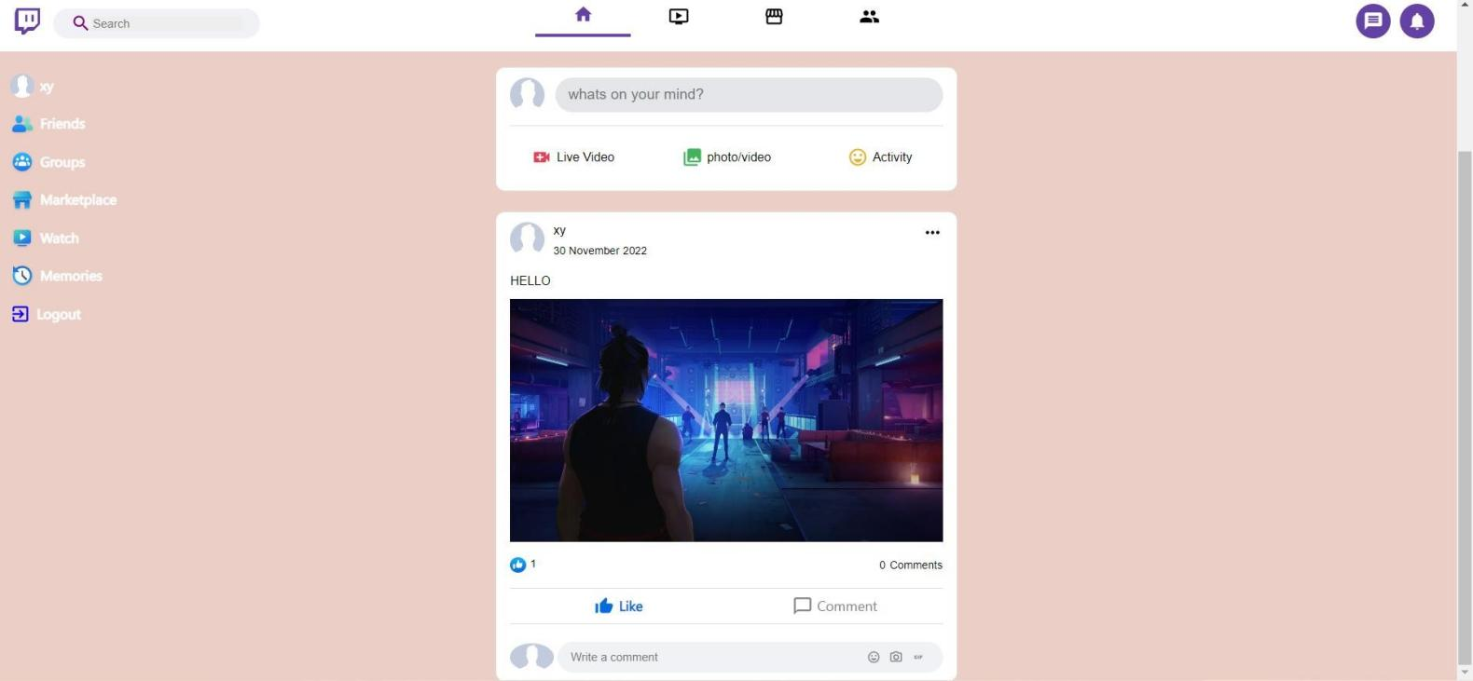

**USER INFO PAGE:**

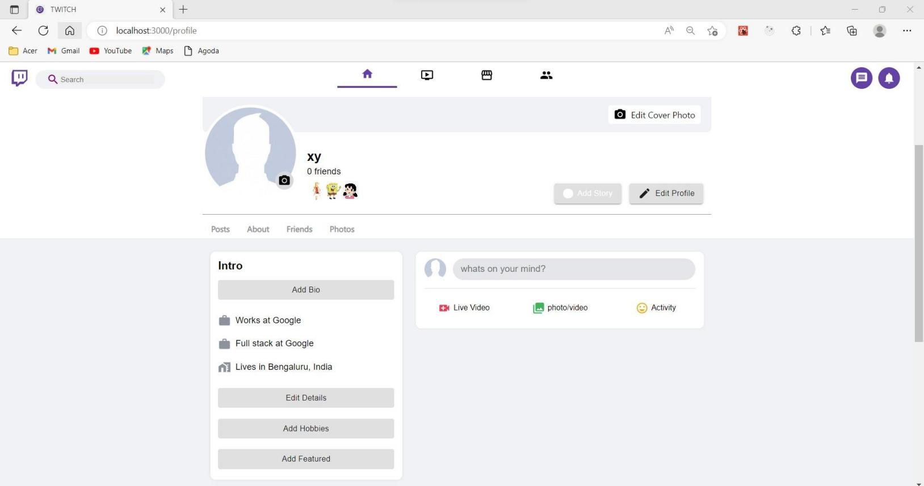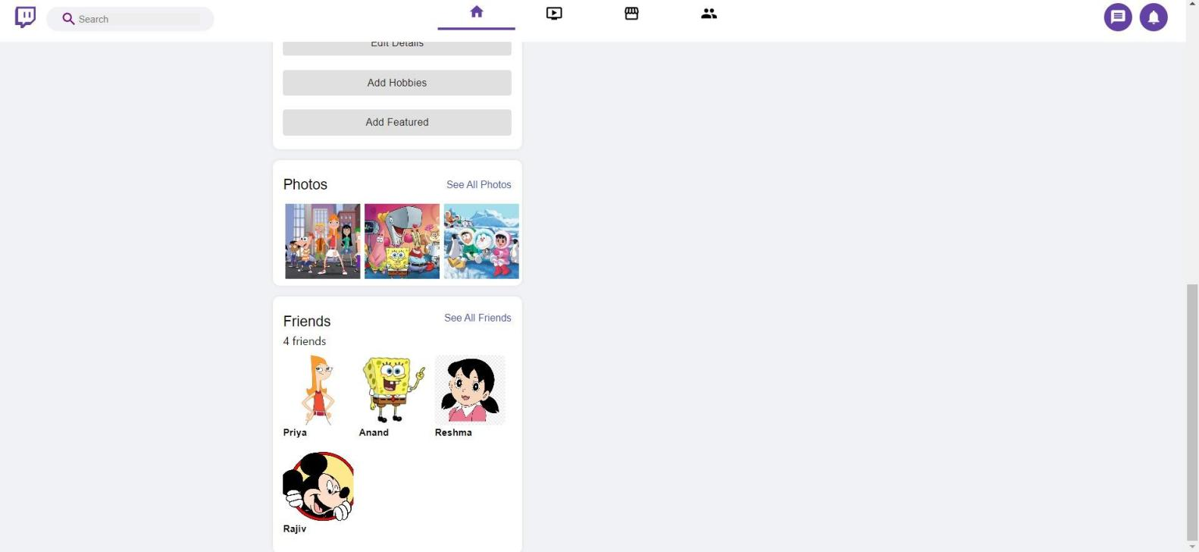

**GROUPS PAGE:**

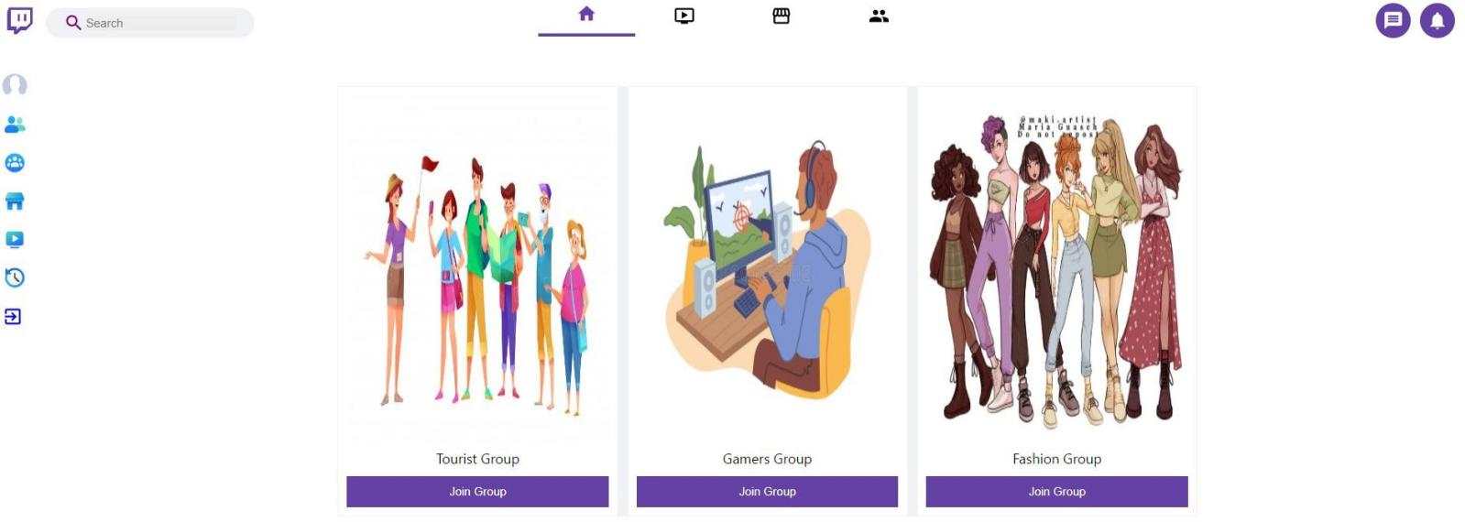

**FIND FRIENDS PAGE:**

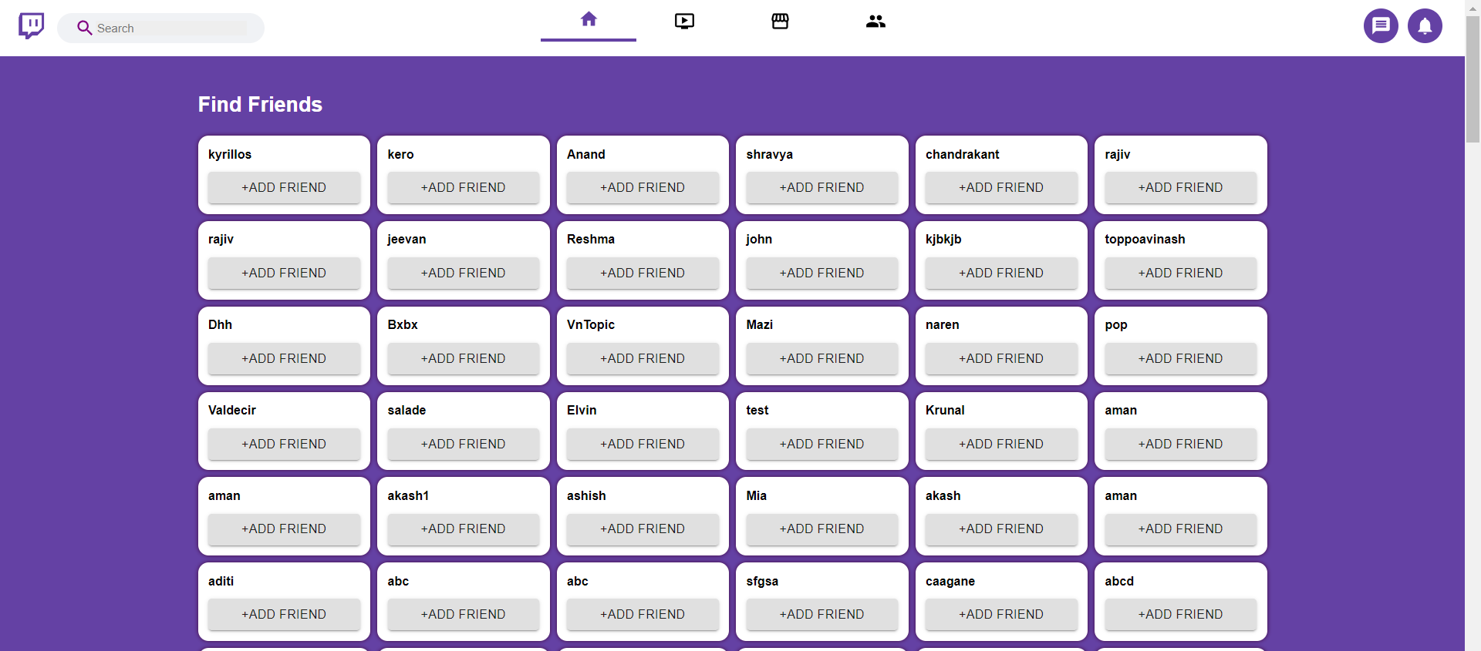

**MONGODB:**

