EDA Findings Note
Trends, correlations and outliers in the AquaTrace modelled dataset
AquaTrace | Visualization of Data, Understanding and Interpretation (VDUI) mini project | Member 1: Data and EDA lead | 29 October 2026
Data note: all operational figures are modelled estimates. Locations, climate and water-stress exposure are real; cooling system, capacity, PUE, WUE and water use are modelled.

1. Summary
- Cooling technology drives water use per kWh. Cooling system explains 68% of the variance in WUE. Evaporative averages 1.58 L/kWh, air-side economizer 0.16, a gap of about 9.7 times.
- Water stress drives risk. Stress tier is the strongest correlate of the risk score (Spearman 0.54) and explains 53% of its variance. This is partly built into the score (see the Risk Score Note).
- The combination is the story. Where stress exists, evaporative and chilled-water sites are almost always High risk (86 to 100% and 32 to 98% by stress tier). Where it does not, no cooling type reaches High.
- Geography matters. 40.6% of Middle East & Africa facility-years are High risk against 5.5% in Europe.
- Outliers cluster in one cooling type. 195 of the 199 WUE outliers are air-side economizer sites.
All numbers describe a modelled dataset. Cooling to WUE and stress to risk relationships are written into the generator, so the analysis demonstrates the method and is not evidence about real facilities.

2. Data checks
Check | Result
Rows, facilities, years | 6,512 facility-year rows, 1,200 facilities, 2019 to 2025
Columns | 43
Null cells | 0
Duplicate rows; duplicate (Facility_ID, Year) | 0; 0
WUE and PUE ranges | WUE within the 0.01 to 4.0 clip; PUE within 1.05 to 2.2
Risk tier balance | 71.1% Low, 17.5% Medium, 11.4% High

3. Trends (2019 to 2025)
Year | Facility-year rows | Total daily water (m3) | Weighted WUE | Avg AI share (%) | High risk (%)
2019 | 675 | 129,942 | 0.674 | 1.7 | 12.7
2020 | 751 | 152,991 | 0.665 | 2.5 | 12.0
2021 | 839 | 180,797 | 0.627 | 4.2 | 11.8
2022 | 916 | 229,576 | 0.623 | 7.7 | 11.4
2023 | 1,027 | 295,982 | 0.626 | 13.0 | 11.4
2024 | 1,104 | 365,281 | 0.621 | 18.9 | 10.9
2025 | 1,200 | 433,687 | 0.599 | 23.9 | 10.3

- Total daily water rose about 3.3 times. The number of facilities in the panel rose about 1.8 times, so water per facility rose about 1.9 times (192 to 361 m3 per facility-day).
- Weighted WUE fell slightly (0.67 to 0.60), the efficiency drift built into the model. The average AI workload share rose from 1.7% to 23.9%.
- The High-risk share drifted down from 12.7% to 10.3%.
The trend is stylised. Facilities are added over time and the growth is steeper than published global estimates. Do not quote it as a real growth rate.
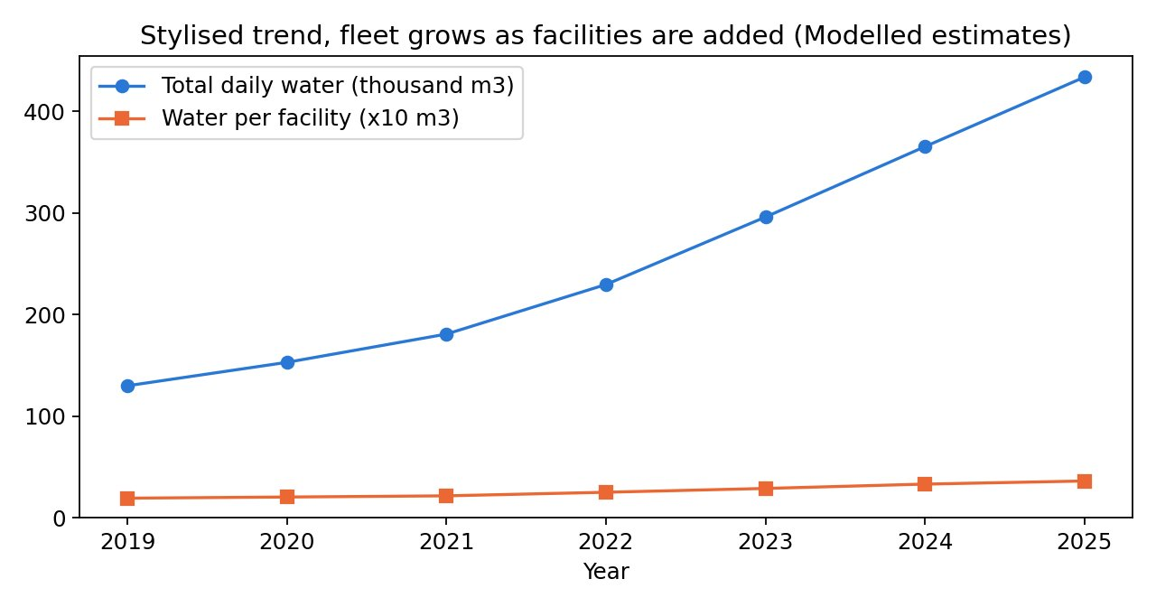
Figure 1. Total daily water and water per facility by year (modelled estimates).

4. WUE by cooling system
Cooling system | Rows | Mean WUE | Median WUE | Mean PUE | High risk (%)
Evaporative | 964 | 1.581 | 1.378 | 1.235 | 12.6
Chilled Water | 1,978 | 1.007 | 0.887 | 1.522 | 17.6
Hybrid | 1,116 | 0.604 | 0.549 | 1.303 | 17.7
Liquid Cooling | 513 | 0.193 | 0.183 | 1.167 | 5.8
Air-Side Economizer | 1,941 | 0.163 | 0.124 | 1.250 | 2.2

- The dashboard bars show weighted WUE (total water divided by total IT energy), for example 1.48 for evaporative. This table shows simple means (1.58). State which one you use.
- Evaporative has the highest WUE but a low PUE, and chilled water the opposite. This is the usual water versus energy trade-off.
- Evaporative has a smaller High-risk share overall (12.6%) than chilled water (17.6%) because many evaporative sites are in low-stress places. The next section shows why this does not weaken the case.
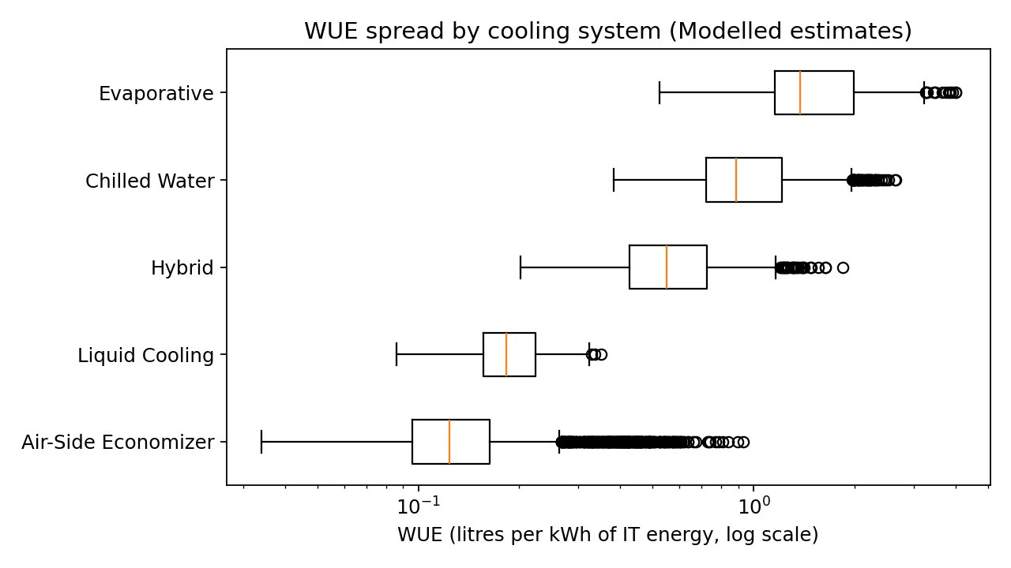
Figure 2. WUE spread by cooling system, log scale (modelled estimates).

5. Correlations
Feature | Spearman with risk score | Spearman with WUE
Stress tier | 0.54 | 0.00
Ambient temperature | 0.38 | 0.53
IT capacity | 0.36 | -0.04
Utilisation | 0.30 | -0.02
AI workload share | 0.17 | -0.06
PUE | 0.11 | 0.47
Relative humidity | -0.01 | 0.05

Category | Variance in risk score explained | Variance in WUE explained
Stress tier | 53% | 0.1%
Cooling system | 21% | 68%
Climate zone | 15% | 31%
Region | 11% | 14%
Facility type | 8% | 5%

- For WUE, the drivers are cooling system, temperature and PUE. Stress, capacity and utilisation hardly matter.
- For the risk score, stress dominates. Capacity and utilisation correlate with risk only because the score includes daily water volume, which grows with size.
- Correlation is not causation. These relationships were written into the data generator.
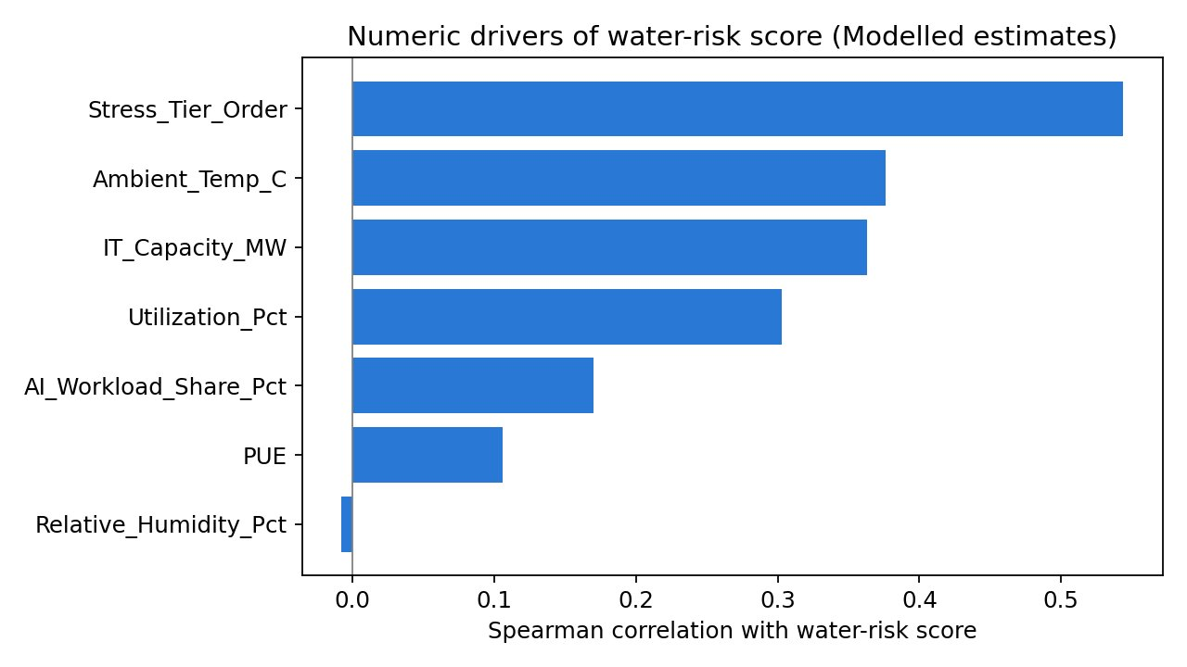
Figure 3. Spearman correlation of numeric features with the water-risk score (modelled estimates).

6. Where risk concentrates
Region | Low (%) | Medium (%) | High (%)
Middle East & Africa | 35.2 | 24.2 | 40.6
Asia-Pacific | 57.6 | 23.0 | 19.4
North America | 72.7 | 17.1 | 10.2
Latin America | 64.0 | 36.0 | 0.0
Europe | 82.1 | 12.5 | 5.5

High-risk share by cooling system and baseline stress tier (%)
Cooling system | Low stress | Moderate | High | Extreme
Evaporative | 0 | 86 | 100 | 100
Chilled Water | 0 | 32 | 89 | 98
Hybrid | 0 | 24 | 64 | 84
Liquid Cooling | 0 | 0 | 19 | 69
Air-Side Economizer | 0 | 0 | 15 | 19

- In facility-years with five or more stress months, about 39% (376 of 964) use evaporative or chilled-water cooling, and 94% of those are High risk.
- Latin America has only two countries (Brazil, Argentina) and no High rows. Treat it as a small sample.
- Some cells are small (for example evaporative in the Extreme tier has 24 rows). Say "about" or "suggests".
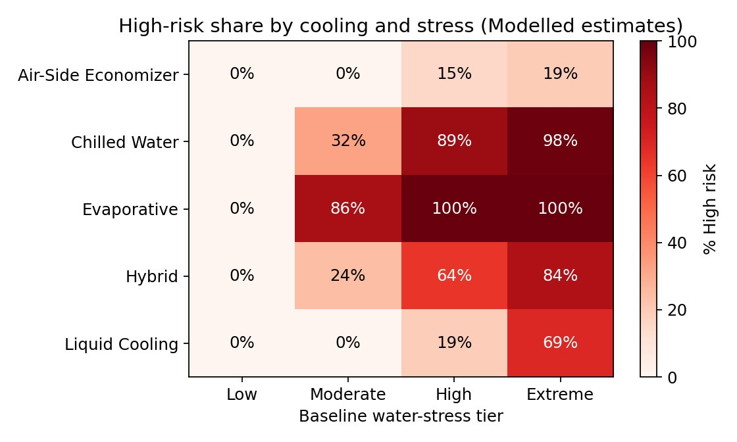
Figure 4. High-risk share by cooling system and stress tier (modelled estimates).

7. Outliers
Outliers were flagged with the Tukey rule (1.5 x IQR on log WUE) within each cooling system. The flag is the WUE_Outlier_Flag column.
Cooling system | Rows | High outliers | Low outliers | Outlier share
Air-Side Economizer | 1,941 | 183 | 12 | 10.05%
Hybrid | 1,116 | 3 | 0 | 0.27%
Liquid Cooling | 513 | 0 | 1 | 0.19%
Chilled Water | 1,978 | 0 | 0 | 0%
Evaporative | 964 | 0 | 0 | 0%

- 199 rows (3.1%) are flagged, almost all high-WUE air-side sites.
- Outliers sit in hotter, more humid places (mean 25.8 C against 16.3 C overall) and appear in every year.
- In this modelled data, air-side WUE responds more strongly to temperature and humidity (see generate_dataset.py), which is the likely cause. Do not present it as a real-world finding.
- Outliers were flagged, not deleted.

8. Do the model and the EDA agree?
Feature | Model importance (permutation, AUC) | EDA strength
Stress tier | 0.351 | Spearman 0.54 (strongest)
IT capacity | 0.013 | Spearman 0.36
Cooling system | 0.012 | Variance explained 0.21
Ambient temperature | 0.006 | Spearman 0.38
PUE, utilisation, AI share, facility type, climate zone | 0.000 | Weak to moderate

- Agreement: both rank water stress first.
- Divergence: the model puts almost all its weight on stress. The EDA also shows temperature and capacity, and cooling is the main driver of WUE. This is expected, because stress alone separates the High tier so sharply. The model inputs exclude WUE, which carries the cooling effect directly.
- Report both views and the difference. The model is a scikit-learn GradientBoosting classifier (not XGBoost) with out-of-fold predictions grouped by facility.

9. Top drivers and recommendation
1. Water stress (strongest driver of risk).
2. Cooling system (main driver of WUE; decisive where stress exists).
3. Ambient temperature (raises WUE and the risk score).
Recommendation for the dashboard conclusion: prioritise retrofit (to hybrid or liquid cooling) or relocation for evaporative and chilled-water facilities in high-stress regions. This is where nearly all the High-risk facility-years are.

10. Limitations
- Operational metrics are modelled estimates, so findings describe the model.
- Relationships are built into the generator, so recovering them is a method check, not a discovery.
- Stress is country-level, not basin-level.
- The year trend is stylised and partly reflects facilities being added.
- The High class is only 11.4% of rows, so use stratified splits and report recall.
Reproduce everything with aquatrace_eda.py (outputs in the eda_output folder).

