Misleading-Visuals Notes
How the AquaTrace dashboard avoids misleading the viewer
AquaTrace | Visualization of Data, Understanding and Interpretation (VDUI) mini project | Member 1: Data and EDA lead | 29 October 2026
Data note: all operational figures are modelled estimates. Locations, climate and water-stress exposure are real; cooling system, capacity, PUE, WUE and water use are modelled.

1. Principles
A chart can be technically correct and still mislead. For each visual we asked: does the axis, scale, label or colour push the viewer toward a conclusion the data do not support? The table lists the risks we checked and what we did.
Risk | What we did | Where
Truncated axes exaggerate differences | Bar charts start at zero. The trend line's y-axis also starts at zero. | Cooling bars, trend line, outlier chart
A reversed time axis flips the story | The trend axis first ran 2025 to 2019, so the line sloped down and suggested falling water use. We corrected it so time runs left to right and the line rises. See section 2. | Trend line
Dual axes invite false comparison | Every chart has a single value axis. | All charts
Modelled data look like measurements | Subtitles say "modelled estimates". Footnotes say locations and water stress are real and operational metrics are modelled. We never say "real facility records". | All charts, slides
Growth confounded with sample size | The trend subtitle says the series is stylised. Water rose 3.3 times, but the panel grew 1.8 times as facilities were added. The title says "partly because facilities were added". | Trend line
Mean versus weighted average | Cooling bars use weighted WUE (total water over total IT energy), which differs from the simple mean (1.48 against 1.58 for evaporative). The unit is stated in the subtitle. | Cooling bars
Shares hide sample size | The region chart shows percentages. Latin America has only two countries and some cooling-by-stress cells are small, so claims use "about" and "suggests". | Region bars
Sums across years mislead | The Total Daily Water card adds all years. It is labelled and only quoted with a year selected. | KPI cards
Color alone carries meaning | Risk tiers have data labels and a legend. The current red, amber and green are temporary and not colour-blind safe. Member 4's palette replaces them. | Region bars, map
Default or unclear titles and labels | Every chart has an insight title, a subtitle and axis titles with units. | All charts
Chart junk | No 3D, no decoration, light gridlines, one blue for single-series charts. | All charts
Correlation read as cause | We call factors "drivers" in the model and EDA, not proven causes. The data are modelled with the relationships built in. | EDA note, slides
Map points read as addresses | Coordinates are city-level with about 5 km jitter. The map notes this. | Map (Member 2)
Titles that overclaim | Every title number was checked against the chart (for example 1.48 / 0.14 is about 10, so "about ten times"). | All charts

2. A real example from our build: the reversed axis
After changing the trend chart's x-axis to categorical so every year shows, Power BI ordered it 2025 to 2019. The values were correct, but the line fell from left to right and read as a decline in water use, the opposite of the data. We fixed it by sorting the axis ascending by Year.
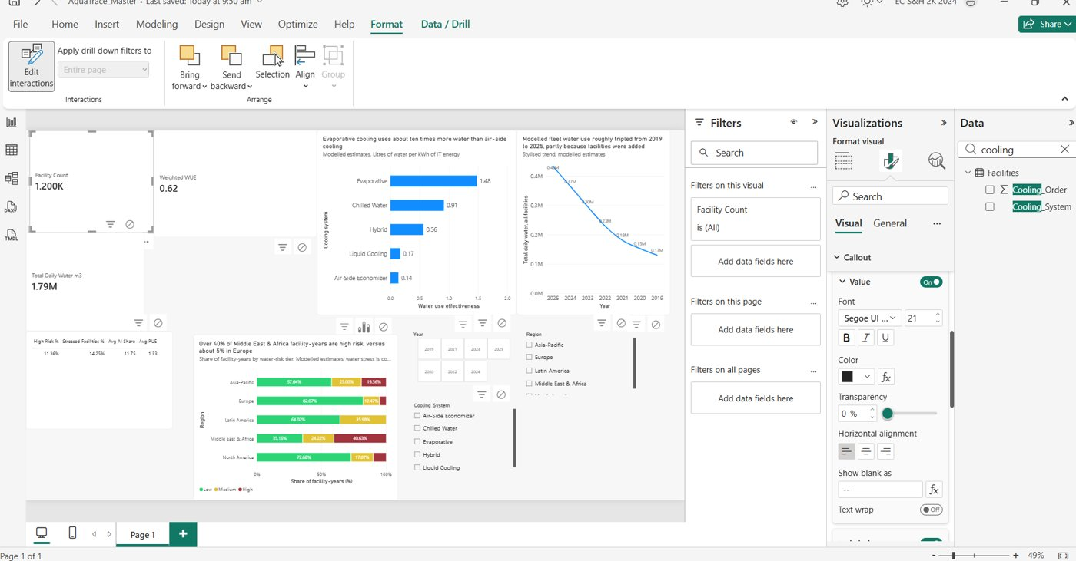
Before: the Year axis runs 2025 to 2019 and the line slopes downward (misleading).
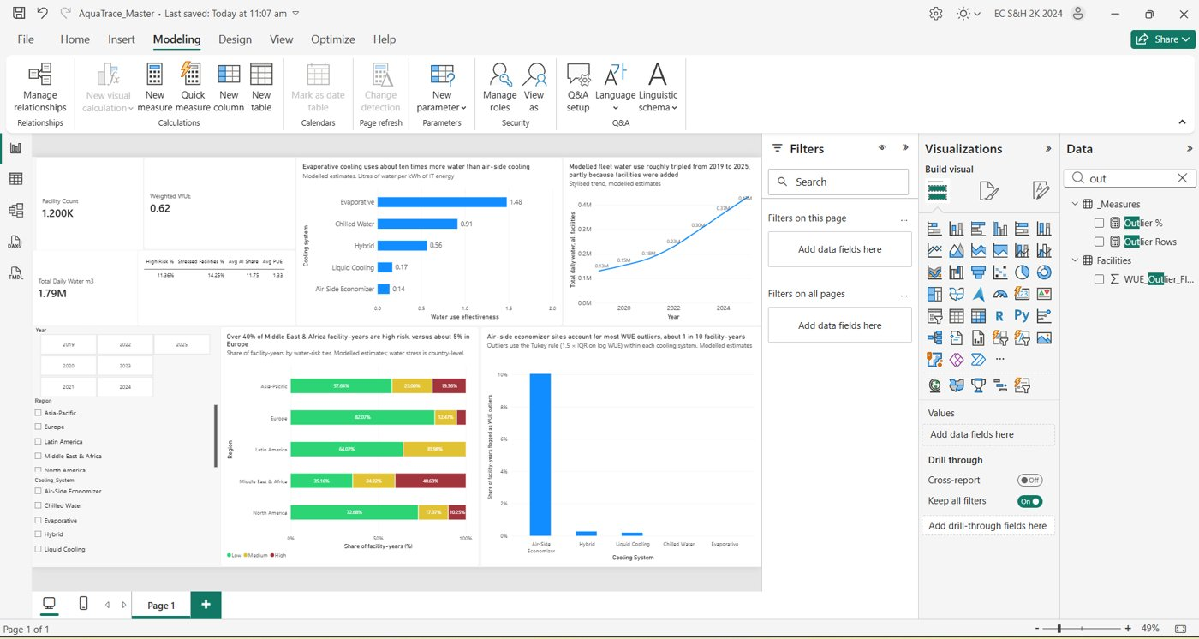
After: the final dashboard. Time runs left to right and the line rises from 2019 to 2025.

3. Peer-review checklist
Each reviewer checks another member's pages against this list.
- Is the title an insight sentence that matches the numbers on the chart?
- Do the axes have titles and units, and do bars start at zero?
- Does the visual say "modelled estimates" where the data are modelled?
- Is meaning carried by labels or shapes as well as colour?
- Is any total or average shown without saying what it covers (years, weighting)?
- Is there any chart junk (3D, decoration, heavy gridlines)?
- Is the sample size clear where shares are shown?

4. Open items
- Add the unit (L/kWh) to the cooling chart's x-axis title.
- Replace the red, amber and green with the colour-blind-safe palette from Member 4.
- Confirm with the teacher whether slicers and KPI cards count toward the 3 to 5 visual limit.

