Step-by-Step Build Documentation
Everything Member 1 did in Power BI and Python, in order, with the buttons used
AquaTrace | Visualization of Data, Understanding and Interpretation (VDUI) mini project | Member 1: Data and EDA lead | 29 October 2026
Data note: all operational figures are modelled estimates. Locations, climate and water-stress exposure are real; cooling system, capacity, PUE, WUE and water use are modelled.

How to read this document
- A path such as Home > Get data > Text/CSV means: click the Home tab, then the Get data button, then the Text/CSV option.
- Ctrl-click means hold the Ctrl key while clicking, to select several items.
- Data pane is the field list on the far right of Power BI. Visualizations pane is the chart-picker next to it. Query Settings is the right-hand pane in Power Query that lists Applied Steps.
- Each part ends with what to check. Screenshots are from the actual build.

Files and tools used
File | What it is for
aquatrace_powerbi.csv | Main table: one row per facility per year (6,512 rows, 43 columns). Loaded into Power BI.
model_importance.csv | Model feature ranking beside EDA statistics, for the "do the two methods agree" slide.
epoch_ai_data_centers.csv, epoch_ai_capacity_by_year.csv | Real AI data-centre data for case stories. Not merged into the main table.
DATA_CARD.md, HANDOFF.md | Documentation: what is real and what is modelled, the risk-score formula and the rules.
aquatrace_eda.py | Python EDA script I ran (Part 7).
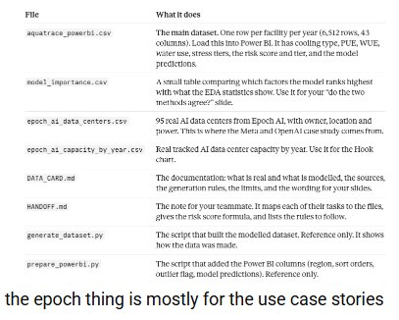
The file list from the handoff package.
Tools: Power BI Desktop (Power Query Editor, Report view, DAX) and Python (pandas, numpy, scipy, matplotlib).

Part 1. Load the data

Step 1.1 First attempt and the error
1. Opened Power BI Desktop and went to Home > Get data.
2. Chose the Excel workbook connector and browsed to aquatrace_powerbi.csv in C:\Users\divya\Downloads\aquatrace_handoff.
3. Power BI showed: "DataFormat.Error: External table is not in the expected format".
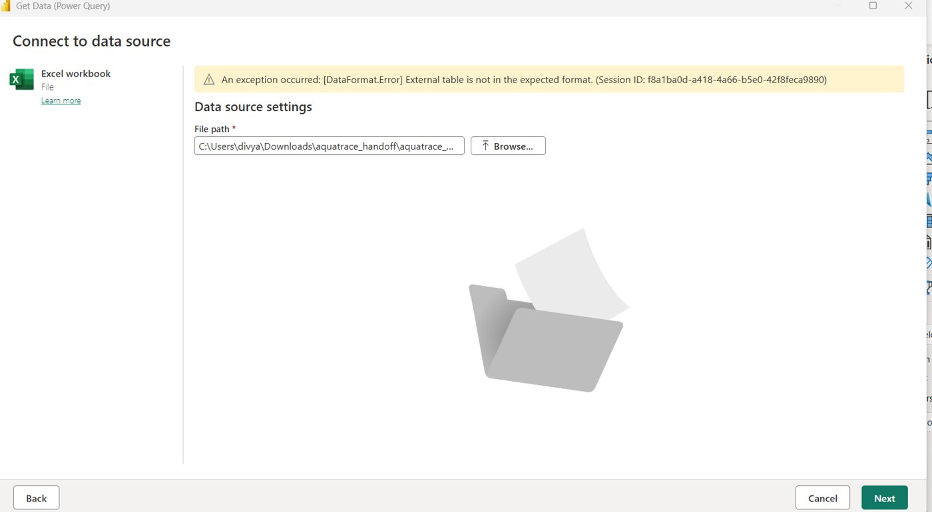
The error. The Excel connector cannot read a CSV file.
Cause: the file is a CSV, but the Excel workbook connector expects an .xlsx file. The data were fine; only the connector was wrong.

Step 1.2 Fix: use the Text/CSV connector
1. Clicked Cancel to close the Excel window.
2. Home > Get data (the small arrow, not the main button) > Text/CSV.
3. Selected aquatrace_powerbi.csv and clicked Open.
4. In the preview, confirmed File Origin 65001 UTF-8 and delimiter Comma.
5. Clicked Transform Data (not Load), which opens the Power Query Editor.
Check: the status bar shows Columns: 43. The preview shows only the first rows, so "Rows: 99+" or "299+" is normal.

Part 2. Clean the data in Power Query

Step 2.1 Check every column type
In the Power Query Editor, each column header has a small icon on its left showing its type: ABC for text, 123 for whole number, 1.2 for decimal. I scrolled across all 43 columns and compared them with the expected types.
Expected type | Columns
Whole number (123) | Year, Year_Commissioned, Stress_Months_Baseline, Stress_Months_3C, High_Risk, all *_Order columns, WUE_Outlier_Flag, Pred_High_Risk, Low_Confidence_Flag, Prediction_Error_Flag
Decimal (1.2) | Latitude, Longitude, IT_Capacity_MW, Utilization_Pct, AI_Workload_Share_Pct, Ambient_Temp_C, Relative_Humidity_Pct, PUE, WUE_L_per_kWh, Daily_Electricity_MWh, Daily_Water_Use_m3, Stress_Weight, Water_Risk_Score, Water_Stress_Index (both), Pred_High_Risk_Prob, Model_Confidence
Text (ABC) | Facility_ID, Facility_Name, Country, City, Climate_Zone, Facility_Type, Cooling_System, Stress_Tier_Baseline, Stress_Tier_3C, Main_Overlap_Sector, Data_Basis, Water_Risk_Tier, Region

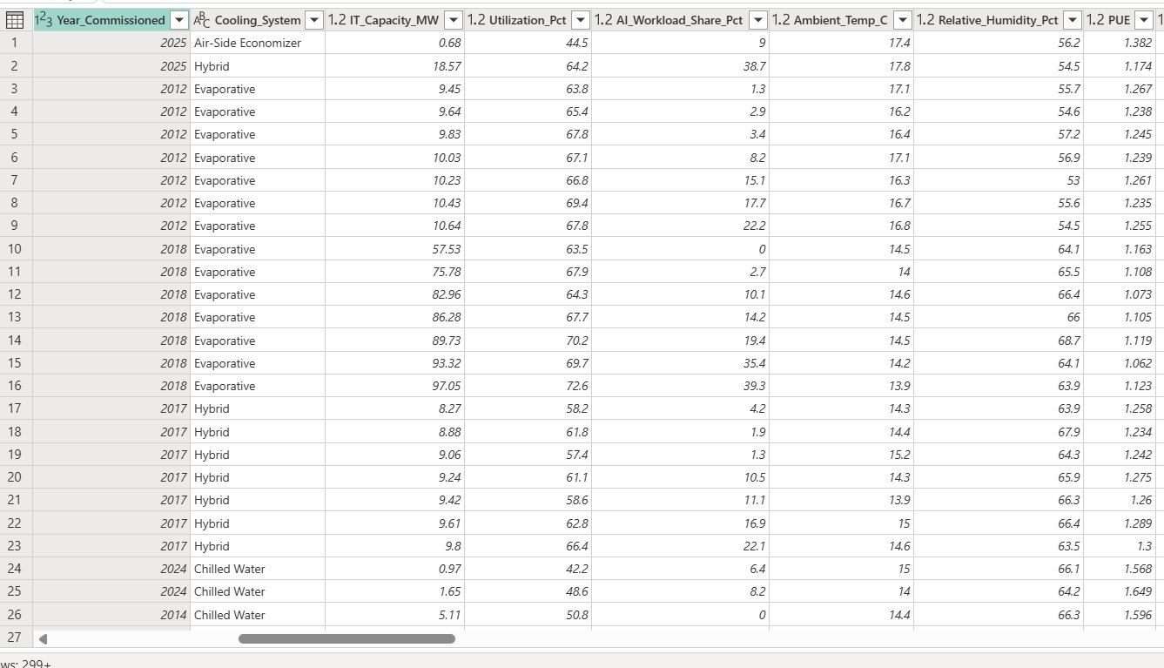
Columns Year_Commissioned to PUE: types are correct.
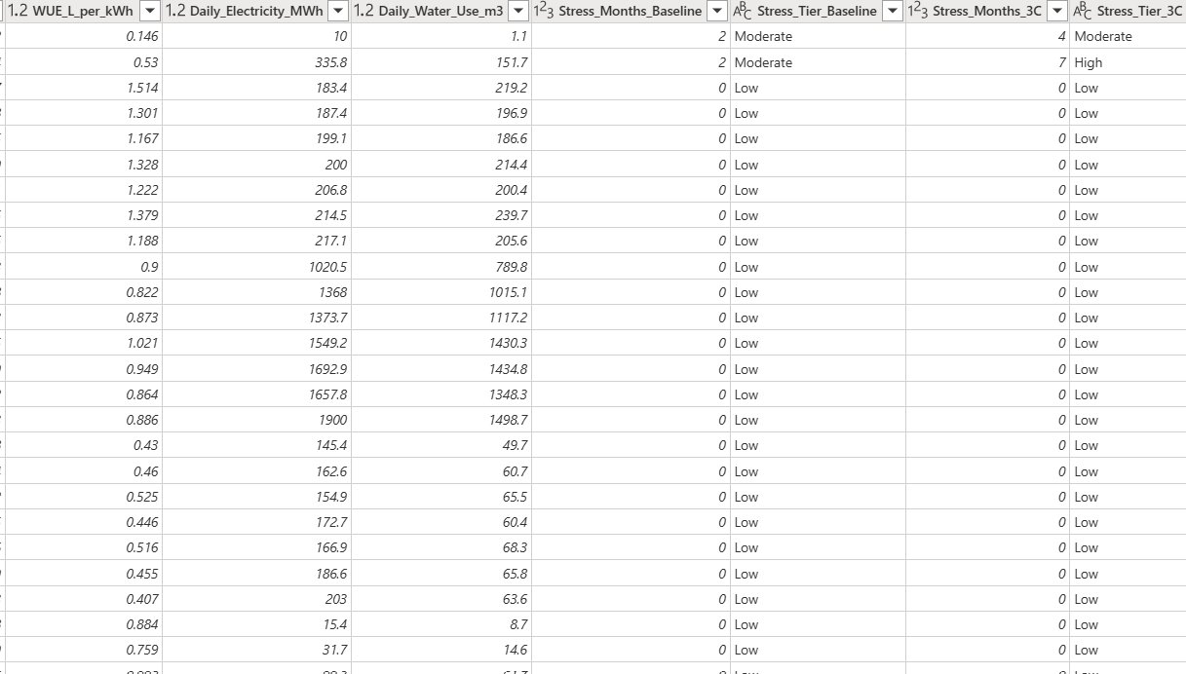
Columns WUE to Stress_Tier_3C: types are correct.
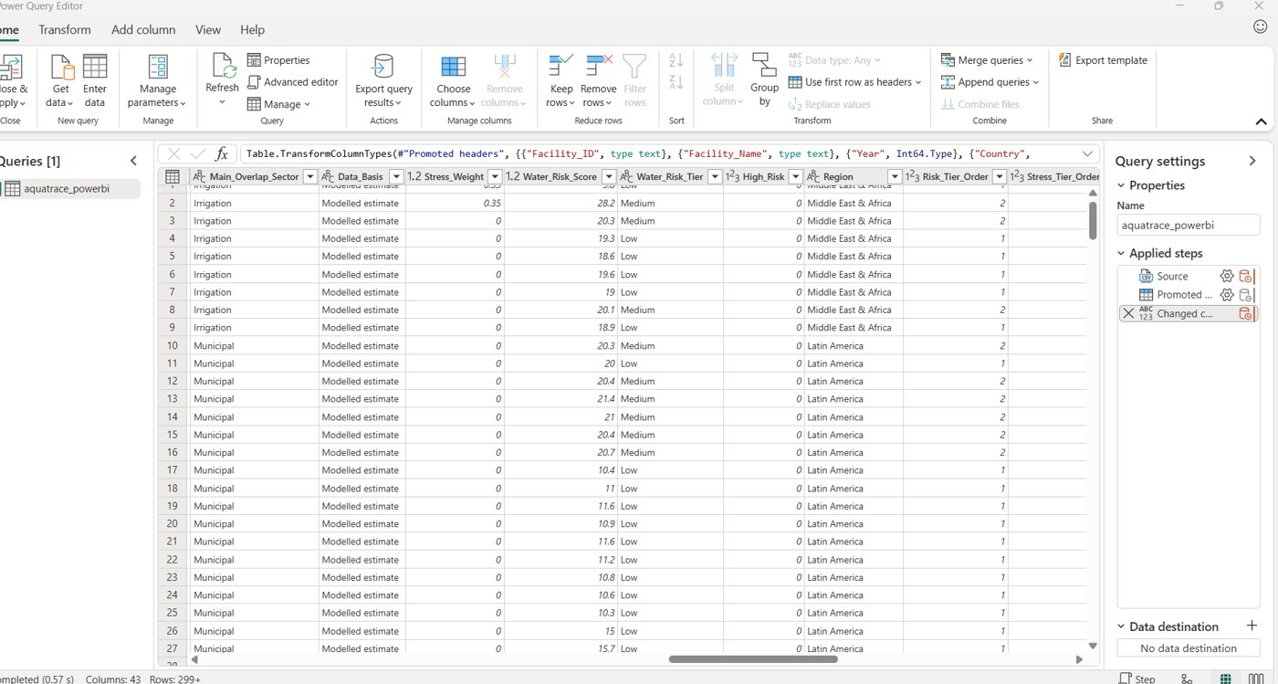
Power Query Editor with Applied Steps (Source, Promoted headers, Changed type) and columns Main_Overlap_Sector to Stress_Tier_Order.
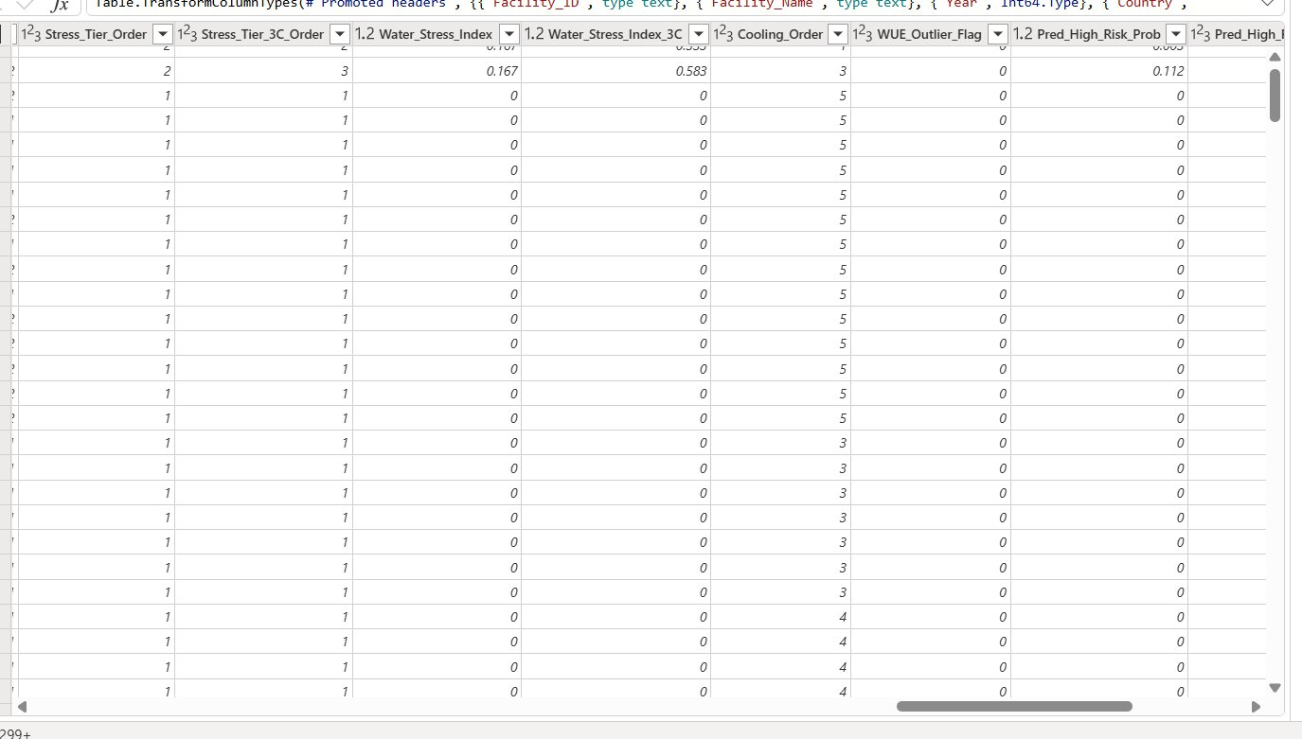
Columns Stress_Tier_Order to Pred_High_Risk_Prob.
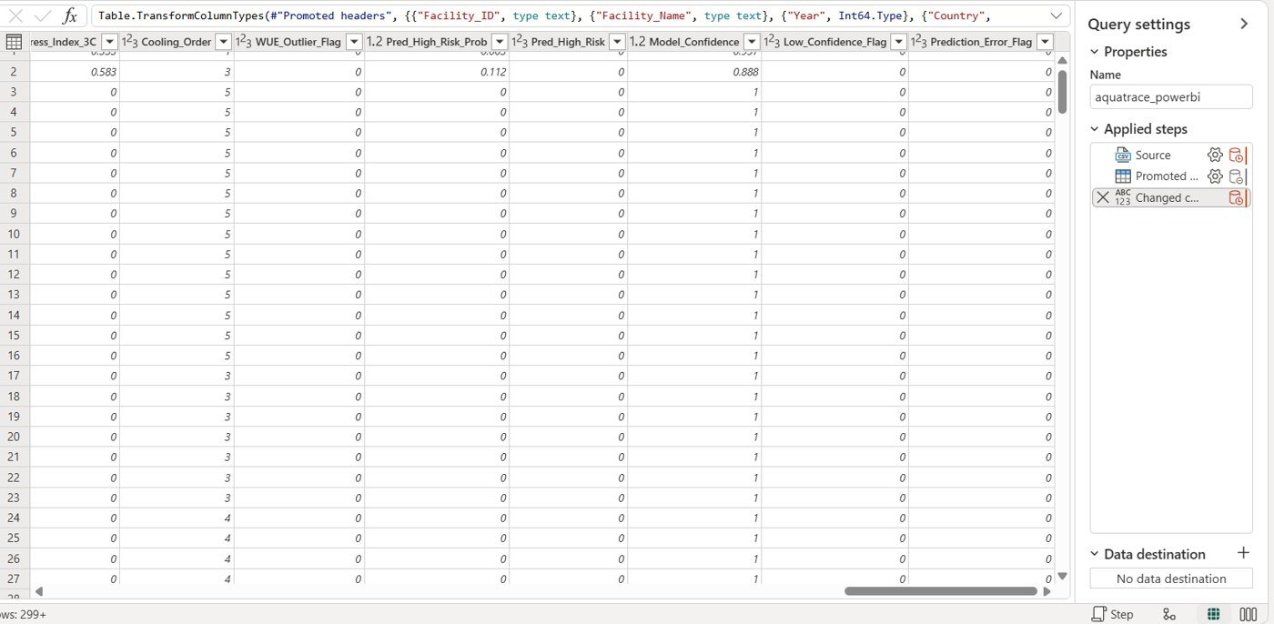
Last columns (flags) and the Applied Steps list.
Result: all types were already correct, so no changes were needed. Power BI had added the steps Source, Promoted Headers and Changed Type automatically.

Step 2.2 Rename the type step
1. In Query Settings > Applied Steps, right-clicked Changed Type.
2. Clicked Rename and typed set data types, then pressed Enter.
Renaming each step makes the Applied Steps list a readable record of the cleaning.

Step 2.3 Trim text columns
1. Clicked the header of Facility_ID, then Ctrl-clicked the other text columns (Facility_Name, Country, City, Climate_Zone, Facility_Type, Cooling_System, Stress_Tier_Baseline, Stress_Tier_3C, Main_Overlap_Sector, Data_Basis, Water_Risk_Tier, Region).
2. Transform tab > Format > Trim. This removes leading and trailing spaces.
3. Renamed the new step trim text.

Step 2.4 Remove duplicates
1. Clicked the Facility_ID header, then Ctrl-clicked the Year header. Together they identify one facility-year.
2. Right-clicked one of the selected headers and chose Remove duplicates.
3. Power Query wrote the step: Table.Distinct(#"trim text", {"Facility_ID", "Year"}).
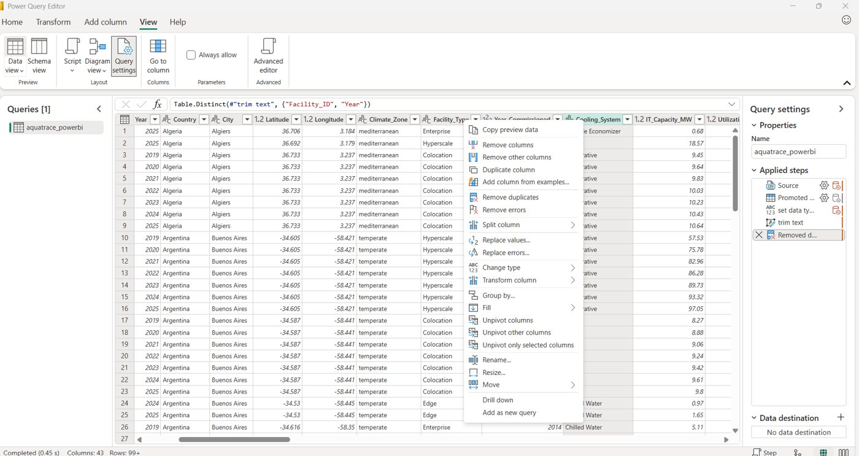
Right-click menu on a column header. Remove duplicates is in this menu.
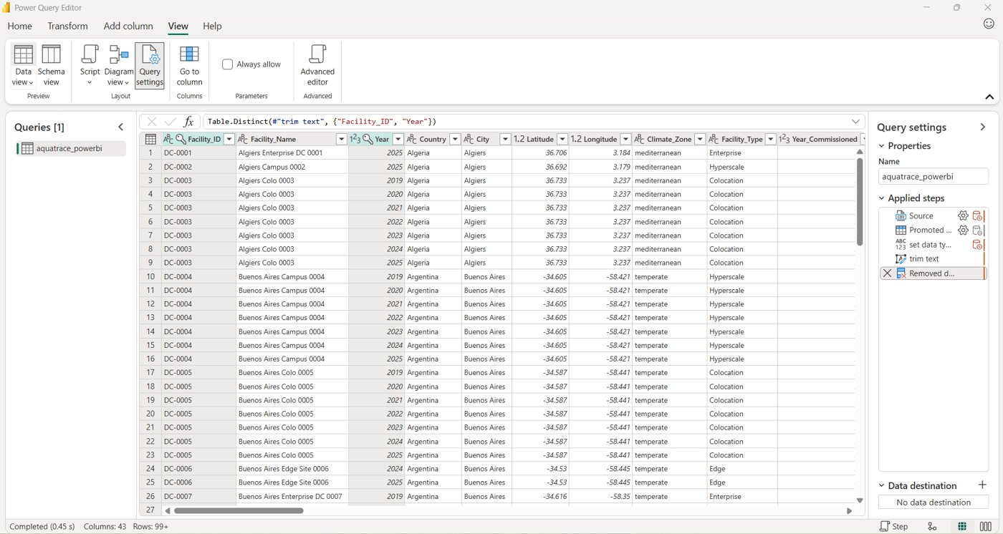
Applied Steps after cleaning: Source, Promoted headers, set data types, trim text, Removed duplicates. The formula bar shows the Table.Distinct step.
Result: the row count after loading is 6,512, so no duplicates were removed. This screenshot is the Power Query evidence (also saved as Power_Query_Applied_Steps.png).

Step 2.5 Check for nulls (empty cells)
1. In the Power Query Editor, View tab > Data view (click the small arrow under the icon).
2. Ticked Enable column profile. This unlocks the other options, which are greyed out until it is on.
3. Then ticked Show column quality details and Show column value distribution.
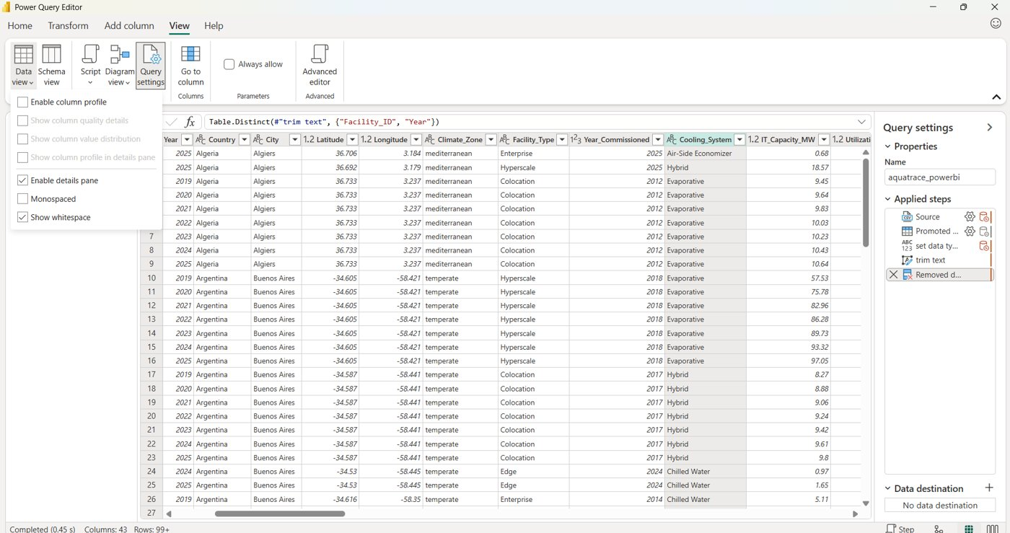
View > Data view menu. Enable column profile must be ticked first.
Each column header then shows Valid, Error and Empty percentages. The target is 100%, 0%, 0%. The Python check later confirmed 0 null cells in the whole file.
Tip: the status bar at the bottom left may say "Column profiling based on top 1000 rows". Click it and choose the entire data set to profile all 6,512 rows.

Step 2.6 Check category values
1. Clicked the drop-down arrow on the Cooling_System header.
The list shows exactly five values: Air-Side Economizer, Chilled Water, Evaporative, Hybrid and Liquid Cooling. There are no blanks and no spelling variants, so trimming worked. The "List may be incomplete" warning only means the filter list is based on the preview.
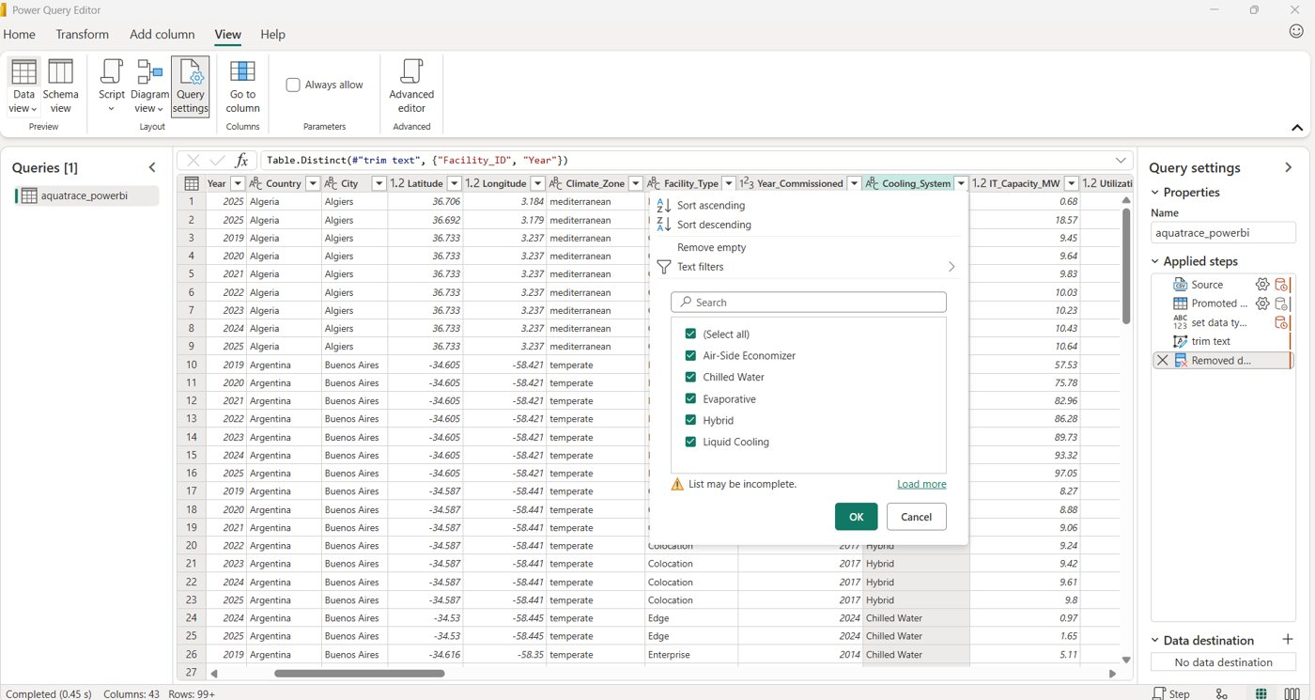
Cooling_System values: five clean categories.

Step 2.7 Load the data
1. Home tab > Close & Apply (top left of the Power Query Editor).
Power BI loaded the table and returned to the main window. The Data pane lists the table. I confirmed it contained 6,512 rows.
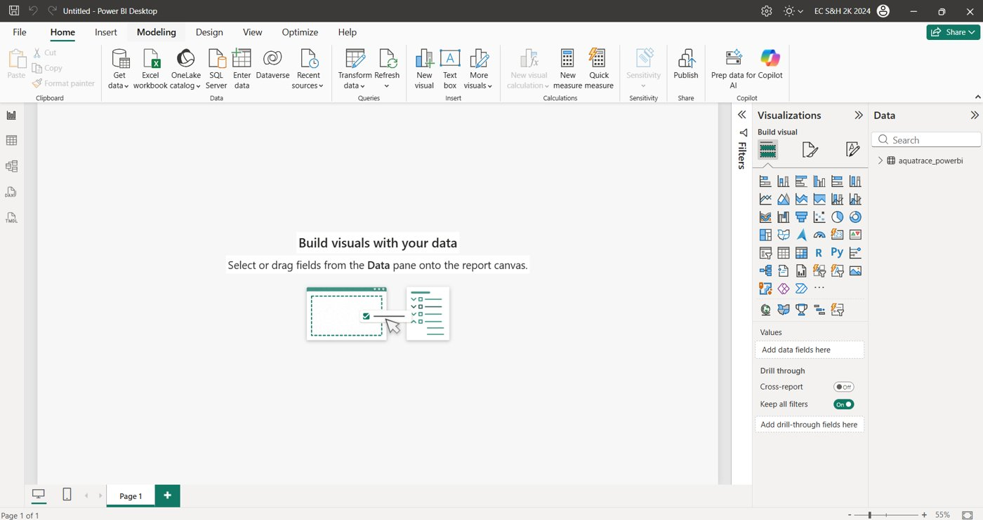
Main Power BI window after loading (the file was still untitled).

Part 3. Set up the data model

Step 3.1 Save the file
Pressed Ctrl + S, named the file AquaTrace_Master.pbix and saved it. I resave after every part.

Step 3.2 Rename the table
1. Clicked the table in the Data pane. A Table tools tab appeared in the ribbon.
2. In the Name box (top left) replaced aquatrace_powerbi with Facilities and pressed Enter.
Pressing Enter commits the rename. The Data pane then shows Facilities. A short name keeps the DAX readable.
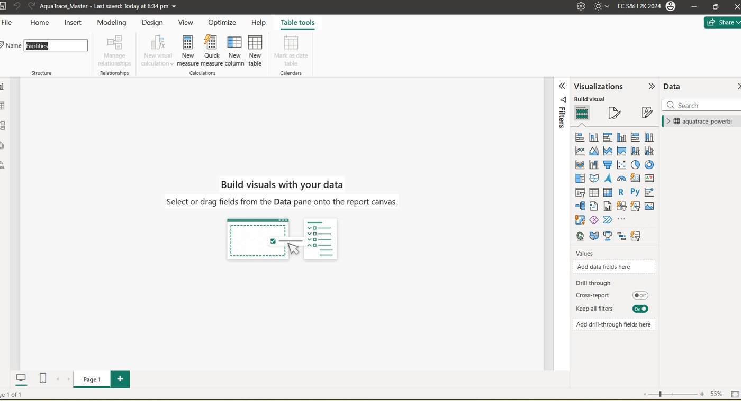
Table tools > Name box.

Step 3.3 Mark Latitude and Longitude as map coordinates
1. Expanded Facilities in the Data pane and clicked the field Latitude. A Column tools tab appeared.
2. Column tools > Data category > Latitude.
3. Clicked Longitude, then Column tools > Data category > Longitude.
4. For Latitude and Longitude (and Year), set Summarization to Don't summarize. This stops Power BI adding the values together when they are used in a chart.
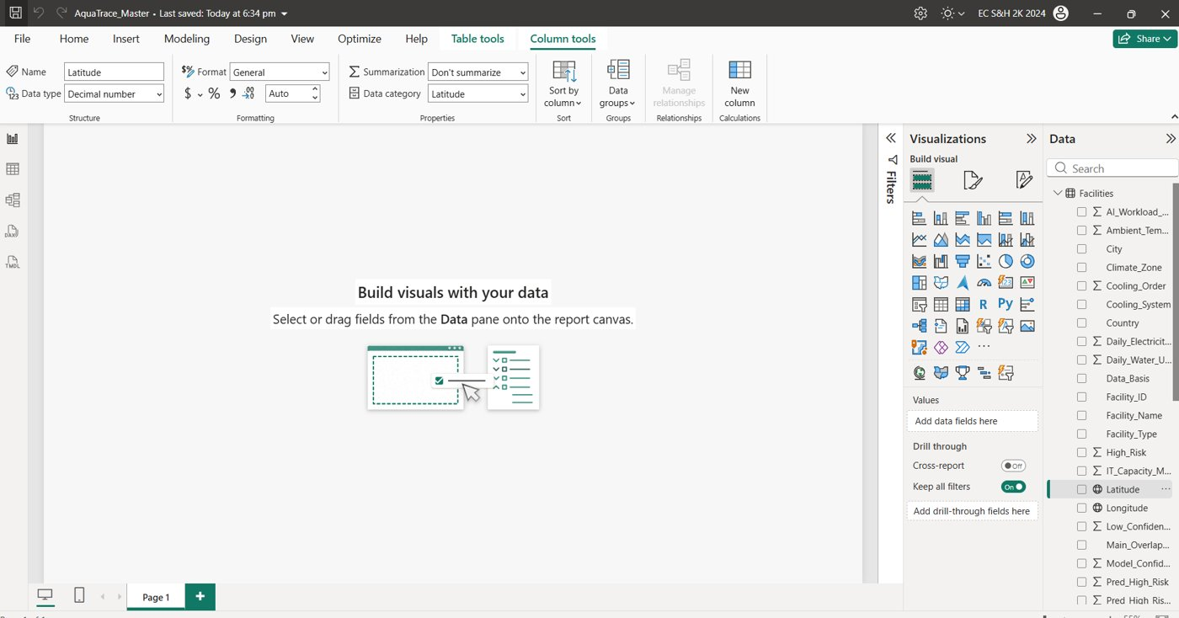
Latitude selected: Data category = Latitude, Summarization = Don't summarize. Both Latitude and Longitude now show a globe icon in the Data pane.
The map must use Latitude and Longitude, not city names, because Power BI can misplace ambiguous city names.

Step 3.4 Set up Year
1. Clicked Year in the Data pane.
2. Column tools > Summarization > Don't summarize. Year is a label, not a number to add up.
3. Left Data category as Uncategorized. The drop-down also offers Postal code and Barcode, which must not be chosen.
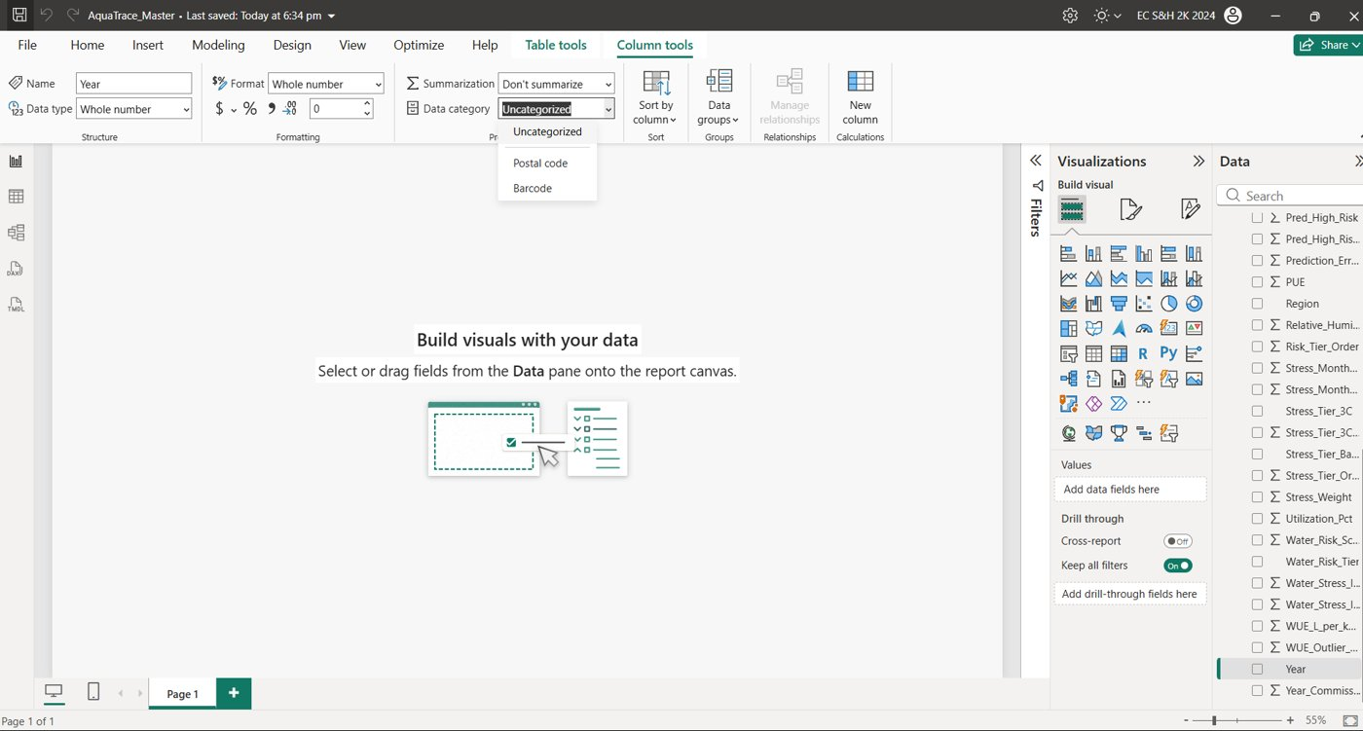
Year column: Whole number, Don't summarize, Data category left as Uncategorized (drop-down shown open).
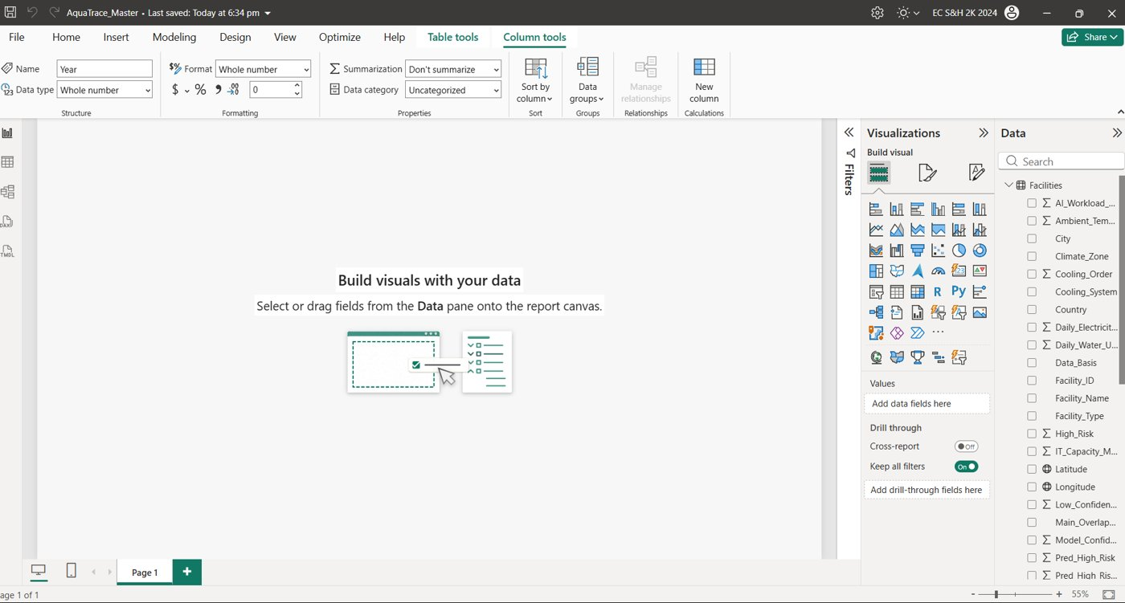
Year no longer shows a sum sign in the Data pane. Latitude and Longitude show globe icons.

Step 3.5 Sort categories in a sensible order
1. Selected the field Cooling_System, then Column tools > Sort by column > Cooling_Order so cooling types sort by WUE rather than alphabetically.
2. Selected Water_Risk_Tier, then Column tools > Sort by column > Risk_Tier_Order so tiers read Low, Medium, High.
No screenshot was captured for this step. To verify, add Water_Risk_Tier to a chart legend and check the order reads Low, Medium, High.

Step 3.6 Create the measures table
1. Clicked the empty canvas, then Home tab > Enter data.
2. Left the grid empty. In the Name box at the bottom typed _Measures.
3. Clicked Load. The new table opened in the Power Query Editor with a single empty column and the message "This table has no rows".
4. Clicked Home > Close & Apply.
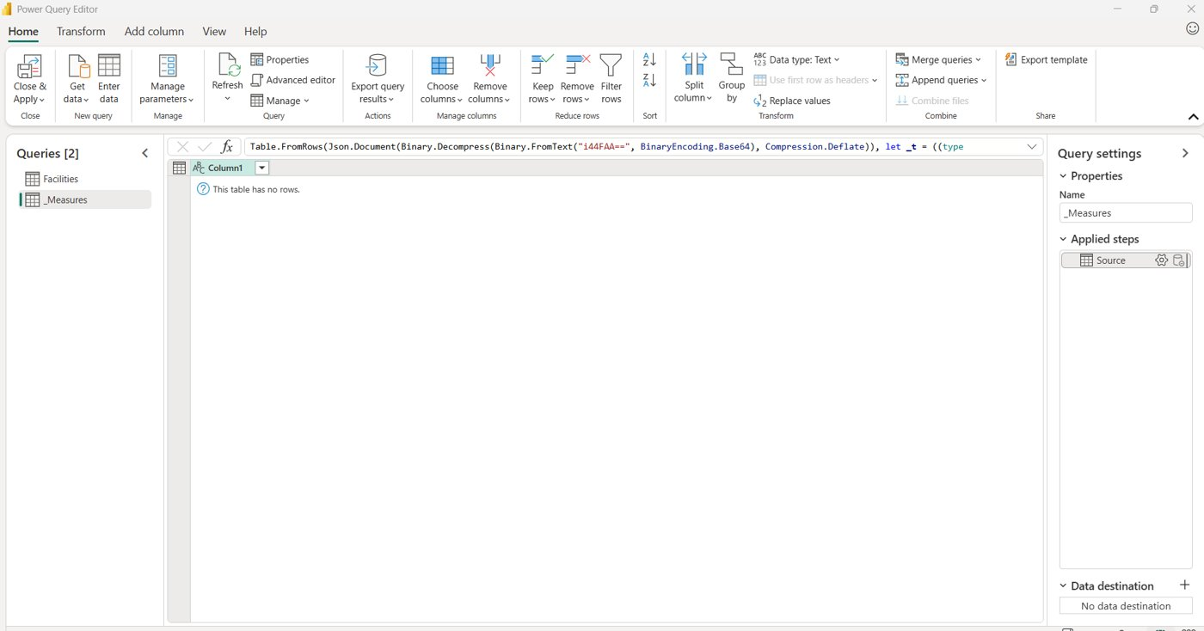
The empty _Measures table in Power Query. It only holds measures.
Keeping all DAX measures in one table makes them easy to find. The empty Column1 can be hidden later.

Part 4. Write the DAX measures

How to add a measure
1. Click _Measures in the Data pane.
2. Home tab > New measure.
3. Type the formula in the formula bar (replace any default text) and press Enter or click the green tick.
Until it is committed the Name box shows the default name "Measure". After committing, the name changes and a calculator icon appears in the Data pane.
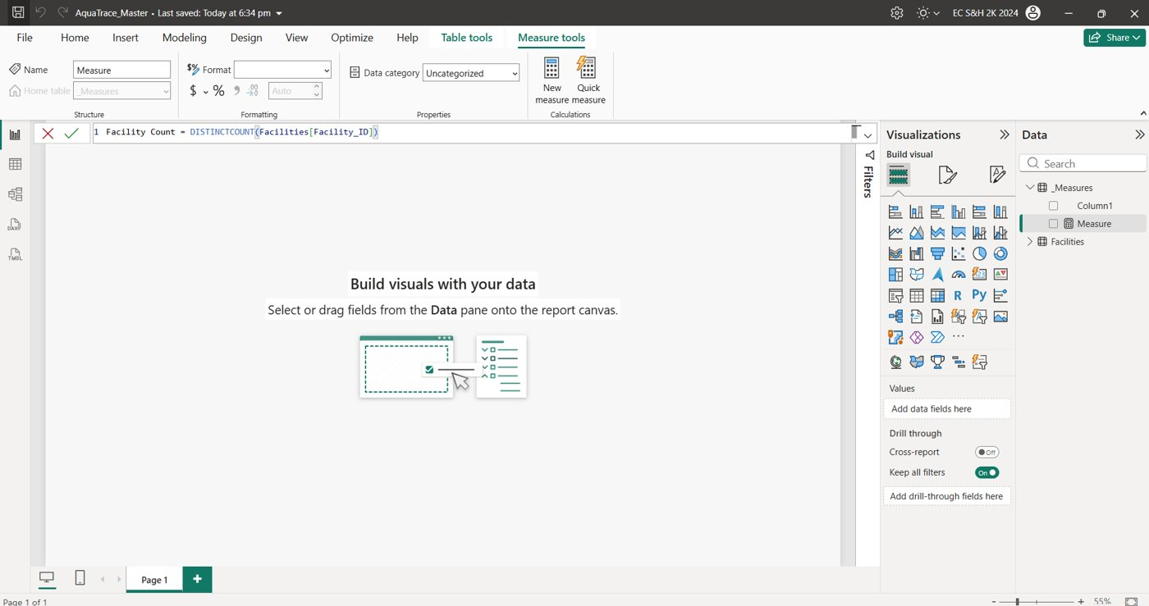
Typing the first measure. The formula bar shows the formula; the Name box still says Measure until it is committed.

The measures
Measure | DAX | Purpose and value seen
Facility Count | DISTINCTCOUNT(Facilities[Facility_ID]) | Number of distinct facilities. 1,200.
Total Daily Water m3 | SUM(Facilities[Daily_Water_Use_m3]) | Water use added up. 1.79M across all years, so only meaningful with a year selected.
Weighted WUE | DIVIDE(SUM(Facilities[Daily_Water_Use_m3]), SUMX(Facilities, Facilities[Daily_Electricity_MWh] / Facilities[PUE])) | Total water over total IT energy. m3 per MWh equals L per kWh. 0.62.
High Risk % | DIVIDE(SUM(Facilities[High_Risk]), COUNTROWS(Facilities)) | Share of facility-years in the High tier. 11.36%.
Stressed Facilities % | DIVIDE(CALCULATE(DISTINCTCOUNT(Facilities[Facility_ID]), Facilities[Stress_Months_Baseline] >= 5), [Facility Count]) | Share of facilities with five or more water-stress months. 14.25%.
Avg PUE | AVERAGE(Facilities[PUE]) | Average energy efficiency. 1.33.
Avg AI Share | AVERAGE(Facilities[AI_Workload_Share_Pct]) | Average AI workload share in percent points. 11.75.
Facility Years | COUNTROWS(Facilities) | Number of facility-year rows. Used for the region chart.
Outlier Rows | SUM(Facilities[WUE_Outlier_Flag]) | Number of WUE outlier rows.
Outlier % | DIVIDE([Outlier Rows], COUNTROWS(Facilities)) | Outlier rows as a share of all rows. Formatted as a percentage.

Naming note: the facility count measure is called Facility Count, because a measure named Facilities would clash with the table name.
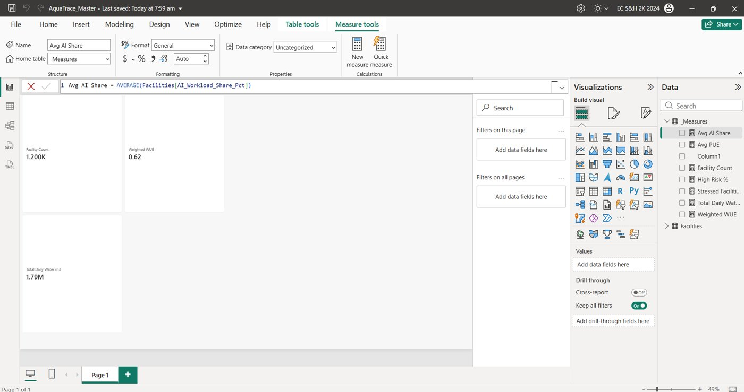
The Data pane lists the measures under _Measures (Avg AI Share being committed).

Format the percentage measures
Clicked the measure name in the Data pane, then Measure tools > Format > Percentage with one decimal place, for High Risk %, Stressed Facilities % and Outlier %.

Part 5. KPI cards and a check table

Step 5.1 Add cards
1. Clicked an empty part of the canvas.
2. In the Visualizations pane picked the Card visual (the icon with 123).
3. Dragged a measure from _Measures into the field. Repeated for Facility Count, Weighted WUE and Total Daily Water m3.
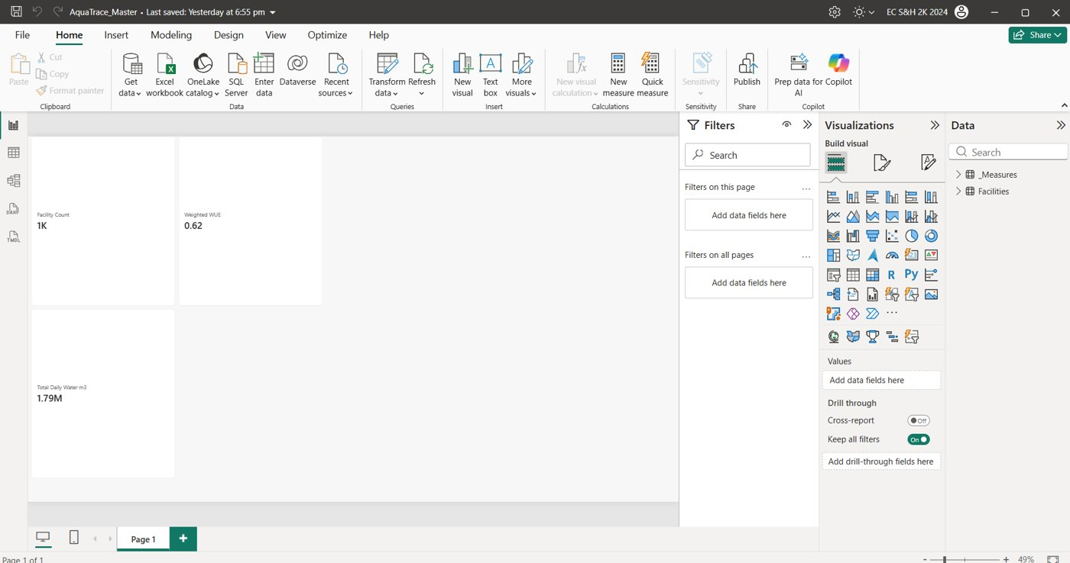
The first three cards. Facility Count shows 1K, Weighted WUE 0.62, Total Daily Water 1.79M.
Check: Facility Count is 1,200 and Weighted WUE 0.62, within the expected range. Total Daily Water adds up all seven years.

Step 5.2 Fix the thousands display
The count card showed "1K". Setting the measure format did not change it, because a card has its own display units that override the measure's format. Selecting a visual changes the ribbon: Measure tools appears only when a measure is selected in the Data pane, while a selected visual shows the Format tab.
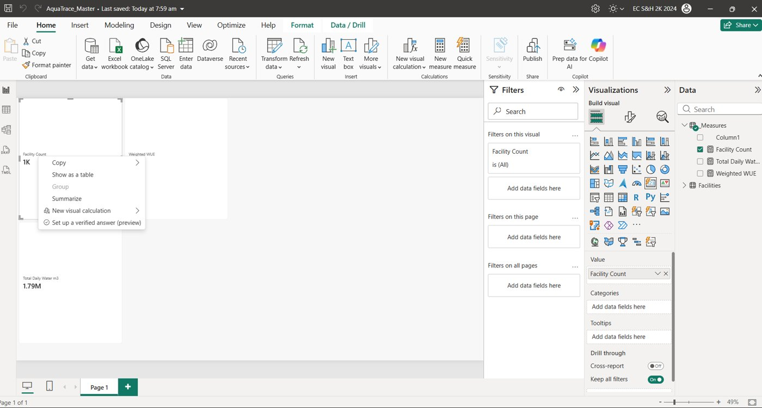
Right-click menu open on the card, and the Format and Data / Drill tabs visible. Press Esc to close the menu.
1. Selected the card, then Format visual (paint-roller icon in the Visualizations pane).
2. On the Visual tab opened Callout, then expanded Value (click the arrow, not the On/Off toggle).
3. Display units is inside Value (use the pane Search box and type "display" to jump to it).
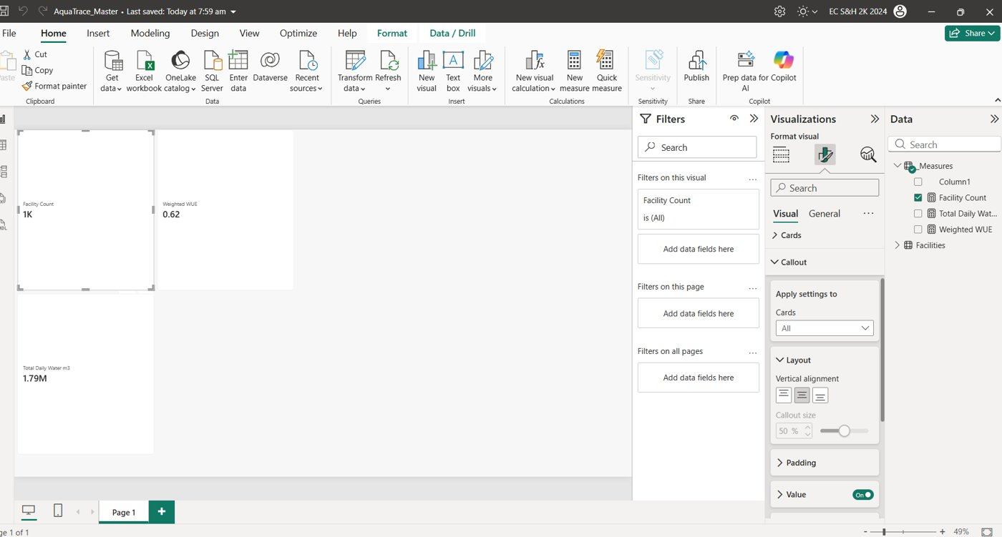
Format visual > Visual > Callout. Display units is under Value, below the font settings.
Decision: the card shows 1.200K when no slicer is chosen, which still reads as 1,200. The team kept it because it is explainable. With a slicer applied the card changes (for example 675).

Step 5.3 Check the four remaining measures in a table
1. Added a Table visual and ticked High Risk %, Stressed Facilities %, Avg AI Share and Avg PUE.
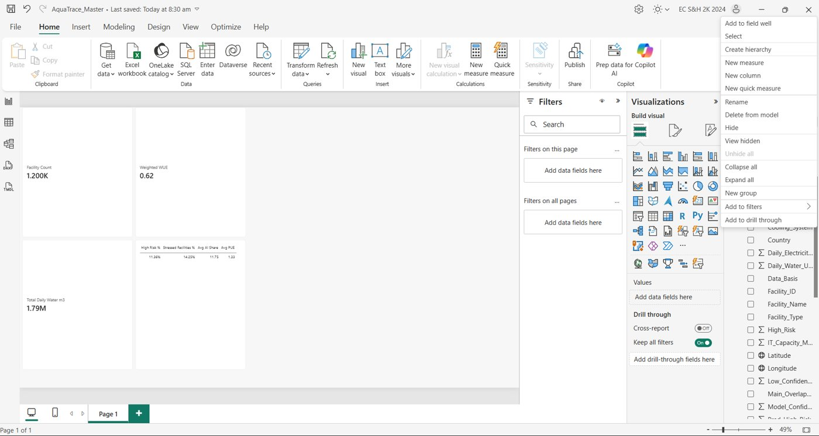
Table check: High Risk % 11.36%, Stressed Facilities % 14.25%, Avg AI Share 11.75, Avg PUE 1.33.
Check: all four values are in the expected ranges (around 11%, 15%, 12 and 1.3). With the 2019 slicer selected the same table showed 12.74%, 15.41%, 1.70 and 1.36, matching the Python trend table.

Part 6. Build the charts

Step 6.1 WUE by cooling system (clustered bar chart)
1. Clicked an empty canvas area. In the Visualizations pane picked Clustered bar chart (horizontal bars).
2. Dragged Cooling_System to Y-axis and the Weighted WUE measure to X-axis.
3. Format visual > General > Title: typed the title "Evaporative cooling uses about ten times more water than air-side cooling", and a subtitle "Modelled estimates. Litres of water per kWh of IT energy". The title was checked: 1.48 divided by 0.14 is about 10.
4. Format visual > Visual > Data labels: turned on, font size 12 or more.
5. Checked that the X-axis starts at 0, then turned on the axis titles (X: water use effectiveness, Y: Cooling system).
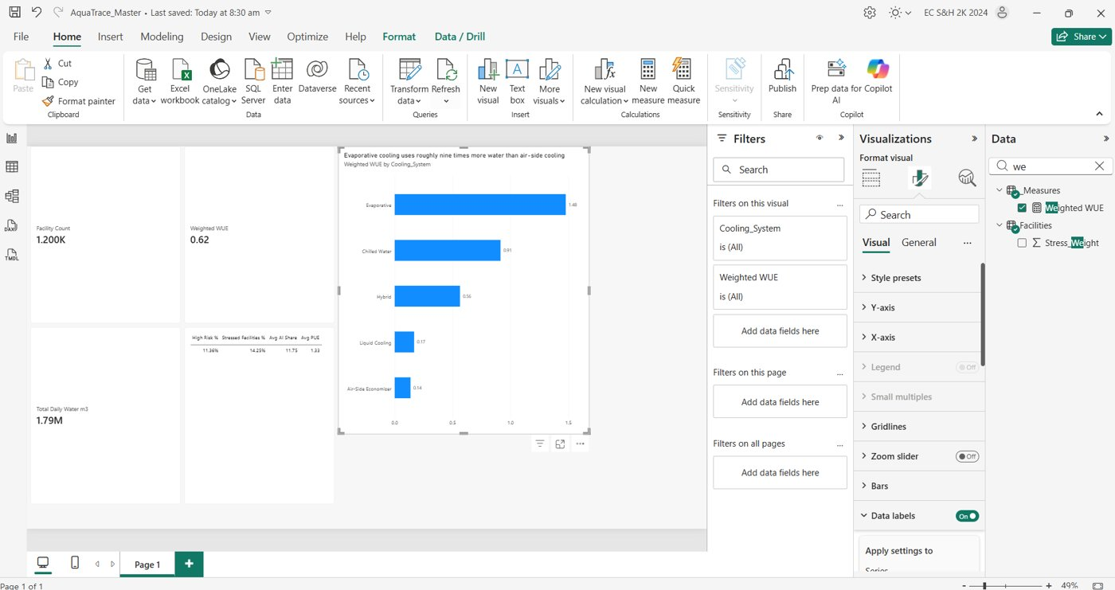
WUE by cooling: Evaporative 1.48, Chilled Water 0.91, Hybrid 0.56, Liquid Cooling 0.17, Air-Side Economizer 0.14.

Step 6.2 Risk tier by region (100% stacked bar chart)
1. Created the measure Facility Years (COUNTROWS of Facilities).
2. Picked 100% stacked bar chart. Region to Y-axis, Facility Years to X-axis, Water_Risk_Tier to Legend.
3. Set tier colours (Low green, Medium amber, High red; temporary) and turned on data labels.
4. Wrote the title from the numbers: "Over 40% of Middle East & Africa facility-years are high risk, versus about 5% in Europe". Subtitle: share of facility-years by risk tier, modelled estimates, water stress is country-level.
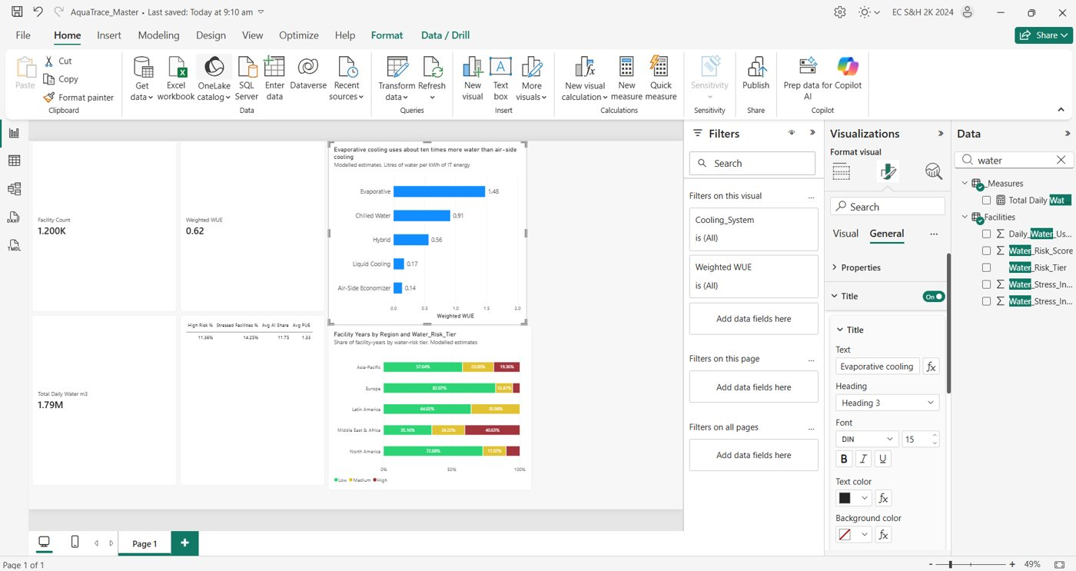
Region chart added. The Format pane is open on the title settings (General tab).
Region | Low | Medium | High
Middle East & Africa | 35.2% | 24.2% | 40.6%
Asia-Pacific | 57.6% | 23.0% | 19.4%
North America | 72.7% | 17.1% | 10.2%
Latin America | 64.0% | 36.0% | 0%
Europe | 82.1% | 12.5% | 5.5%

Step 6.3 Trend by year (line chart)
1. Picked Line chart. Year to X-axis, Total Daily Water m3 to Y-axis.
2. Format visual > Y-axis: set the minimum to 0 so the line is not exaggerated.
3. Format visual > X-axis > Type > Categorical so every year is shown.
4. Data labels on, position Above, font size 12. Title: "Modelled fleet water use roughly tripled from 2019 to 2025, partly because facilities were added". Subtitle: stylised trend, modelled estimates.
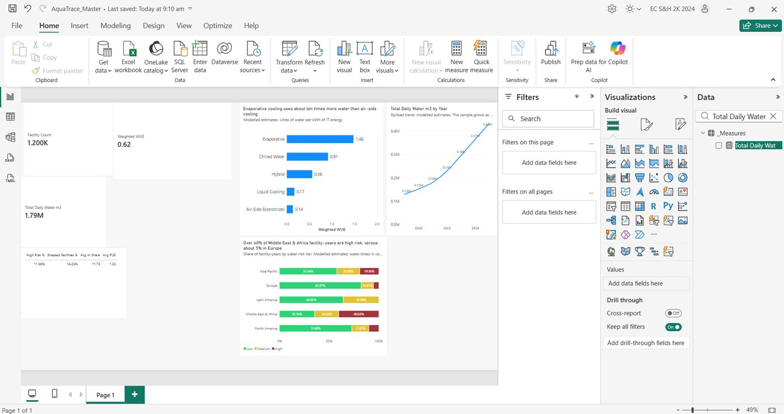
The trend chart with all charts on the page. At this point the Year axis runs in the wrong direction (see the problem below).
Problem found: after switching to Categorical the years ran 2025 to 2019 and the line sloped down. Fix: hover the chart, click the three dots (...), Sort axis > Year, then Sort axis > Sort ascending (or set the X-axis Type to Continuous with minimum 2019 and maximum 2025). The final dashboard shows the corrected chart.

Step 6.4 Slicers (Year, Region, Cooling system)
1. Clicked an empty canvas area and picked the Slicer visual in the Visualizations pane.
2. Dragged Year into the Field well. Under Format visual > Slicer settings > Options > Style chose Tile.
3. Added a second slicer with Region (List) and a third with Cooling_System (List).
4. Gave each slicer a short title (Year, Region, Cooling system).
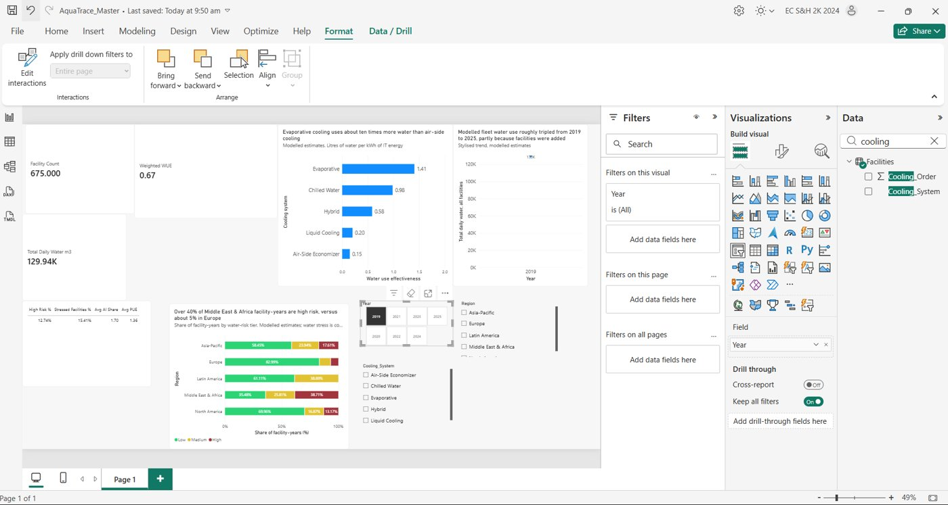
Three slicers added. In this view 2019 is selected, and the trend chart had collapsed to a single point. The Format tab with Edit interactions is open.

Step 6.5 Stop the Year slicer filtering the trend line
Selecting one year in the Year slicer would reduce the trend line to one dot. Edit interactions keeps the full line.
1. Selected the Year slicer.
2. Format tab > Edit interactions. Small icons appear at the top-right of every other visual: a funnel (Filter) and a circle with a diagonal line (None).
3. On the trend line chart, clicked the None icon (circle with a diagonal line).
4. Clicked Edit interactions again to leave the mode.
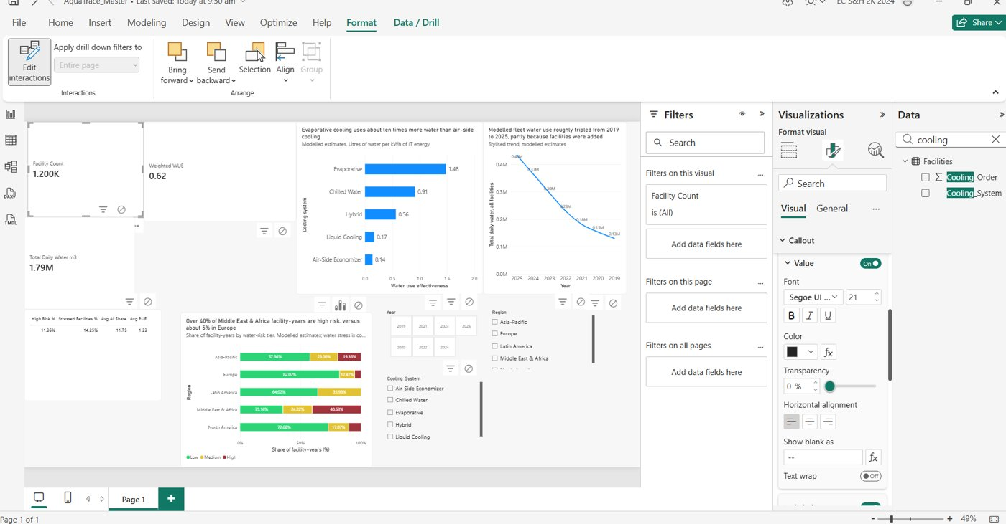
Edit interactions active. The icons appear on every visual. The trend line chart keeps all years while the other visuals filter.
Check: with a year selected, the cards and the other charts change, but the trend line still shows every year. Click the eraser icon above the slicer (or the selected year again) to clear it before taking screenshots.

Step 6.6 WUE outlier chart
1. Created the measures Outlier Rows and Outlier % (Part 4).
2. Picked Clustered column chart. Cooling_System to X-axis, Outlier % to Y-axis, Outlier Rows to Tooltips.
3. Data labels on, Y-axis from 0, axis titles added. Title: "Air-side economizer sites account for most WUE outliers, about 1 in 10 facility-years". Subtitle: Tukey rule, 1.5 x IQR on log WUE within each cooling system, modelled estimates.
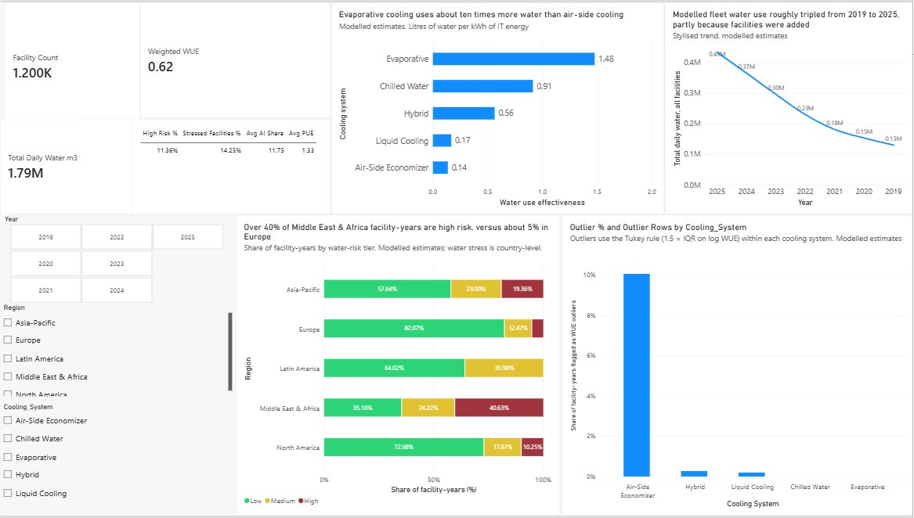
The tidied dashboard with the outlier chart added.

Step 6.7 Final dashboard
After fixing the trend axis order and the outlier chart title, the page looks like this.
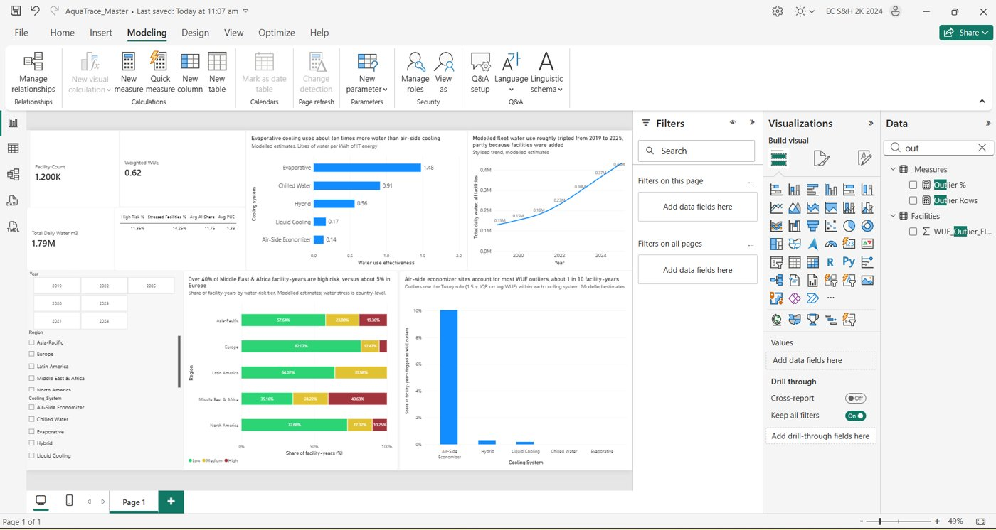
Final Page 1: KPI cards, WUE by cooling, trend by year, region risk tiers, outlier chart and slicers.

Part 7. Python EDA
I ran aquatrace_eda.py on aquatrace_powerbi.csv. The script sits in the same folder as the data and writes its results to an eda_output folder.
1. Installed the libraries once: pip install pandas numpy scipy matplotlib.
2. Opened a terminal in the folder and ran: python aquatrace_eda.py
3. The script prints findings and saves CSV tables and four charts.
Script section | What it does
1. Data checks | Shape, nulls, duplicates, value ranges, tier shares.
2. Trend by year | Facilities, total water, weighted WUE, AI share, water per facility.
3. WUE by cooling | Mean and median WUE, PUE and High-risk share per cooling system.
4. Correlations | Spearman correlations and variance explained (eta squared).
5. Risk by region and stress | Tier shares by region, High-risk share by cooling and stress tier.
6. Outliers | Tukey rule on log WUE, high versus low, by climate and year.
7. Model vs EDA | Reads model_importance.csv and ranks both views.
8. Charts | WUE box plot, correlations, High-risk heat map, trend.

The findings are written up in 02_EDA_Findings_Note.docx.

Part 8. Problems met and how they were fixed
Problem | Cause | Fix
"External table is not in the expected format" | Excel connector used on a CSV file. | Home > Get data > Text/CSV.
Column profile options greyed out | Enable column profile was off. | View > Data view > tick Enable column profile first.
Could not find Column tools or Sort by column | The tab only appears when a single column is selected in the Data pane. | Left-click the field name, not the tick box.
Card still showed 1K after setting the measure format | The card's display units override the measure format. | Format visual > Callout > Value > Display units.
Could not find the Edit interactions icons | A slicer must be selected first, and visuals overlapped. | Select the slicer, Format > Edit interactions, then click the None icon on the trend chart.
Trend line sloped downward | The categorical Year axis sorted descending. | Sort axis > Year > Sort ascending.
Region slicer cut off and overlapping | Layout not yet tidied. | Resize or use a drop-down slicer in the final layout pass.

Part 9. Final verification
Check | Expected | Result
Rows loaded | 6,512 | Confirmed
Columns | 43 | Confirmed
Facility Count | 1,200 | 1.200K on the card (1,200)
Weighted WUE | About 0.6 to 0.7 | 0.62
High Risk % | About 11% | 11.36%
Stressed Facilities % | About 15% | 14.25%
Avg PUE | About 1.3 | 1.33
Trend direction | Rising 2019 to 2025 | Fixed (see final screenshot)

Still to do
- Add (L/kWh) to the cooling chart's x-axis title.
- Tidy the layout: slicer spacing and the KPI row.
- Replace the red, amber and green with the colour-blind-safe palette from Member 4.
- Add a Row_Key (Facility_ID joined with Year) when Member 3 sends their CSVs.
- Confirm with the teacher whether slicers and KPI cards count toward the 3 to 5 visual limit.

Appendix. Where things are in the interface
I want to... | Go to
Load a CSV | Home > Get data > Text/CSV
Open Power Query | Home > Transform data (or Transform Data in the load preview)
Trim text | Power Query: Transform > Format > Trim
Remove duplicates | Select the key columns, right-click a header > Remove duplicates
Check nulls | Power Query: View > Data view > Enable column profile, then Show column quality details
Rename a step | Right-click the step in Applied Steps > Rename
Apply Power Query changes | Power Query: Home > Close & Apply
Rename a table | Select the table: Table tools > Name box
Set map coordinates | Select the field: Column tools > Data category
Stop a number being added up | Select the field: Column tools > Summarization > Don't summarize
Sort one column by another | Select the field: Column tools > Sort by column
Create an empty table | Home > Enter data
Create a measure | Select _Measures: Home > New measure
Format a measure | Select the measure: Measure tools > Format
Change a visual's look | Select the visual: Format visual (paint roller) in the Visualizations pane
Card display units | Format visual > Visual > Callout > Value > Display units
Stop one visual filtering another | Select the slicer: Format > Edit interactions > None icon on the other visual
Sort a chart axis | Hover the chart > three dots > Sort axis

