Step1:
Starting supervisor
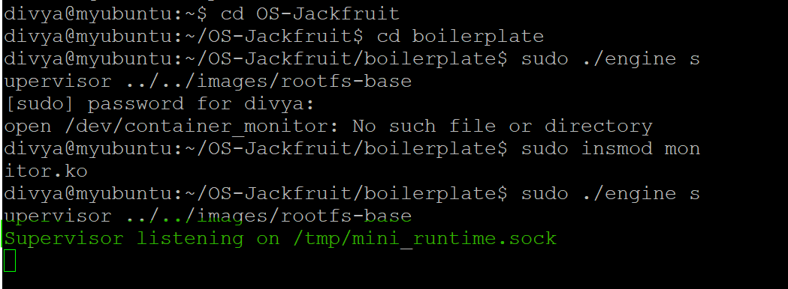
Step2:
Starting multiple containers in another terminal.
Supervisor console o/p:
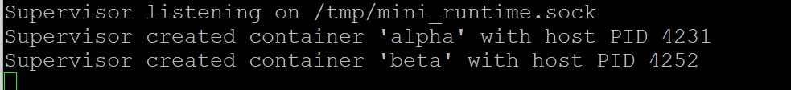

Step3:
Checking container status:
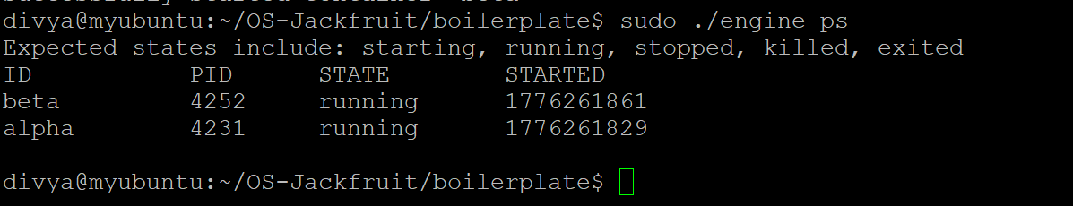

Step1:
Showing container status using “engine ps “command ,o/p contains ID,PID,STATE of container along with started timestamp.


Step1:
Starting a container which produces a message every 5seconds.(producer)

Step2:
Checking container status:
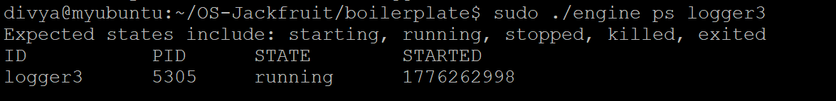
Step3:
Checking logs using log command(consumer)
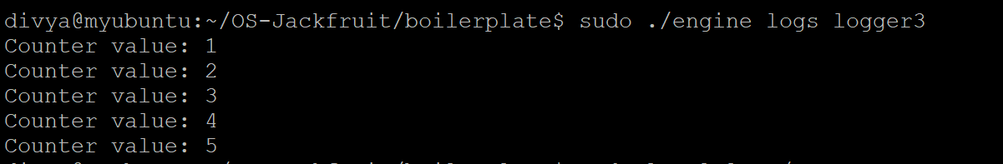

Step4:
Log file location
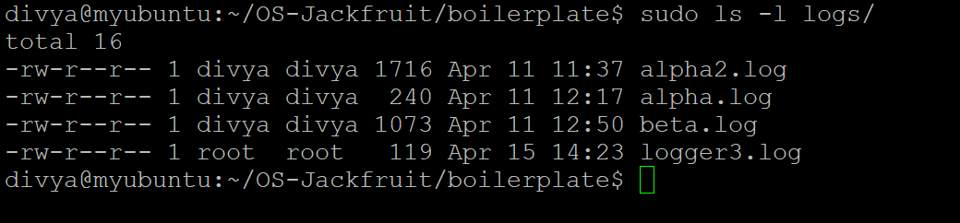

Step1:
Container started using CLI

Step2:
Supervisor responds
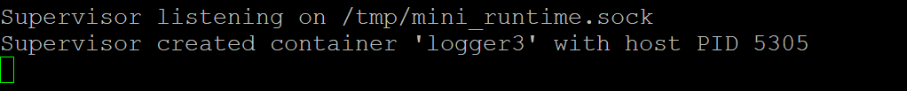

Step3:
Container stopped using CLI:
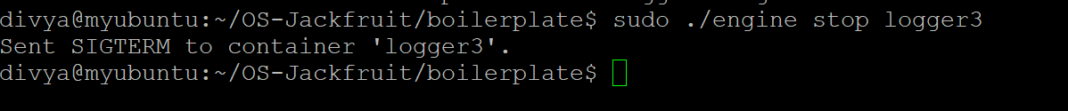
Supervisor response:
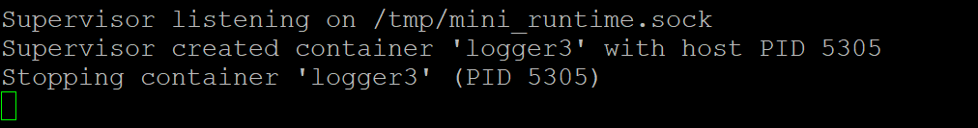
Step4:
Blocking container started using run CLI command
Supervisor status:
Engine ps status in a new terminal
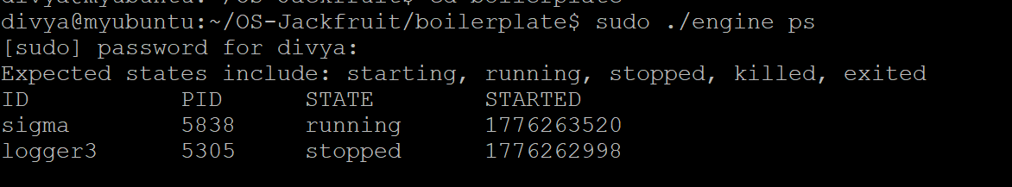
Stopping container which was started using run command: (^C)
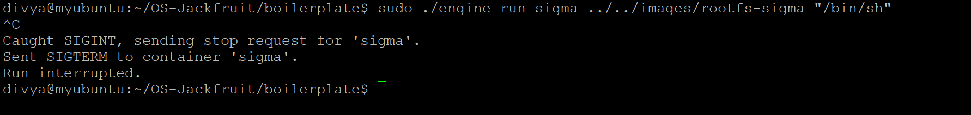
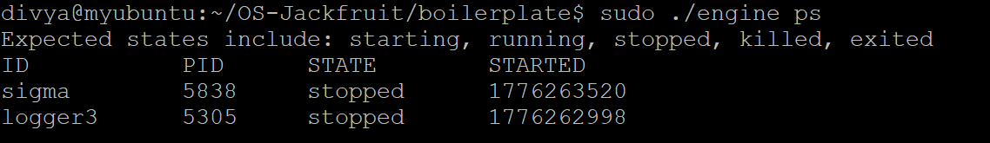
Step1:
Memory hogging container started

Step2:
Memory usage of container using log command

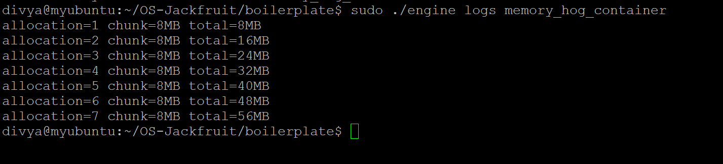
Soft limit warning from dmesg
Step1: Hard limit exceeded message through dmesg:
Container getting killed automatically after warning:
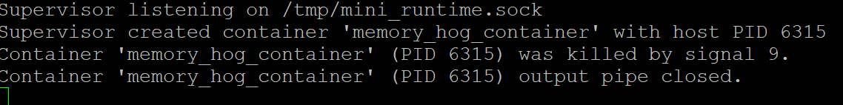
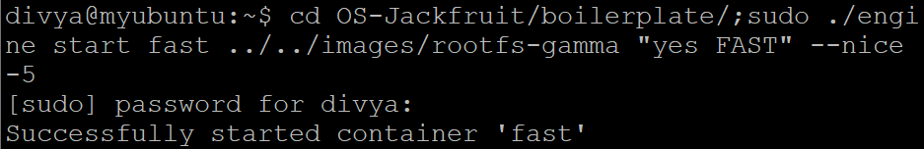

When supervisor is shut down excecution:
