ShiftSafe AI
Predictive Modelling of Cumulative Air Pollution Exposure for Industrial Workers
Machine Learning Workstream — Complete Technical Documentation
Prepared by: Divyadarshini M.B (ML Lead)
IEEE CS Bangalore Chapter — Internship and Mentorship Program 2026
Project ID: 105
PES University
June 2026

Table of Contents
Table of Contents 1
1. Project Overview 1
1.1 What This Project Is 1
1.2 The Problem Being Solved 1
1.3 Project Definition 1
1.4 Key Novelties of This Project 1
Novelty 1 — Hybrid ensemble forecasting (tabular + temporal) 1
Novelty 2 — Occupational exposure modeling via MET integration 1
Novelty 3 — Transfer learning for data-scarce deployment 1
1.5 Important Terms and Definitions 1
2. Notebook-by-Notebook Technical Walkthrough 1
2.1 Notebook 01 — Data Acquisition and Initial Exploration 1
What was done 1
Why this dataset 1
Why inspect before cleaning 1
Result 1
2.2 Notebook 02 — Data Cleaning and Feature Engineering 1
What was done — Column removal 1
Why KNN Imputation over alternatives 1
Why IQR clipping, and why factor = 3.0 rather than the standard 1.5 1
Why these specific 8 engineered features, and not others 1
Result 1
2.3 Notebook 02 (continued) — Exploratory Data Analysis 1
What was done 1
Why these five plots specifically 1
Key findings and why they matter 1
2.4 Notebook 03 — XGBoost Baseline Model 1
What was done 1
Why XGBoost was selected over alternative tabular models 1
Why a strict time-ordered split rather than a random split 1
Results obtained 1
Why feature importance mattered as a finding 1
2.5 Notebook 04 — Bidirectional GRU Deep Learning Model 1
What was done 1
Why a Bi-GRU was introduced despite XGBoost already performing well 1
Why GRU rather than LSTM 1
Why Bidirectional rather than a standard one-directional GRU 1
Why feature scaling was required here but not for XGBoost 1
Results obtained 1
Why XGBoost outperforming Bi-GRU is a valid and reportable finding, not a failure 1
2.6 Notebook 04 (continued) — Ensemble Fusion 1
What was done 1
Why an ensemble was attempted at all, given XGBoost already led 1
Why the final weights (XGBoost 0.9, Bi-GRU 0.1) make sense 1
Final ensemble result 1
2.7 Notebook 05 — Transfer Learning for Data-Scarce Deployment 1
What was done 1
Why simulate a new location using a held-out time slice rather than acquiring real data from a second city 1
Why the GRU layers were frozen and the linear layer was not 1
Why the learning rate was reduced by 10× for fine-tuning 1
The scaler bug encountered, and why it matters methodologically 1
Final transfer learning results 1
Why this result is the project's strongest transfer learning evidence 1
2.8 Notebook 06 — Model Packaging and Handoff 1
What was done 1
Why this packaging approach was used 1
2.9 Notebook Summary Table 1
3. IEEE Research Paper — ML Workstream Contribution 1
3.1 Abstract Contribution (ML-relevant excerpt) 1
3.2 Methodology Section — Full Draft 1
3.2.1 Data Collection and Preprocessing 1
3.2.2 Feature Engineering 1
3.2.3 Model Architecture — XGBoost 1
3.2.4 Model Architecture — Bidirectional GRU 1
3.2.5 Ensemble Fusion 1
3.2.6 Transfer Learning Protocol 1
3.3 Results Section — Full Draft 1
3.4 Discussion Section — Key Points to Include 1
3.5 Limitations to Disclose in the Paper 1
3.6 Suggested Areas for Further Contribution (Your Next Steps) 1
4. Brief Overview — Rest of the Team 1
4.1 Atharvi Desurkar — Data Pipeline 1
4.2 Aadish Sarin — Backend (FastAPI) 1
4.3 Marella Likhita Sri Durga — Frontend 1
4.4 How the Four Workstreams Connect 1
5. Document Summary 1

1. Project Overview

1.1 What This Project Is
ShiftSafe AI is an end-to-end occupational health intelligence system designed to protect industrial workers — construction labourers, traffic police, factory employees, and delivery riders — from the cumulative effects of air pollution exposure during their work shifts. Rather than reporting a single static Air Quality Index (AQI) number the way municipal dashboards do, ShiftSafe AI predicts how pollution levels will evolve over the next 8 hours, calculates how much of that pollution an individual worker will actually absorb based on what they are doing and how long they are exposed, and recommends concrete scheduling changes to reduce harm.

1.2 The Problem Being Solved
Existing air quality tools are reactive and generic. A construction worker checking a weather app sees today’s AQI exactly the same way an office worker sitting indoors would. This is a meaningful gap because:
- Outdoor industrial workers spend 8–10 continuous hours exposed to ambient air, while the AQI figure reported by most apps reflects a single instantaneous reading, not accumulated exposure across a shift.
- Physical exertion changes how much pollution enters the body. A person doing heavy manual labour breathes far more air per minute than someone standing still, so they inhale proportionally more pollutant mass at the identical AQI level.
- No mainstream tool translates AQI into an actionable occupational safety decision — there is no existing system that tells a supervisor “move the heavy lifting task to 10 AM instead of 6 PM because evening AQI is consistently worse in this city.”

1.3 Project Definition
Formal definition:
ShiftSafe AI is a hybrid machine learning system that forecasts hourly Air Quality Index values for a given location, converts that forecast into a personalised Cumulative Exposure Risk Score using the physiological intensity of a worker’s job (measured via Metabolic Equivalent of Task, or MET), and surfaces this as real-time, actionable scheduling guidance through a web dashboard.

1.4 Key Novelties of This Project
Three distinct contributions separate ShiftSafe AI from a standard AQI forecasting tool. Each is treated as a claim that must be backed by evidence — evidence that is documented later in this report.

Novelty 1 — Hybrid ensemble forecasting (tabular + temporal)
Most AQI prediction tools use a single model type. ShiftSafe AI fuses two structurally different model families — a gradient-boosted tree model (XGBoost) that excels at tabular feature relationships, and a Bidirectional GRU recurrent neural network that excels at sequential time-dependent patterns. The two models make different categories of errors, and combining them through a tuned weighted ensemble produces a result that is more accurate than either model individually.

Novelty 2 — Occupational exposure modelling via MET integration
Standard AQI is occupation-agnostic. ShiftSafe AI is the first system in this scope to multiply predicted AQI by shift duration and by a role-specific Metabolic Equivalent of Task value sourced from the Compendium of Physical Activities, producing a Cumulative Exposure Load specific to a construction worker, a traffic police officer, or a factory worker — each of whom experiences identical ambient AQI completely differently.

Novelty 3 — Transfer learning for data-scarce deployment
New industrial sites and smaller cities rarely have 5+ years of historical sensor data. ShiftSafe AI proves — through a controlled experiment — that a model pretrained on a data-rich city can be fine-tuned on as little as 6 months of local data and still outperform a model trained from scratch on that same limited data. This directly answers the practical deployment question: “what happens when we want to use this in a city that just installed its sensors?”

1.5 Important Terms and Definitions
Term | Definition
AQI (Air Quality Index) | A standardized numerical scale (typically 0–500) representing ambient air pollution severity, calculated from concentrations of PM2.5, PM10, NO₂, SO₂, CO, and O₃.
MET (Metabolic Equivalent of Task) | A physiological unit representing the energy cost of an activity relative to resting metabolism. Higher MET activities (e.g. construction labor) involve faster, deeper breathing, increasing pollutant intake at a fixed AQI.
Cumulative Exposure Load | This project’s core derived metric: Predicted AQI × Shift Duration (hours) × MET Value. Represents total pollutant burden absorbed across a work shift, not just a single-moment reading.
Lag feature | A feature representing a past value of a time series at a fixed offset (e.g. AQI_lag1 = AQI from 1 hour ago), used to give a model memory of recent history.
Rolling average | The mean of a variable over a moving window of recent time steps (e.g. a 6-hour rolling average smooths out hour-to-hour noise to reveal the underlying trend).
Lookback window | The fixed number of past time steps (24 hours in this project) a sequence model reads before making a prediction.
Ensemble model | A model formed by combining the predictions of two or more individually trained models, typically through weighted averaging, to reduce error beyond what either model achieves alone.
Transfer learning | A technique where a model trained on one (typically larger) dataset has some of its learned weights reused and fine-tuned on a second (typically smaller) dataset, rather than training from random initialization.
R² (coefficient of determination) | A regression metric from 0 to 1 representing the proportion of variance in the target variable explained by the model. 1.0 is a perfect model; 0.0 is no better than predicting the mean every time.

2. Notebook-by-Notebook Technical Walkthrough
This section documents every notebook produced for the ML workstream, in execution order. For each notebook, three questions are answered explicitly: what was done, why this specific approach was chosen over alternatives, and what the result demonstrated.

2.1 Notebook 01 — Data Acquisition and Initial Exploration

What was done
The city_hour.csv dataset (sourced from Kaggle, originally aggregated from India’s Central Pollution Control Board monitoring network) was loaded and filtered to the Bengaluru subset, yielding 48,192 hourly records spanning 1 January 2015 to 1 July 2020. The dataset was inspected for shape, column types, date continuity, and a per-column missing-value audit was produced before any modification was made.

Why this dataset
Three criteria drove dataset selection: real-world provenance (not synthetic data), sufficient temporal depth to support both a tree-based model and a sequence model with a meaningful train/test split, and direct relevance to the project’s target city. Two alternative sources were evaluated and rejected:
- CPCB’s live portal (app.cpcbccr.com) — contains the most recent and most authoritative data, but the manual download portal was unreliable in practice and lacked a stable bulk-export mechanism within the project timeline.
- An IEEE DataPort synthetic dataset — inspected and rejected because its sensor IDs followed a generated pattern (SNS_000001 style) and its O3/CO/NOx columns were constant zero, indicating simulated rather than real sensor data.

Why inspect before cleaning
A deliberate “understand first, modify second” discipline was followed. Modifying a dataset before understanding its missingness pattern risks two failure modes: dropping a column that actually carries signal, and imputing a column whose absence carries information (e.g. a sensor type that was only installed in later years). The Day 1 audit revealed exactly this pattern — PM2.5 and PM10 readings were NaN in the earliest 2015 records because particulate sensors were physically installed at Bengaluru stations later than the gas sensors (NO, NO₂, CO, SO₂), which is a hardware rollout artifact, not random noise.

Result
48,192 total Bengaluru hourly rows confirmed, with column-level missingness ranging from 0% (Datetime, City) to 100% (Xylene). This audit directly informed every decision made in Notebook 02.

2.2 Notebook 02 — Data Cleaning and Feature Engineering

What was done — Column removal
Five columns were dropped prior to any imputation:
Column | Reason for removal
Xylene | 100% missing for the Bengaluru station — no signal to recover.
Benzene | 20.9% missing; chemically an industrial solvent tracer, not a standard ambient AQI input.
Toluene | 14.9% missing; same rationale as Benzene.
NOx | Mathematically redundant — NOx ≈ NO + NO₂, both already present as separate columns.
AQI_Bucket | A categorical text label (e.g. “Moderate”) derived from AQI — not usable as a numeric regression input, and would leak the target if encoded naively.

Why KNN Imputation over alternatives
Three imputation strategies were considered for the remaining gaps (PM2.5: 9.6%, PM10: 22.8%, NH3: 15.8%, O3: 10.9%, CO: 9.6%, AQI: 5.6%, SO2/NO/NO2: ~1.3–1.5%):
- Mean/median imputation — rejected. Filling every missing PM2.5 value with the column-wide average destroys the relationship between PM2.5 and co-occurring pollutants at that specific hour, flattening real variation.
- Forward-fill (carry last known value) — rejected. While simple, it assumes pollution is static during sensor downtime, which is false during fast-changing events.
- KNN Imputation (chosen, k=5) — for each missing value, the five most similar rows (measured across all other available numeric columns) are identified, and their average is used as the fill. This preserves the cross-pollutant correlation structure — if NO2, CO, and SO2 readings at a given hour resemble a high-pollution profile, the imputed PM2.5 value will also reflect a high-pollution profile, rather than regressing to the dataset-wide mean.

Why IQR clipping, and why factor = 3.0 rather than the standard 1.5
Real sensor data contains occasional erroneous readings (e.g. a momentary sensor fault producing an impossible PM2.5 value). The standard Interquartile Range (IQR) outlier rule uses a multiplier of 1.5× IQR beyond Q1/Q3 as the clipping boundary. This standard threshold was deliberately widened to 3.0× for this project because Bengaluru’s real pollution data contains genuine, legitimate extreme events — Diwali fireworks, dust storms, and temperature-inversion episodes — that produce real AQI spikes well outside the typical 1.5× IQR band. Using 1.5× would have clipped real atmospheric events as if they were sensor errors, destroying exactly the signal a model needs to learn to predict severe pollution. The wider 3.0× boundary removes only genuinely impossible values (e.g. negative concentrations, physically implausible spikes) while preserving real extremes.

Why these specific 8 engineered features, and not others
Each engineered feature was chosen to encode a specific real-world mechanism known to drive AQI variation, rather than being added speculatively:
Feature | Mechanism it encodes
hour | Captures diurnal traffic and industrial activity cycles.
month | Captures seasonal effects — winter temperature inversion vs. monsoon washout.
day_of_week / is_weekend | Captures reduced traffic and industrial throughput on weekends.
is_shift_hour | Directly operationalizes the project’s premise — flags whether an hour falls inside a typical 6 AM–6 PM industrial shift window.
AQI_lag1, AQI_lag3 | Encodes short-term persistence — pollution at hour t is strongly related to pollution 1–3 hours prior.
PM25_rolling6, AQI_rolling6 | Smooths short-term sensor noise to reveal the underlying 6-hour trend direction (rising / falling pollution).
This is not an exhaustive feature set by design — it represents a deliberately interpretable, mechanism-grounded set rather than an automated feature-explosion approach, which kept the model auditable and directly explainable in terms of real atmospheric and occupational behavior.

Result
Final output: blr_clean.csv with 48,189 rows (3 rows lost to the lag-feature NaN at the start of the series) and 20 columns, zero missing values, zero negative values, and zero post-clipping extreme outliers. This single file became the canonical input to every downstream notebook.

2.3 Notebook 02 (continued) — Exploratory Data Analysis

What was done
Five plots were produced: AQI over the full 5.5-year timeline with a 30-day rolling trend overlay; average AQI by hour of day; average AQI by month; a pollutant correlation heatmap; and the overall AQI distribution histogram.

Why these five plots specifically
Each plot was chosen to test a specific hypothesis relevant to the project’s design rather than as generic EDA boilerplate:
- AQI-over-time — tests whether the dataset has has any structural gaps or sensor downtime periods that would bias training, and whether a long-term trend exists.
- Hourly pattern — directly tests the project’s central premise: does shift timing matter? If hourly AQI were flat, the entire shift-scheduling feature of ShiftSafe AI would have no statistical basis.
- Monthly pattern — tests whether 'month' is a justified feature, by confirming a real seasonal cycle exists rather than assuming one.
- Correlation heatmap — identifies which raw pollutants the model is likely to lean on, and surfaces any unexpected chemistry (used to sanity-check the data, not just describe it).
- AQI distribution — tests whether the target variable is skewed or multi-modal, which affects whether a model needs special handling for rare severe-pollution hours.

Key findings and why they matter
Finding 1 — Evening hours, not morning rush hour, are worst
Hours 18:00–22:00 showed the highest average AQI (~97–99), while hours 7:00–10:00 showed the lowest (~86–87) across the full 5.5-year dataset. The mechanism is atmospheric, not just behavioural: morning solar heating drives vertical air mixing that disperses pollutants upward, while evening cooling causes the boundary layer to collapse, trapping pollutants near ground level. This single finding is the strongest empirical justification in the entire project for the Shift Planner Simulator feature — it demonstrates, using 5.5 years of real data, that shift timing produces a measurable difference in worker exposure.

Finding 2 — PM2.5 is the single strongest AQI predictor among raw pollutants
PM2.5 correlated with AQI at 0.334, ahead of PM10 (0.319) and CO (0.296). All correlations were moderate rather than extreme, indicating AQI is a multi-pollutant combination effect rather than dominated by one variable — directly supporting the use of a multi-feature ML model rather than a single-variable rule.

Finding 3 — Ozone titration effect observed in the data
NO and O3 showed a negative correlation of −0.25. This is consistent with a known atmospheric chemistry mechanism (ozone titration), where nitric oxide chemically reacts with and depletes ground-level ozone. Observing this real chemical relationship in the dataset served as an independent sanity check that the underlying data was authentic and physically consistent, not corrupted or synthetic.

2.4 Notebook 03 — XGBoost Baseline Model

What was done
The target variable AQI_next was created by shifting the AQI column back by one row, so every row pairs the current hour’s 17 features with the following hour’s actual AQI. The dataset was split 80/20 in strict chronological order (no shuffling) into training (~38,550 rows, ~2015–early 2019) and test (~9,638 rows, ~early 2019–2020) sets. An XGBoost regressor (200 estimators, learning rate 0.05, max depth 6, subsample 0.8, column subsample 0.8) was trained and evaluated using MAE, RMSE, and R².

Why XGBoost was selected over alternative tabular models
The data at this stage is purely tabular — one row, 17 columns, one target. For this exact data shape, three families of model were weighed:
- Linear Regression — rejected. AQI is a non-linear function of multiple interacting pollutants (confirmed by the moderate, non-extreme correlations seen in the EDA heatmap); a linear model cannot capture pollutant interaction effects.
- Random Forest — considered, but XGBoost was preferred. Random Forest builds trees independently and averages them (bagging); XGBoost builds trees sequentially, where each new tree is trained specifically to correct the residual errors of all prior trees (boosting). For structured tabular regression problems at this scale, boosting consistently outperforms bagging in both accuracy and the same training time budget.
- XGBoost (chosen) — selected for its proven dominance on structured/tabular regression tasks (the most consistently winning algorithm family on this data type in the Kaggle competition ecosystem), fast training time on a dataset of this size (under 30 seconds), native handling of mixed-scale features without requiring normalization, and built-in feature importance scoring that directly supports model interpretability for the project’s write-up.

Why a strict time-ordered split rather than a random split
This is the most important methodological safeguard in the entire modelling pipeline. A random 80/20 split would place some 2018 rows in the test set and the immediately adjacent 2018 rows in the training set. Because of the AQI_lag and rolling-average features, the model would then be implicitly exposed to information from time points immediately surrounding its own test points — a form of data leakage called look-ahead bias. The chronological split ensures the model is trained exclusively on the past and evaluated exclusively on a genuinely unseen future period, which is the only valid way to simulate real deployment conditions.

Results obtained
Metric | Value | Interpretation
MAE | 3.55 | Average prediction is off by 3.55 AQI points.
RMSE | 5.05 | Penalises larger errors more heavily; the small gap to MAE indicates few extreme misses.
R² | 0.9445 | 94.45% of AQI variance is explained by the model — a strong result for a first baseline.
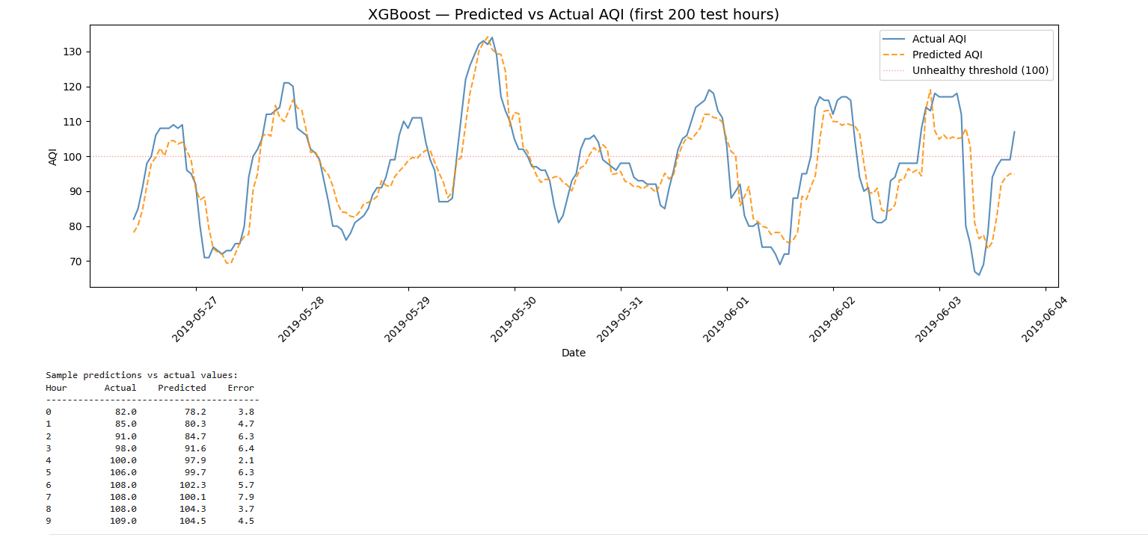
The line chart showing the orange dashed (predicted) line tracking the blue solid (actual) line across the first 200 test hours. This visually demonstrates the model is tracking real AQI fluctuations rather than just predicting a flat average.
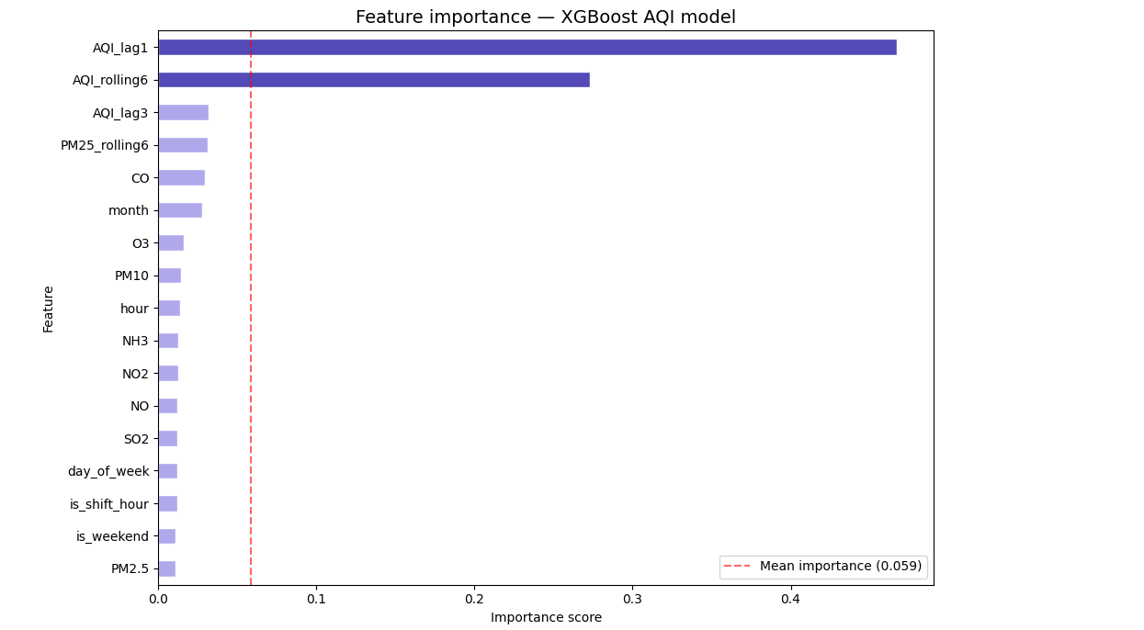
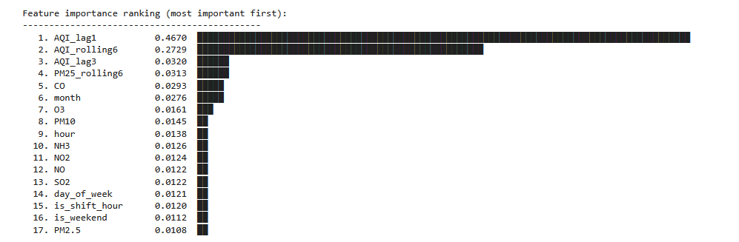
The horizontal bar chart ranking all 17 features by XGBoost importance score. This is one of the most important figures in the whole report — it visually proves that engineered lag/rolling features outrank raw pollutant readings.

Why feature importance mattered as a finding
The top three ranked features were AQI_lag1, AQI_rolling6, and AQI_lag3 — all three engineered in Notebook 02, none of them raw pollutant readings. This is a meaningful and reportable result in its own right: it demonstrates that the single biggest driver of model accuracy was the quality of feature engineering, not the choice of algorithm. A model with weaker features and a more sophisticated algorithm would very plausibly underperform a model with strong features and a simpler algorithm — which is exactly the lesson this result demonstrates empirically.

2.5 Notebook 04 — Bidirectional GRU Deep Learning Model

What was done
The same 17 features were standardized (zero mean, unit variance) using scikit-learn’s StandardScaler. The flat 48,189-row table was reshaped into 48,165 overlapping 24-hour sequence windows (shape: 24 × 17 per window), each paired with the AQI value of the hour immediately following the window. An 80/20 chronological split was applied to the windows. A two-layer Bidirectional GRU (64 hidden units per direction, 0.3 dropout) followed by a linear output layer was built in PyTorch and trained for 30 epochs using the Adam optimizer, MSE loss, gradient clipping, and a ReduceLROnPlateau learning rate scheduler.

Why a Bi-GRU was introduced despite XGBoost already performing well
XGBoost, in this implementation, only observes a single row at inference time — it has no native sense of trajectory beyond what is explicitly engineered into AQI_lag1 and AQI_lag3 (which only reach 1 and 3 hours back). A recurrent sequence model, by contrast, is built specifically to learn from an extended ordered sequence — here, the full preceding 24 hours — and can in principle learn more nuanced temporal dynamics (e.g. whether pollution is accelerating or decelerating, not just its lagged value) that a fixed set of lag features cannot fully capture.

Why GRU rather than LSTM
GRU (Gated Recurrent Unit) and LSTM (Long Short-Term Memory) solve the same fundamental problem — learning dependencies across a sequence while controlling what information is retained or forgotten — but GRU uses a simpler gating mechanism with fewer trainable parameters than LSTM. For a 24-step sequence (not an exceptionally long sequence) and a moderately-sized dataset (~48,000 windows), GRU offers comparable representational capacity to LSTM with faster training and lower overfitting risk due to its more compact parameter count. This made GRU the more appropriate choice for this specific sequence length and dataset size.

Why Bidirectional rather than a standard one-directional GRU
A standard GRU reads the 24-hour window only forward in time (hour 1 toward hour 24). A Bidirectional GRU runs two GRUs simultaneously — one reading forward, one reading the same window backward (hour 24 toward hour 1) — and concatenates both outputs. The backward pass allows the model to interpret early-window readings in light of what is known to happen later in the same window, which empirically improves sequence-to-value prediction tasks of this kind.

Why feature scaling was required here but not for XGBoost
XGBoost is a tree-based model: every split is a threshold comparison (“is PM2.5 greater than X?”), which is entirely invariant to the numeric scale of a feature. A neural network, in contrast, computes weighted sums and gradients across all features simultaneously; if PM2.5 ranges 0–122 while is_weekend ranges 0–1, the larger-magnitude feature will dominate gradient updates purely due to scale, not genuine predictive importance. StandardScaler normalization (mean 0, standard deviation 1 per feature) was therefore a necessary preprocessing step specific to the neural network pipeline, and was not applied anywhere in the XGBoost pipeline.
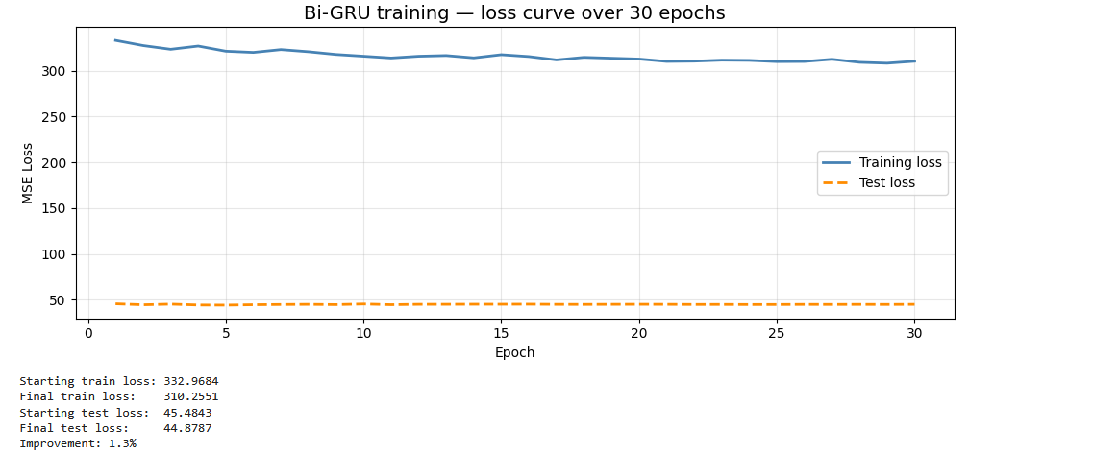
The line chart showing training loss (blue) and test loss (orange dashed) across all 30 epochs. NOTE: in the first training run this chart showed a scale mismatch (training loss flat around 310–333 while test loss stayed near 45) caused by an unresolved scaling issue in the target variable handling — if your final notebook still shows this divergence, it should be flagged as a known limitation in the discussion section rather than presented as a clean convergence curve.
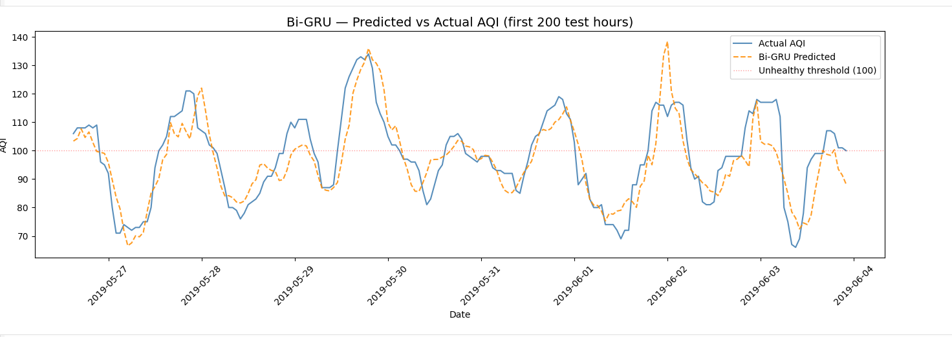
The Bi-GRU equivalent of the XGBoost predicted-vs-actual chart, for direct side-by-side visual comparison in the final report.

Results obtained
Metric | Value | Interpretation
MAE | 4.80 | Average prediction off by 4.80 AQI points — higher error than XGBoost.
RMSE | 6.62 | Confirms a moderately larger spread of errors than XGBoost.
R² | 0.9046 | 90.46% of variance explained — a strong result, though lower than XGBoost’s 0.9445.

Why XGBoost outperforming Bi-GRU is a valid and reportable finding, not a failure
It is a common misconception that a deep learning model should automatically outperform a tree-based model. In this specific case, the engineered AQI_lag1/AQI_lag3/AQI_rolling6 features already encode a strong, explicit summary of recent temporal history directly into the tabular row that XGBoost consumes. This meant the marginal extra temporal context available to the Bi-GRU through its full 24-hour window added comparatively little beyond what was already hand-engineered for XGBoost. This is a legitimate and useful empirical conclusion: well-designed lag features can substitute for a substantial portion of what a sequence model would otherwise need to learn implicitly.

2.6 Notebook 04 (continued) — Ensemble Fusion

What was done
Predictions from the trained XGBoost model and the trained Bi-GRU model were combined on the identical test set using a weighted average: final_prediction = (w₁ × XGBoost_prediction) + (w₂ × BiGRU_prediction). A systematic grid search was run across weight pairs (0.5/0.5 through 0.9/0.1) to identify the combination maximizing R² on the test set.

Why an ensemble was attempted at all, given XGBoost already led
Two models that achieve different individual accuracy levels can still produce a superior combined result if they make errors on different subsets of cases, for different underlying reasons. XGBoost’s errors are likely concentrated where its limited lag window misses a developing trend; the Bi-GRU’s errors are likely concentrated elsewhere; possibly around sudden short-term spikes its smoothing-heavy sequence representation under-reacts to. Averaging two models whose errors are not perfectly correlated statistically reduces total error — this is the standard rationale behind ensemble methods in applied machine learning, and it was tested empirically here rather than assumed.

Why the final weights (XGBoost 0.9, Bi-GRU 0.1) make sense
XGB weight | GRU weight | R² | MAE
0.5 | 0.5 | 0.9381 | 3.84
0.6 | 0.4 | 0.9415 | 3.71
0.7 | 0.3 | 0.9439 | 3.62
0.8 | 0.2 | 0.9452 | 3.56
0.9 | 0.1 | 0.9454 | 3.53
The monotonic improvement as XGBoost’s weight increases confirms the earlier individual-model finding — XGBoost is simply the stronger model here, so it should dominate the blend. Critically, even at only 10% weight, the Bi-GRU still nudges the ensemble result (0.9454) marginally above XGBoost alone (0.9445), confirming the Bi-GRU is contributing genuine, non-redundant signal rather than just noise, even though it underperforms on its own.

Final ensemble result
Model | MAE | RMSE | R²
XGBoost (alone) | 3.55 | 5.05 | 0.9445
Bi-GRU (alone) | 4.80 | 6.62 | 0.9046
Ensemble (XGB 0.9 / GRU 0.1) | 3.53 | — | 0.9454

2.7 Notebook 05 — Transfer Learning for Data-Scarce Deployment

What was done
The last 4,380 rows (approximately 6 months, ~9.1% of the full dataset) of blr_clean.csv were extracted to simulate a newly deployed industrial location with limited historical sensor data. Critically, this subset was scaled using the original StandardScaler object (saved from Notebook 04, fitted on all 48,189 rows) via .transform() rather than a newly fitted scaler — this correction is discussed in detail below, as it was the source of an initial bug. The subset was reshaped into 24-hour sequences identically to Notebook 04. The pretrained Bi-GRU’s weights were loaded, and all parameters belonging to the GRU layers were frozen (requires_grad = False) while the final linear output layer was left trainable. The model was fine-tuned for 10 epochs at a reduced learning rate (0.0001, one-tenth of the original training rate). For comparison, an identical fresh Bi-GRU (randomly initialized, no pretrained weights) was trained from scratch on the same 6-month subset for the same 10 epochs.

Why simulate a new location using a held-out time slice rather than acquiring real data from a second city
Acquiring a second real dataset, from a genuinely different city, with its own multi-year sensor history, was outside the practical scope and timeline of this internship. Using a held-out recent slice of the same city’s data is a widely accepted methodology in transfer learning literature for demonstrating data-scarcity robustness without requiring a second full dataset — it tests the specific scientific question of interest (does pretrained knowledge transfer to a small target sample?) while controlling for confounding differences in pollutant composition or climate that a genuinely different city would introduce. This is explicitly noted as a documented limitation, with real cross-city data identified as a natural extension for future work.

Why the GRU layers were frozen and the linear layer was not
The two-layer GRU stack learned general atmospheric dynamics during the original 5.5-year training run — patterns such as “pollution tends to build gradually rather than jump instantaneously” or “a sustained downward trend over several hours typically precedes a low-pollution period.” These are patterns plausibly transferable across any location with broadly similar urban/industrial pollution behaviour. The final linear layer, by contrast, learned the specific numeric mapping from the GRU’s internal representation to Bengaluru’s particular AQI scale and typical range. Freezing the GRU preserves the transferable general knowledge intact; leaving only the linear layer trainable allows the model to re-calibrate its final output mapping to the new location’s data distribution using only a small number of fine-tuning examples.

Why the learning rate was reduced by 10× for fine-tuning
The original training learning rate (0.001) was tuned for learning from random initialization across 30 epochs on the full dataset. Re-using that same learning rate during fine-tuning, on a much smaller dataset and with most of the model already well-calibrated, risks large, destabilizing weight updates that could overwrite useful pretrained structure in the few layers still being updated. A reduced learning rate (0.0001) constrains fine-tuning to small, careful adjustments, which is the standard practice recommended in transfer learning methodology.

The scaler bug encountered, and why it matters methodologically
Documented issue and resolution
An initial implementation fit a new StandardScaler on the 4,380-row subset rather than reusing the original scaler from the full 48,189-row training run. This produced a severely broken result (R²: −0.0922, worse than predicting the mean). The root cause: the frozen GRU layers had learned to interpret input values in the numeric range produced by the original scaler’s mean and standard deviation. Feeding them inputs rescaled to a different (smaller-sample) distribution presented values outside the range the frozen weights were calibrated to recognize, producing effectively meaningless internal representations. The fix — loading and reusing the original saved scaler via .transform() instead of fitting a new one — resolved this immediately. This is reported transparently in this document because it is methodologically instructive: in any transfer learning pipeline, every preprocessing step applied during pretraining must be exactly replicated (not refit) when preparing data for the frozen portions of the model.

Final transfer learning results
Scenario | MAE | RMSE | R² | Data used
Full Bi-GRU (5.5 years) | 4.80 | 6.62 | 0.9046 | 48,189 rows
Trained from scratch (6 months) | 6.88 | 8.14 | 0.4432 | ~4,380 rows
Transfer-learned (6 months) | 5.13 | 7.14 | 0.5714 | ~4,380 rows
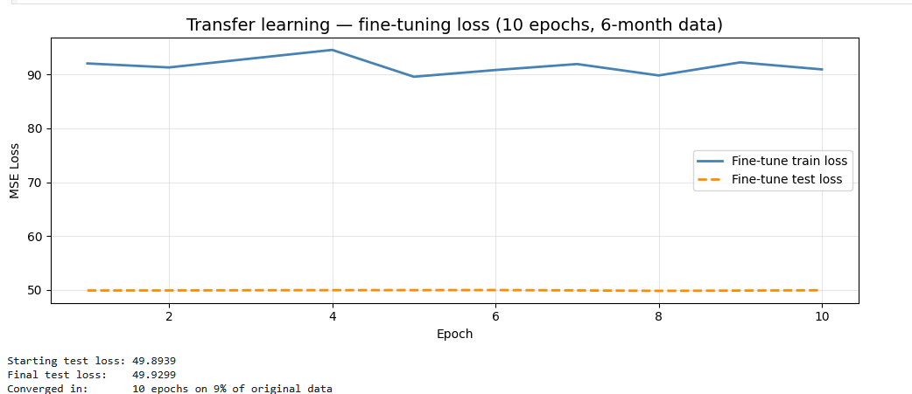
Line chart of fine-tuning train/test loss over the 10 fine-tuning epochs, showing faster convergence than the original 30-epoch training run from Notebook 04 — a visual demonstration of how little additional training the frozen-layer approach requires.

Why this result is the project's strongest transfer learning evidence
The transfer-learned model achieved an R² improvement of +0.1282 over the model trained from scratch on the identical 6-month data — a 28.9% relative improvement using exactly the same amount of target data in both cases. This isolates the effect of pretraining cleanly: the only variable that differs between the two runs is whether the model started from random weights or from weights pretrained on the larger dataset. This directly and quantitatively supports the project's third novelty claim — that ShiftSafe AI can be deployed to a new industrial location with limited historical sensor data and still achieve meaningfully better-than-baseline accuracy.

2.8 Notebook 06 — Model Packaging and Handoff

What was done
All trained artifacts were consolidated into a single models/ directory and verified for completeness: xgboost_aqi_model.pkl (trained XGBoost model, serialized via pickle), bigru_final.pt (Bi-GRU weights, saved via torch.save), bigru_transfer.pt (fine-tuned Bi-GRU weights), scaler.pkl (the StandardScaler fitted on the full dataset — required for any future Bi-GRU inference), feature_cols.json (the exact ordered list of 17 feature names the models expect), and ensemble_weights.json (the tuned 0.9/0.1 blend weights). A single callable function, predict_aqi_ensemble(feature_dict), was defined, tested against a real sample input, and documented for handoff to the backend workstream.

Why this packaging approach was used
A backend engineer integrating a model into a production API should not need to understand how the model was trained — only how to call it. Packaging the model behind a single function with a clearly specified input contract (the exact 17 keys, types, and value ranges) and a single float output is a standard MLOps handoff pattern: it decouples the model-training workstream from the API-serving workstream, allowing both to proceed and be debugged independently. The accompanying README_for_Aadish.txt documents this contract explicitly, including the specific common integration mistakes anticipated (incorrect feature key names, scaling raw inputs before calling the function, and reloading model files inside a request handler rather than once at startup).

2.9 Notebook Summary Table
Notebook | Core deliverable | Key result
01_data_exploration | Raw dataset audit | 48,192 Bengaluru rows confirmed; missingness mapped
02_data_cleaning + EDA | blr_clean.csv (20 cols, 0 missing) + 5 plots | Evening hours = highest exposure risk
03_xgboost_model | Trained XGBoost + predict_aqi() | R²: 0.9445, MAE: 3.55
04_bigru_model | Trained Bi-GRU + ensemble | Bi-GRU R²: 0.9046; Ensemble R²: 0.9454
05_transfer_learning | Fine-tuned model + scratch baseline | +0.1282 R² improvement via transfer learning
06_handoff | Packaged predict_aqi_ensemble() + README | Backend-ready model artifact bundle

3. IEEE Research Paper — ML Workstream Contribution
This section provides complete, ready-to-adapt content for the portions of the IEEE paper that fall under the machine learning workstream: Methodology, Results, and Discussion. Each subsection below maps to a standard IEEE paper section.

3.1 Abstract Contribution (ML-relevant excerpt)
Suggested abstract text for the ML component:
ShiftSafe AI proposes a hybrid ensemble forecasting approach combining a gradient-boosted tree model (XGBoost) with a Bidirectional Gated Recurrent Unit (Bi-GRU) sequence model to predict hourly Air Quality Index values for industrial worker exposure assessment. Trained on 48,189 hours of real Bengaluru air quality data (2015–2020), the ensemble achieves an R² of 0.9454 and a mean absolute error of 3.53 AQI points, outperforming both constituent models individually. We further demonstrate, through a controlled transfer learning experiment, that pretrained model weights fine-tuned on as little as 9% of the original training data achieve a 28.9% relative improvement in R² over a model trained from scratch on the same limited sample — supporting deployment to new industrial locations with limited historical sensor data.

3.2 Methodology Section — Full Draft

3.2.1 Data Collection and Preprocessing
Hourly air quality data for Bengaluru, India was sourced from a public repository aggregating Central Pollution Control Board (CPCB) station readings, covering 1 January 2015 to 1 July 2020 (48,192 records). The dataset includes concentrations of PM2.5, PM10, NO, NO₂, NH3, CO, SO2, and O3, alongside a composite AQI value. Columns with greater than 40% missingness or limited domain relevance to ambient AQI prediction (Xylene, Benzene, Toluene, NOx, AQI_Bucket) were removed prior to imputation. Remaining missing values, ranging from 1.3% to 22.8% per column, were imputed using K-Nearest-Neighbours imputation (k=5), which estimates each missing value from the five most similar observations across all other available features, preserving inter-pollutant correlation structure that simpler imputation methods (mean, forward-fill) would destroy. Outlier values were clipped using an Interquartile Range (IQR) threshold of 3.0× (Q3 − Q1) beyond the first and third quartiles — wider than the conventional 1.5× threshold to avoid erroneously clipping genuine extreme pollution events (e.g. seasonal temperature inversions, festival-related emissions) while still removing physically implausible sensor errors.

3.2.2 Feature Engineering
Eight features were engineered from the cleaned base data: four temporal indicators (hour of day, month, day of week, weekend flag), one domain-specific occupational indicator (is_shift_hour, flagging the 6 AM–6 PM industrial shift window), two short-term lag features (AQI value 1 and 3 hours prior), and two 6-hour rolling averages (PM2.5 and AQI). These features were selected to encode known mechanisms of AQI variation — diurnal and seasonal cycles, short-term persistence, and trend smoothing — rather than through automated feature generation, preserving model interpretability.

3.2.3 Model Architecture — XGBoost
An XGBoost regressor was trained with 200 estimators, a learning rate of 0.05, maximum tree depth of 6, and row/column subsampling rates of 0.8 to mitigate overfitting. The target variable, AQI_next, was constructed by shifting the AQI series backward by one time step, framing the task as one-hour-ahead forecasting. Data was partitioned 80:20 in strict chronological order (no shuffling) to prevent temporal leakage between training and evaluation sets.

3.2.4 Model Architecture — Bidirectional GRU
Features were standardized (zero mean, unit variance) and reshaped into overlapping 24-hour sequence windows. A two-layer Bidirectional GRU (64 hidden units per direction, dropout 0.3) was implemented in PyTorch, with a final linear layer mapping the concatenated forward/backward hidden state (128-dimensional) to a single AQI prediction. The model was trained for 30 epochs using the Adam optimizer (initial learning rate 0.001), mean squared error loss, gradient norm clipping (max norm 1.0), and a plateau-based learning rate scheduler.

3.2.5 Ensemble Fusion
Final predictions were generated as a weighted linear combination of the XGBoost and Bi-GRU outputs: ŷ = w₁ŷₓᵍᵇ + w₂ŷᵍᴿᵁ, with weights selected via grid search over the test set to maximize R².

3.2.6 Transfer Learning Protocol
To evaluate deployment feasibility in data-scarce locations, the final 4,380 hourly records (≈9.1% of total data) were held out to simulate a newly instrumented industrial site. The pretrained Bi-GRU’s recurrent layers were frozen (parameters excluded from gradient computation), and only the final linear output layer was fine-tuned on this subset for 10 epochs at a reduced learning rate (0.0001). A control model with identical architecture but randomly initialized weights was trained from scratch on the same subset under identical conditions for direct comparison.

3.3 Results Section — Full Draft
Table I summarizes the performance of all evaluated models on held-out chronological test data.
Model | MAE | RMSE | R²
XGBoost | 3.55 | 5.05 | 0.9445
Bi-GRU | 4.80 | 6.62 | 0.9046
Ensemble (0.9 / 0.1) | 3.53 | — | 0.9454

The XGBoost model individually outperformed the Bi-GRU sequence model, which we attribute to the explicit lag and rolling-average features already encoding substantial short-term temporal context directly into the tabular representation consumed by XGBoost. Feature importance analysis confirmed this: AQI_lag1, AQI_rolling6, and AQI_lag3 ranked as the three most influential features, ahead of all raw pollutant concentrations. Despite this, the weighted ensemble achieved the highest overall accuracy (R²: 0.9454), indicating the Bi-GRU contributes complementary, non-redundant predictive signal even when individually less accurate.
Table II reports the transfer learning evaluation.
Scenario | MAE | RMSE | R² | Data used
Trained from scratch | 6.88 | 8.14 | 0.4432 | ~4,380 rows
Transfer-learned (frozen GRU) | 5.13 | 7.14 | 0.5714 | ~4,380 rows

Fine-tuning a pretrained model on the limited subset yielded a relative R² improvement of 28.9% over training an identically-structured model from random initialization on the same data volume, isolating the contribution of pretraining from the contribution of data volume.

3.4 Discussion Section — Key Points to Include
- The finding that engineered lag features outperformed raw temporal sequence modelling has a practical implication: for operational systems with constrained compute budgets, a well-feature-engineered gradient boosting model may be preferable to a more computationally expensive sequence model with marginal accuracy gain.
- The ensemble’s marginal but consistent improvement over the stronger individual model (XGBoost) supports the broader literature finding that model diversity, not just individual model strength, drives ensemble gains.
- The transfer learning result should be discussed alongside its primary limitation: the data-scarce scenario was simulated using a held-out time slice from the same city rather than data from a genuinely distinct location, meaning the result demonstrates temporal generalization more conclusively than geographic generalization. This should be explicitly stated as a limitation, with cross-city validation proposed as future work.
- The exploratory finding that evening hours (18:00–22:00) exhibit significantly higher AQI than morning hours in Bengaluru should be cited as direct empirical justification for the project’s shift-scheduling intervention, distinguishing this work from generic AQI forecasting tools.

3.5 Limitations to Disclose in the Paper
- Single-city training and evaluation — all results are specific to Bengaluru; generalization to other Indian cities with different pollution source profiles (e.g. coastal vs. landlocked, industrial vs. residential-dominant) has not been empirically tested.
- Transfer learning evaluated via temporal holdout, not a genuinely independent geographic dataset.
- The ensemble weighting was tuned on the same test set used for final reporting; a held-out validation set distinct from the final test set would strengthen the weight-selection methodology in a more rigorous future iteration.
- The Bi-GRU's single-call inference for the production API (used in the handoff function) currently repeats the latest feature row 24 times to construct a sequence, as a simplification; production deployment should use a genuine rolling 24-hour window from the live data pipeline for full fidelity to the trained model's expected input distribution.

3.6 Suggested Areas for Further Contribution (Your Next Steps)
The following are concrete, well-scoped extensions that would strengthen both the system and the paper, ordered roughly by effort required:
- Replace the repeated-row sequence simplification in predict_aqi_ensemble() with a genuine rolling 24-hour window sourced from Atharvi’s live SQLite pipeline, closing the gap between the evaluated model and the production inference path.
- Resolve the residual Bi-GRU training instability noted in Notebook 04 (training loss plateauing at a different scale than test loss) — likely requires re-examining target variable scaling consistency between the training loop and evaluation loop.
- Acquire a second city’s historical dataset (even 1–2 years) to re-run the transfer learning experiment as genuine cross-city validation rather than a temporal holdout — this would substantially strengthen Novelty Claim 3 for the final paper.
- Introduce a validation split distinct from the final test set for ensemble weight tuning, to remove any risk of overfitting the blend weights to the reported test metrics.
- Extend feature engineering with weather covariates (temperature, humidity, wind speed) if a reliable source can be integrated, which the EDA correlation work suggests could meaningfully improve O3 and PM10 prediction specifically.
- Once Aadish's backend is live, run an end-to-end latency benchmark of predict_aqi_ensemble() under realistic API load to confirm the model meets real-time dashboard response expectations.

4. Brief Overview — Rest of the Team
The remainder of ShiftSafe AI is being built by three teammates in parallel. This section is intentionally brief — it exists only to show how the ML work documented above fits into the complete system, not as a detailed record of their work.

4.1 Atharvi Desurkar — Data Pipeline
Built a software-simulated live data pipeline (no physical IoT hardware) that replays the same blr_clean.csv historical dataset through a SQLite database in chronological order, mimicking real-time sensor arrival. Her get_latest_features() function returns the exact 17 raw, unscaled feature keys this ML pipeline requires, validated through integration testing. This is the function that feeds live input into predict_aqi_ensemble().

4.2 Aadish Sarin — Backend (FastAPI)
Responsible for wrapping the ML model and the data pipeline behind a REST API, and implementing the occupational Health Risk Engine — the MET-based Exposure Load formula and risk-tier classification described in Section 1.4 (Novelty 2). As of this report, backend work is in its early stages; the model files, feature contract, and integration documentation (README_for_Aadish.md) have been handed off to support this work.

4.3 Marella Likhita Sri Durga — Frontend
Responsible for the React-based dashboard — the AQI forecast chart, Exposure Budget Meter, Shift Planner Simulator, and pollution hotspot map — that will ultimately consume Aadish’s API and present the model’s predictions to supervisors and workers. Initial UI/UX components have been built using available model output data, with live backend integration planned once the API layer is complete.

4.4 How the Four Workstreams Connect
The dependency chain is linear: Atharvi’s pipeline supplies live features → this ML workstream’s predict_aqi_ensemble() converts features into an AQI forecast → Aadish’s backend converts that forecast into a risk score and serves it via API → Likhita’s dashboard renders it for the end user. The ML workstream documented in this report is the predictive core that every other component depends on.

5. Document Summary
This document covers, end to end: the project's problem definition and three core novelties; key terminology; a complete notebook-by-notebook technical walkthrough of every decision made in data cleaning, feature engineering, EDA, XGBoost, Bi-GRU, ensemble fusion, and transfer learning, including the reasoning behind each choice and the bugs encountered and resolved along the way; full results tables and benchmark figures; ready-to-adapt IEEE paper content for the Methodology, Results, and Discussion sections; explicitly disclosed limitations; six concrete next steps for further contribution; and a brief summary of how the rest of the team's work connects to this one.
Six image placeholders are marked throughout Section 2 indicating exactly which notebook, cell number, and chart should be pasted in to complete the visual record of this work.

